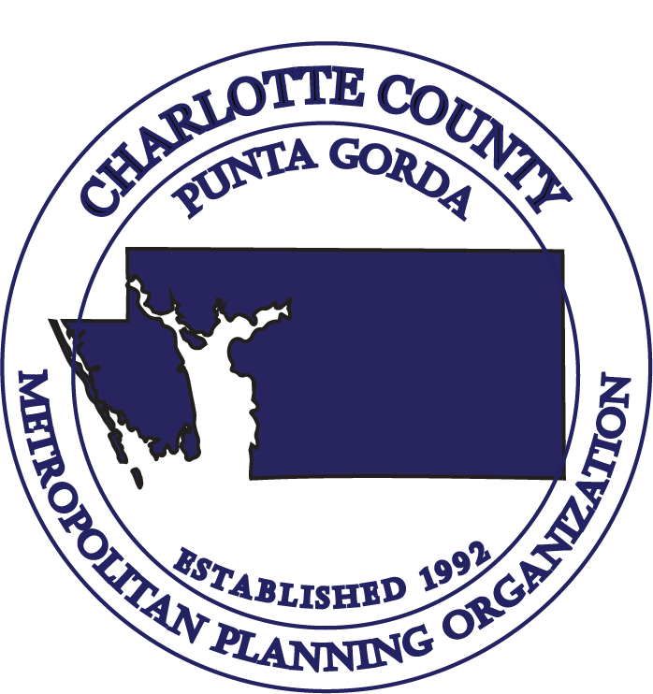

CHARLOTTE COUNTY – PUNTA GORDA METROPOLITAN PLANNING ORGANIZATION
TECHNICAL ADVISORY COMMITTEE (TAC)

MEETING AGENDA

9:30 a.m., Wednesday, November 8, 2023
Charlotte County Transit Facility
545 Theresa Boulevard
Port Charlotte, FL 33954

- Call to Order & Roll Call

- Public Comments on Agenda Items

- Election of 2024 Officers

- Chairs Report

- Consent Agenda:
- Approval of Minutes: September 27, 2023 Meeting

- Florida Department of Transportation (FDOT) Report

- FDOT Draft Tentative Five-Year Work Program FY 2025 through FY 2029

- 2050 Socio-Economic (SE) Data Development – Final Update

- Charlotte County Advanced Traffic Management Systems

- 2024 FDOT Safety Performance Measures Discussion

- Freight Mobility & Trade Plan Updates

- Public Comments

- Staff Comments

TECHNICAL ADVISORY COMMITTEE (TAC) MEETING

CHARLOTTE COUNTY – PUNTA GORDA

METROPOLITAN PLANNING ORGANIZATION

9:30 a.m., Wednesday, November 8, 2023

14. Member Comments

15. Adjournment (Next TAC Meeting – March 6, 2024)

No stenographic record by a certified court reporter is made of these meetings. Accordingly, anyone seeking to appeal any decisions involving the matters herein will be responsible for making a verbatim record of the meeting/testimony and evidence upon which any appeal is to be based. (F.S. 286.0105)

IN ACCORDANCE WITH THE AMERICANS WITH DISABILITIES ACT AND CHAPTER 286.26 FLORIDA STATUTES, PERSONS NEEDING SPECIAL ACCOMMODATIONS TO PARTICIPATE IN THIS PROCEEDING SHOULD CONTACT THE CHARLOTTE COUNTY-PUNTA GORDA METROPOLITAN PLANNING ORGANIZATION AT LEAST FORTY-EIGHT (48) HOURS PRIOR TO THE MEETING. CALL (941) 883-3535 BETWEEN 8:00 A.M. AND 4:00 P.M., MONDAY THROUGH FRIDAY.

The MPO’s planning process is conducted in accordance with Title VI of the Civil Rights Act of 1964 and related statutes. Any person or beneficiary who believes he or she has been discriminated against because of race, color, religion, sex, age, national origin, disability, or familial status may file a complaint with the Charlotte County-Punta Gorda MPO Title VI Coordinator Wendy W. Scott at (941) 883-3535 or by writing her at 18500 Murdock Circle, Building B, Suite 200, Port Charlotte, FL 33948.

CHARLOTTE COUNTY-PUNTA GORDA METROPOLITAN PLANNING ORGANIZATION
18500 Murdock Circle, Building B, Suite 200, Port Charlotte, FL 33948 Telephone: (941) 883-3535 Fax: (941) 883-3534

