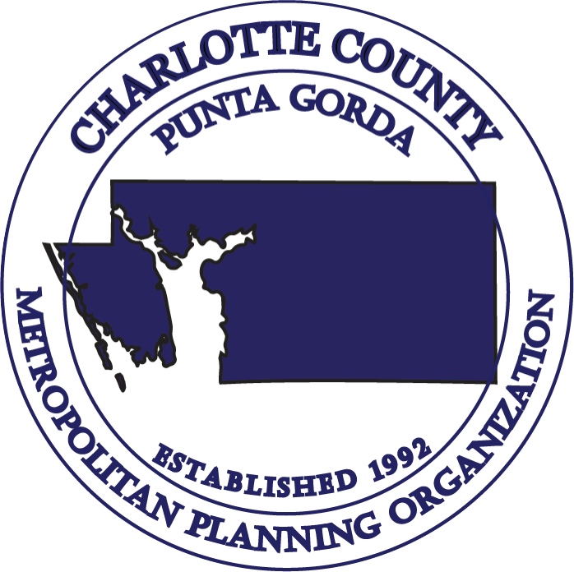
CHARLOTTE COUNTY - PUNTA GORDA
METROPOLITAN PLANNING ORGANIZATION
MINUTES OF THE JUNE 28, 2023
TECHNICAL ADVISORY COMMITTEE (TAC) MEETING
Charlotte Community Foundation
227 Sullivan Street
Punta Gorda, FL 33950

MEMBERS PARTICIPATING

Mitchell Austin, City of Punta Gorda, TAC Chair
Robert Fakhri, Charlotte County Public Works
Brett White, Charlotte County Airport Authority
Don Scott, Lee County MPO
Shirley Ciampi, Charlotte County Transit Division
Shaun Cullinan, Charlotte County Community Development
Joshua Hudson, Charlotte County Economic Development (Virtual)
Patrick Fuller, Charlotte County Emergency Management (Virtual)

OTHERS PARTICIPATING

D’Juan Harris, MPO Director
Lakshmi N. Gurram, MPO Principal Planner
Betty-Ann Sherer, MPO Planner
Wendy Scott, MPO Planner (Virtual)
Bekie Leslie, MPO Administrative Services Coordinator (Virtual)
April Santos, Charlotte County Public Works
Rich Lisenbee, Charlotte County Signal System Specialist
Jody Mansell, Charlotte County Lighting District Superintendent
Pamela Barr, FDOT District One
Brett Kamm, Kimley-Horn
Babuji Ambikapathy, VHB (Virtual)
Katherine Tellez, Fehr & Peers (Virtual)

MEMBERS ABSENT

Tony Conte, Charlotte County Public Schools
June Fisher, DeSoto County
Carl Benge, City of North Port

- Call to Order & Roll Call

TAC Chair Mitchell Austin called the meeting to order at 9:30 A.M. The roll call was taken; a quorum was present.

- Public Comments on Agenda Items

There were no public comments.

- Consent Agenda:

- Approval of Minutes: April 26, 2023, Meeting
Brett White made a motion to approve the Consent Agenda. Shaun Cullinan seconded the motion, and it was passed unanimously.

- Chairs Report

The Chair had nothing specific to report at this time.

- Florida Department of Transportation (FDOT) Report

Pam Barr informed members: FDOT is preparing to work on the upcoming Work Program cycle for FY 2025 through FY 2029. Ms. Barr indicated that the Public Hearing is anticipated to occur in October/November of this year.

At the previous committee meeting, a member inquired about the missing and damaged signage due to Hurricane Ian along US 41. She indicated that the materials have been ordered and FDOT is now awaiting an installation schedule from the contractor.

- FY 2023/2024 Unified Planning Work Program (UPWP)/MPO Agreement Amendments
Director Harris briefly summarized the purpose of the UPWP and outlined the following revisions/amendments being proposed in this amendment:
- Moving $20,000 from Task 2 - Data Collection & Analysis Planning salary line into its consultant line
- Adding in Task 4 - Long Range Transportation Plan (LRTP) including $31,469 SL dollars under the consultant line. This funding will be utilized for the development of the 2050 LRTP Update
- Adding in Task 6 - Special Project Planning the new language for Safe Street for All and adding funding under Task 6 - Special Project consultant account the federal grant funding amount of $249,500 and local share is $62,500
- Add additional allocation for FTA 5305(d) in the amount of $1,192 to Task 8 – Transit and Transportation Disadvantaged (TD) Planning
- Adding additional funding allocation in Task 8 – Transit and Transportation Disadvantaged (TD) Planning for TD Planning in the amount of $1,237
- Updating FY 2024 all FY 2024 Statements and Assurances form
- Amending the MPO Agreement to reflect all new funding allocations.

Budgeted Action:

Funding Source | Source Level | Previous  FY 2024 UPWP Allocation | New FY 2024 UPWP Allocation | UPWP FY 2024 Increase
5305(d) | PL | $86,491 | $87,683 | $1,192
TD | State | $23,887 | $25,124 | $1,237
SL | PL | New | $31,469 | $31,469
SS4A | Federal | New | $249,500 | $249,500
SS4A | Local | New | $62,500 | $62,500

Shaun Cullinan made a Motion to recommend the MPO Board amend the FY 2024 Unified Planning Work Program (UPWP) to include the following updates: (1) Safe Streets and Roads for All grant award to Task 6 – Special Project Planning in the amount of $312,000 (includes federal and local share), (2) add verbiage to Task 6 to include Development of SS4A Comprehensive Safety Action Plan Activities, (3) SL funds in the amount of $31,469 to Task 4 – Long Range Transportation Plan (LRTP), and (4) FTA Section 5305(d) funds in the amount of $1,192 to Task 8 Transit, and (5) Transportation Disadvantaged (TD) funds in the amount of $1,237 to Task 8 – TD Planning. This Motion allows for the transmittal of the amendments to the MPO Agreement, FY 2024 updated Statements and Assurances forms and the FDOT Cost Analysis Certification form. These revisions will allow staff to make minor non-financial changes and adjustments based upon input received from FDOT. Brett White seconded the motion, and it was passed unanimously.

- Safe Streets and Roads for All (SS4A) Federal Grant Agreement

Director Harris gave a brief background on the Safe Streets and Roads for All federal grant funding awarded to the Charlotte County-Punta Gorda MPO to develop a Comprehensive Safety Action Plan.

The Comprehensive Safety Action Plan will provide an in-depth analysis of roadway crash data in Charlotte County and strategically identify project priority recommendations to countermeasure the incidence of crashes in Charlotte County based on the Federal Highway Administration’s (FHWA) Safe System Approach. Development of the plan is anticipated to take up to one year, as noted in the timeline located in the TAC meeting packet. Once the plan is adopted, local jurisdictions within Charlotte County will be eligible to apply for SS4A Project Implementation funding for transportation safety improvements of up to $50,000,000 per project. The goal is to identify and implement short-term, mid-term and ultimate transportation solutions that will reduce or eliminate serious injuries and fatal crashes on public roadways.

The federal grant award amount is $249,500. The required local match will be provided by Charlotte County in the amount $62,500, yielding a total project budget of $312,000. A resolution authorizing the execution of the SS4A Grant Agreement with the US DOT has been reviewed by the MPO Board Legal Counsel and was placed in the TAC meeting packet.

Shaun Cullinan made a Motion to recommend MPO Board approval of Resolution 2023-02 for signature by the MPO Chair and to authorize the MPO Director to execute the Charlotte County-Punta Gorda MPO’s Safe Streets and Roads for All Planning Grant Agreement with the United States Department of Transportation (including making minor adjustments as required). Don Scott seconded the motion, and it was passed unanimously.

- Safe Streets and Roads for All (SS4A) Consultant Selection

Director Harris – reviewed the SS4A consultant selection process which took place on June 14, 2023, the SS4A consultant selection committee held in-person presentations amongst the three responding GPC consultants vying for the opportunity to develop the Charlotte County-Punta Gorda Comprehensive Safety Action Plan. The SS4A selection committee ranked the consultants based on the criteria below:
SS4A Selection Committee Scoring Criteria | Possible Score
Understanding of Safe Systems Approach and Pragmatic Examples of Application of Principles | 20
Experience Developing Vision Zero / Comprehensive Safety Action Plans | 20
Implementation Strategies to Address Issues along High Injury Network (Can be proposed or based on previous case studies) | 20
Public Engagement / Public Involvement Strategy / Stakeholder Considerations | 15
Innovative Utilization of Technology | 15
Response to Questions | 10

Upon tallying the scoring criteria, the SS4A selection committee unanimously recommended VHB as the consultant to develop the Charlotte County-Punta Gorda Comprehensive Safety Action Plan.

D’Juan Harris informed that once approved by the MPO Board, MPO Staff will negotiate a Scope of Services for development of the Comprehensive Safety Action Plan.

Robert Fakhri inquired if the Draft High Injury Network is the primary focus of the study. D’Juan Harris responded that other areas of concern will be analyzed during the study. The High Injury Network will identify problem crash areas and the study will provide countermeasure project recommendations to mitigate the occurrence of serious injuries and fatalities on public roadways.

Shaun Cullinan made a Motion to recommend MPO Board approval of the SS4A selection

committee’s consultant recommendation: to authorize the MPO Staff to develop a Work

Assignment Order and Scope of Services with the selected consultant; and to authorize the

MPO Chair to sign the Work Assignment Order. Brett White seconded the motion, and it was passed unanimously.

- 2050 Socioeconomic Data development update

Laks Gurram introduced Brett Kamm of Kimley Horn & Associates who briefed the Committee on the status of the 2050 Long Range Transportation Plan (LRTP) 2020 Data Needs for the Model Validation.

Brett Kamm reviewed a PowerPoint presentation which provided updates on the following topics:

- Forecasting Process
- Population and Employment Control Totals
- Outstanding Data Needs
- Next Steps

He informed that the University of Florida Bureau of Business and Economic Research (BEBR) average of medium and high population projections may still be considered low.

Mitchell Austin noted in both the city and the county, there has recently been greater interest in infill and redevelopment of existing sites. Mr. Austin inquired if this is taken into account during data collection?

Brett Kamm responded that this plan currently does not take redevelopment into account, however it will be considered for the future forecast.

Shaun Cullinan noted that Charlotte County Community Development is currently doing some population projections with Metro-Forecasting. It is the general perception that the current population of Charlotte County is over 200,000.

- Sun Trail Projects - Discussion

Laks Gurram informed that the Florida Greenways and Trails Council (FGTC) serves as an extension to advise the Florida Department of Environmental Protection on Greenways and Trails related issues.

He informed that the MPO Staff had an opportunity to attend the council meeting that was held on April 13th & 14th of 2023 in Tallahassee. Proposed changes to the SUN Trail alignment maps were discussed for their approval at this meeting. The changes were presented to this committee back at the November 30, 2022, meeting.

He informed the committee about the additional changes proposed to the existing route in downtown Punta Gorda. The proposed modified alignment would take the route from Cooper Street to Taylor Road. One goal is to strategically align these Shared Use Pathways

away from motor vehicle traffic to allow for safer travel of pedestrians and cyclists. SUN Trail Shared Use Pathways are the gold standard for trail development and the MPO is striving to attain as many SUN Trail Pathways as feasible within Charlotte County.

The status of the SUN Trail funded projects in Charlotte County for FY 2024 through FY 2028 Draft Tentative Work Program are listed below:

- Cape Haze Pioneer Trail (SR 776) from US 41 to Gillot Blvd; PE- $468,000 (FY 2024)
- Cape Haze Pioneer Trail (SR 776) from Gillot Blvd to Myakka State Forrest; PE $189,019 (FY 2024)
- US 41 (SR 45) at South Fork Alligator Creek; PE $290,000 (FY 2025)

Chair Austin noted the current SUN Trail alignment within the city, goes down US41, and the corridor is constrained from the Charlotte Harbor down to Airport Road. The City of Punta Gorda’s ultimate goal is to have loops around the city; from Cooper Street to Taylor Road and the south to US 41 Northbound. This approach provides a much safer route. The city supports this realignment.

- Public Comments

There were no public comments.

- Staff Comments

Director Harris noted he was appreciative to have a quorum for this meeting. He noted if there were any topics anyone would like to discuss at a future committee meeting, please forward them to MPO staff.

- Member Comments

There were no public comments.

- Adjournment

There being no further business, the meeting was adjourned at 10:21 A.M. The next regularly scheduled TAC meeting will be held on Wednesday, September 27, 2023, both virtually and in-person at the Charlotte County Community Foundation 227 Sullivan Street, Punta Gorda, Florida 33950 at 9:30 a.m.

