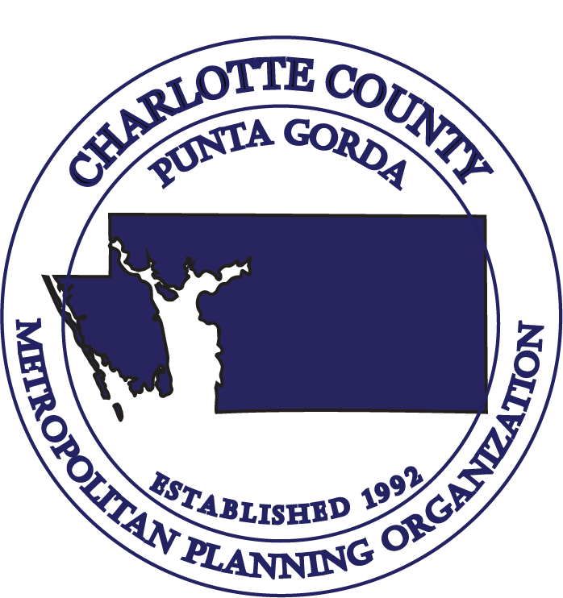

CHARLOTTE COUNTY – PUNTA GORDA
METROPOLITAN PLANNING ORGANIZATION
CITIZENS’ ADVISORY COMMITTEE (CAC)

MEETING AGENDA

1:30., Wednesday, September 27, 2023
Charlotte Community Foundation
227 Sullivan Street
Punta Gorda, FL 33950

- Call to Order & Roll Call

- Pledge of Allegiance

- Public Comments on Agenda Items

- Reports:
A. Chair’s Report
B. City of Punta Gorda Report
C. Charlotte County Report
D. Sheriff’s Report

- Florida Department of Transportation (FDOT) Report

- Consent Agenda:
- Approval of Minutes: June 28, 2023, Meeting
- Draft MPO Board and Advisory Committees Meeting Schedule for Calendar Year 2024

- FY 2023/2024 Unified Planning Work Program (UPWP)/MPO Agreement Amendment

- 2023 Transportation Improvement Program (TIP) Roll Forward Amendment

- 2050 Socio-Economic (SE) Data Update

- Safe Streets and Roads for All – Comprehensive Safety Action Plan Scope Review

- Reapportionment Plan Update

- Charlotte County Economic Development Overview

CITIZENS’ ADVISORY COMMITTEE (CAC) MEETING

CHARLOTTE COUNTY – PUNTA GORDA

METROPOLITAN PLANNING ORGANIZATION

1:30 p.m., Wednesday, September 27, 2023

- Project Priority Mapping Tool Presentation

- Public Comments

- Staff Comments

- Member Comments

- Adjournment (Next CAC Meeting – November 8, 2023)

No stenographic record by a certified court reporter is made of these meetings. Accordingly, anyone seeking to appeal any decisions involving the matters herein will be responsible for making a verbatim record of the meeting/testimony and evidence upon which any appeal is to be based. (F.S. 286.0105)

IN ACCORDANCE WITH THE AMERICANS WITH DISABILITIES ACT AND CHAPTER 286.26 FLORIDA STATUTES, PERSONS NEEDING SPECIAL ACCOMMODATIONS TO PARTICIPATE IN THIS PROCEEDING SHOULD CONTACT THE CHARLOTTE COUNTY-PUNTA GORDA METROPOLITAN PLANNING ORGANIZATION AT LEAST FORTY-EIGHT (48) HOURS PRIOR TO THE MEETING. CALL (941) 883-3535 BETWEEN 8:00 A.M. AND 4:00 P.M., MONDAY THROUGH FRIDAY.

The MPO’s planning process is conducted in accordance with Title VI of the Civil Rights Act of 1964 and related statutes. Any person or beneficiary who believes he or she has been discriminated against because of race, color, religion, sex, age, national origin, disability, or familial status may file a complaint with the Charlotte County-Punta Gorda MPO Title VI Coordinator Wendy W. Scott at (941) 883-3535 or by writing her at 18500 Murdock Circle, Building B, Suite 200, Port Charlotte, FL 33948.

CHARLOTTE COUNTY-PUNTA GORDA METROPOLITAN PLANNING ORGANIZATION
18500 Murdock Circle, Building B, Suite 200, Port Charlotte, FL 33948 Telephone: (941) 883-3535 Fax: (941) 883-3534

