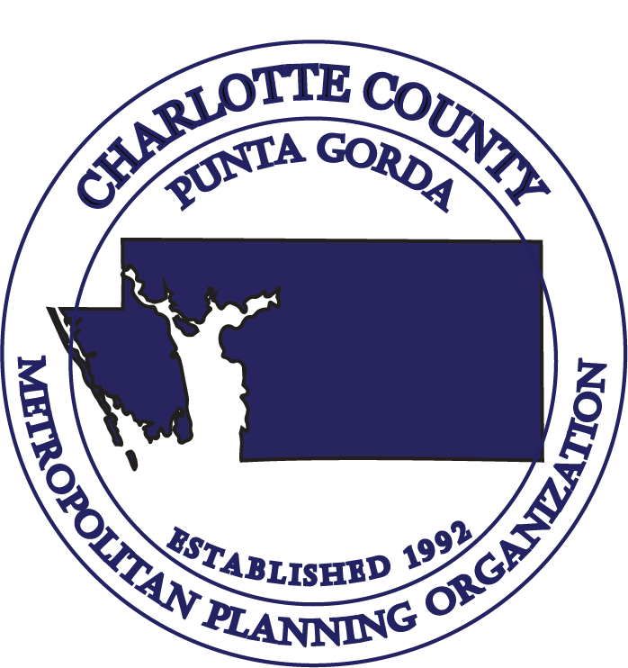

TECHNICAL ADVISORY COMMITTEE (TAC) MEETING

CHARLOTTE COUNTY – PUNTA GORDA
METROPOLITAN PLANNING ORGANIZATION
Tel: (941) 883-3535

AGENDA

9:30 a.m., Wednesday, June 28, 2023
Charlotte Community Foundation
227 Sullivan Street
Punta Gorda, FL 33950

- Call to Order & Roll Call

- Public Comments on Agenda Items

- Consent Agenda:
- Approval of Minutes: April 26, 2023, Meeting

- Chairs Report

- Florida Department of Transportation (FDOT) Report

- FY 2023/2024 Unified Planning Work Program (UPWP)/MPO Agreement Amendments

- Safe Streets and Roads for All (SS4A) Federal Grant Agreement

- Safe Streets and Roads for All (SS4A) Consultant Selection

- 2050 Socioeconomic Data development update

- Sun Trail Projects - Discussion

- Public Comments

- Staff Comments

- Member Comments

- Adjournment – (Next TAC Meeting - September 27, 2023)

TECHNICAL ADVISORY COMMITTEE (TAC) MEETING

CHARLOTTE COUNTY – PUNTA GORDA

METROPOLITAN PLANNING ORGANIZATION

9:30 a.m., Wednesday, June 28, 2023

No stenographic record by a certified court reporter is made of these meetings. Accordingly, anyone seeking to appeal any decisions involving the matters herein will be responsible for making a verbatim record of the meeting/testimony and evidence upon which any appeal is to be based. (F.S. 286.0105)

IN ACCORDANCE WITH THE AMERICANS WITH DISABILITIES ACT AND CHAPTER 286.26 FLORIDA STATUTES, PERSONS NEEDING SPECIAL ACCOMMODATIONS TO PARTICIPATE IN THIS PROCEEDING SHOULD CONTACT THE CHARLOTTE COUNTY-PUNTA GORDA METROPOLITAN PLANNING ORGANIZATION AT LEAST FORTY-EIGHT (48) HOURS PRIOR TO THE MEETING. CALL (941) 883-3535 BETWEEN 8:00 A.M. AND 4:00 P.M., MONDAY THROUGH FRIDAY.

The MPO’s planning process is conducted in accordance with Title VI of the Civil Rights Act of 1964 and related statutes. Any person or beneficiary who believes he or she has been discriminated against because of race, color, religion, sex, age, national origin, disability, or familial status may file a complaint with the Charlotte County-Punta Gorda MPO Title VI Coordinator Wendy W. Scott at (941) 883-3535 or by writing her at 18500 Murdock Circle, Building B, Suite 200, Port Charlotte, FL 33948.

CHARLOTTE COUNTY-PUNTA GORDA METROPOLITAN PLANNING ORGANIZATION
18500 Murdock Circle, Building B, Suite 200, Port Charlotte, FL 33948 Telephone: (941) 883-3535 Fax: (941) 883-3534

