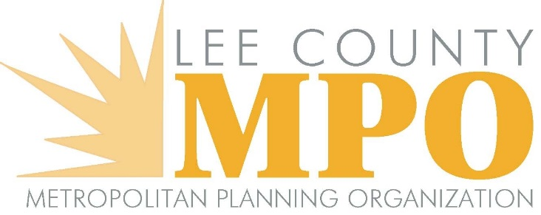
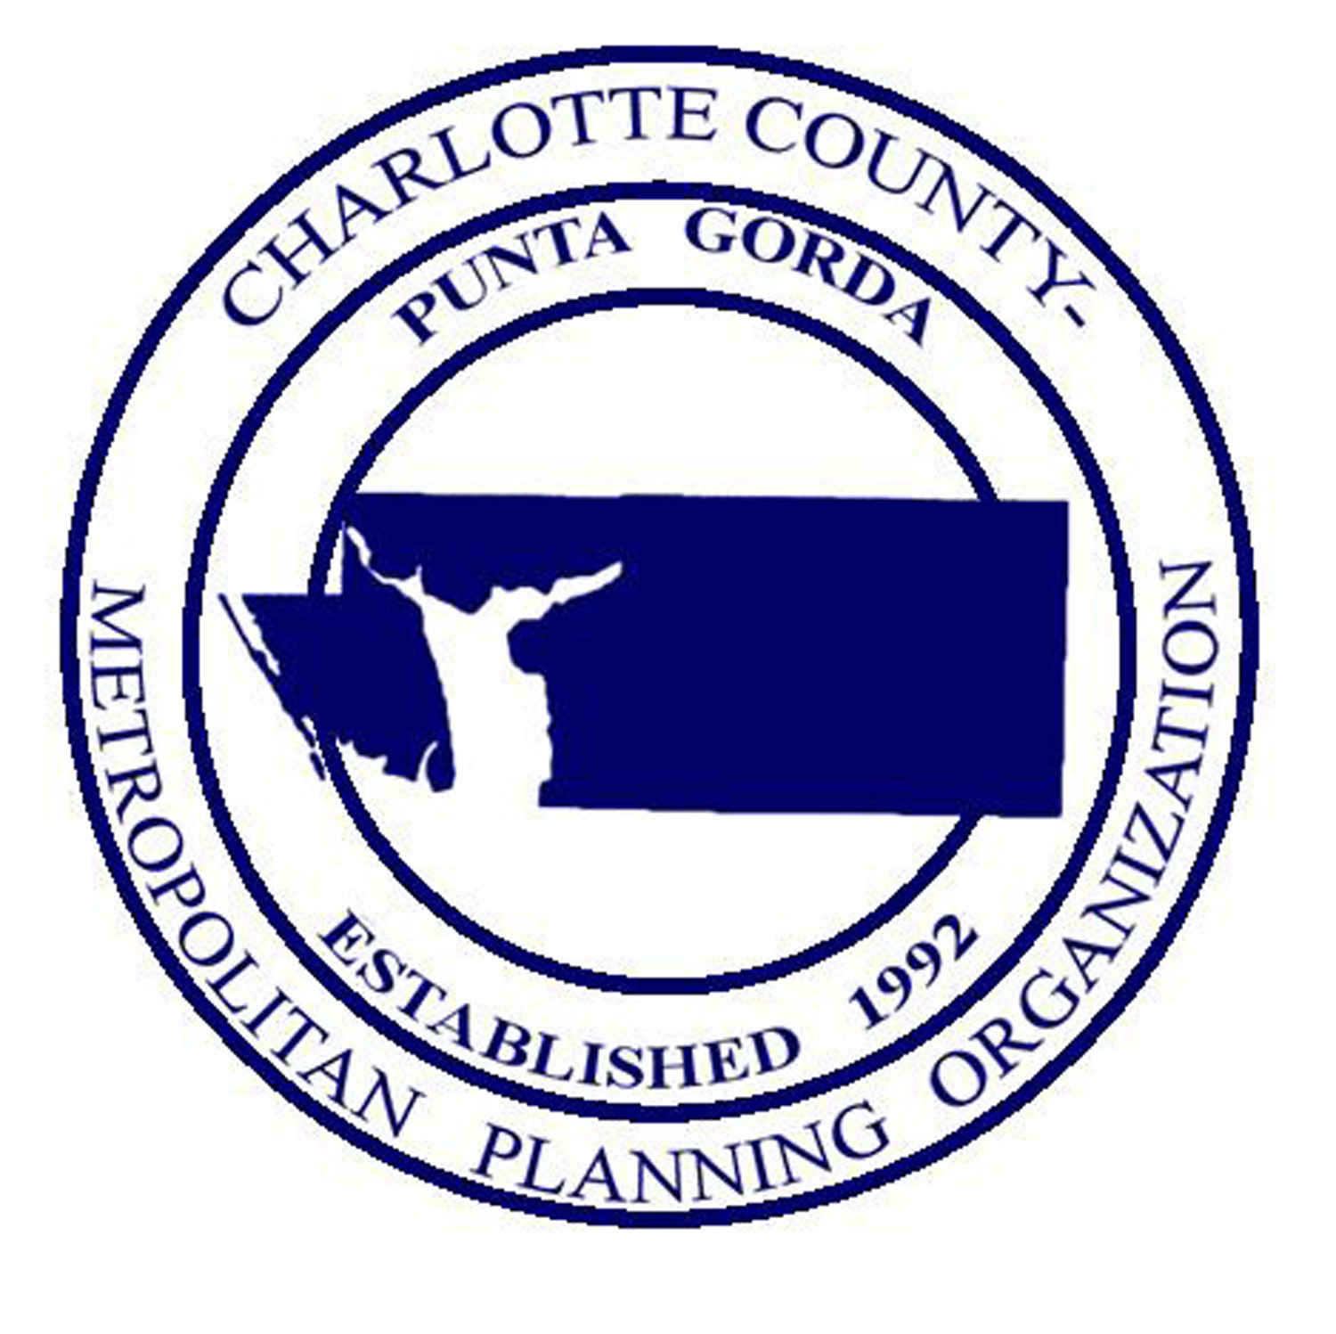

JOINT MEETING OF THE CHARLOTTE COUNTY-PUNTA GORDA METROPOLITAN PLANNING ORGANIZATION BOARD AND LEE COUNTY METROPOLITAN PLANNING ORGANIZATION BOARD

Charlotte Harbor Event and Convention Center

75 Taylor Street, Punta Gorda, Florida

Hibiscus Hall A and B, at 10:00 a.m.

Friday, February 19, 2021

- Call to Order/Roll Call/Invocation
- Chairs’ Comments
- Public Comments on Agenda Items
- Approval of Agenda
- FDOT Report
- I-75 Managed Lanes Study Presentation
- Review and Comment on the Joint Transportation Regional Incentive Program (TRIP) Project Priority List
- Burnt Store Road Corridor Improvements - Status Update
- Status of Planned SR 31 Improvements
- I-75 Purple Heart Highway Initiative

- Next Meeting Date
- Staff Comments
- Member Comments
- Public Comments
- Adjournment

All interested parties are invited to appear and be heard on each of the above items. Written comments filed with the MPO will be considered. Copies of all of the above proposed documents are available by calling the Lee MPO Office at 239-244-2220 or the Charlotte County-Punta Gorda MPO Office at 941-883-3535.

THIS NOTICE is published pursuant to the requirements of the Federal Laws, Florida Statutes and MPO Policy. NO STENOGRAPHIC RECORD BY A CERTIFIED COURT REPORTER IS MADE OF THIS MEETING. ACCORDINGLY, ANY PERSON WHO MAY SEEK TO APPEAL ANY DECISIONS INVOLVING THE MATTER NOTICED HEREIN WILL BE RESPONSIBLE FOR MAKING A VERBATIM RECORD OF THE TESTIMONY AND EVIDENCE AT THIS MEETING UPON WHICH ANY APPEAR IS TO BE BASED.

Public participation is solicited without regard to race, color, national origin, age, sex, religion, disability, or family status. Persons who require special accommodations under the Americans with Disabilities Act or persons who require translation services (free of charge) should contact the Lee MPO at 239-244-2220 or the Charlotte County-Punta Gorda MPO at 941-883-3535 at least seven (7) days prior to the meeting.
The MPO’s planning process is conducted in accordance with Title VI of the Civil Rights Act of 1964 and related statutes. Any person or beneficiary who believes he/she has been discriminated against because of race, color, religion, sex, age, national origin, disability or family status may file a complaint with the LEE MPO Title VI Coordinator Calandra Barraco at (239) 244-2220 or by writing her at P. O. Box 150045, CAPE CORAL, FLORIDA 33915 OR the Charlotte County-Punta Gorda MPO Title VI Coordinator Wendy W. Scott at (941) 883-3535 or by writing her at 25550 Harbor View Road, Suite 4, Port Charlotte, FL 33980

