Charlotte County-Punta Gorda MPO
2045 Long Range Transportation Plan

Route to 2045
DRAFT Public
Participation Plan
Summary Report

Prepared for

Prepared by:
1000 N. Ashley Drive Suite 400
Tampa, FL 33602

Table of Contents
Section 1: Introduction 1-1
Section 2: Visioning and Big Picture 2-1
2.1 Stakeholder Interviews 2-1
2.1.1 Route to 2045 Stakeholder Interview Summary 2-2
2.1.2 Charlotte Rides TDP Stakeholder Interview Summary 2-5
2.2 MPO Board and Advisory Committee Visioning Workshops 2-8
2.2.1 Headliner Activity 2-8
2.2.2 Headliner Activity 2-9
Section 3: Technical, Practical, Feasible & Corridors 3-1
3.1 Web-based Survey 3-1
3.1.1 Heading 3 3-1
3.2 Needs Plan Workshops 3-1
3.3 MPO Board Meeting#2 Initial Needs and Financial Plan 3-1
3.4 MPO Board Meeting #3 Needs and Cost Prioritization Plan 3-1
Section 4: Making Route to 2045 Happen 4-1
4.1 Interactive Online Engagement Tool 4-1
4.1.1 Heading 3 4-1
4.2 Cost Feasible Workshops 4-1
4.3 MPO Board Meeting #4 Cost Feasible Plan 4-1

Appendices
Appendix A: Newsletter A-1
Appendix B: Stakeholder Interview Questionnaire B-1
Appendix C: Visioning Workshop Meeting Results C-4

List of Figures
Figure 2-1: Best Newspaper Headlines for Year 2045 2-8
Figure 2-2: Most Feared Newspaper Headlines for Year 2045 2-9

List of Maps
To Be Determined

List of Tables
Table 2-1: Phase I Workshop and Interview Participants 2-1
Table 2-2: Selected Stakeholder Information 2-1
Table 2-3: How would you rate the importance of these factors when selecting future Pedestrian projects? 2-4
Table 2-4: How would you rate the importance of these factors when selecting future Bicycling projects? 2-4
Table 2-5: How would you rate the importance of these factors when prioritizing future transportation projects? 2-4
Table 2-6: Current Funding Allocation for Transportation Improvements for 2040 LRTP and Average Stakeholder Funding Allocation for 2045 LRTP 2-5
Table 2-7: Charlotte Rides TDP Stakeholder Information 2-6

Introduction
The purpose of this report is to provide additional details on the overall public involvement process and activities that lead to the development of the 2045 LRTP. The public involvement activities were divided into three phases that engaged the public, local leaders and elected officials in the establishment of a vision for 2045 and a transportation plan that will bring that vision to fruition. Phase I was designed to address the visioning and big picture topics. Phase II focused on the technical work identifying transportation improvements and projects that were evaluated for cost feasibility and prioritization. Finally Phase III identified implementation steps.
Phase I – Visioning & Big Picture
- Stakeholder Interviews
- Kick-Off Technical Advisory Committee (TAC) and Citizens Advisory Committee (CAC) meetings/ visioning workshop (07/17/2019)
- MPO Board Kick-Off Meeting/ visioning workshop (07/29/2019)
Phase II – Technical, Practical, Feasible & Corridors
- Web-based Survey (07/2019 to 04/2020)
- Needs Plan Workshops (various dates)
Phase II – Making Route to 2045 Happen
- Interactive online engagement tool (03/2020 to 06/2020)
- Cost Feasible Workshops (various dates)
- MPO Board Adoption Hearing (10/05/2020)
Finally, a newsletter was prepared and distributed to the MPO partners and public to update everyone on the LRTP process. The newsletter provided an overall framework of the LRTP process and information included in the Public Participation Plan. The newsletter was easy to understand and geared towards a non-technical audience, using infographics to convey concepts in a user-friendly manner. Electronic versions of the newsletter were distributed via the MPO’s website and through an e-mail blast to the MPO’s mailing list. A copy of the newsletter is included in Appendix A.

Visioning and Big Picture
Phase I of the Public Participation Plan consisted of interviews with key stakeholders and several briefings with the MPO Board, CAC, and TAC. One-on-one interviews were conducted with a questionnaire and discussion topics to gather input from stakeholders on the transportation system, future growth and economic development trends. Initial input from the MPO Board and advisory committees was gathered through facilitated visioning workshops that included survey questions and a visioning exercise. Table 2-1 lists the dates and the number of participants in the interviews and visioning sessions. Summaries of these activities are described in sections 2.1 and 2.2.
Table 2-1: Phase I Workshop and Interview Participants
Meeting and Date | Participants
Stakeholder Interviews (6/19 - 7/19) | 9
TAC / CAC Visioning Workshop (7/17/19) | 19
MPO Board Kick-Off Meeting/ Visioning Workshop (7/29/19) | 16*
*includes 8 MPO Board Members and 8 participants

Stakeholder Interviews
In-person and phone interviews were conducted in June and July 2019 with 9 key stakeholders to obtain input on prevailing thoughts on future growth, economic development and quality of life, and the type of investments in the transportation system that are needed to best serve all of Charlotte County through the year 2045. Key comments and recurring themes from these interviews will help to frame and guide later public involvement activities throughout the plan development. Table 2-2 provides a list of those contacted and interviewed as a part of Route to 2045 outreach efforts.
Table 2-2: Selected Stakeholder Information
Name & Position | Organization
Raymond Sandrock, County Administrator | Charlotte County
Howard Kunik, City Manager | City of Punta-Gorda
Wendie Vestfall, Tourism Development Director | Punta Gorda/Englewood Beach Visitor and Convention Bureau (VCB)
Micah Richins, Chief Operating Officer | Sunseeker Resorts
Gary Nelson, Senior Vice President of Planning and Development | Kitson & Partners (Babcock Ranch)
Jim Parrish, Chief Executive Officer | Charlotte County Airport Authority
Jennifer Hecker, Executive Director | Charlotte Harbor National Estuary Program (CHNEP)
Dave Gammon, Director | Charlotte County Economic Development
Shane Simmons, President | Cheney Brothers Inc.

A questionnaire and discussion topics were developed for the interviews, and each stakeholder was provided the same questions and topics. The questionnaire and discussion topics for the interviews are included in Appendix B. In addition to the interview summary for the Route to 2045 LRTP update, a summary from stakeholder interviews for the recent Charlotte Rides Transit Development Plan (TDP) update has been included to provide more input on transit service.

Route to 2045 Stakeholder Interview Summary
The input received during the stakeholder interviews was reviewed, and major themes were identified and are summarized in the following sections.
Future Growth
- Population Growth – Stakeholders agreed that the Florida Bureau of Economic and Business Research (BEBR) population projection of 229,000 residents in Charlotte County by year 2045 was adequate but could be higher. One stakeholder noted that a recent Western Michigan University Study projected Charlotte County’s population could exceed 247,000 by 2040. Stakeholders noted that the majority of the population growth would occur in Babcock Ranch and within established Community Redevelopment Areas (Murdock Village, Parkside, Charlotte Harbor, City of Punta Gorda). Several stakeholders expressed that there is significant seasonal influx and that there should be focus on attracting year-round residents. It was also noted by one stakeholder that development is occurring where there’s insufficient or no supporting infrastructure.
- Employment Growth – The majority of stakeholders agreed with the BEBR employment projection of over 93,500 jobs by 2045. Several stakeholders noted that there was potential for greater job growth if operations at the Punta Gorda Airport expanded dramatically. The main locations identified for employment growth were around the Punta Gorda Airport, within existing Redevelopment Areas (Murdock Village, Parkside Charlotte Harbor, Punta Gorda), and in Babcock Ranch. Stakeholders commented that they saw job growth occurring in commercial, retail, resort and service industries, and ancillary industries to the airport.
- Growth Challenges – The main growth challenges that stakeholders noted in the interviews were attracting a qualified workforce, affordable housing, maintaining water quality (Gulf, rivers, lakes, household/drinking) for residents and visitors. Funding for transportation and other infrastructure needs was also identified as a challenge by the stakeholders.
Economic Development and Quality of Life
- Quality of Life – Stakeholders responded that the water/water activities, the relaxed and quiet lifestyle, and the County’s openness and general attitude towards working with developers and business were the best features of Charlotte County. The greatest concerns for the County over the next 25 years were identified as attracting a qualified workforce, planning sustainable growth and development, and degradation of the water quality. Stakeholders commented that the most important issues facing the County regarding future quality of life were maintaining the water quality for residents and to support tourism, planning sustainable growth and development, attracting a qualified workforce, and investing in transportation infrastructure. One stakeholder noted that intensification of development put pressure on environmentally sensitive land and waterways; identifying these areas were noted as important ways to maintain water quality and the quality of the environment in future development and transportation projects.
- Economic Development – Stakeholders noted that workforce housing and training, transportation options, water quality, marketing residential development and industry ready sites are several efforts that could improve economic viability and encourage economic development. When asked if crime had an impact on the economy, all stakeholders responded “no”. However, some stakeholders noted that with population and job growth, crime may have an impact on the economy in the future.
- Community Character – Stakeholders strongly agreed that multi-use trails and complete streets concepts provide an important benefit to the quality of life in Charlotte County. Preserving rural living as a lifestyle choice was important to stakeholders. While availability of public transportation was noted as medium important to current quality of life, many stakeholders indicated that public transportation and fixed route transit will be much more important with job and population growth, and to attract a younger workforce.
Transportation System
- Transportation Improvements – When asked about areas that were under served by transit or areas that should receive a higher transit priority, stakeholders noted locations that supported employment, health services, and recreation. These areas included Punta Gorda Airport and Interstate Airport Park, hospital areas, Port Charlotte, Murdock Circle, Parkside, Englewood Beach, and the Sunseeker. Stakeholders indicated that intersection operations, traffic calming, and traffic signal coordination/technology were important improvements for safety and movement of pedestrians and vehicles. One stakeholder expressed that road widening was needed on Edgewater Drive and Harborview Road.
- Transportation Priorities – Stakeholders ranked connectivity to employment, schools, businesses, and future transportation routes as the highest importance in selecting future pedestrian projects (Table 2-3). Future bicycling projects that prioritized bike lanes and trails for daily transportation and connectivity between residential developments were ranked as higher priority by stakeholders (Table 2-4). When prioritizing all future transportation projects, stakeholders most frequently chose preserving existing infrastructure, improving safety for pedestrians and bicyclists, and improving multimodal service and capacity as their top choices (Table 2-5). When asked about factors in developing a balanced regional transportation system, stakeholders ranked education campaigns, complete streets policies, and safety policies higher than enforcement campaigns.

Table 2-3: How would you rate the importance of these factors when selecting future Pedestrian projects?
Pedestrian Improvement | Low | Medium | High
Connectivity to Schools | 0 | 1 | 7
Connectivity to shopping or other activity centers | 0 | 1 | 6
Connectivity to parks and community centers | 0 | 2 | 6
Connectivity with future transit routes | 1 | 2 | 4
Sidewalks on major roads | 3 | 0 | 4
Connectivity between residential developments | 2 | 3 | 2
Sidewalks on neighborhood streets | 2 | 3 | 2
Connections to neighboring counties | 1 | 4 | 1

Bicycling Improvement | Low | Medium | High
Bike lanes or trails for use as a mode of daily transportation | 0 | 5 | 3
Recreational bicycle lanes or trails in and between residential developments | 0 | 4 | 3
Off-road recreational trails | 2 | 3 | 3
Connections to neighboring counties | 2 | 2 | 3
Table 2-4: How would you rate the importance of these factors when selecting future Bicycling projects?

Table 2-5: How would you rate the importance of these factors when prioritizing future transportation projects?
Prioritization Factors | Low | Medium | High
Preservation of Existing Infrastructure | 0 | 0 | 7
Promoting economic development in the county | 0 | 1 | 7
Improving safety for pedestrians and bicyclists | 0 | 3 | 5
Improving multimodal infrastructure, service and/or capacity | 0 | 3 | 5
Improving hurricane evacuation routes | 1 | 2 | 5
Sidewalks on major roads | 2 | 1 | 5
Adding “missing links” to improve the connectivity of our collector and arterial road network | 0 | 4 | 4
Elevating major roads that are vulnerable to sea-level rise | 2 | 2 | 4
Improving safety for drivers | 1 | 4 | 3
Implementing fixed/flex-hybrid route bus service in Charlotte County | 2 | 3 | 3
Speeding up automobile traffic | 2 | 3 | 3
Interconnecting adjoining neighborhoods | 0 | 7 | 1
Adding lanes to increase roadway capacity | 1 | 5 | 2
Slowing down automobile traffic | 4 | 3 | 1
Introducing commuter rail service between Charlotte County and adjacent counties | 5 | 3 | 0
- Transportation Funding – Stakeholders were asked to review the funding allocation for transportation improvements for the 2040 LRTP and make suggestions for funding allocation for the 2045 LRTP. Stakeholders, on average, reduced the amount of funding allocated to building and widening existing roads and increased the funding allocation to all other areas of transportation improvements. The most notable increase was for roadway maintenance and walk/bike/trails (Table 2-6). Local transportation revenue options that were noted by stakeholders for consideration included Municipal Service Benefit Unit (MSBU) funds, gas tax, extending the sales tax, and tolls/user fees. Information campaigns that highlight benefits and end goals of the program were provided as strategies to support successful implementation of new transportation revenue sources.

Table 2-6: Current Funding Allocation for Transportation Improvements for 2040 LRTP and Average Stakeholder Funding Allocation for 2045 LRTP
Transportation Improvements | 2040 LRTP Funding Allocation | Average Stakeholder Funding Allocation for 2045 LRTP
Build/widen existing roads | 84% | 70%
Roadway Maintenance | 5% | 10.60%
Intersections (including safety) | 3% | 6.50%
Transit (Fixed Route and Dial-a-Ride) | 5% | 5.60%
Walk/ Bike /Trails | 2% | 7.30%
Total | 99% | 100%

- Transportation Technology – Stakeholders were supportive of researching and identifying the benefits and opportunities for implementing technology innovations in the LRTP. Technology targeting safety and freight movement were emphasized. One stakeholder noted that technology supporting the business aspect of the freight industry (electronic logging, temperature control, invoicing) has improved timing and service delivery for the freight industry.

Charlotte Rides TDP Stakeholder Interview Summary
Stakeholder interviews were conducted as a apart of the Charlotte Rides TDP update to gather input from policy, agency, or community leaders regarding the future for Charlotte County Transit System (CCT) in the community and consideration of location conditions for transit as assessed through the perceptions and attitudes of stakeholders within the community. Interviews were conducted in January and February 2019. Table 2-7 shows the list of stakeholders contacted and interviewed in the Charlotte Rides TDP update.

Table 2-7: Charlotte Rides TDP Stakeholder Information
Name & Position | Organization
Ken Doherty, Chairman | Board of County Commissioners
Christopher Constance, Commissioner | Board of County Commissioners
Bill Truex, Commissioner | Board of County Commissioners
Stephen R. Deutsch, Commissioner | Board of County Commissioners
Joe Tiseo, Commissioner | Board of County Commissioners
Gordon Burger, Director | Budget & Administrative Services
Carrie Hussey, Director | Human Services
Dave Gammon, Interim Director | Economic Development
Larry Brown, Officer, Veterans Affairs | Local Coordinating Board
Cornelius Moore, Florida Dept. of Children & Families | Local Coordinating Board
Mike Mansfield, CEO/Executive Director Charlotte County Habitat for Humanity | Local Coordinating Board
Cindy Montgomery, Workforce Development | CareerSource Southwest Florida
Angie Matthiessen, Executive Director | United Way of Charlotte County
Nancy Johnson, Chief Executive Officer | TEAM Punta Gorda
Eric DeYoung, President | TEAM Punta Gorda
James W. Herston, Business Owner | Charlotte Harbor Redevelopment Agency (CRA) Advisory Committee
Lucienne Pears, Vice President of Economic and Business Development | Babcock Ranch
Stephen Carter, Member Chair | TEAM Parkside

Overall, Charlotte Rides TDP stakeholder interviewees indicated the need for more transit options in Charlotte County, including innovative solutions to increase access to key employment and commercial hubs on the US-41 corridor and providing transit services that can accommodate the needs of older adults.
Improvements to Existing Services
All stakeholders agreed that CCT could improve service supply and implement more options to attract more ridership and grow the service. Key service improvements included the following:
- More service options – All stakeholders agreed that dial-a-ride service was necessary for older adults but noted that the service is too limited for other population segments requiring options to be connected to economic and educational opportunities. Stakeholders also perceived the growing tourism and service industries in Charlotte County as demand for more transit options to connect those throughout the county.
- More efficient scheduling – Stakeholders commented that more efficient scheduling to reduce reservation times is a top priority to help improve effectiveness and increase ridership. Increasing service availability was indicated as necessary for those who use it for medical and work-related trips.
- Service area expansion – Expanding the service area, especially towards the Babcock Ranch neighborhood in the eastern part of the county, was considered a necessary improvement to help connect people to the medical offices that are relocating their offices to the area and for doctors and other staff that move to the new development. Other areas considered to be underserved are Florida Southwest College, which is fostering training programs and other educational opportunities.
Innovative Service Ideas
- On-demand service options – All stakeholders acknowledged the growth of Charlotte County and the need for more services to augment the current dial-a-ride option. Most stakeholders mentioned needing a new and innovative service solution that could serve older adults who are unable to drive and the working population throughout the county. Many agreed that a technology-based hybrid service combining a fixed-route route system serving the main US-41 corridor would assist those who need to connect to major corridors but also appreciate demand-type services. Stakeholders frequently mentioned implementing multiple technology-based demand service options such as micro-transit and ridesharing to help supplement any future service types.
Funding and Support
Support and awareness were high among the stakeholders, and all were aware of CCT and generally how it operates.
- Partnerships – Most stakeholders mentioned partnering with private service companies to fund transit to enable dependable transit options for all. Stakeholders also commented that fostering private partnerships with developers and employers may assist marketing purposes and possibly support a route.
- Taxes – Some stakeholders remarked that they would support the County raising or adding taxes to benefit expanding transit services, although it was acknowledged that many county residents probably would not be in favor of raising taxes.

MPO Board and Advisory Committee Visioning Workshops
The visioning workshops were held on July 17 and July 29 and were designed to gather input and direction for developing Route to 2045. Table 1-1 lists the workshops that were conducted with the MPO Board and Advisory Committee and the number of participants at each workshop. Two activities were conducted at the workshops. The first was the headliner activity which asked participants to envision their most desired and most feared newspaper headlines in 2045. The second activity included a series of 17 question where participants provided their preferred response. Highlights from these activities are included in the following section with the full results included in Appendix C.

Headliner Activity
Members of the TAC, CAC and MPO Board were asked to imagine the best and worst/most feared newspaper headlines for the year 2045. Figure 2-1 and 1-2 show the range of headlines that were received for this activity.

Figure 2-1: Best Newspaper Headlines for Year 2045
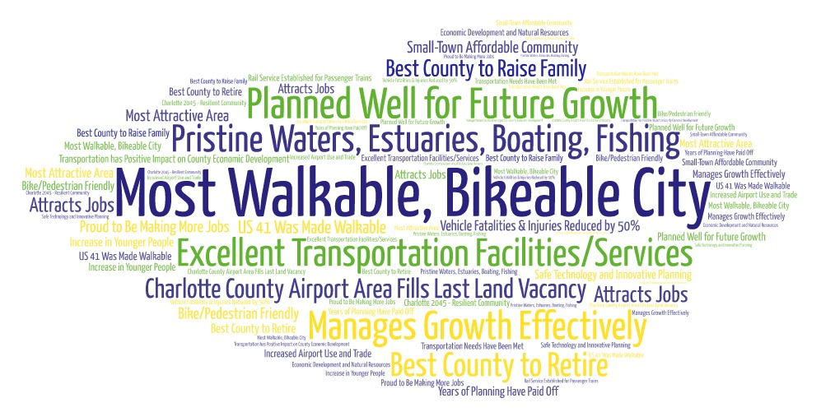

Figure 2-2: Most Feared Newspaper Headlines for Year 2045
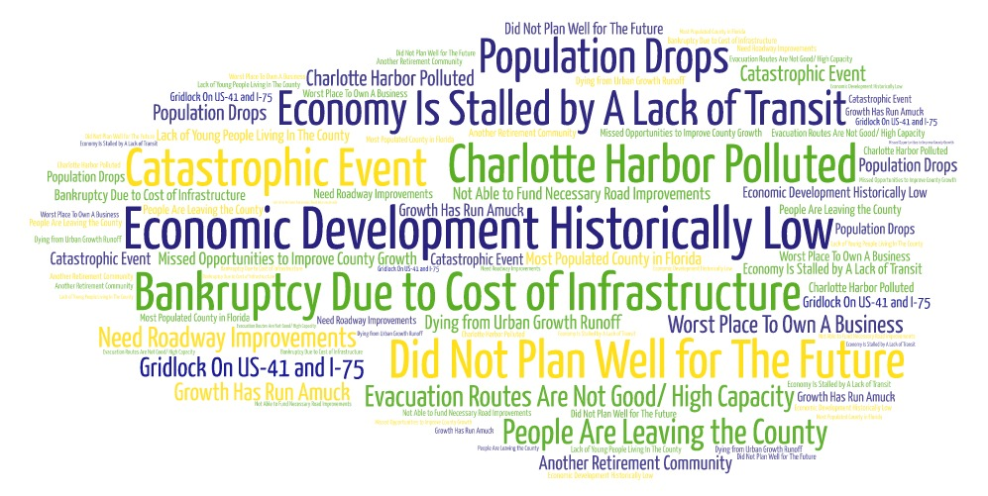

Headliner Activity
Members of the TAC, CAC and MPO Board were asked to imagine the best and worst/most feared newspaper headlines
Future Growth
The Bureau of Economics & Business Research (BEBR) projects that Charlotte County population will grow and exceed 229,000 people by 2045. MPO Board and Committee members were asked if they agree with the research. A great number of Board and Committee members agreed, but 20 to 30 percent of respondents did not. In terms of whether the County had the right balance between employment and population, all respondents said no. Over forty percent of MPO Board and Committee members highlighted the need for larger companies to locate in Charlotte County (manufacturing, financial services, health care). Forty-five percent of MPO Board members indicated the need for better education to retain next generation of workers and forty-two percent of Committee members said the County needs more jobs to strengthen employment to population ratio and overall quality of life.
Transportation Funding
- Majority of the respondents said they would rather invest more in improving multimodal infrastructure and implementing complete streets policy. The two other choices with a high number of votes were to invest more in technology to make traffic flow better and maintain what Charlotte County already has in place.
- Majority of respondents would rather invest more in building roundabouts or traffic circles where appropriate, while twenty-five percent of MPO Board members would invest in installing 4-way stops or traffic signals. Only a small number of respondents wanted more investment focused on adding and building new roads.
- In case of limited funding, majority of respondents would focus first on where there are safety concerns. The second choice was to focus on where there are the highest needs for capacity, then where growth is expected or planned, and finally on projects equally throughout the County.
- Assuming the same budget and time frame, respondents were asked how much they would invest on bicycle and pedestrian facilities and multi-use trails, most respondents said they would invest up to 2% of the budget. Another twenty eight percent of the respondents from the TAC/CAC Committee members said they would invest 6% of the budget.
- When asked what percent of the budget they would invest over a 20 year period on safety and congestions improvements, assuming a $500,000,000 budget, TAC/CAC Committee members where in favor of investing a higher percentage of the budget (10-15%) than the MPO Board members (5%).
- A large number of respondents from the TAC/ CAC Committee indicated that they would rather invest more in implementing a fixed route along US 41 with community circulators. Another twenty six percent of the responses wanted to focus on simply implementing a small community circulator bus.
- On the topic of investing in public transportation, majority MPO Board members said they would rather improve current county transit service (Dial-a-Ride).
Transportation Modes
- Almost all the respondents agreed that a higher priority should be given to road projects on evacuation routes.
- Majority of respondents agreed that safety and intersection projects are more important than roadway capacity projects.
- Majority of respondents agreed that maintaining existing roads is more important than expanding and adding new roads.
- In choosing the top three solutions to improve transportation, the MPO Board and the CAC/TAC Committee members ranked using technology to address congestion and building roundabouts/traffic circles instead of stop signs or signals as the top two solutions. The MPO board ranked building more lanes to address congestion as their third solution and the TAC/CAC Committee ranked their third solution as improving public transportation.
- Majority of CAC/TAC Committee member responses indicated that it is important to have public transportation to Punta Gorda Airport. When asked how soon the fixed route transit should be implemented, an equal number of Committee members (33% each) said as soon as possible and in the next five years.
- On the importance of a fixed public transportation route to the Punta Gorda Airport, forty-seven percent of MPO Board members said it was not important and twenty-nine percent of Board members were neutral. Thirty-eight percent of Board members said that the fixed route transit should never be implemented, while thirty-seven percent said it should be implemented in the next fifteen years and beyond.
- The majority of CAC/ TAC Committee and half of MPO Board members agreed or strongly agree that complete streets policies are important for developing a balanced regional transportation system.
- In terms of connecting to nearby regions, respondents chose investing more in connecting to the north and connecting equally to the north, east, and south.
Below are other comments that were recorded during the TAC and CAC meetings.
CAC:
- The 2045 LRTP Plan should consider seasonal traffic and populations increases.
- Activities such as education and marketing/advertising of the multimodal benefits of transit should be included so that people are aware of the services that are provided and available.
- Geographic limitations are a hurdle to the area. Only two bridges provide connection across the harbor area creating a constraint. Environmental preservation/management areas limit connectivity to the Heartland Region.
- The LRTP should consider how existing corridors can incorporate multiple uses; freight, autos, and multimodal options.
- Charlotte County tax base isn’t diverse. Small business friendly policies could help encourage job growth and opportunities to keep younger adults from moving out of the county.
- Many public agencies, including the sheriff, are struggling to have a full staff. The wage scale and other community assets don’t encourage young adults to stay in or move to Charlotte.
- We should consider having stronger regional and transit connections. The region has been without intercity (Amtrak) rail service from more than 30 years.
- Coordination with other departments and agencies (economic development, public works, utilities) outside of transportation should be explored as part of the LRTP implementation.
- Partnerships for identifying public-private opportunities should be explored. Examples include identifying opportunities for coordinating with Sunseekers for providing employment-based transportation.

TAC:
- Technology is a factor that should be considered more strongly during the development of the 2045 LRTP
- In order to develop vibrant centers consistent with the LRTP goals, bicycle and pedestrian safety is an absolute must consideration.
- Coordination with the Emergency Operations Center is critical for identifying improvements for hurricane evacuation. Of specific note is the need for east to west connection to the limited north/south routes.

Technical, Practical, Feasible & Corridors

Web-based Survey

Heading 3

Heading 4

Needs Plan Workshops

MPO Board Meeting#2 Initial Needs and Financial Plan

MPO Board Meeting #3 Needs and Cost Prioritization Plan

Making Route to 2045 Happen

Interactive Online Engagement Tool

Heading 3

Heading 4

Cost Feasible Workshops

MPO Board Meeting #4 Cost Feasible Plan

Appendices
Appendix A: Newsletter
Appendix B: Stakeholder Interview Questionnaire
Appendix C: Visioning Workshop Meeting Results

Appendix A: Newsletter

Appendix B: Stakeholder Interview Questionnaire
The Charlotte County-Punta Gorda MPO has started the development of the 2045 Long Range Transportation Plan which identifies and prioritizes transportation projects for Federal and state funding through the year 2045. As part of the process, information and insights are being collected from community and organizational leaders throughout the MPO planning area. The interviews are designed to obtain the prevailing thoughts about future growth, economic development and quality of life, and the type of investments in the transportation system that are needed to best serve all of Charlotte County through the year 2045.

Name: ________________________________________ Organization:___________________
Interview date, time, and location:________________________________________________
Future Growth
1) The University of Florida Bureau of Economic and Business Research (BEBR) projects that the population of Charlotte County will grow by more than 51,000 people exceeding 229,000 by the year 2045, or nearly 1.5% per year. On a scale of 1 to 5, how much do you agree with this projection?

(Strongly Disagree) 1 ---- 2 ---- 3 ---- 4 ---- 5 (Strongly Agree)

2) Where do you see this population growth occurring?
- Within establish Community Redevelopment Areas (Murdock Village, Parkside, Charlotte Harbor, City of Punta Gorda)
- Within the City of Punta Gorda
- Babcock Ranch
- Redevelopment on Cape Haze Peninsula and Englewood
- Burnt Store Road / US 41
- East of I-75
3) The number of jobs in Charlotte County is also expected to increase by 2045. If the relationship of jobs to population remains constant through 2045 (41 jobs/100 people), there will be more than 93,500 jobs by 2045, representing a growth of 23,000 jobs or 1% per year. On a scale of 1 to 5, how much do you agree with this projection?

(Strongly Disagree) 1 ---- 2 ---- 3 ---- 4 ---- 5 (Strongly Agree)

4) Where do you see this employment growth occurring?
- Within establish Community Redevelopment Areas (Murdock Village, Parkside Charlotte Harbor, Punta Gorda,)
- Within the City of Punta Gorda
- Babcock Ranch
- Redevelopment on Cape Haze Peninsula and Englewood
- Burnt Store Road / US 41
- Around the Airport

5) What do you think will be the biggest challenges Charlotte County and Punta Gorda will face as it continues to grow?
- Funding and political will to fund transportation and other infrastructure needs
- Good planning/smart and sustainable growth
  - Jobs/housing balance
  - Land use to support transit
  - Proper development (scale, intensity/density, mix of uses)
  - Maintaining attractiveness for seasonal and retirees while attracting younger people
- Improving overall quality of life
- Other challenges
  - Retirees on fixed incomes
  - Cost of flood insurance
  - Providing services to low-income population

Economic Development and Quality of Life

6) What is the best feature of Charlotte County?

_________________________________________________________________________________

_________________________________________________________________________________

7) What is your greatest concern for Charlotte County over the next 25 years?

_________________________________________________________________________________

_________________________________________________________________________________

8) What are the most important issues facing the County regarding the future quality of life?

_________________________________________________________________________________

_________________________________________________________________________________

9) What are the most important efforts that could be initiated to improve the economic viability and encourage economic development within Charlotte County?

_________________________________________________________________________________

_________________________________________________________________________________

10) What impact do you feel the issue of crime has on the economy of Charlotte County?
_________________________________________________________________________________

_________________________________________________________________________________

11) On a scale of 1 to 5, do you agree that Multi-Use Trails or Complete Streets Concepts provide an important benefit to the quality of life in Charlotte County?

(Strongly Disagree) 1 ---- 2 ---- 3 ---- 4 ---- 5 (Strongly Agree)

12) On a scale of 1 to 5, do you agree that preserving rural living as a lifestyle choice is important to the quality of life in Charlotte County?

(Strongly Disagree) 1 ---- 2 ---- 3 ---- 4 ---- 5 (Strongly Agree)

13) On a scale of 1 to 5, how important to the quality of life for all citizens in Charlotte County is the availability of public transportation?

(Least Important) 1 ---- 2 ---- 3 ---- 4 ---- 5 (Most Important)

Transportation System

14) Are there areas currently not served or under-served by transit that should receive a higher priority? If so, where?

15) Please identify your top 3 areas for the following improvements on the map:
- Widening existing roads
- Building new roads
- Safety and congestion
- Bicycle and Pedestrian
- Intersection / Operations
- Traffic Signal Coordination / Technology
- Other future multimodal improvements

16) How would you rate the importance of these factors when selecting future Pedestrian projects?
Pedestrian Improvement | Low | Medium | High
Connectivity between residential developments
Connectivity to Schools
Connectivity to parks and community centers
Connectivity with future transit routes
Connectivity to shopping or other activity centers
Sidewalks on neighborhood streets
Connections to neighboring counties
Sidewalks on major roads
Others:

17) How would you rate the importance of these factors when selecting future Bicycling projects?
Bicycling Improvement | Low | Medium | High
Recreational bicycle lanes or trails in and between residential developments
Off-road recreational trails
Connections to neighboring counties
Bike lanes or trails for use as a mode of daily transportation
Others:

18) How would you rate the importance of these factors when prioritizing future transportation projects?
Prioritization Factors | Low | Medium | High
Improving multi-modal infrastructure, service and/or capacity
Adding lanes to increase roadway capacity
Improving safety for pedestrians and bicyclists
Improving safety for drivers
Promoting economic development in the county
Implementing fixed/flex-hybrid route bus service in Charlotte County
Speeding up automobile traffic
Slowing down automobile traffic
Adding “missing links” to improve the connectivity of our collector and arterial road network
Interconnecting adjoining neighborhoods
Introducing commuter rail service between Charlotte County and adjacent counties
Improving hurricane evacuation routes
Elevating major roads that are vulnerable to sea-level rise
Preservation of Existing Infrastructure
Sidewalks on major roads
Others:

19) On a scale of 1 to 5, how important are the following policies for developing a balanced regional transportation system?
Complete Streets Policy (Least Important) 1 ---- 2 ---- 3 ---- 4 ---- 5 (Most Important)
Safety Policy (Least Important) 1 ---- 2 ---- 3 ---- 4 ---- 5 (Most Important)
Education Campaigns (Least Important) 1 ---- 2 ---- 3 ---- 4 ---- 5 (Most Important)
Enforcement Campaigns (Least Important) 1 ---- 2 ---- 3 ---- 4 ---- 5 (Most Important)

20) What percentage of funding would you allocate toward the following types of improvements?
2040 LRTP 2045 LRTP
Build/ Widen existing roads _84__% _____%
Roadway Maintenance __5__% _____%
Intersections (including safety) __3__% _____%
Transit (Fixed Route and Dial-a-Ride) __5__% _____%
Walk/Bike/Trails __2__% _____%
Total: 100%

21) As Federal and state funding will not be enough to meet the transportation needs of the MPO planning area, should changes be considered in local transportation funding for transportation?
Gas Tax
Impact Fees
Ad Valorem Assessments
Extend the sales tax
Policy Implemented Tax Increment

22) How can the Charlotte County-Punta Gorda MPO planning area be successful in implementing any new revenue sources?

_________________________________________________________________________________

_________________________________________________________________________________

_________________________________________________________________________________

23) Technology is quickly being integrated into automobiles and transportation planning. How can the MPO best address the future technology innovations and implementation in the LRTP?

_________________________________________________________________________________

_________________________________________________________________________________

_________________________________________________________________________________

Appendix C: Visioning Workshop Meeting Results
MPO Board Polling Questions

The following data was collected on July 29, 2019.
Question 1: Were you involved in the 2040 LRTP update? (Multiple Choice) [Number of responses: 7]
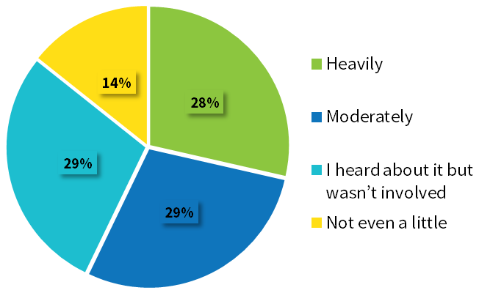
Question 2: The BEBR projects that the population of Charlotte County will grow by more than 51,000 people exceeding 229,000 by the year 2045, or nearly 1.5% per year. How much do you agree with this projection? (Multiple Choice) [Number of responses: 6]
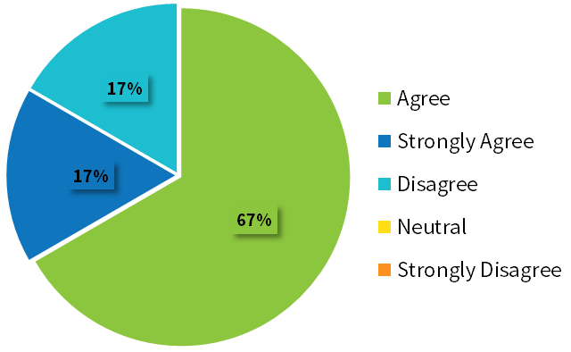
Question 3: Does Charlotte County have the right balance between employment and population? (Multiple Choice) [Number of responses: 9]
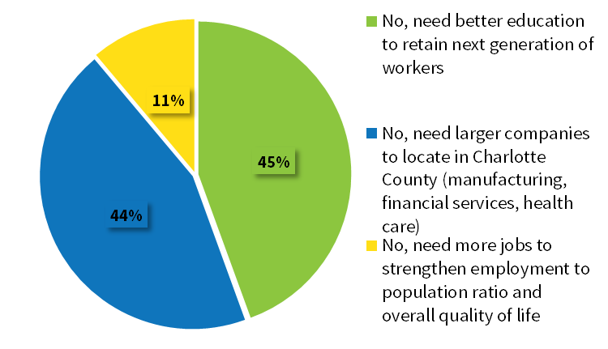

Question 4: How important are complete streets policies for developing a balanced regional transportation system? (Multiple Choice) [Number of responses: 8]
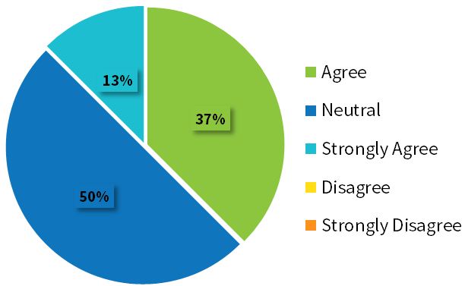
Question 5: What are the best solutions to improve transportation? (CHOOSE TOP 3) (Multiple Choice - Multiple Response) [Number of responses: 21]

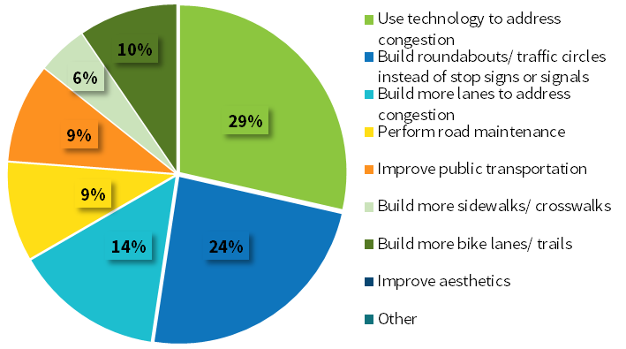

Question 6: What would you rather invest more in? (Multiple Choice) [Number of responses: 8]

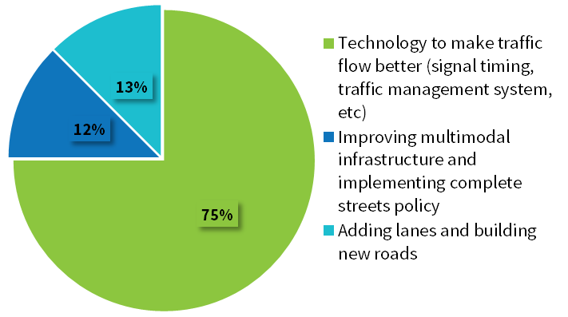
Question 7: What would you rather invest more in? (Multiple Choice) [Number of responses: 8]
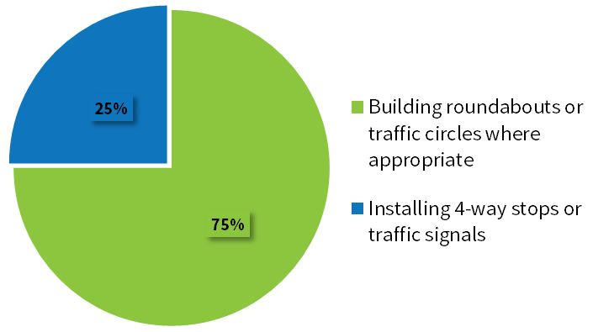
Question 8: How would you invest the limited funds? (Multiple Choice) [Number of responses: 8]
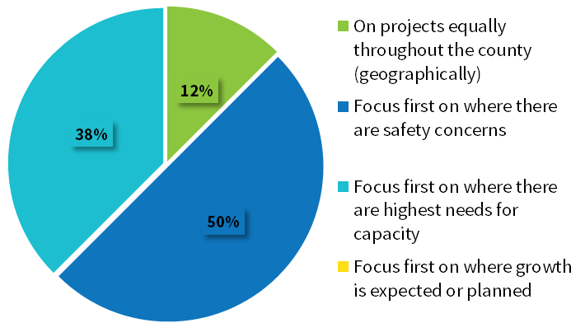
Question 9: When prioritizing road projects, would you give higher priority to those on evacuation routes? (Multiple Choice) [Number of responses: 8]
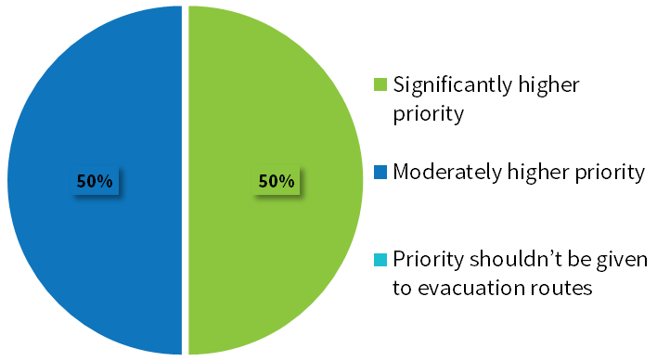
Question 10: When prioritizing regional road projects, would you invest more in connecting… (Multiple Choice) [Number of responses: 8]
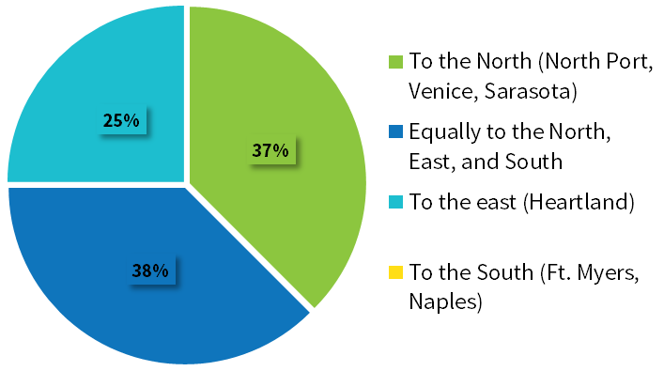
Question 11: Safety and intersection projects are more important than roadway capacity projects. (Multiple Choice) [Number of responses: 8]
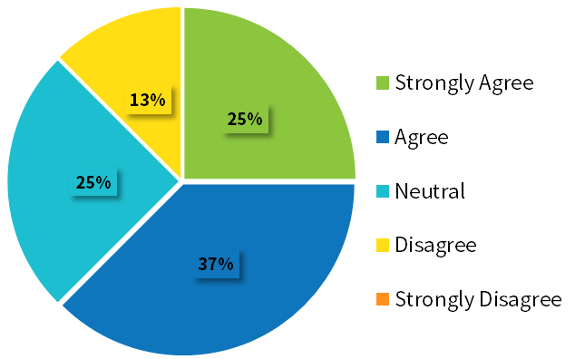

Question 12: Maintaining existing roads is more important than expanding and adding new roads. (Multiple Choice) [Number of responses: 8]
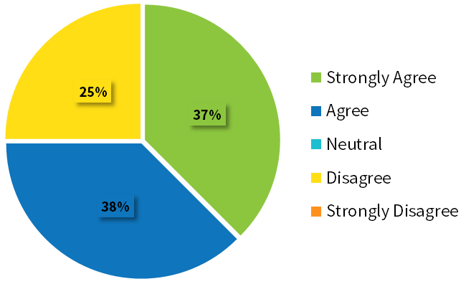

Question 13: What level of public transportation would you rather invest in? (Multiple Choice) [Number of responses: 8]
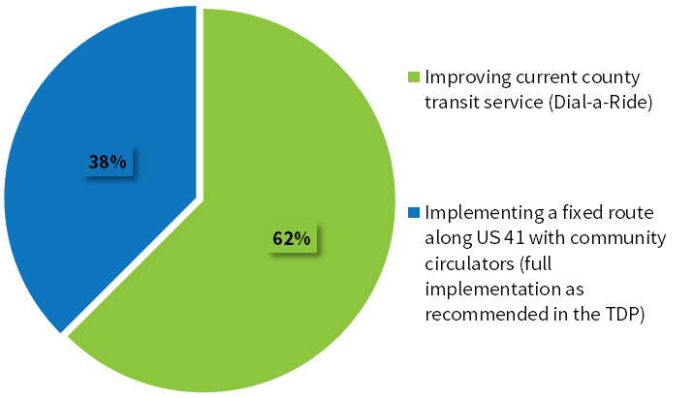
Question 14: How important is it to have public transportation to the Punta Gorda Airport? (Multiple Choice) [Number of responses: 7]
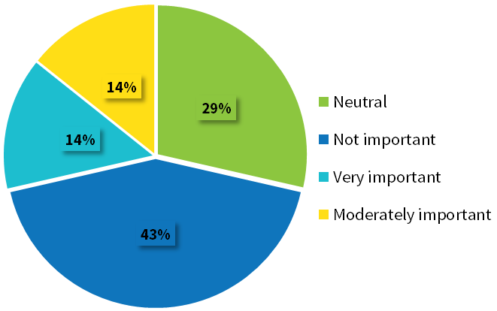

Question 15: When should fixed route transit be implemented? (Multiple Choice) [Number of responses: 8]
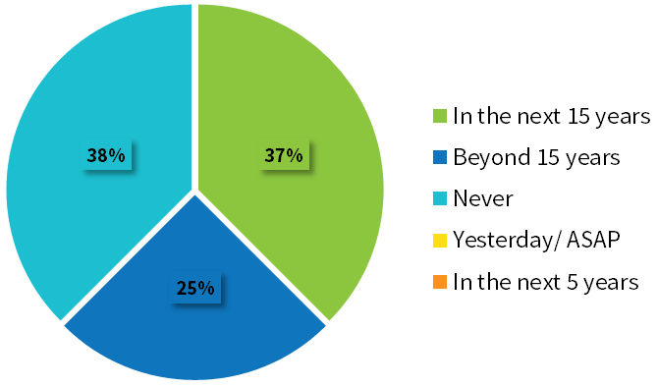
Question 16: Assuming you had $500,000,000 budget, what percent of your budget would you invest over the 20-year time frame on bicycle and pedestrian facilities, and multi-use trails? (Multiple Choice) [Number of responses: 7]
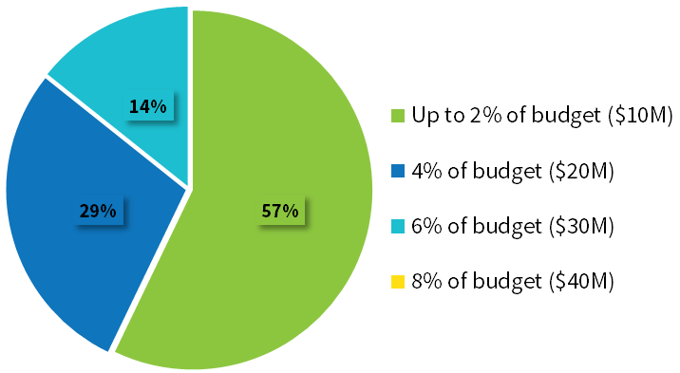

Question 17: Assuming you had $500,000,000 budget, what percent of your budget would you invest over the 20-year time frame on safety and congestion improvements (e.g. short-term, more bang for the buck projects like coordinated signal timing)? (Multiple Choice) [Number of responses: 7]
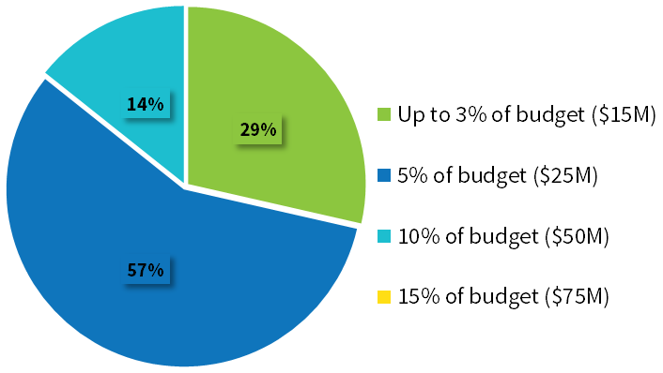

TAC/CAC Polling Questions
The following data was collected on July 17, 2019.
Question 1: Were you involved in the 2040 LRTP update? (Multiple Choice) [Number of responses: 23]
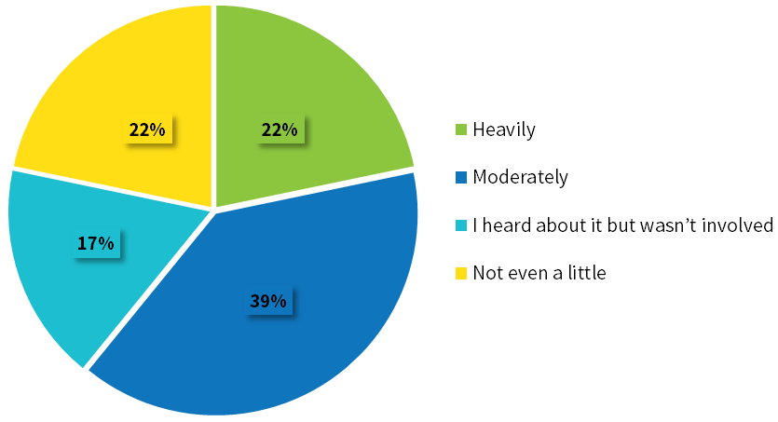
Question 2: The BEBR projects that the population of Charlotte County will grow by more than 51,000 people exceeding 229,000 by the year 2045, or nearly 1.5% per year. How much do you agree with this projection? (Multiple Choice) [Number of responses:20]
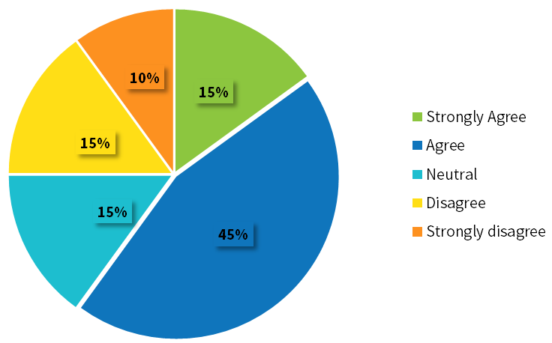
Question 3: Does Charlotte County have the right balance between employment and population? (Multiple Choice) [Number of responses: 19]
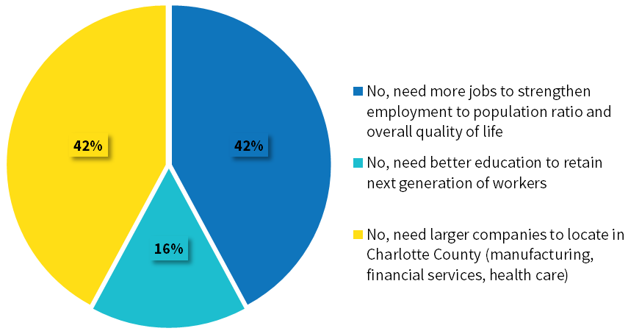
Question 4: How important are complete streets policies for developing a balanced regional transportation system? (Multiple Choice) [Number of responses: 19]
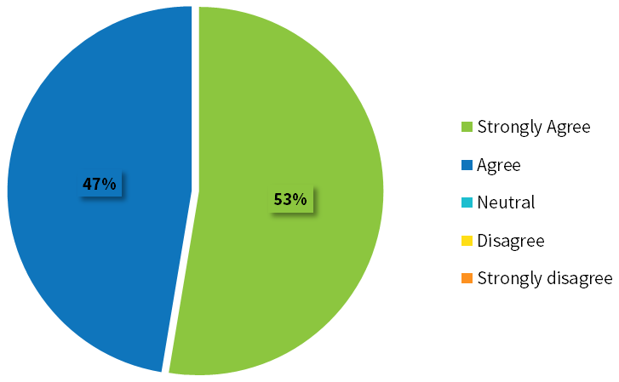
Question 5: What are the best solutions to improve transportation? (CHOOSE TOP 3) (Multiple Choice - Multiple Response) [Number of responses: 55]
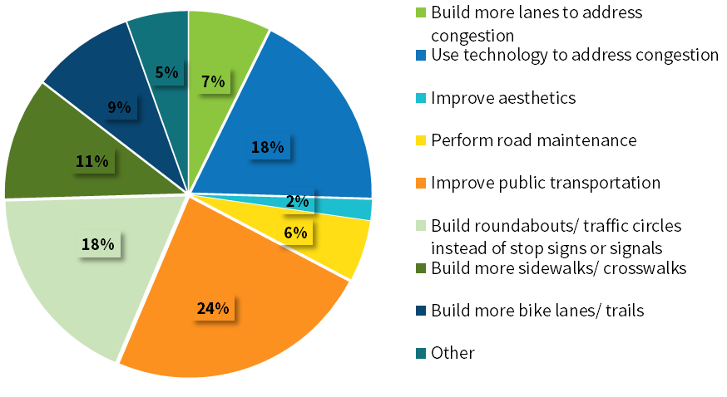
Question 6: What would you rather invest more in? (Multiple Choice) [Number of responses: 20]
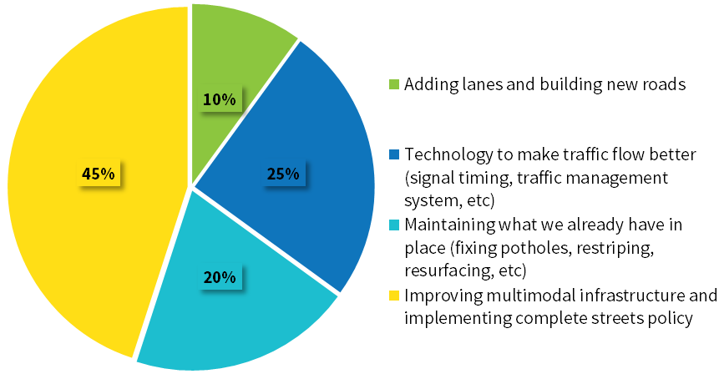

Question 7: What would you rather invest more in? (Multiple Choice) [Number of responses: 19]
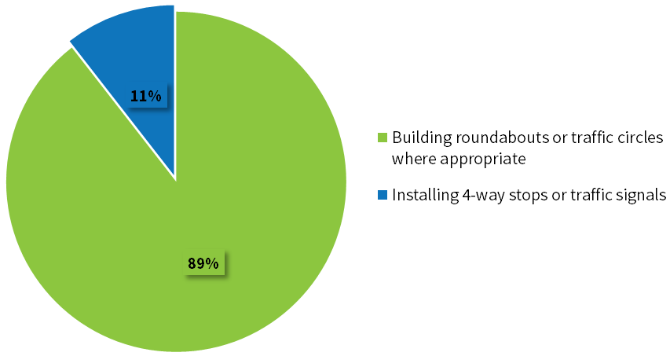
Question 8: How would you invest the limited funds? (Multiple Choice) [Number of responses: 19]
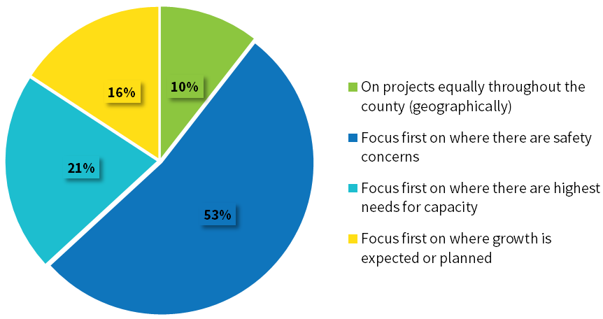
Question 9: When prioritizing road projects, would you give higher priority to those on evacuation routes? (Multiple Choice) [Number of responses: 19]
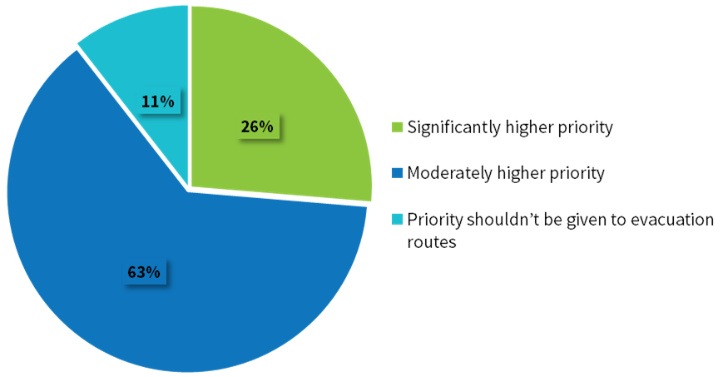
Question 10: When prioritizing regional road projects, would you invest more in connecting… (Multiple Choice) [Number of responses: 18]
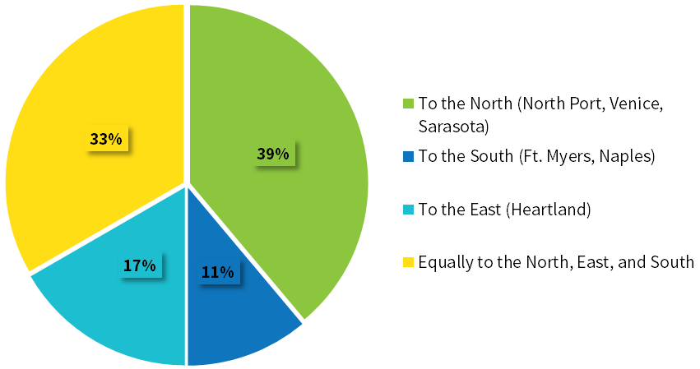
Question 11: Safety and intersection projects are more important than roadway capacity projects. (Multiple Choice) [Number of responses: 19]
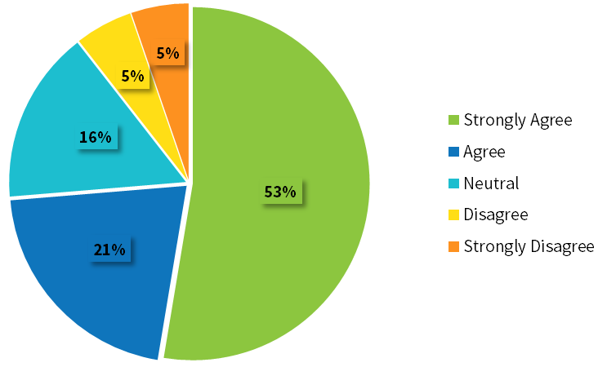
Question 12: Maintaining existing roads is more important than expanding and adding new roads. (Multiple Choice) [Number of responses: 18]
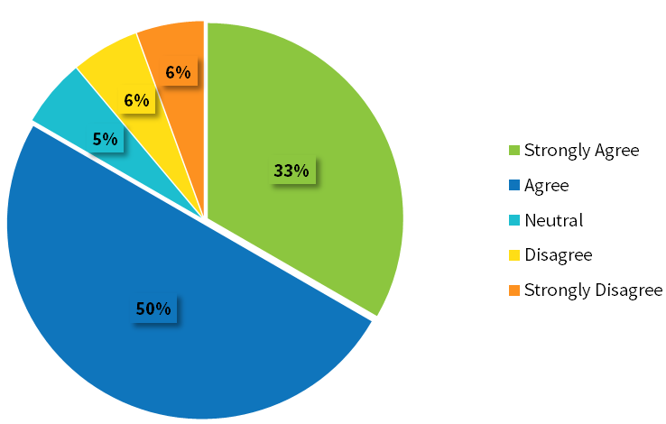
Question 13: What level of public transportation would you rather invest in? (Multiple Choice) [Number of responses: 19]
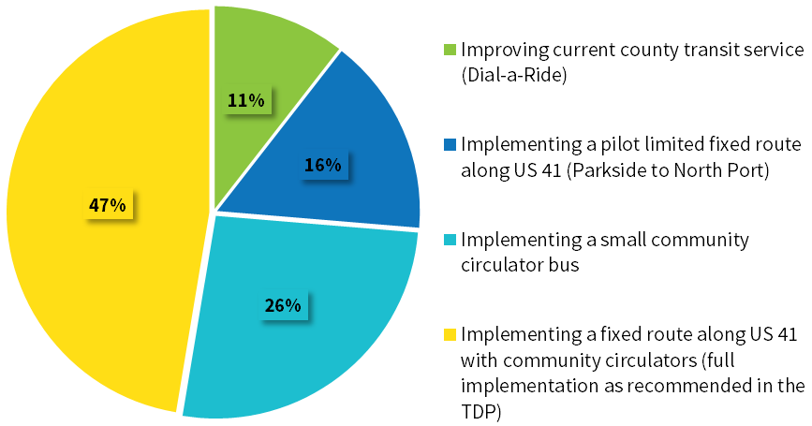
Question 14: How important is it to have public transportation to the Punta Gorda Airport? (Multiple Choice) [Number of responses: 19]
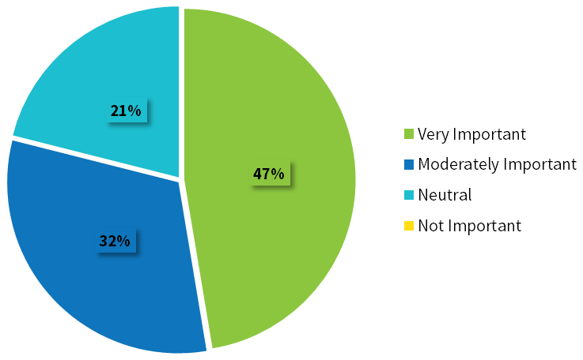

Question 15: When should fixed route transit be implemented? (Multiple Choice) [Number of responses: 18]
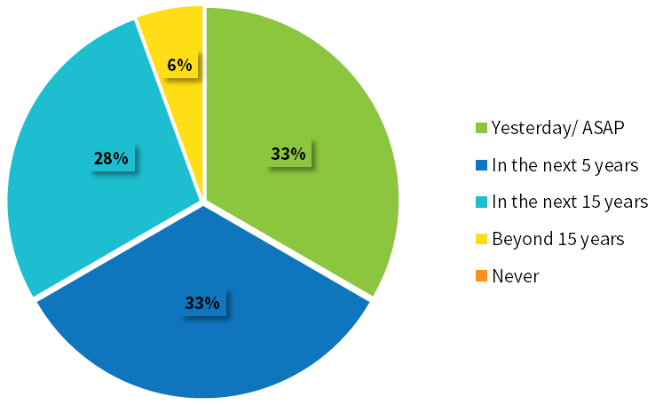
Question 16: Assuming you had $500,000,000 budget, what percent of your budget would you invest over the 20-year time frame on bicycle and pedestrian facilities, and multi-use trails? (Multiple Choice) [Number of responses: 18]
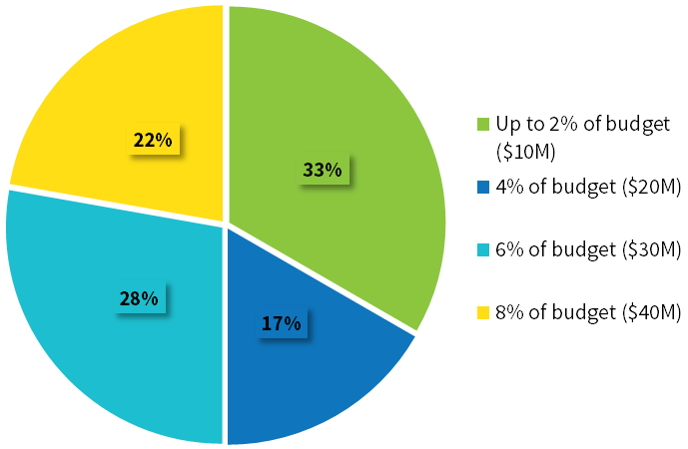
Question 17: Assuming you had $500,000,000 budget, what percent of your budget would you invest over the 20-year time frame on safety and congestion improvements (e.g. short-term, more bang for the buck projects like coordinated signal timing)? (Multiple Choice) [Number of responses: 18]
