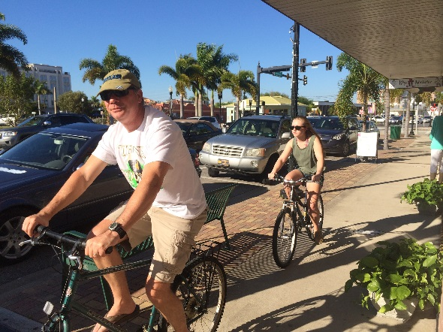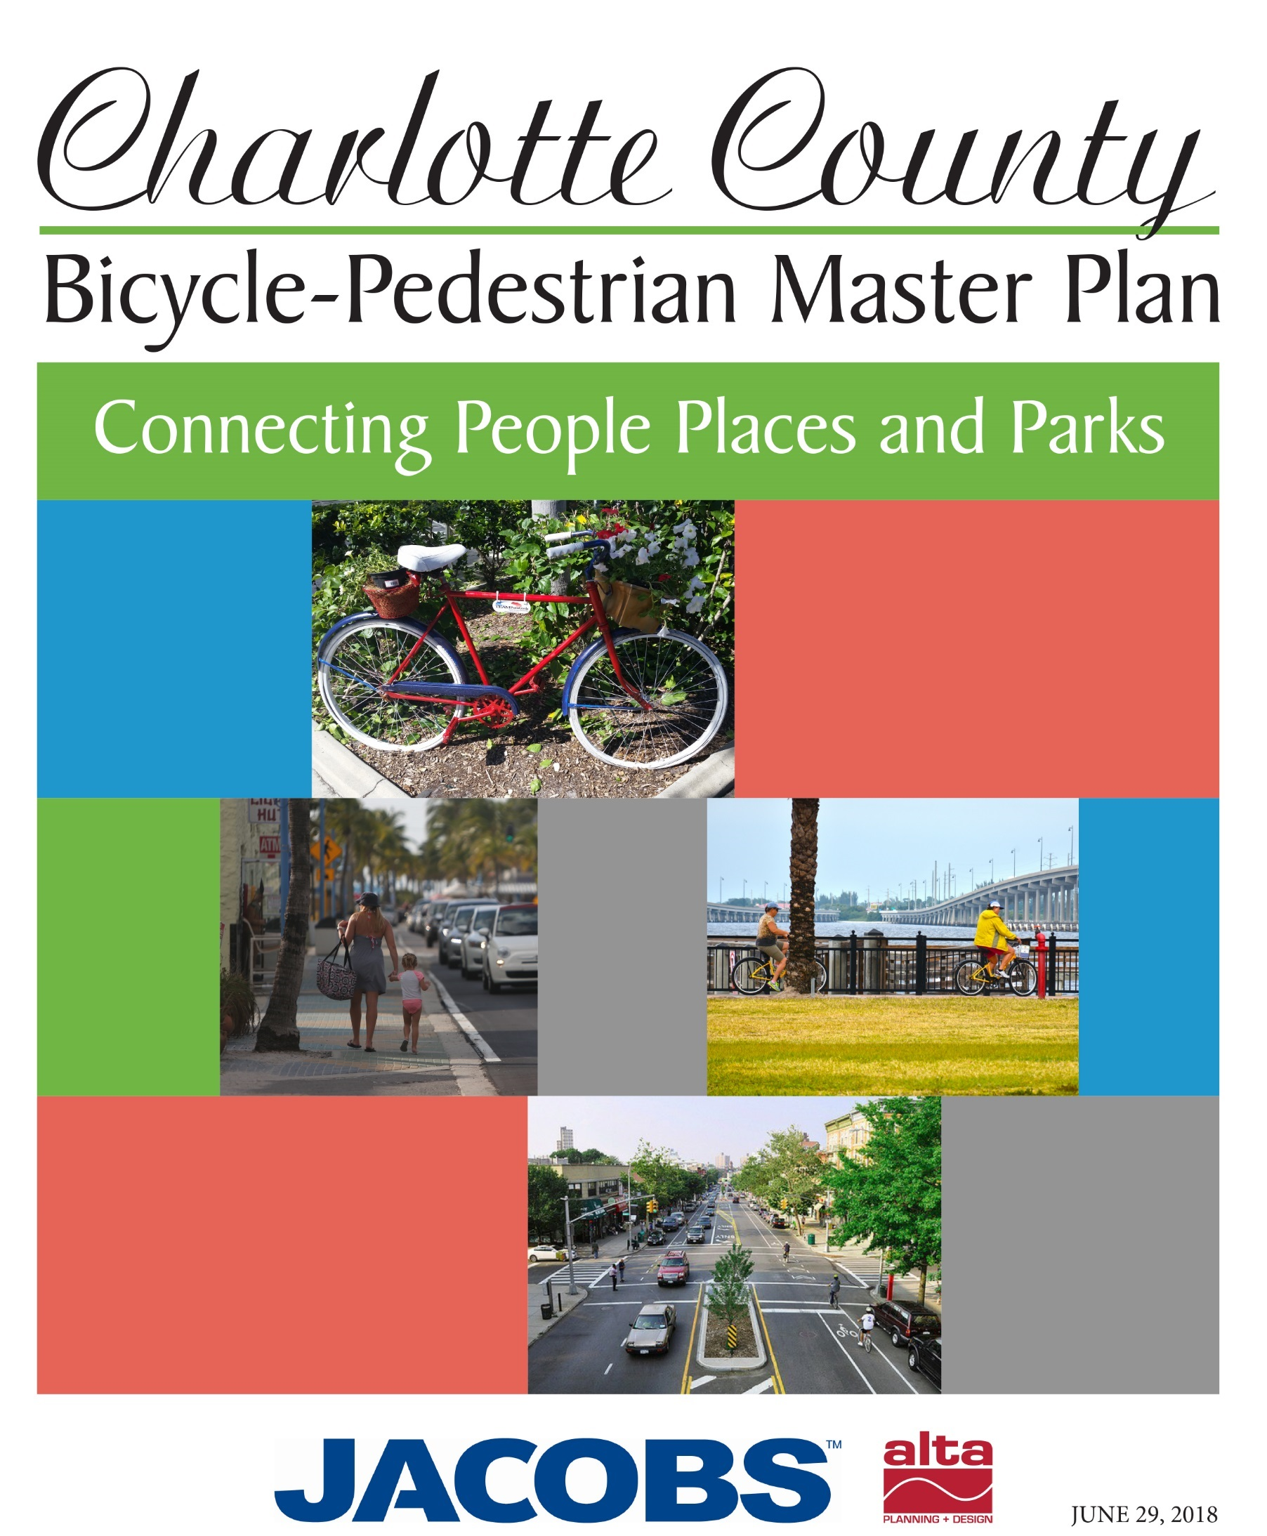

October 29, 2018

Executive Summary

**Table of Contents**

Executive Summary 1

Figure 1: An example of existing bicycle and pedestrian wayfinding in Punta Gorda. 1

1. Vision and Goals 1

Goals 2

Figure 2: Connecting to places where people live, work and play is key to increasing people walking and biking in Charlotte County. 2

2. The Planning Process 3

Figure 3: The MPO Bicycle Pedestrian Advisory Committee discussing the Plan. 3

Public Involvement 3

Needs Assessment 4

3. Design Guidance 5

Figure 4: Design guidance in this Plan includes photos, renderings, and important references to key design guidelines from national and state entities. 5

4. Recommendations and Costs 6

Project Recommendations 6

Table 1: Summary of Project Mileage Recommendations by Type 7

Table 2: Summary of Project Recommendations and Conceptual Costs 7

Figure 5: County-wide Recommendations for Bicycling, Intersection, and Trail Projects. 8

Table 3: Tier 1 Project List for Implementation between before 2024 10

Table 4: Tier 2 Project List for Implementation between 2024-2029 11

Table 5: Tier 3 Project List for Implementation after 2030 12

Table 6: Crossing improvement project list for Implementation as funds become available. 14

5. Implementation Strategies 16

Infrastructure 16

Figure 6: A before and after photo rendering provided courtesy of the City of Punta Gorda, produced by 17

Agenor & Campbell Structural Engineers 17

6. Program Action Steps 18

Figure 7: An Open Streets event and demonstration project in Rome, Georgia, provided people with the opportunity to experience their built environment with music and games. 18

Table 7: Estimated Existing and Proposed FTE for Programs 19

7. Policy Action Steps 19

Adopt this Plan 19

Update Development Regulations and Land Development Codes with Walking and Biking Oriented Standards 19

Adopt Complete Streets Policy in Support of Existing Vision Zero Policy 19

Funding 20

# Executive Summary

Charlotte County, located along Florida’s southwest Gulf Coast, has many geographic, environmental, and urban features that make it bicycle- and pedestrian-friendly. The county’s climate provides acceptable temperatures for much of the year, the topography is flat, and most of the County’s residents live within an ideal biking or walking distance to key employment, commercial and recreational centers. While the conditions are ideal, without an integrated multimodal network of on and off-road bicycle and pedestrian facilities connecting parks and recreation facilities or other attractions with neighborhoods, there are currently limited opportunities for safe and practical bicycle and pedestrian travel.

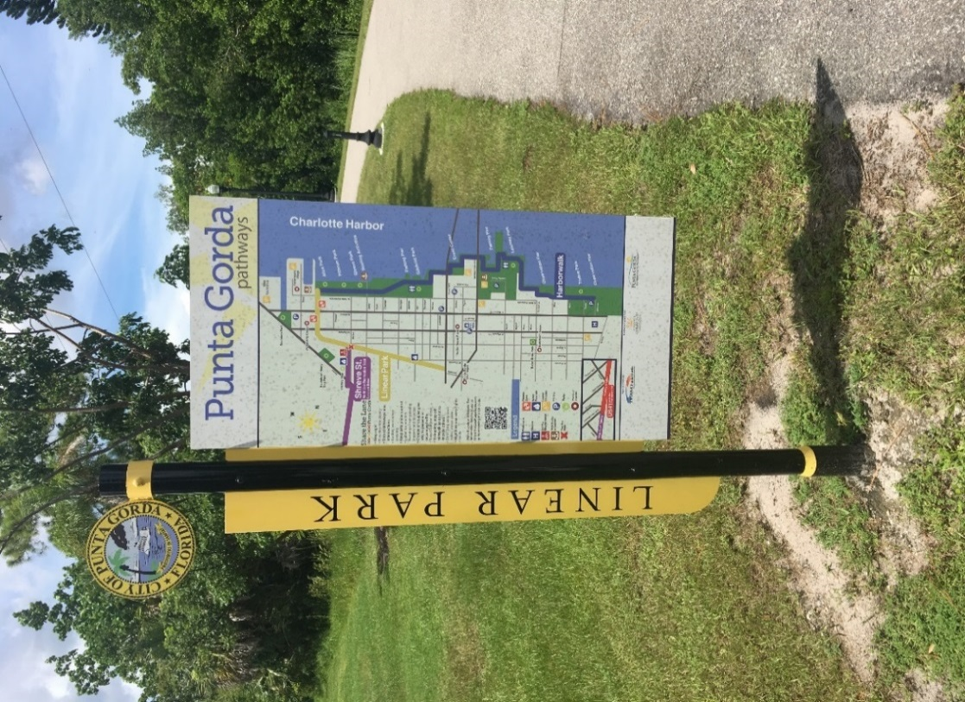

Figure 1: An example of existing bicycle and pedestrian wayfinding in Punta Gorda.

This inaugural Bicycle and Pedestrian Master Plan is an important first step to create that network in Charlotte County. The overall goal of the bikeway and walking recommendations are to create a connected network in Charlotte County that facilitates biking and walking for transportation and recreation. An adopted bicycle and pedestrian master plan is necessary to receive federal and state funds and qualify for special programs and private grants. This plan will serve as a guide for local decision makers and government staff on where and how to spend limited resources on pedestrian and bicycle projects.

Adoption should be considered as the first step of implementation. Once adopted, the MPO and Charlotte County will be able to make better transportation related decisions with its partners so that the goals of the plan are accomplished. Adopting the Plan indicates intent to implement over time and does not commit the MPO and the County to dedicate or allocate funds.

## Vision and Goals

The Master Plan was shaped by a vision and key themes that were developed and endorsed by the public, the Project Steering Committee (PSC), MPO committees and the MPO Board. The Vision states that:

***Walking and Biking in Charlotte County sho­uld be a comfortable, convenient, and safe transportation choice for people of all ages and abilities. An improved network should facilitate connections to places where people live, work and play for those who already walk or bike, while programs and policies provide for encouragement and protections of new system users.***

Several key themes are embedded in this vision, including comfort, convenient, safe and all ages and abilities.

* **Comfortable** suggests the envisioned network is low stress and an attractive travel option for all users, including people who are new to walking and biking.
* **Convenient** relates to the utility of the network, ensuring that people who are walking and biking do not unnecessarily need to traverse well outside or cross substantial barriers in their journey to reach their destination.
* **Safe** means the future network should be developed in a means that removes hazards to people walking and biking and prioritizes the protection of these roadway users.
* **All Ages and Abilities** emphases the need to plan, design and build walking and biking facilities that is safe for people to use who have limited mobility, or are aged between 8 and 80 years old.
* **Educate** by creating events and educational programs oriented towards safe use of facilities by all users.

The vision and themes helped guide the development of the recommendations and outcomes of this Plan.

### Goals

When the Plan is fully implemented, the following key policy and infrastructure goals will be accomplished:

* Apply for and achieve Bicycle Friendly Community Designation by the League of American Bicyclists and Walk Friendly Designation by the Pedestrian and Bicycle Information Center for Charlotte County and the City of Punta Gorda.
* Reduce the pedestrian and bicyclist crash index in the County by half within ten years in support of the MPO’s Vision Zero initiative.
* Double the combined walking and bike commute mode share from 2.2 percent in 2016 to 4.4 percent in 2028.
* Complete the SUN Trail portion of the Florida Greenways and Trails Priority System within Charlotte County by 2045.
* 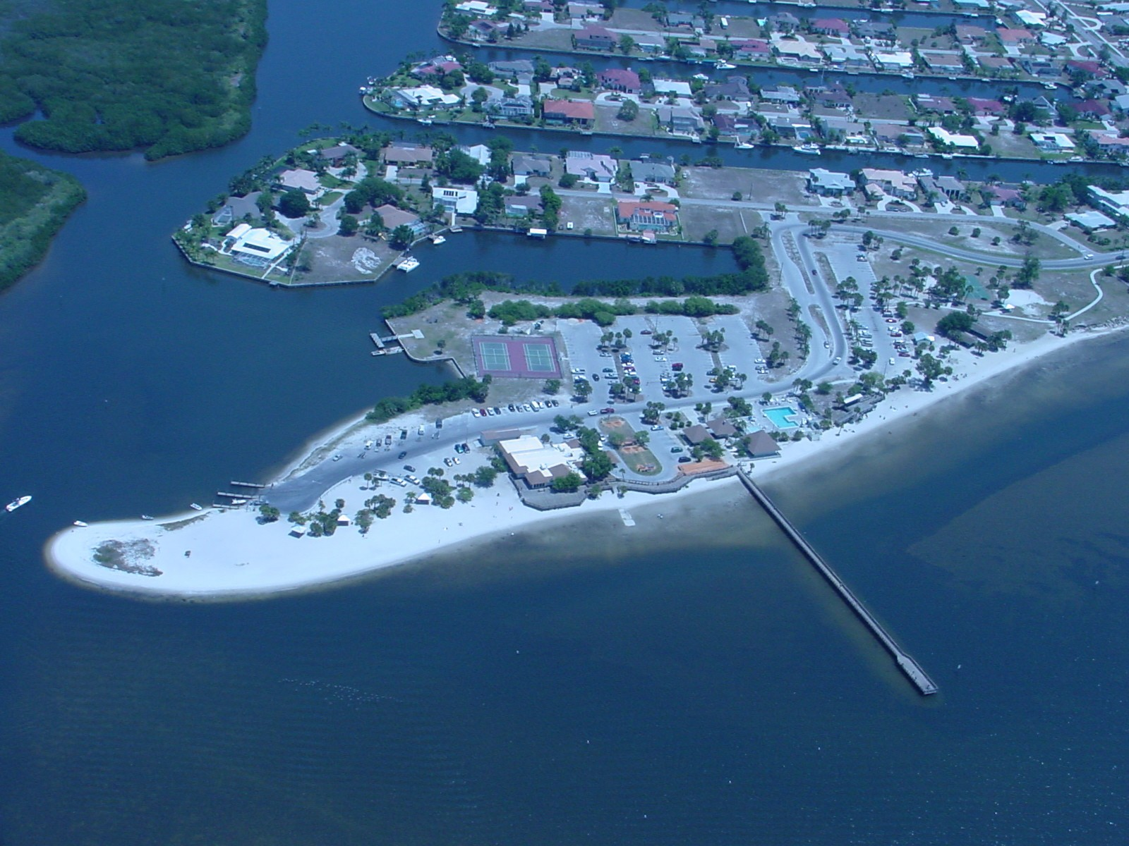Create at least one new educational campaign geared towards improving safety.

Figure 2: Connecting to places where people live, work and play is key to increasing people walking and biking in Charlotte County.

## The Planning Process

This master plan was developed over one year through a series of meetings, desktop analysis, site visits and public input. The plan responded to a comprehensive scope of work developed by the MPO and Charlotte County with review and recommendations by the Florida Department of Transportation. The consultant team used local and national best practices to develop this plan. The steps below outline the process:

* Inventory existing bicycle and pedestrian infrastructure
* Review adopted plans and policies in Charlotte County and Punta Gorda
* Conduct field work and site visits related to the development of facilities including using drone technology
* Identify gaps and needs based upon field work, stakeholder and public concerns, and existing infrastructure inventory
* Conduct four public workshop meetings and meetings with staff and stakeholders throughout the process to update and verify findings
* Develop design, infrastructure, programs and policy recommendations for countywide review and approval
* 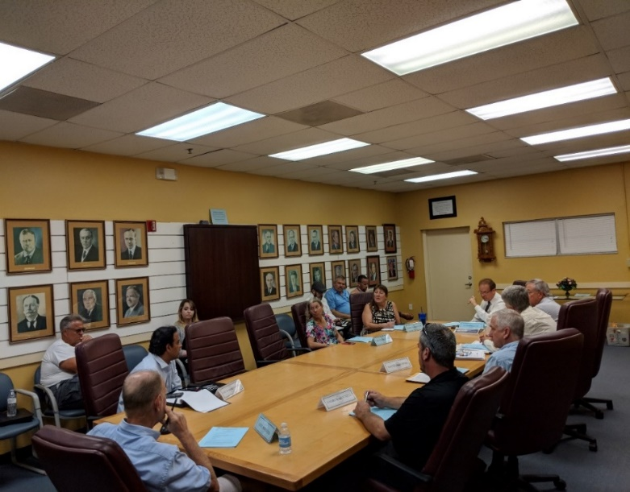Review local, state, and federal design guidance and make recommendations improving the design of local bicycle and pedestrian projects

Figure 3: The MPO Bicycle Pedestrian Advisory Committee discussing the Plan.

* Prioritize gaps in biking and walking infrastructure within the network
* Identify new bikeway and walkway projects for gaps within the network
* Develop costs for recommended facilities and a funding and implementation plan
* Submit the draft Plan for review and approval by the Public, Project Steering Committee, MPO committees and MPO Board

The Project Steering Committee (PSC) met five times in the planning process and played a substantial role in reviewing recommendations, developing design guidelines, and setting the framework for productive discourse. Key questions discussed at the PSC helped develop a vison and goals for the plan.

### Public Involvement

As part of the planning process, an online map and website was created to inform the public about the plan and to collect public input from people who could not attend public workshops. The Wikimap social media site collected over 425 comments on topics ranging from specific walking and biking improvements, to intersections and general comments.

Four public workshop meetings were held in the 10-month study planning process to receive input on the plan’s development. At these workshops, community members were asked to share what improvements are needed, priority of these improvements, and ideas on improving the walking and biking experience in Charlotte County.

Some takeaways from the public include:

* Add bicycle facilities for commuting, not just for recreation
* Plan a biking and walking system that is safe for all ages and abilities
* Add sidewalks in neighborhoods to connect schools and shopping
* Create a system of shared-use pathways that connect to adjacent counties
* Implement the proposed SUN Trail network
* Improve crossings at major roadways such as US 41 and US 17
* Consider road or lane diets in strategic areas such as downtown Punta Gorda
* Add pedestrian and bicycle infrastructure when funding becomes available

### Needs Assessment

The needs assessment process identified a series of gaps and needs within the county. These gaps were used to generate prospective projects and were reviewed by the PSC and at the public workshops. The prioritization process consisted of a desktop analysis using GIS to score each project against criteria within these key themes:

**Mobility:** Provide access to places where people live, work, and play by extending and closing gaps in the network.

**Safety:** Improve safety of high crash locations and where high-volume roads create stressful walking and biking conditions.

**Land Use/Economic Development Impacts:** Identify the economic impact of historically disadvantaged areas and areas with substantial planned growth of jobs and residents in 2040.

**Public Opinion:** Integrate public preference from public workshops and Wikimap into prioritization.

Each of these themes is composed of different measurable criteria as indicated in the chart below.

**Determining Prioritized Project Need**

Two additional analyses were undertaken to identify demand. First, a demand analysis was conducted using readily available census-based demographic information compiled by the MPO to identify areas where citizens may be most reliant on active transportation and transit and most vulnerable to unsafe infrastructure, health disparities and inaccessible destinations. The resulting composite map was used to identify areas with the greatest propensity to generate walking and biking trips in Charlotte County.

Second, application criteria established by the Pedestrian and Bicycle Information Center and the League of American Bicyclists was reviewed to identify strengths, weaknesses, opportunities and gaps. The result is a scorecard template, located in the appendix of the Existing Conditions technical memorandum, for Bicycle Friendly Community (BFC) and Walk Friendly Community (WFC) programs and a BFC and WFC readiness assessment to identify whether member jurisdictions are ready to apply for either national program. The results can also be used by the MPO’s Bicycle and Pedestrian Advisory Committee to identify policy, program and project recommendations and to help support implementation and monitor progress.

## Design Guidance

The study completed an inventory of bicycling and walking design treatments and provides guidelines for their development. These treatments are tools for creating a safe and accessible community. The guidelines are not a substitute for a more thorough evaluation by a landscape architect or engineer for final design of facility improvements.

**National Guidance:**

* The Federal Highway Administration’s (FHWA) Manual on Uniform Traffic Control Devices (MUTCD) defines the standards used by road managers nationwide to install and maintain traffic control devices on all public streets, highways, bikeways, and private roads open to public traffic.
* American Association of State Highway and Transportation Officials (AASHTO) Guide for the Development of Bicycle Facilities (2012) provides guidance on dimensions, use, and layout of specific bicycle facilities.
* The AASHTO A Policy on Geometric Design of Highways and Streets (2011), commonly referred to as the “Green Book,” contains the current design research and practices for highway and street geometric design.
* Trails for the 21st Century (1993) guides communities on how to convert unused railway and canal corridors into recreational trails.
* The FHWA Separated Bike Lane Planning and Design Guide provides guidance to the use of protected bicycle lanes, providing information on this low-stress roadway connection.
* The NACTO Small Towns and Rural Areas Multimodal Networks Guide is a design resource and idea book, intended to help small towns and rural communities support safe, comfortable, and active travel for people of all ages and abilities. More information is available from [www.ruraldesignguide.com.](http://www.ruraldesignguide.com/)

**State Guidance:**

* The FDOT Design Manual (FDM) (2018) is currently being updated and provides guidance on bike and pedestrian facilities, including shared use paths.
* The Florida Greenbook (2016) is currently being updated and will provide guidance on dimensions, design requirements and standards for bike and pedestrian facilities, including shared use paths.
* The Plans Preparation Manual (PPM) provides facility design standards for pedestrian and bicycle facilities in Chapter 8 “Pedestrian, Bicycle and Public Transit Facilities.”
* The Florida Complete Streets Implementation Plan (2015) outlines a five-part implementation framework and process for integrating a Complete Streets approach into FDOT’s practice.



Figure 4: Design guidance in this Plan includes photos, renderings, and important references to key design guidelines from national and state entities.

## Recommendations and Costs

The plan outlines an implementation plan that identifies recommended projects, programs, and policies. Capital project recommendations identified in the recommendations Technical Memorandum have been prioritized into Tiers. These Tiers represent the recommended order to implement projects within five years, from five to ten years and beyond ten years. Projects that can be implemented quickly, typically those in Tier 1 are able to be implemented in fairly, short order. Longer term projects, those in Tiers 2 and 3, require greater coordination between stakeholders to fully permit, engineer and construct the facilities.

The bikeway recommendations for this plan include new on-street bikeways (including advisory shoulders, bike lanes, buffered bike lanes, separated bicycle lanes and shared-use paths) to dramatically increase Charlotte County’s bicycle facility network connectivity. The recommendations lay the groundwork for a comprehensive, safe, and logical network that connects the western, central and eastern sections of the county and its neighborhoods. The bicycling recommendations for each roadway were carefully selected based on current roadway characteristics and design considerations consisting of factors such as average annual daily traffic, existing facilities, width of pavement and right-of-way when available and current posted speed.

The sidewalk and crossing network includes a combination of sidewalks, advisory shoulders, shared-use paths and enhanced street crossings. At full build out, the network will improve connections to neighborhoods, schools, parks, shopping and jobs. The recommendations for each sidewalk and crossing project were carefully selected based on current roadway characteristics, previous plans, public input and design considerations such as vehicle speeds and volumes.

### Project Recommendations

A total of 53 projects consisting of 165 miles of sidewalks, bikeways and paved shoulders, shared-use paths and crossing projects are identified in this plan. This is in addition to the existing 530 miles of biking and walking infrastructure in Charlotte County. (Table 1) This plan is creating a major connective network of arteries with the neighborhood system being a secondary connectivity network**.** In Punta Gorda the Punta Gorda Pathways is that principal arterial network of bicycle and pedestrian infrastructure which connects major destinations and neighborhoods. Then within the neighborhoods or business districts there is a finer grain network of "quieter streets" and sidewalks to get people to the final destinations.

Table 1: Summary of Project Mileage Recommendations by Type

|  |  |  |  |  |
| --- | --- | --- | --- | --- |
| Type | Existing* | Proposed** | Total | % Increase |
| Sidewalks | 393 | **17** | 413 | 4% |
| Bikeways & Paved Shoulders | 93 | **54** | 147 | 58% |
| Shared-Use Paths | 44 | **94** | 138 | 216% |
| Total | 530 | **165** | 695 | 30% |

*Existing includes all local sidewalks (MSBU, Sales Tax, City of Punta Gorda, Charlotte County and FDOT sidewalks)

**Proposed focuses on non-neighborhood streets and not within MSBUs or the City of Punta Gorda

This plan’s 53 biking and walking project recommendations strive to balance all roadway user needs for safe and comfortable networks. A summary of the project recommendations is described in **Table 2** including the type of project, number of miles of the project and recommended project width. Recommendations provided are conceptual, include planning level cost estimates and should be implemented at the corridor level through an annual work program.

Table 2: Summary of Project Recommendations and Conceptual Costs

|  |  |  |
| --- | --- | --- |
| Type | Details | Costs |
| Bikeways and Paved Shoulders Projects | 11 projects; 54 miles of 7-foot-wide paved shoulders | **$38.2M** |
| Sidewalk Projects | 11 projects; 17 miles of 5-foot-wide facilities | **$4.1M** |
| Shared Use Path Projects | 24 projects; 94 miles of 12-foot-wide facilities | **$31.5M** |
| Crossing & Advisory Shoulder Improvement Projects* | Costs include mid-block signal at Charlotte Sports Park and full signalization at San Casa & Avenue of the Americas. Does not included 6 projects which need further study. | **$1.4M** |
| TOTAL ESTIMATED COSTS: |  | **$75.2M** |

*Many crossing projects do not have a cost estimate reflected in Table 2. Intersection projects costs cannot be determined at the planning level as more detailed engineering analysis will be required to identify potential design treatments and associated costs

The recommended networks are shown in Figure 5.

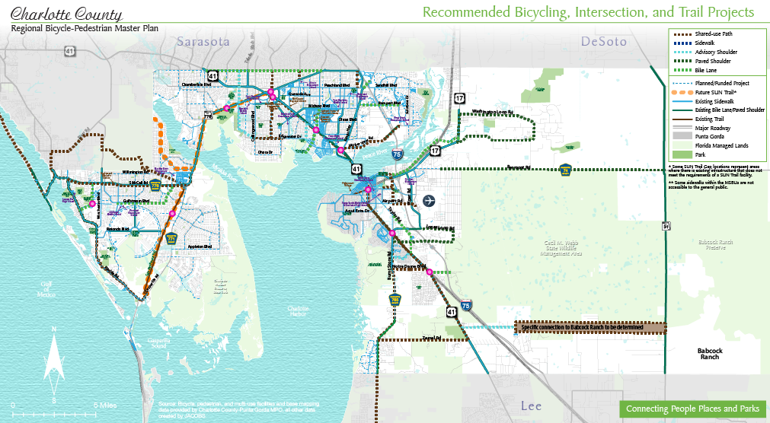

Figure 5: County-wide Recommendations for Bicycling, Intersection, and Trail Projects.

Figure 1. County-wide Recommendations for Bicycle Projects

All project recommendations identified in this Master Plan were prioritized into project tiers as described in **Tables 3 through 6**, representing the recommended order for implementing projects. The project rankings were based on the prioritization identified in the recommendations section. The needs of all roadway users, including the safety and comfort of people walking, bicycling, accessing transit and driving, must be balanced with roadway characteristics and corridor constraints.

Tier 1 projects can be implemented quickly, typically within five years. Tiers 2 and 3 are longer-term projects and require greater coordination between stakeholders to fully permit, engineer and construct. Tier 2 projects can be implemented within five to ten years and Tier 3 projects will take longer than ten years to implement.

The County, MPO and City of Punta Gorda can demonstrate their commitment to carrying out this Plan and will better sustain enthusiasm generated during the planning process by quickly identifying specific project priorities. Tier 1 projects should be considered in each area of Charlotte County to ensure that biking and walking infrastructure is well-distributed geographically. Tier 2 and Tier 3 projects should be included in transportation plans. Because these projects require more time and coordination to implement, it is possible these projects may be partially or wholly implemented by stakeholders other than the MPO.

The following tables provide the project recommendations that resulted from the Bicycle and Pedestrian Master Plan process along with each recommendation’s conceptual cost and implementation priority tier. The recommendations are based out of the needs plan, input from stakeholders and the public and input from the MPO.

Table 3: Tier 1 Project List for Implementation between before 2024

| **Project ID** | **Project Name** | **Sidewalk Improvement** | **Bikeway Improvement** | **Estimated Project Cost** | **Included in LRTP/ CIP/CNA?** | **Project Rank** |
| --- | --- | --- | --- | --- | --- | --- |
| 24 | US 41 (Lee County Line to Tucker’s Grade) |  | Shared-Use Path, one side | $2,161,844 | Y | 1 |
| 6 | South County Reg. Park Internal Road (Carmalita St. to Cooper St.) | Sidewalk, one side | Advisory Shoulder | $160,343 | N | 2 |
| 12 | E/W Utility Easement (N/S Follows utility easement to Education Ave) |  | Shared-Use Path, one side | $181,953 | N | 3 |
| 2 | Port Charlotte Blvd (Edgewater Dr. to US 41) |  | Shared-Use Path, one side | $262,660 | Y | 4 |
| 8 | Harbor View Rd. (US 41 to Sulstone Dr.) |  | Shared-Use Path, one side | $983,778 | Y | 5 |
| 9 | Edgewater Dr (Collingswood Blvd. to Midway Blvd.) |  | Shared-Use Path, one side | $476,011 | Y | 6 |
| 1 | Notre Dame Blvd (Burnt Store Rd. to US 41) | Sidewalk or Shared-Use Path, one side | Sidewalk or Shared-Use Path, one side | $482,847 to  $524,243 | Y | 7 |
| 15 | US 41 (Tucker’s Grade to Burnt Store Rd) |  | Shared-Use Path, one side | $974,526 | Y | 8 |
| 41 | US 41 (Peace River Bridge to Midway Blvd) |  | Shared-Use Path, one side | $1,422,598 | Y | 9 |
| 13 | Airport Rd (FSW to Piper Rd. and Piper Rd. to Riverside Dr.) |  | Shared-Use Path, one side | $1,174,982 | N | 10 |
| 45 | Taylor Road (Airport Rd to US 41) | Separated Bike Lane, One Way |  | $2,642,373 | Y | 11 |
| 53 | Loveland Blvd (Peachland Blvd. to Veterans Blvd.) |  | Shared-Use Path, one side | $305,310 | Y | 12 |
| 16 | Zemel Rd (Burnt Store Rd. to US 41) |  | Shared-Use Path, one side | $1,662,245 | N | 13 |
| 3 | Tucker’s Grade (US 41 to Wildlife Mgmt. Area) | Sidewalk, one side | Buffered bike lanes | $1,440,714  Bikeway  $312,431  Sidewalk | Y | 14 |

Table 4: Tier 2 Project List for Implementation between 2024-2029

| Project ID | Project Name | Sidewalk Improvement | Bikeway Improvement | Estimated  Project Cost | Included in LRTP/ CIP /CNA? | Project Rank |
| --- | --- | --- | --- | --- | --- | --- |
| 38 | SUN Trail on US 41 (Midway Blvd. to SR 776) |  | Shared-Use Path, one side | $723,481 | N | 15 |
| 47 | Rampart Blvd. (Kings Hwy to Rio de Janeiro Ave.) | Sidewalk, one side | Separated Bike Lane, One Way | Bikeway  $432,481  Sidewalk  $149,115 | Y | 16 |
| 42 | SUN Trail (Cape Haze Pioneer Trail Corridor) Pioneer Trail to Boca Grande |  | Shared-Use Path, one side | $220,245 | N | 17 |
| 17 | Fruitland Ave/Avenue of the Americas (San Casa Rd. to Gulfstream Blvd.) | Sidewalk, one side |  | $357,402 | Y | 18 |
| 36 | SUN Trail (SR 776 to Myakka State Forest) |  | Shared-Use Path, one side | $678,285 | N | 19 |
| 44 | SUN Trail on Placida Rd (Gasparilla Rd. to SR 776) |  | Shared-Use Path, one side | $2,996,636 | N | 20 |
| 39 | SUN Trail on Burnt Store Rd (Scham Rd. to Jones Loop Rd.) |  | Shared-Use Path, one side | $693,684 | N | 21 |
| 21 | Oil Well Rd (US 41 to Granville Rd.) | Sidewalk, one side |  | $762,141 | Y | 22 |
| 40 | SUN Trail on Beach Rd (Gulf Blvd to SR 776) |  | Shared-Use Path, one side | $1,082,970 | N | 23 |
| 7 | San Casa Dr (Placida Rd. to SR 776) |  | Separated Bike Lane, One Way | $1,434,737 | Y | 24 |
| 11 | Harbor Blvd (Port Charlotte Beach complex to Midway Blvd.) | Sidewalk, gap closures | Separated Bike Lane, One Way | 2,346,746 | Y | 25 |
| 37 | SUN Trail on SR 776 (Gasparilla Rd. to US 41) |  | Shared-Use Path, one side | $2,503,165 | N | 26 |
| 20 | SR 776 (Sarasota County Line to Gasparilla Rd.) |  | Shared-Use Path, both sides | $4,422,373 | Y | 27 |
| 48 | Atwater St (Veterans Blvd to Hillsborough Blvd.) | Sidewalk, one side | Shared-Use Path, one side | $132,546 | Y | 28 |

Table 5: Tier 3 Project List for Implementation after 2030

| Project ID | Project Name | Sidewalk  Improvement | Bikeway Improvement | Estimated Project Cost | Included in LRTP/CIP/CNA? | Project Rank |
| --- | --- | --- | --- | --- | --- | --- |
| 50 | O’Donnell Blvd (North Charlotte Reg. Park to US 41) |  | Advisory Shoulder | *TBD - requires study | Y | 29 |
| 51 | Royal Poinciana (Burnt Store Rd. to US 41) |  | Shared-Use Path, one-side (part of City complete streets project) | *TBD - requires study & verification. City of Punta Gorda has estimated cost at $2,250,000 million for a complete streets project per CIP Unfunded Project Request list | Y (City Council action to plan for a Shared-Use Path rather than Advisory Shoulder) | 30 |
| 10 | Pellam Blvd/Prineville St (Edgewater Dr. to County Line) |  | Shared-Use Path, one side | *TBD - requires study | N | 31 |
| 4 | Moss Rd (Charlotte Sports Park to No. Charlotte Reg. Park) |  | Advisory Shoulder | TBD – requires further study | N | 32 |
| 19 | Edgewater Dr./Flamingo Blvd ext. (Collingswood Blvd. to County Line) | Sidewalk | Shared Use Path and/or Paved Shoulder | *TBD -requires further study | Y | 33 |
| 5 | Gulfstream Blvd (Fruitland Ave. to SR 776) | Sidewalk, one side | Bike Lane | Bikeway $2,992,203  Sidewalk  $951,493 | Y | 34 |
| 14 | Washington Loop Rd. (US 17 S. to US 17 N.) | Paved Shoulder | Paved Shoulder | $8,203,403 | N | 35 |
| 18 | CR 74/Bermont Rd. (Richards Blvd. to SR 31) | Paved Shoulder | Paved Shoulder | $9,191,930 | Y | 36 |
| 52 | Hillsborough Blvd (Cranberry Blvd./US 41 to Veterans Blvd.) | Sidewalk, one side | Separated Bike Lane, One Way | $284,028 | Y | 37 |
| 43 | SUN Trail on Burnt Store Rd (Lee County Line to Zemel Rd.) |  | Shared-Use Path, one side | $688,940 | N | 38 |
| 35 | SUN Trail on US 41 (N. Jones Loop Rd to Peace River Bridge) |  | Shared-Use Path, one side | $1,464,873 | N | 39 |
| 49 | Kings Hwy (Veterans Blvd. to Sandhill Blvd) | Sidewalk, one side | Separated Bike Lane, One Way | $298,229 | Y | 40 |
| 46 | Jones Loop Rd (Burnt Store Rd. to Piper Rd) | Paved shoulder | Paved Shoulder | $4,208,105 | Y | 41 |
| 23 | Babcock Ranch Connection |  | Shared-Use Path, one side | $5,939,673 | N | 42 |
| 22 | Riverside Drive (Marion Ave. to US 17) |  | Paved Shoulder | $3,706,766 (5.5 Mile) | N | 43 |

Table 6: Crossing improvement project list for Implementation as funds become available.

| Project ID | Project Name | Crossing improvements | Estimated Project Cost | Included in LRTP/CIP/CNA? | Project Tier | Project Rank |
| --- | --- | --- | --- | --- | --- | --- |
| 25 | Cape Haze Pioneer Trail near Rotonda Blvd E. | Enhanced Crosswalk | *TBD - requires study | Y | 1 | 1 |
| 28 | US 41 @ Harbor Blvd | Enhanced Crosswalk | *TBD - requires study | N | 1 | 2 |
| 27 | SR 776 @ Fairgrounds/Charlotte Sports Park | Crossing Enhancements/Traffic Signal | $1,100,000 | Y | 1 | 3 |
| 29 | US 41 @ Murdock Circle E | Median Safety Islands and at intersection. Consider LPIs to give people walking time | *TBD- requires study | Y | 2 | 4 |
| Project ID | **Project Name** | **Crossing improvements** | **Estimated Project Cost** | **Included in LRTP/CIP/CNA?** | **Project Tier** | **Project Rank** |
|  |  | to safely enter the intersection. |  |  |  |  |
| 30 | US 41 @ Harbor View Rd/Edgewater Blvd | Add North to South Crossing across US 41. Add Median Safety Islands, Consider LPIs to give people walking time to safely enter the intersection. | *TBD- requires study | Y | 2 | 5 |
| 31 | Veterans Blvd @ Murdock Circle E | Median Safety Islands and at intersection. Consider LPIs to give people walking time to safely enter the intersection. | *TBD- requires study | Y | 2 | 6 |
| 32 | US 41 @ Burnt Store Road | Median Safety Islands and at intersection. Consider LPIs to give people walking time to safely enter the intersection. | *TBD- requires study | Y | 2 | 7 |
| 33 | US 41 @ Carmalita St | Full Traffic Signal | *TBD- requires study | Y | 2 | 8 |
| 34 | US 41 @ Tuckers Grade | Median safety islands and at intersection. Consider LPIs to give pedestrians time to safely enter the intersection. | *TBD- requires study | Y | 3 | 9 |
| 26 | San Casa Drive @ Avenue of the Americas | Full Traffic Signal | $257,597 | Y | 3 | 10 |

## Implementation Strategies

This plan describes construction methods for the proposed pedestrian and bicycle facilities outlined in the Recommendations chapter. Note that many types of transportation facility construction and maintenance projects can be used to create new facilities. It is much more cost-effective to provide facilities during roadway construction and re‑construction projects than to initiate the improvements later as “retrofit” projects.

To take advantage of upcoming opportunities and to incorporate bicycle and pedestrian facilities into routine transportation and utility projects, the Charlotte County-Punta Gorda MPO should monitor FDOT projects and any other transportation improvements to look for opportunities for integrating plan recommendations. While doing this, MPO and government staff should be aware of the different procedures for state and local road improvements.

### Infrastructure

Many types of transportation facility construction and maintenance projects can be used to create new facilities. It is much more cost-effective to provide facilities during roadway construction and re‑construction projects than to initiate the improvements later as “retrofit” projects.

To take advantage of upcoming opportunities and to incorporate bicycle and pedestrian facilities into routine transportation and utility projects, the Charlotte County-Punta Gorda MPO should monitor FDOT projects and any other transportation improvements to look for opportunities for integrating plan recommendations. While doing this, MPO and government staff should be aware of the different procedures for state and local road improvements. Figure 5 is an example of this.

* **Bridge Construction or Replacement.** Provisions should always be made to include a walking and bicycling facility as a part of roadway bridges. All new or replacement bridges should accommodate two-way travel for all users. Even though bridge construction and replacement does not occur regularly, it is important to consider these policies for long-term pedestrian planning. Figures on the next page depict such facilities.
* **Easements.** The County Public Works Department and City of Punta Gorda should explore opportunities to revise existing easements to accommodate public access for shared-use path facilities.
* **Charlotte County-Punta Gorda MPO Transportation Improvement Program**. This program provides opportunities for funding of active transportation projects either as part of roadway projects or as stand-alone projects.
* **Local Roadway Construction or Reconstruction**. Pedestrians and bicyclists should be accommodated any time a new road is constructed or an existing road is reconstructed.
* **Residential and Commercial Development**. New development and redevelopment should require sidewalks, bikeways, and safe crosswalks.
* **Resurfacing, Restoration and Rehabilitation Projects (3R).** 3R projects provide a clean slate for re-allocating roadway space through revised pavement markings.
* **Retrofit Roadways with New Bicycle and Pedestrian Facilities**. In some locations, it may be easier to add pavement for bikeways or sidewalks, but other segments could require tree and landscaping removal, or re-grading ditches. Some roads may have excess capacity and are candidates for a “road diet” solution to create space for bikeways or walkways. Road diets reallocate unused motor vehicle travel lanes to increase roadway safety for all users and in some cases, could create space for on-street parking, on-street bikeways, walkways, and even shared-use paths.

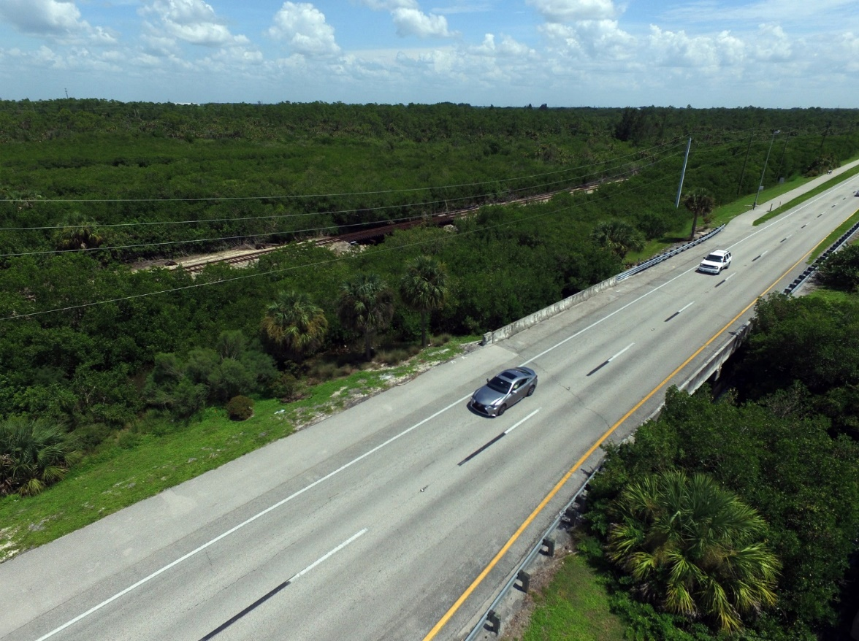

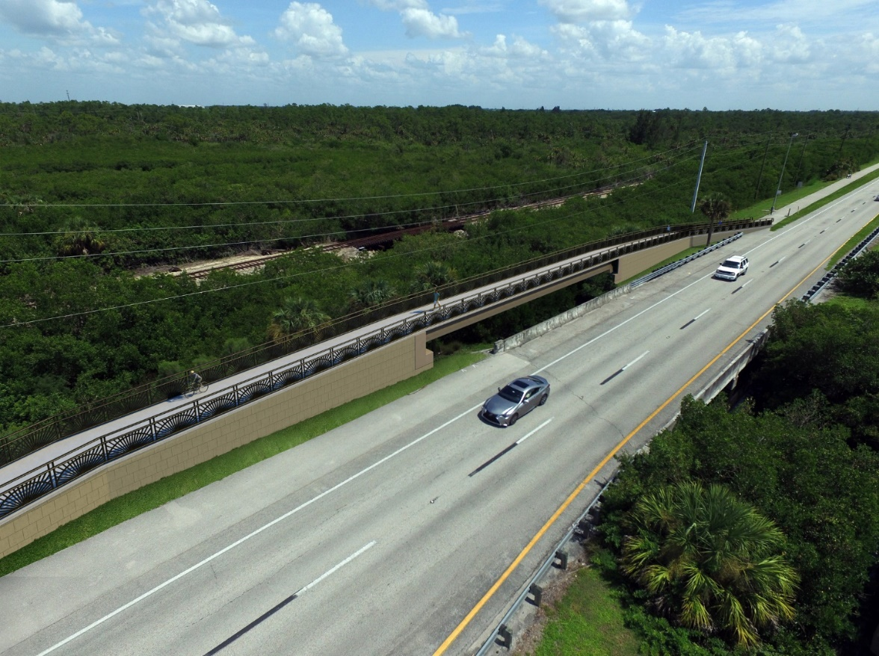

Figure 6: A before and after photo rendering provided courtesy of the City of Punta Gorda, produced by

Agenor & Campbell Structural Engineers

## Program Action Steps

While policies and regulatory standards provide a legal basis for facility development, programs build support for walking and biking facilities and establish a strong walking and biking culture in Charlotte County. The Recommendations chapter of this plan provides action steps intended to be implemented from 2019 onward. A necessary element of a walk-friendly and bicycle-friendly community is a safe and positive culture of travel and recreation. Programs focus on providing education, encouragement, and enforcement to support people making healthy lifestyle and travel choices.

The MPO and local stakeholders are already championing many effective programs to encourage and invite people to walk and bike more frequently. These programs require collaborative partnerships due to the large geographic size of the county and smaller population.

For this Plan, program recommendations are focused on maintaining and enhancing existing programs

* **Safe Routes to Schools** - The Johns Hopkins Children’s Hospital leads a regional effort with staff sharing responsibilities between different school boards to improve walking and biking access to schools. They also regularly provide classes to teach children how to walk and bike to school safely. This organization should continue to work with law enforcement agencies and other stakeholders to work with area schools and the Charlotte County School District to promote safe access to school and promote physical activity.
* **Public Safety Education and Enforcement –** MPO and partner stakeholders, including law enforcement should continue to conduct regular education and enforcement campaigns to promote a culture of safe travel for all roadway users. The focus should be on drivers as well as people walking and biking.

Figure 7: An Open Streets event and demonstration project in Rome, Georgia, provided people with the opportunity to experience their built environment with music and games.

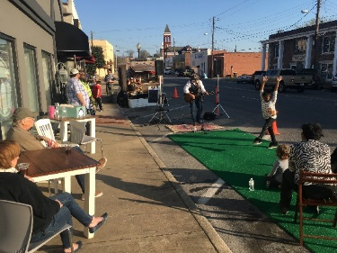

* **Walking and Biking Open Street Events** - The City of Punta Gorda, Charlotte County and local organizations regularly host annual events that include charity run/walks and bike rides. These events promote a healthy lifestyle and serve as a source of tourism too. These events should include National Bike Month events where municipalities and towns across the country participate in National Bike Month annually, held in May. The League of American Bicyclists hosts a website for event organizers. It is recommended that the MPO host National Bike Month events and activities annually, with support from the Bicycle and Pedestrian Advisory Committee and local biking groups and businesses.
* **Public Service Announcements** – Law enforcement agencies and local bicycle and pedestrian advocacy clubs should continue using existing Public Service Announcements (PSA) from FDOT and national safety partners to promote safety initiatives. Local agencies should also consider developing local PSAs in addition to relying on external programs. Materials are more relatable to local transportation users when they use local statistics and roadway information.

Policy guides government decision making and funding allocations and can often create support for new facilities. The MPO already has policies in place that contribute to the walking and biking environment in the County. The policy recommendations for this plan provide next steps for improving the bicycle and walk friendliness of the area. Table 7 provides estimated existing and proposed full time equivalent (FTE) employees for Programs proposed in this plan.

Table 7: Estimated Existing and Proposed FTE for Programs

|  |  |  |
| --- | --- | --- |
| Programs | Existing FTE – Estimated | Proposed FTE – Estimated |
| Safe Routes to Schools | 10% | 15% |
| Public Safety Education and Enforcement | 10% | 15% |
| Walking and Biking Open Street Events | 5% | 15% |
| Public Safety Announcements | 5% | 10% |
| Walking and Biking Website | - | 10% |
| Pilot Programs | - | 20% |
| Conduct Roadway Safety Audits | - | 10% |
| Conduct Annual Bike/Ped Counts at Key Locations | - | 10% |
| Silver Sneaker Program | - | 10% |
| **Total FTE** | **30%** | **115%** |

## Policy Action Steps

Several policy steps are crucial to the success of future planning implementation. These steps will legitimize the recommendations found in this plan and support policy decision-making necessary to carry out those recommendations.

### Adopt this Plan

Adoption should be considered as the first step of implementation. Once adopted, the MPO and Charlotte County will be able to make better transportation related decisions with its partners so that the goals of the plan are accomplished. Most importantly, having an adopt plan is a crucial component for many federal, state and private sources. Adopting the Plan indicates intent to implement over time and does not commit the MPO and the County to dedicate or allocate funds.

### Update Development Regulations and Land Development Codes with Walking and Biking Oriented Standards

Many standards in the county are ripe for updating to provide better facilities for people biking and walking. Development regulations and regulations regarding roadway development both shape the built environment and the safety and convenience of active transportation infrastructure. A full list of recommendations is available in the Design Guidance Technical Memorandum.

Updating development regulations with enhanced bike parking standards is a key step to enhancing convenience for people biking. Bike parking requirements should be explicitly required with commercial, multi-family and civic developments. Use the Association of Pedestrian and Bicycle Professionals Bicycle Parking Guidelines for resources on best practices related to site design, construction, and number of bike parking spaces to require.

### Adopt Complete Streets Policy in Support of Existing Vision Zero Policy

A Complete Street is for everyone, including people walking, biking, taking a bus or driving. Complete streets are designed and operated in a manner which is safe for everyone, regardless of age and ability. They provide access to destinations, places where people live, work and play. Each street is unique and requires an understanding of the surrounding context and community needs. Complete streets are designed to benefit all people as they improve safety, equity, and livability.

This Plan recommends that Charlotte County adopt a Complete Streets policy. In addition to adopting a Complete Streets policy, the City of Punta Gorda and Charlotte County should develop and adopt street design guidelines identified in this plan to support the policy and communicate desired street treatments. The policy is intended to support the Vision Zero efforts of the County and MPO and are not intended to supersede those efforts.

### Funding

Achieving the vision defined within this Plan will require, among other things, a stable and recurring source of funding that can leverage grant dollars from state, federal and private sources. Communities across the country that have successfully engaged in pedestrian and bicycle programs have relied on multiple funding sources to achieve their goals. No single source of funding will meet the recommendations identified in this Plan. Instead, stakeholders will need to work cooperatively with municipal, state, and federal partners to generate funds sufficient to implement the Plan. A description of local, state, federal and private funding sources funding sources is identified in the Funding Technical Memorandum.

Local funds should be leveraged to attract additional Federal and State grant funds to pay for necessary right-of-way acquisition and project design, construction, and maintenance expenses. Also, the MPO should continually maintain a back-log of designed projects that are “shovel ready” to take advantage of future funding opportunities as they become available.

The MPO 2040 Long Range Transportation Plan Needs Plan identified bicycle, pedestrian, and multi-use trail facility projects along roads without existing facilities or that have gaps or missing links. The MPO 2040 Long Range Transportation Plan Cost Feasible Plan includes $14.6 million in Present Day Costs (PDC) or $22.4 million in year of expenditure (YOE) for bicycle, pedestrian, and multiuse trail facility projects. This total cost and projected revenues includes only bicycle, pedestrian and multi-use trail projects identified separately from road projects, as those improvements are included in the total cost for highway projects. The MPO 2040 cost feasible plan provides an excellent and vetted source providing projected revenue stream to implement projects in this Plan through the year 2040.

Given the constant change in funding availability at Local, State, and Federal levels, it is difficult to know what financial resources will be available at different time frames during the implementation of this Plan. However, there are important actions to take in advance of major investments, including key organizational steps, the initiation of education and safety programs, and the development of strategic, lower-cost infrastructure improvements.