Charlotte County-Punta Gorda MPO 2045 Long Range Transportation Plan

Route to 2045 LRTP Executive Summary Report
Adopted October 5, 2020

Prepared for:
The Charlotte County-Punta Gorda Metropolitan Planning Organization

Prepared by:

1000 N. Ashley Drive Suite 400
Tampa, FL 33602

Table of Contents
Section 1: Route to 2045 Overview 1-1
  - Mapping the Route to 2045 1-1
  - Public Involvement – Guiding the Plan 1-2
  - Plan Development 1-5
  - Funding Route to 2045 1-5
Section 2: Vision for the Route to 2045 2-1
2.2 Consistency with State and Local Plans 2-2
Section 3: Population and Employment Growth 3-1
3.1 Growth Allocation 3-3
Section 4: Implementing the Route to 2045 4-1
  - Defining the Needs 4-1
  - Environmental Mitigation 4-16
  - Funding for Route to 2045 4-18
  - Route to 2045 Cost Feasible Plan 4-19

Appendix A: Performance Measures and System Performance Report .................................................. A-1

List of Figures
Figure 1-1 Charlotte County-Punta Gorda MPO Planning Area Map 1-1
Figure 1-2 Summary of Route to 2045 Public Involvement Activities 1-3
Figure 1-3: Equity Assessment Areas 1-4
Figure 1-4: Route to 2045 Development Process 1-5
Figure 3-1: Charlotte County - Punta-Gorda MPO Population Historic Growth and
Forecast (2000-2045) 3-1
Figure 3-2: Major Development Areas 3-3
Figure 3-3: Growth in Population and 2045 Forecast 3-4
Figure 3-4: Growth in Employment and 2045 Forecast 3-5
Figure 4-1: Existing and Committed Number of Lanes 4-2
Figure 4-2: Congested and High Crash Locations 4-3
Figure 4-3: Traffic Signals and ITS 4-3
Figure 4-4: CMP Intersections and Corridors 4-4
Figure 4-5: Transit Service Needs 4-6
Figure 4-6: Bicycle/Pedestrian Master Plan Needs 4-9
Figure 4-7: Four-Step Travel Demand Modeling Process 4-11
Figure 4-8: Roadway Needs 4-15
Figure 4-9: Charlotte County Environmental Features 4-17
Figure 4-10: Bicycle/Pedestrian Master Plan Cost Feasible Projects 4-25
Figure 4-11: Roadway Cost Feasible Map 4-29

List of Tables
Table 1-1: Available Revenue for the 2045 LRTP 1-6
Table 2-1: Comparison of FTP and Charlotte County -Punta Gorda 2045 LRTP Goals 2-2
Table 2-2: Comparison of FAST Act Planning Factors and Charlotte County – Punta Gorda MPO
2045 LRTP Goals 2-3
Table 3-1: Population and Employment Forecasts 3-1
Table 3-2: Employment Forecast by Employee Type 3-2
Table 4-1: Transit Needs Projects and Costs 4-7
Table 4-2: Bicycle Pedestrian Master Plan 4-10
Table 4-3: Roadway Needs List ($ Millions, 2019 Present Day Cost) 4-12
Table 4-4: Potential Environmental Mitigation Strategies 4-16
Table 4-5: Revenue Projection Summary – Year-of-Expenditure Revenues 4-18
Table 4-6: Bicycle/Pedestrian Master Plan Cost Feasible Projects 4-21
Table 4-7: Roadway Cost Feasible Projects List ($ Millions Future Year of Expenditure) 4-27

Section 1: Route to 2045 Overview
The most significant aspect of the Charlotte County-Punta Gorda Metropolitan Planning Organization’s (MPO) mission is to ensure future mobility for residents and visitors in Charlotte County and Punta Gorda, as well as a portion of southwest DeSoto County within the MPO’s planning area boundary. To do so, the MPO guides the transportation planning process which includes the development of the Long Range Transportation Plan (LRTP) to identify future transportation improvements.
Route to 2045 is the brand name for the LRTP, coined by the Charlotte County Punta Gorda MPO, that identifies the “route” to meet the transportation needs of Charlotte County and a portion of southwestern DeSoto County for the next 25 years. Route to 2045 addresses cost feasible highway, transit, bicycle, and pedestrian projects through the year 2045. The improvements identified in this Plan provide for future mobility needs and enhance safety and security within the planning area boundary. The map in Figure 1-1 shows the planning area and key features within the MPO’s planning area.
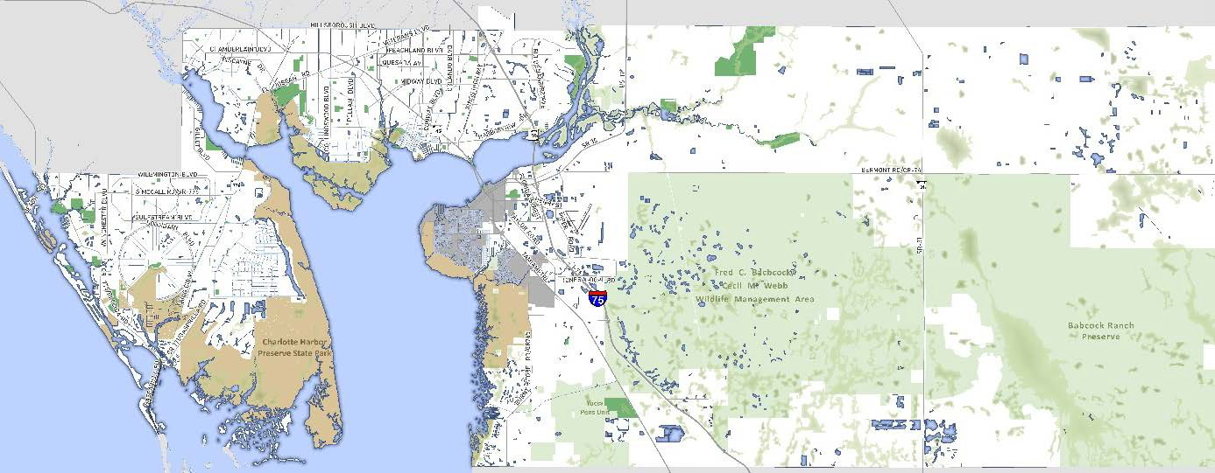
Figure 1-1 Charlotte County-Punta Gorda MPO Planning Area Map

Mapping the Route to 2045
The LRTP establishes a vision to address the transportation system needs through cost feasible improvements in Charlotte County over the next 25 years. The multimodal plan documented in this report outlines highways; public transportation (transit); and bicycle, pedestrian, and multi-use trail facilities. The purpose of this plan is to address federal and state requirements by identifying projects that are cost feasible for each mode of travel.
This 2045 LRTP represents a significant and visionary effort to address the long-term transportation needs of Charlotte County, City of Punta Gorda, and the southwest corner of DeSoto County. Key highlights of this plan include:

    - Population and employment forecasts that consider growth in the existing core and current plans for the Babcock Ranch Development in the eastern portion of the county.
    - Updated revenue projections from federal, State and local transportation sources.
    - Extensive public involvement included in-person meetings and workshops, multiple online surveys, an interactive online mapping application, and the MPO’s first “cost feasible” virtual workshops.
    - A review of existing public transportation priorities and incorporation of the first-ever Charlotte County Regional Bicycle/Pedestrian Master Plan.
This Executive Summary Report was prepared to summarize the Route to 2045 LRTP developed by the MPO. This Summary Report is organized into four main sections:
- Section 1 includes an introduction and outline of the report, an overview of the transportation investment in Route to 2045, and a summary of the public involvement.
- Section 2 provides an overview of the goals and performance measures in the Route to 2045 LRTP and their consistency with state and federal planning requirements.
- Section 3 describes the future expected growth in population and jobs for Charlotte County through 2045. This projected growth creates a backdrop for determining future travel demands and the areas of greatest need for future transportation investments.
- Section 4 presents the draft Cost Feasible LRTP and the analysis for determining financial feasibility. This analysis includes a review of the multimodal needs that have been identified along with a review of the reasonably expected future transportation revenues.
In addition to the summary review document, detailed technical reports documenting the LRTP development area available on the MPO’s website (www.ccmpo.com) and by contacting MPO Staff. The technical reports provide additional details on the methodology and analysis which guided the development of the Route to 2045 LRTP.

Public Involvement – Guiding the Plan
The Charlotte County – Punta Gorda MPO is charged with the planning and programming of federal and State transportation funds for transportation projects within its metropolitan urbanized area. However, it is the citizens and residents of each metropolitan area and region who ultimately decide the future of their transportation system. Therefore, engaging the public through various involvement activities throughout the entire LRTP development process is essential to accurately capturing the vision and collective future of the area and region.
The primary purpose of the public engagement activities has been to facilitate meaningful dialogue with the public regarding the Plan update and the needs and desires of the community. The public was involved in the visioning process and the Needs Plan development to discuss population and employment forecasts and needed transportation improvements for all modes. During the Cost Feasible Plan development, the MPO held its first ever virtual workshops to ask the public to weigh in on the projects identified in the Needs Plan to assist in prioritizing projects for funding. The in-person workshops were adapted to virtual workshops in response to the COVID-19 pandemic.

A detailed Public Involvement Summary Technical Memorandum includes the summaries of the stakeholder interviews, interactive online mapping applications, online surveys, and the public workshops conducted (both in-person and virtually) during the LRTP update. The public was welcomed, contacted, and encouraged to attend any and all workshops and Board Meetings throughout the Plan update process. Figure 1-2 provides a summary of Route to 2045 public involvement activities and the number of participants involved.
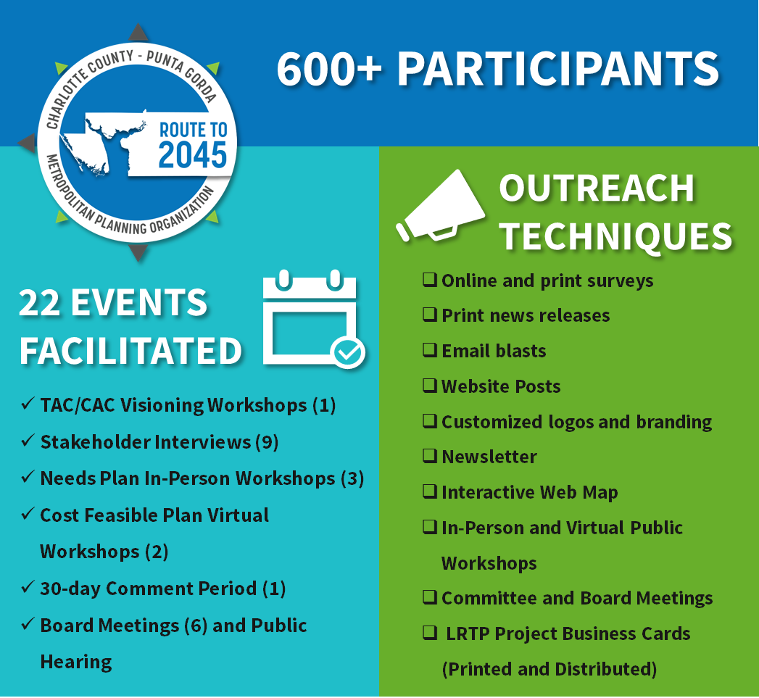
Figure 1-2 Summary of Route to 2045 Public Involvement Activities

1.2.1 Environmental Justice
Like many Florida Counties, Charlotte County is comprised of a mix of ethnicities, incomes, and individuals of diverse wants and needs. Identifying concentrations of populations with diverse needs across the County aides in assessing the demands and impact upon Charlotte County’s transportation and transit system and helps target public investments to areas with specific needs in an efficient manner. Six factors, based on socio-economic measures from the U.S. Census Bureau’s American Community Survey, were evaluated to identify Environmental Justice (EJ) areas and concentrations of other protected groups. The six factors include households below poverty, non-white/non-Hispanic populations, Hispanic populations, English proficiency, populations age 65 or older, and zero vehicle households.

A geographic analysis was conducted to identify census block groups with higher concentrations of each of the EJ factors. A detailed Technical Memorandum provides a description of this geographic analysis and the methodology used to identify EJ areas. s. Figure 1-3 illustrates EJ areas within Charlotte County Punta Gorda region.

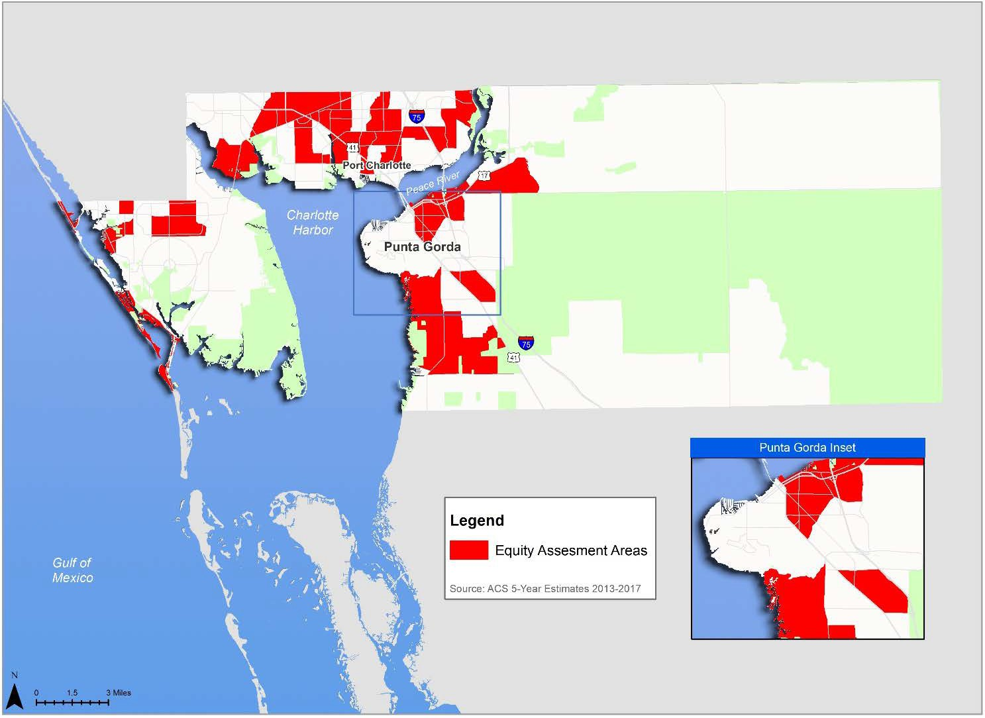
Figure 1-3: Equity Assessment Areas

Plan Development
There are two major aspects required in the development of the LRTP. The first is the identification of the transportation needs of the community. Second is determining how will we pay for the needs (Cost Feasible). The identification of needs considers projected growth and how it may affect the transportation system, and the community’s aspirations for the future. The Cost Feasible Plan identifies the needs that can be funded with available transportation revenues. The LRTP addresses the surface transportation network including roadways, transit, and non-motorized (bicycle and pedestrian) facilities.
This document summarizes the Route to 2045 LRTP components in both map and tabular formats while providing an overview of the process followed for establishing a community vision and goals that guided the LRTP development. Figure 1-4 provides an overview of the steps that were followed in developing the results and recommendations for the Route to 2045 LRTP.

Figure 1-4: Route to 2045 Development Process
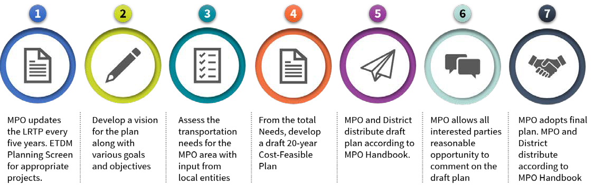

Funding Route to 2045
The Route to 2045 Cost Feasible Plan reflects a $1.42 billion transportation program covering the years 2021 to 2045. These revenues are insufficient to address the County’s future mobility needs that result from future growth in population and employment expected by 2045. In 2020, voters in Charlotte County will be asked to extend a one-penny Local Government Infrastructure Surtax that was first enacted in 1995 and has been extended by referendum four times since. Table 1-1 illustrates the revenues estimated to be available for the 2045 LRTP

Table 1-1: Available Revenue for the 2045 LRTP ($ Millions YOE)

Funding Source | 2021-  2025 | 2026-  2030 | 2031-  2035 | 2036-  2045 | Total (2026-45)
Capacity Programs – Highway
SIS Highways | $0.00 | $0.00 | $31.09 | $55.43 | $86.53
Other Arterials - Construction and ROW | $57.17 | $69.44 | $74.92 | $155.89 | $357.42
Other Arterials - Product Support | $12.60 | $15.30 | $16.50 | $34.30 | $78.70
Transit (Federal/State)
1State and Federal (FDOT) | $16.78 | $17.78 | $20.33 | $50.32 | $105.2
Metropolitan and Regional Programs
TALU | $0.23 | $0.23 | $0.23 | $0.46 | $1.15
TALL | $1.24 | $1.24 | $1.24 | $2.47 | $6.17
TALT | $1.04 | $1.04 | $1.04 | $2.08 | $5.19
TRIP | $1.32 | $1.97 | $2.19 | $4.49 | $9.97
Fuel Taxes to Local Governments
Constitutional | $12.02 | $12.45 | $12.71 | $25.81 | $62.98
County | $5.28 | $5.45 | $5.54 | $11.23 | $27.50
Municipal - Punta Gorda | $0.76 | $0.81 | $0.85 | $1.78 | $420
Fuel Taxes Levied Locally
Ninth-Cent Countywide | $5.50 | $5.68 | $5.79 | $11.71 | $28.67
First LOFT (6 cents), Unincorporated County | $27.81 | $28.77 | $29.36 | $59.70 | $145.64
First LOFT (6 cents), Punta Gorda | $3.21 | $3.32 | $3.39 | $6.88 | $16.80
Second LOFT (5 cents), Unincorporated County | $20.37 | $21.09 | $21.52 | $43.74 | $106.73
Second LOFT (5 cents), Punta Gorda | $1.47 | $1.53 | $1.56 | $3.16 | $7.71
Impact Fees
Countywide | $0.00 | $23.80 | $23.80 | $47.60 | $95.20
Punta Gorda | $0.00 | $0.25 | $0.25 | $0.50 | $1.00
Local Government Infrastructure Sales
Countywide | $13.47 | $38.33 | $45.63 | $117.31 | $214.74
Punta Gorda | $1.54 | $4.39 | $5.22 | $13.43 | $24.58
Transit Funding
Local (County, Farebox, Other) | $5.10 | $6.03 | $6.03 | $15.09 | $32.26
Total Revenues | $186.90 | $258.89 | $309.17 | $663.38 | $1,418.34

By creating a partnership between local jurisdictions and FDOT, that combines local revenues such as impact fees and other non-traditional transportation funding sources (i.e. TRIP, sales tax initiatives, etc.) with Florida Department of Transportation Funds, the MPO, FDOT, and the local governments have the potential to fund a significant number of local and state capacity projects that support safety, growth, economic enhancements, and development. This also allows the MPO to invest more on citizen priorities like complete streets, transit, and bicycle/pedestrian facilities.

Section 2: Vision for the Route to 2045
The primary step in developing the Vision Statement and Goals for Route to 2045 was to review the existing Vision Statement and Goals in the 2040 LRTP to determine their relevance with the planning requirements under the FAST Act and consistency with the FTP Policy Element, countywide comprehensive plans and other relevant planning reports. Since the Vision Statement and Goals set the foundation for the entire planning effort, it is important that they reflect the direction of the community. The Vision Statement, Goals and Objectives from the 2040 LRTP were determined to be relevant for 2045 with minor amendments. The LRTP Subcommittee met to review the 2040 goals and refined the Goals slightly to reflect current activities and community vision. The LRTP Vision Statement and Goals are listed below.

Route to 2045 Vision Statement
Provide an efficient and reliable multimodal transportation system that supports safe, resilient and accessible transportation choices that enhance the quality of life for all who live, visit, work, and play in the County.

Route to 2045 Goals
GOAL 1  Ensure Efficient Travel for all Modes of Transportation | GOAL 2  Expand Transportation Choices for Everyone
GOAL 3  Preserve Natural Spaces While Promoting a Healthy Community | GOAL 4  Support Vibrant Centers  and the Local Economy
GOAL 5

Enhance Safety and Security for Everyone

The goals of the LRTP are supported by measurable objectives and performance measures which summarize the resulting conditions for 2045. Appendix A provides a detail listing of the Federally required performance measures and targets that have been adopted by the MPO

2.2 Consistency with State and Local Plans
Consistency with the National Planning Factors and Goals of the Florida Transportation Plan (FTP) are critical components of the Charlotte County – Punta Gorda MPO 2045 LRTP. Demonstrating this consistency is a major milestone in conducting the LRTP and ensuring that the planning conducted by the Charlotte County– Punta Gorda MPO meets and supports the expectations of the Federal and State requirements. The following section demonstrates consistency with the local Comprehensive Plans, the FAST Act and the FTP Policy Element.
Table 2-1 provides the correlation between the Goals of the FTP and the Goals of the Charlotte County
– Punta Gorda MPO 2045 LRTP.
Table 2-1: Comparison of FTP and Charlotte County -Punta Gorda 2045 LRTP Goals

2015 FDOT FTP Policy Element Goals | Charlotte County-Punta Gorda MPO 2045 LRTP Goals
1. Safety & Security for Residents, Visitors, and Businesses. | Goal 5 – Safety and Security
2. Agile, Resilient, and Quality Infrastructure. | Goal 1 – Efficient Travel Goal 5 – Safety and Security
3. Efficient and Reliable Mobility for People and Freight. | Goal 1 – Efficient Travel Goal 4 – Vibrant Centers  Goal 5 – Safety and Security
4. More Transportation Choices for People and Freight. | Goal 2 – Transportation Choices Goal 3 – Natural Spaces  Goal 4 – Vibrant Centers
5. Transportation Solutions that Support  Florida’s Global Economic Competitiveness. | Goal 1 – Efficient Travel Goal 4 – Vibrant Centers
6. Transportation Solutions that Support Quality Places to Live, Learn, Work, and Play. | Goal 2 – Transportation Choices Goal 3 – Natural Spaces  Goal 5 – Safety and Security
7. Transportation Solutions that Support  Florida’s Environment and Conserve Energy. | Goal 2 – Transportation Choices Goal 3 – Natural Spaces

Table 2-2 demonstrates the consistency between the ten National Planning Factors listed in the FAST Act and the Goals of the Charlotte County– Punta Gorda 2045 LRTP. These Planning Factors outline the federal position on planning. The Goals identified by the MPO are aligned with these factors.

Table 2-2: Comparison of FAST Act Planning Factors and Charlotte County – Punta Gorda MPO 2045 LRTP Goals

Charlotte County-Punta Gorda MPO 2045 LRTP

FAST Act Planning Factors

Support Economic Vitality

Goal 1 Efficient Travel

Goal 2 Transportation Choices

Goal 3 Natural Spaces

Goal 4 Vibrant Centers

Goal 5 Safety & Security

2045 Long Range Transportation Plan | Executive Summary Report
2-3

Increase Safety

- Increase Security

- Increase Accessibility and Mobility of People and Freight

- Improve Quality of Life, Environment, Energy Conservation, and Plan Consistency

- Integration and Connectivity

- System Management

- Preservation of Existing Transportation System

- Improve Resiliency and Reliability

- Enhance Travel and Tourism

Section 3: Population and Employment Growth
Socioeconomic data, such as population and employment information, are a vital component of travel demand forecasting models used for transportation and hazard mitigation planning. Changes and shifts in demographic and socio-economic trends will continue to impact future transportation needs throughout Charlotte County.
Figure 3-1 and Table 3-1 show that Charlotte County’s population forecast will be 260,550 persons with a projected employment total of approximately 77,051 employees in 2045. This represents an increase in population of 94,993 persons and 28,092 employees from 2015 to 2045. The forecasted population and employment for Charlotte County from 2015 to 2045 represents an annualized growth rate of around 1.5 percent. In 2020, the State of Florida implemented stay-at-home orders and social distancing regulations in response to COVID-19. This global pandemic is one example of uncertainties that exist when projecting future populations. While short periods of high growth or decline has and will continue to exist, the population forecast to 2045 is based on an expectation of averaged growth over the time period. As seen in historic population estimates, peaks have valleys have existed in Charlotte County that coincide with catastrophic events such as Hurricane Charley and times of prosperity.
Figure 3-1: Charlotte County - Punta-Gorda MPO Population Historic Growth and Forecast (2000-2045)
300,000
184,305
2000
141,627
Historic
County Projection
2020
2045
260,550

250,000

200,000

150,000

100,000

50,000

0
2000
2002
2004
2006
2008
2010
2012
2014
2016
2018
2020
2022
2024
2026
2028
2030
2032
2034
2036
2038
2040
2042
2044

Table 3-1: Population and Employment Forecasts

Variable | 2015 | 2045 | Growth
Household Population | 165,557 | 260,550 | 94,993
Dwelling Units | 97,813 | 153,144 | 55,331
Resident Workers | 98,790 | 156,330 | 57,540
Total Employees | 48,959 | 77,051 | 28,092

The recommended population and employment forecasts assume that over the next thirty years:
- Industrial employment in Charlotte County will slightly decline as a percent of population.
- Commercial employment will continue to slightly increase as a percent of population.
- Total employment will continue to grow at the same rate as population growth.
Table 3-2 summarizes the employment forecast by employee type that were used for estimating future travel demand. The employment types include broad categorization of jobs as industrial, commercial, and service. Table 3-2 summarizes majority of new jobs will be in the service sector consistent with current employment opportunities in Charlotte County.
Table 3-2: Employment Forecast by Employee Type

Variable | 2015 | 2045 | Growth
Industrial Employment | 4,874 | 7,546 | 2,672
Commercial Employment | 14,174 | 23,673 | 9,499
Service Employment | 29,911 | 45,832 | 15,921
Total Employment | 48,959 | 77,051 | 28,092

3.1 Growth Allocation
Forecasting population and employment for the year 2045 includes not only estimating the number of people living and working in Charlotte County, but also allocating the people and jobs geographically throughout the County.
Population and employment growth were allocated to subareas of the County to Traffic Analysis Zones (TAZs), which are used for estimating future traffic and use of the transportation system. Approved or planned developments were incorporated into this allocation. Land Use controls through the County and City Comprehensive Plans were also used for determining availability for future growth potential. Coordination with County and City planners identified the major developments and expectations for growth through 2045. Major development areas within Charlotte County (such as Babcock Ranch, Sunseekers, and West Port which is located in Murdock Village) are shown in Figure
3-2. Figure 3-3 shows the growth in household population along with the total 2045 population that was estimated. Likewise, Figure 3-4 shows projected growth in employment along with the 2045 employment estimates.
Figure 3-2: Major Development Areas
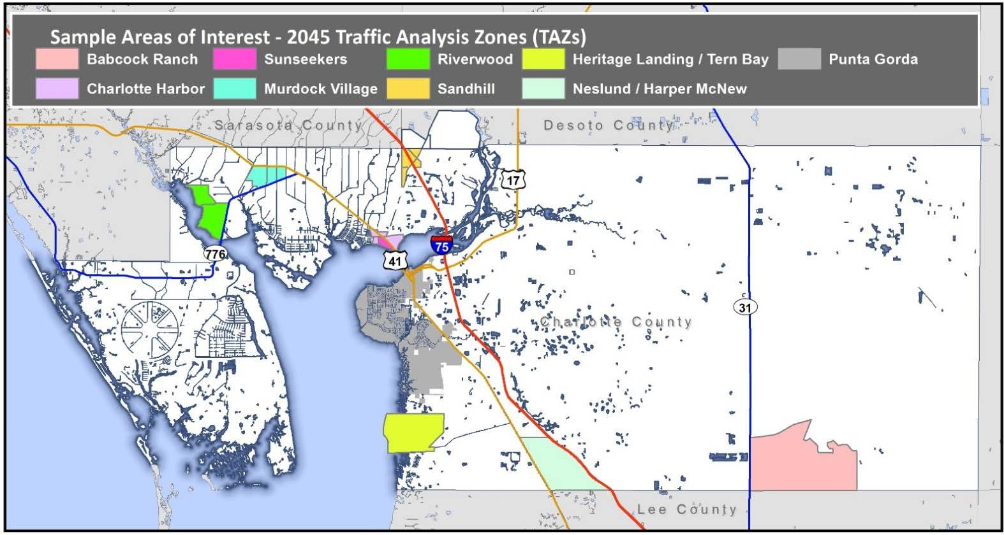

Figure 3-3: Growth in Population and 2045 Forecast
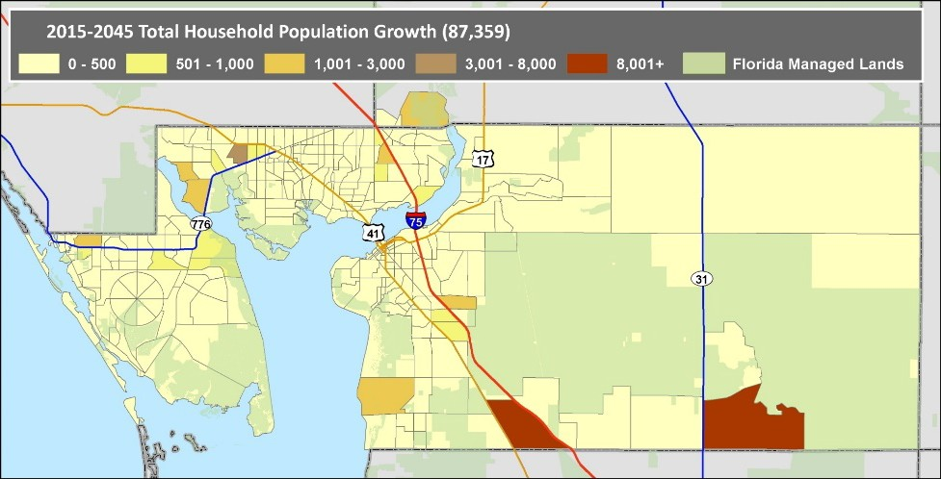
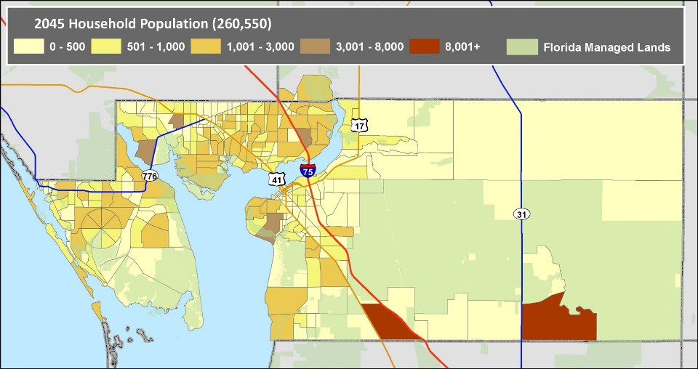

Figure 3-4: Growth in Employment and 2045 Forecast
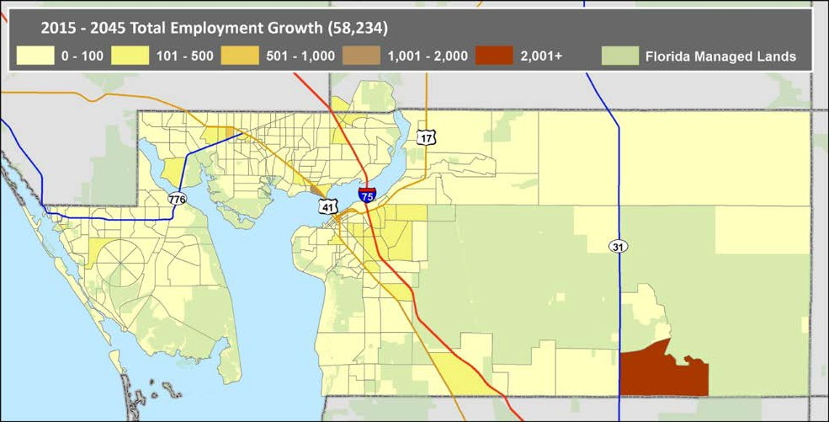
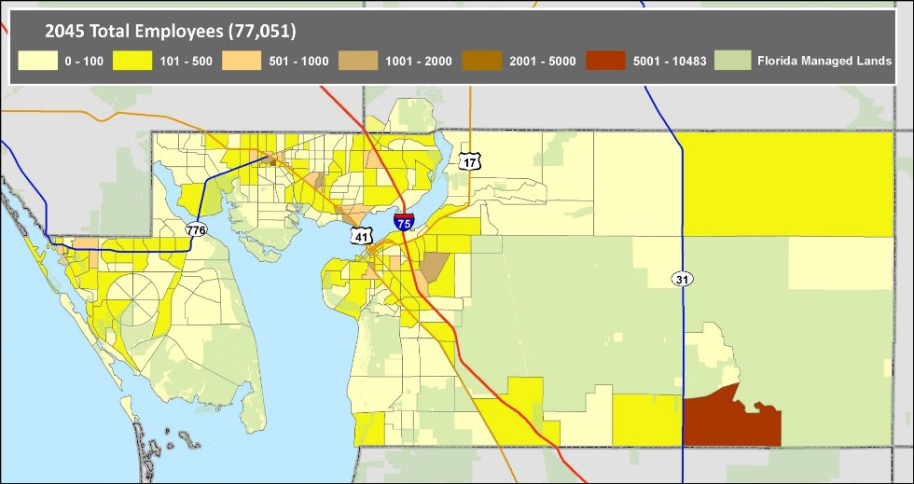

Section 4: Implementing the Route to 2045

Defining the Needs
The Needs Assessment identified projects to support the ultimate vision of mobility to meet the future transportation demands for the Charlotte County-Punta Gorda MPO planning area, without regard for cost and available funding. An extensive process was conducted to identify projects that are needed in the future. This included a comprehensive review of the projects identified in the 2040 LRTP; review of the recently completed Charlotte County Transit Development Plan and the Charlotte County Regional Bicycle/Pedestrian Master Plan; working with Charlotte County- Punta Gorda MPO, Charlotte County, DeSoto County, and City of Punta Gorda staff; working with stakeholders, including the MPO Board; and working with the public.
Determining the transportation projects and strategies to include in the Route to 2045 Cost Feasible LRTP was based on evaluation of the prioritized needs and availability of transportation revenues. This section provides a listing of the major projects identified during the Needs Assessment phase of the LRTP.

Existing and Committed Transportation Conditions
Prior to developing the list of projects needed to ensure mobility in the future, hot spot locations were identified to understand where deficiencies, safety and operational concerns exist. To identify these locations, analysis of transportation data was reviewed against the existing transportation system and projects committed to be completed over the next five years. Figure 4-1 illustrates the transportation projects currently underway and funded for construction through 2025.

Congestion and Safety
Analysis of roadway conditions including a review of traffic congestion and crashes. Figure 4-2 highlights the locations within Charlotte County where congestion was identified, and hot spot crash locations based on data report from 2014 to 2018. Locations along US 41, within the City of Punta Gorda and the I- 75 at King Highway interchange appear as the congested and high-crash locations.

Traffic Signals and Intelligent Transportation Systems
An essential component to provide for safe and effective operation of a transportation system includes the traffic control devices that impact capacity of the roadway network but can improve safety and efficiency through traffic signal timing and incident management via adjustments made by the Charlotte County Traffic Management Center (TMC) staff. As a study prioritized by the MPO and funded for completion next year, the ITS Master Plan will provide guidance for relevant ITS technologies and discuss project implementation priorities throughout the County. ITS technology projects that should be considered within the ITS Master Plan should provide congestion mitigation and safety improvements.
These types of projects include but are not limited to dynamic messaging, advanced traveler information systems, integrated corridor management, transit signal priority, and support for operational strategies and improvements. Figure 4-3 provides an overview of the 100 traffic signals currently communicating with the TMC, 13 isolated signals that are not connected and the location of 65 Closed Circuit Television (CCTV) cameras used for traffic monitoring.

2045 Long Range Transportation Plan | Executive Summary Report
4-2

Figure 4-1: Existing and Committed Number of Lanes
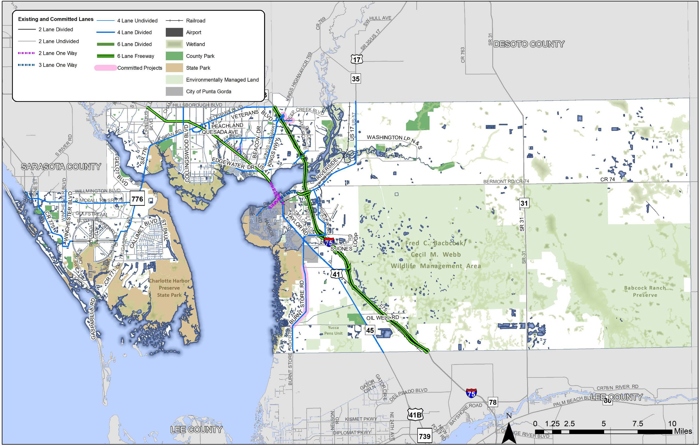

2045 Long Range Transportation Plan | Executive Summary Report
4-3

Figure 4-2: Congested and High Crash Locations
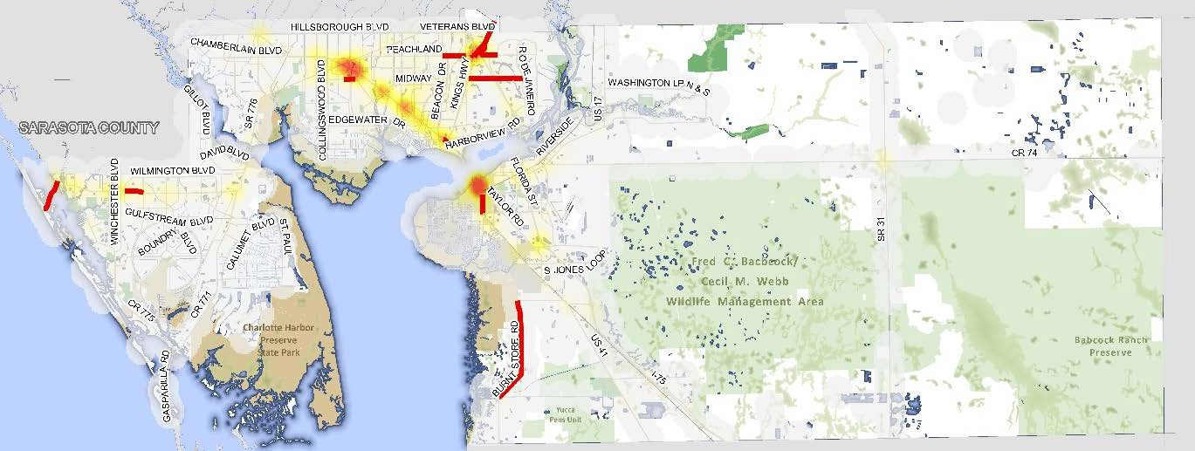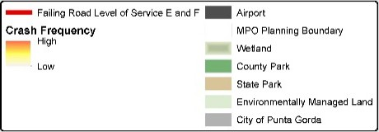
Figure 4-3: Traffic Signals and ITS
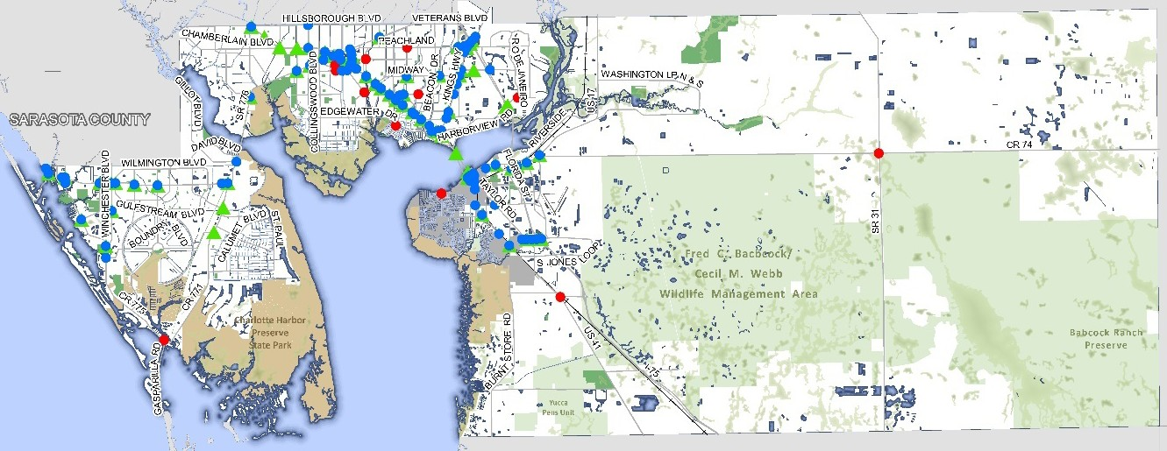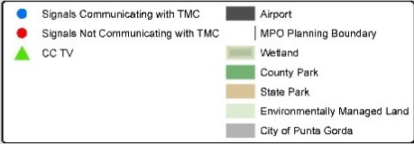

Priority Intersection and Corridor Studies
To improve how traffic operates and the safety of those using the transportation system, strategies for improving the function of roads or reducing travel demand were identified. The MPO has prioritized improvements at intersections and along key corridors consistent with the crash and congestion analysis. Figure 4-4 shows the specific intersection along SR 776, US 41 and US 17 at SR 31 where the MPO has prioritized funding for intersection improvements.
FDOT has conducted the US 41 Corridor Vision Plan which includes a series of mobility and safety related strategies for the corridor that align with the community’s vision. SR 776 serves as the only connection in Charlotte County across the Myakka River. The MPO has identified this critical transportation corridor as a priority. Future study and evaluation of this corridor will provide the MPO and FDOT with the specific strategies and locations for future transportation investments.

2045 Long Range Transportation Plan | Executive Summary Report
4-4

Figure 4-4: CMP Intersections and Corridors
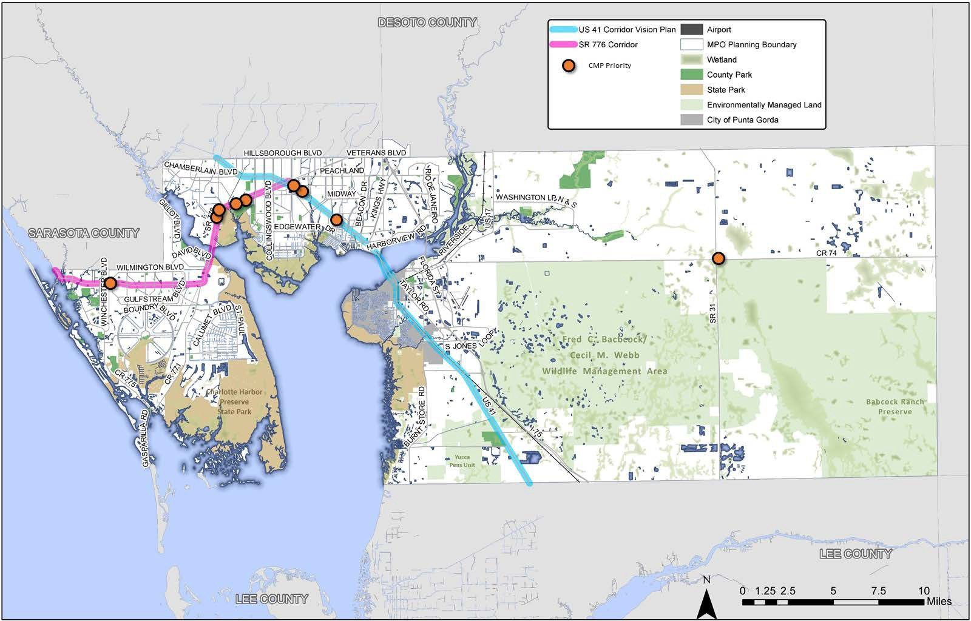

2045 Long Range Transportation Plan | Executive Summary Report
4-5

Transit Needs
The analyses of public input and technical data, together with the baseline conditions assessment and performance reviews conducted previously as part of the Charlotte Rides Transit Development Plan were used in developing the list of transit alternatives by identifying areas that have characteristics shown to be supportive of transit.
Several needs were developed for the Charlotte Rides 10-Year TDP, as summarized below.
The Charlotte Rides implementation plan presented in Table 4-1 outlines improvements that are included in the 10-year Cost-Efficient Plan, as well as unfunded needs. The table also shows the implementation years, as applicable, operating and capital costs associated with the improvements, and type of anticipated funding sources for the Plan.
It should be noted that the schedule shown in the table does not preclude the opportunity to delay or advance any projects. As priorities change, funding assumptions do not materialize, or more funding becomes available, this project implementation schedule should be adjusted. The Transit Needs and service areas are shown in Figure 4-5.

2045 Long Range Transportation Plan | Executive Summary Report
4-6

Figure 4-5: Transit Service Needs
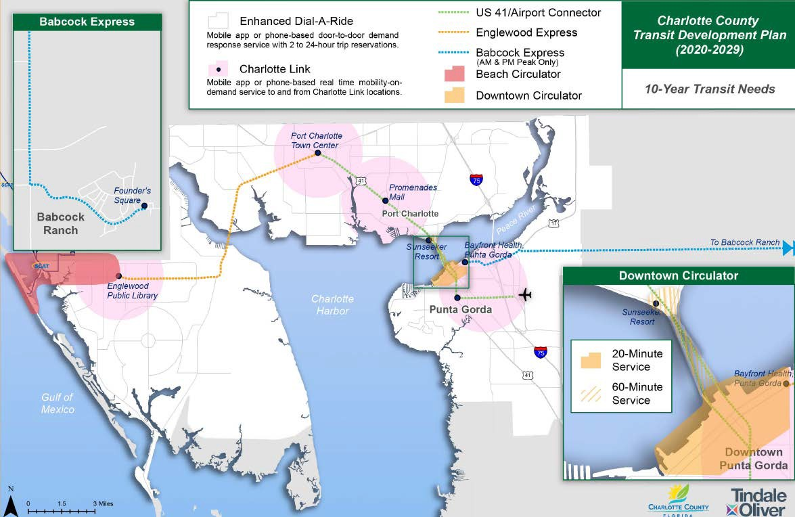

Table 4-1: Transit Needs Projects and Costs

Improvement | Implement.  Year | Annual Operating  Cost (2019$) | Capital Costs (2019$) | Potential Revenue  Source
Enhance/Add Mobility On Demand
Enhanced Dial‐A‐Ride Service | 2022 | $ 2,522,507 | $ 3,718,000 | Existing
Charlotte Link Service | 2024 | $ 442,080 | $ ‐ | Existing
Add Technology‐Based Bus
Babcock Express | 2026 | $ 127,746 | $ 72,000 | Existing/ FDOT
US 41/Airport Connector | 2028 | $ 447,110 | $ 144,000 | Existing/  FDOT
Englewood Express | Unfunded | $ 230,694 | $ 72,000 | n/a
Downtown Circulator | Unfunded | $ 230,694 | $ 72,000 | n/a
Beach Circulator | Unfunded | $ 269,769 | $ 72,000 | n/a
Infrastructure/Technology/Other
Bus Stop Infrastructure Program ‐  Signs, Benches, Shelters | 2020‐29 | $ ‐ | $ 570,000 | Existing
Marketing/Awareness Campaign | 2020‐29 | $ ‐ | $ 150,000 | Existing
Real‐Time Bus Locator App &  Reservation Technology Upgrades | 2020‐29 | $ ‐ | $ 350,000 | Existing
New Administration and Operations Facility | 2021‐22 | $ ‐ | $ 2,593,000 | Federal Grant
Transit Planning Services/2024 TDP  Major Update | 2024 | $ ‐ | $ 200,000 | Existing
Employee Bus Pass/Subsidy  Programs | 2020‐29 | n/a | n/a | n/a
Promote TDM Strategies | 2020‐29 | n/a | n/a | n/a
Service Performance Monitoring  Program | 2020‐29 | n/a | n/a | n/a
Notes:
      - No new additional local funding is assumed.
      - Annual revenues from federal, state, and local sources are based on the CCT’s 2020 Budget and discussions with CCT staff.
      - Total of $2.5 million in Federal Section 5339 grants is assumed to find the new administration and operations facility

Bicycle/Pedestrian Needs
In 2018, the MPO Board adopted the first-ever Charlotte County Regional Bicycle and Pedestrian Master Plan. The overall goal of the recommendations from this study was to create a connected network of walking and cycling facilities. Since adoption of the Master Plan, the MPO, FDOT, Charlotte County and the City of Punta Gorda have made transportation related decisions with this goal in mind. The needs shown in Figure 4-6 and listed in Table 4-2 were developed in coordination with a technical Project Steering Committee and through public comments received during the development of the Bicycle/Pedestrian Master Plan.
Highlights of the proposed multi-use trail, pedestrian, and bicycle needs include the following:
  - Expansion of the bicycle network, including all roads being improved on the highway needs plan (except I-75), as road improvements would include paved shoulders with the intent to put bicycle facilities in place concurrently
  - Expansion of the sidewalk network associated with new roadway construction or road improvements constructed; building sidewalks in the urbanized area ensures that more county residents have access to sidewalk facilities, and it promotes safety and transit usage
  - Expansion of the conceptual multi-use trails; trails could be selected as revenues become available.

2045 Long Range Transportation Plan | Executive Summary Report
4-9

Figure 4-6: Bicycle/Pedestrian Master Plan Needs
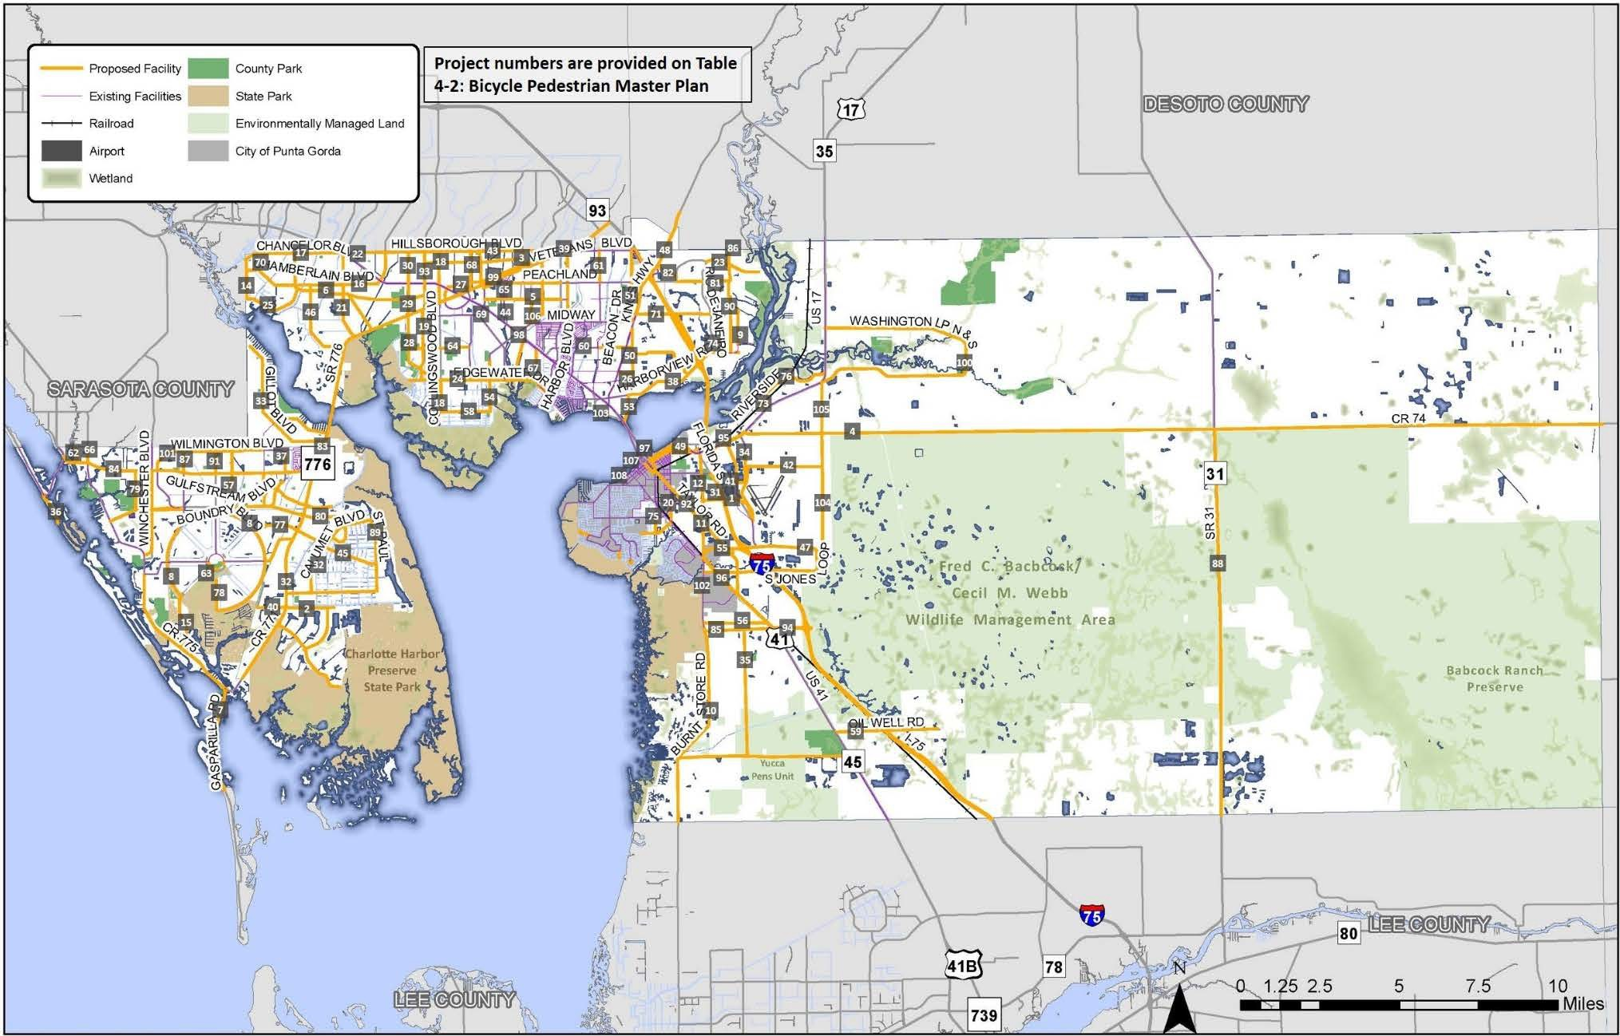

2045 Long Range Transportation Plan | Executive Summary Report
4-10
Table 4-2: Bicycle Pedestrian Master Plan

ID Number | Facility |  | ID Number | Facility
BP 1 | Airport Rd |  | BP 55 | North Jones Loop Rd
BP 2 | Appleton Blvd |  | BP 56 | Notre Dame Blvd
BP 3 | Atwater St |  | BP 57 | Oceanspray Blvd
BP 4 | Bermont Rd (CR 74) |  | BP 58 | Ohara Blvd
BP 5 | Birchcrest Blvd |  | BP 59 | Oil Well Rd
BP 6 | Biscayne Dr |  | BP 60 | Olean Blvd
BP 7 | Boca Grande Causeway |  | BP 61 | Orlando Blvd
BP 8 | Boundary Blvd |  | BP 62 | Oxford Dr
BP 9 | Broadpoint Dr |  | BP 63 | Parade Circle
BP 10 | Burnt Store Rd (segment 1) |  | BP 64 | Pear St/Wintergarden Ave
BP 11 | Burnt Store Rd (segment 2) |  | BP 65 | Peachland Blvd
BP 12 | Burnt Store Rd Ext. |  | BP 66 | Pine St
BP 13 | Calumet Blvd |  | BP 67 | Port Charlotte Blvd
BP 14 | Campbell St |  | BP 68 | Prineville St
BP 15 | Cape Haze Dr |  | BP 69 | Quesada Avenue
BP 16 | Chamberlain Blvd |  | BP 70 | Ramblewood St
BP 17 | Chancellor Blvd |  | BP 71 | Rampart Blvd
BP 18 | Collingswood Blvd |  | BP 72 | Ravenswood Blvd
BP 19 | Como St |  | BP 73 | Regent Rd
BP 20 | Cooper St |  | BP 74 | Rio De Janerio Ave
BP 21 | Cornelius Blvd |  | BP 75 | Rio Villa Dr
BP 22 | Dahlgren Ave Ext. |  | BP 76 | Riverside Dr
BP 23 | Deep Creek Blvd |  | BP 77 | Rotonda Blvd East
BP 24 | Edgewater Dr |  | BP 78 | Rotonda Blvd South
BP 25 | Eisenhower Dr |  | BP 79 | San Casa Dr
BP 26 | Elmira Blvd |  | BP 80 | San Domingo Blvd
BP 27 | Enterprise Dr/Paulson Dr |  | BP 81 | Sandhill Blvd
BP 28 | Flamingo Blvd (segment 1) |  | BP 82 | Sandhill Blvd Bypass (New Road)
BP 29 | Flamingo Blvd Ext. |  | BP 83 | S McCall Rd/El Jobean Rd (SR 776)
BP 30 | Flamingo Blvd (segment 2) |  | BP 84 | S McCall Rd (SR 776)
BP 31 | Florida St |  | BP 85 | Scham Rd
BP 32 | Gasparilla Rd (CR 771) |  | BP 86 | Seasons Dr
BP 33 | Gillot Blvd |  | BP 87 | Spinnaker Blvd
BP 34 | Golf Course Blvd |  | BP 88 | SR 31
BP 35 | Green Gulf Blvd |  | BP 89 | St Paul Dr
BP 36 | Gulf Blvd |  | BP 90 | Sulstone Dr/Highlands Rd
BP 37 | Gulfstream Blvd |  | BP 91 | Sunnybrook Blvd
BP 38 | Harbor View Rd |  | BP 92 | Taylor Rd
BP 39 | Harbor Blvd Ext. |  | BP 93 | Toledo Blade Blvd
BP 40 | Harness Rd |  | BP 94 | Tucker's Grade
BP 41 | Henry St |  | BP 95 | US 17
BP 42 | Henry St (New Road) |  | BP 96 | US 41 (segment 1)
BP 43 | Hillsborough Blvd |  | BP 97 | US 41 (Replace Bridge)
BP 44 | Hinton St |  | BP 98 | US 41 (segment 2)
BP 45 | Ingram Blvd |  | BP 99 | Veterans Boulevard
BP 46 | Jacobs St |  | BP 100 | Washington Loop Rd
BP 47 | Jones Loop Rd |  | BP 101 | Wilmington Rd
BP 48 | Kings Highway |  | BP 102 | Burnt Store Road (Segment 3)
BP 49 | Lavilla Rd |  | BP 103 | Charlotte Harbor CRA
BP 50 | Loveland Blvd (segment 1) |  | BP 104 | Grove Boulevard
BP 51 | Loveland Blvd (segment 2) |  | BP 105 | Grove Boulevard Extension
BP 52 | Marathon Blvd |  | BP 106 | Harbor Blvd
BP 53 | Melbourne St |  | BP 107 | Marion Avenue
BP 54 | Midway Blvd |  | BP 108 | Olympia Avenue

2045 Long Range Transportation Plan | Executive Summary Report
4-11

Roadway Needs
Identification of roadway needs for the 2045 LRTP started with a review of the 2040 LRTP, adopted by the MPO Board in 2015. Through public outreach and review of projected travel demand an updated list of needs through 2045 was developed. The list of needs was presented to the MPO Board in May 2020 and the draft needs were approved for continued review and development.
Roadway needs through 2045 have been identified based on future travel demand. Included in the LRTP needs are roadway widening projects and intersection improvements to address traffic flow and operations. Future roadway corridors and potential interchanges along I-75 were also identified.
The District 1 Regional Planning Model (D1RPM), was utilized for assessing and determining the roadway needs based on the future expected traffic demand. Regional coordination and testing of alternatives were conducted with the Sarasota/Manatee MPO, Lee County MPO, Heartland Regional Transportation Planning Organization (TPO), Collier MPO, and Polk TPO. The Regional Planning Model uses a traditional four-step process (see Figure 4-7) to forecast traffic demand and transportation choice options for the future 2045 conditions.
Figure 4-7: Four-Step Travel Demand Modeling Process

(1) Trip Generation - How many trips will I make?
(2) Trip Distribution - where will my trip take me?
(3) Mode Choice - How will I travel?
(4) Route Choice - Which roads will I travel on?

A listing of the roadway needs is found in Table 4-3 followed by Figure 4-8 showing the limits of the projects identified in the needs.

Table 4-3: Roadway Needs List ($ Millions, 2019 Present Day Cost)

Map ID | Facility | From | To | Existing Lanes | Length (Miles) | Project Description | PD&E / PE  Cost | ROW Cost | CST Cost | Committed Funding (2020-2025) | Future Funding Needed  (2026-2045)
1 | Airport Road | Taylor Rd | Piper Road | 2 | 1.75 | Widen 2 to 4 lanes | $4.10 | $4.71 | $20.50 |  | $29.31
2 | Bermont Rd (CR 74) | US 17 | Strasse Blvd | 2 | 2.69 | Widen 2 to 4 lanes | $4.67 | $8.86 | $23.31 |  | $36.84
3 | Bermont Rd (CR 74) | Strasse Blvd | SR 31 | 2 | 12.15 | Widen 2 to 4 lanes | $21.06 | $40.03 | $105.31 |  | $166.40
4 | Burnt Store Rd | Zemel Rd | Scham Rd | 2 | 4.17 | Widen 2 to 4 lanes | Fully Funded |  |  |  | $0.00
5 | Burnt Store Rd | N Jones Loop | Taylor Rd | 2 | 0.98 | Widen 2 to 4 lanes | $1.72 | $1.32 | $11.48 |  | $14.52
6 | Burnt Store Rd Extension | Taylor Rd | Florida St @ US 17 | 0 | 2.12 | New 4-lane | $7.83 | $34.25 | $39.16 |  | $81.25
7 | Edgewater Dr (Phase 3) | Midway Blvd | Collingswood Blvd | 2 | 1.54 | Widen 2 to 4 lanes | $2.20 | $0.00 | $25.00 | $2.20 | $25.00
8 | Edgewater Dr (Phase 4) | Collingswood Blvd | Samantha Ave | 0 | 1.30 | Roadway realignment and new bridge | $2.10 | $0.00 | $23.00 | $25.10 | $0.00
9 | Edgewater Dr / Flamingo (Phase  5) | Collingswood Blvd | SR 776 | 2 | 2.62 | Widen 2 to 4 lanes | $1.00 | $0.00 | $20.00 | $1.00 | $20.00
10 | Flamingo Blvd | SR 776 | US 41 | 2 | 0.97 | Widen 2 to 4 lanes | $2.27 | $3.38 | $11.36 |  | $17.02
11 | CR771 | Appleton Blvd | Rotunda Blvd East | 2 | 1.00 | Widen 2 to 4 lanes | $2.34 | $0.00 | $11.71 |  | $14.06
12 | Hillsborough Blvd/Raintree Blvd | Veterans Blvd |  | 0 | 0.10 | New 2-lane connection | $0.32 | $0.89 | $1.60 |  | $2.81
13 | Henry Street (New Road) | Golf Course Boulevard | Loop Connector | 0 | 3.90 | New 2-lane | $12.49 | $0.00 | $62.46 |  | $74.95
14 | Hillsborough Blvd | Cranberry Blvd | Toledo Blade Blvd | 2 | 1.08 | Widen 2 to 4 lanes | $2.53 | $3.76 | $12.65 |  | $18.95
16 | I-75 | Near Oil Well Road |  |  |  | Future Interchange | $0.00 | $9.80 | $164.53 |  | $174.33
17 | I-75 (Sarasota County) | @ Yorkshire Street |  |  |  | Future Interchange | $0.00 | $9.80 | $164.53 |  | $174.33
18 | Kings Hwy | Sandhill Blvd | Desoto County line | 2 | 0.79 | Widen 2 to 4 lanes | $1.85 | $1.38 | $9.25 |  | $12.48
19 | Loveland Blvd | Westchester Blvd | Kings Hwy | 2 | 7.97 | Widen 2 to 4 lanes | $18.67 | $27.77 | $93.37 |  | $139.82
20a | Loveland Blvd | Midway Blvd | Peachland Blvd | 2 | 1.22 | Widen 2 to 4 lanes | $2.86 | $4.25 | $14.29 |  | $21.40
20b | Loveland Blvd | Peachland Blvd | Veterans Blvd | 2 | 0.97 | Widen 2 to 4 lanes | $2.27 | $3.38 | $11.36 |  | $17.02
21 | N Jones Loop | Burnt Store Rd | Piper Road | 4 | 3.78 | Widen 4 to 6 lanes | $7.92 | $5.99 | $44.65 | $1.22 | $57.34
22 | Peachland | Cochran Blvd | Harbor Blvd | 2 | 2.75 | Widen 2 to 4 lanes | $6.44 | $9.58 | $32.22 |  | $48.24
23 | Prineville Dr | Paulson Dr | Hillsborough Blvd | 2 | 2.42 | Widen 2 to 4 lanes | $5.67 | $8.43 | $28.35 |  | $42.45
24 | Quesada Ave | Cochran Blvd | Harbor Blvd | 2 | 2.41 | Widen 2 to 4 lanes | $5.65 | $4.20 | $28.23 |  | $38.08
25 | Rampart Blvd | Victoria Estates St | Rio De Janeiro Ave | 2 | 1.24 | Widen 2 to 4 lanes | $2.91 | $2.16 | $14.53 |  | $19.59
26 | San Casa Dr | CR 775 | SR 776 | 2 | 2.09 | Widen 2 to 4 lanes | $4.90 | $7.28 | $24.48 |  | $36.66
29 | S McCall Road (SR 776) | Crestview Dr | CR 775 | 4 | 1.47 | Widen 4 to 6 lanes | $3.47 | $4.19 | $17.37 |  | $25.03
30 | SR 776 | CR 775 | Spinnaker Blvd | 4 | 3.08 | Widen 4 to 6 lanes | $7.46 | $4.88 | $36.38 | $2.00 | $46.72
30a | SR 776 | CR 775 | Spinnaker Blvd | 4 | 3.08 | Add turn lanes at major  intersections | $2.72 | $8.07 | $13.62 |  | $24.42
 | Potential Candidate Intersections: Oriole, Gulfstream, Spinnaker |  |  |  |  |  |  |  |  |  | $0.00
31 | SR 776 | Spinnaker Blvd | CR 771 (Gasparilla Rd) | 4 | 4.10 | Widen 4 to 6 lanes | $9.69 | $6.49 | $48.43 |  | $64.62
31a | SR 776 | Spinnaker Blvd | CR 771 (Gasparilla Rd) | 4 | 4.10 | Add turn lanes at major intersections | $4.54 | $13.45 | $22.70 |  | $40.70
 | Potential Candidate Intersections: Sunnybrook, Oceanspray, David, Gulfstream, Coliseum
32 | SR 776 | CR 771 (Gasparilla Rd) | Flamingo Blvd | 4 | 6.42 | Widen 4 to 6 lanes | $15.17 | $10.17 | $75.84 |  | $101.18

Map ID | Facility | From | To | Existing Lanes | Length (Miles) | Project Description | PD&E / PE  Cost | ROW Cost | CST Cost | Committed Funding (2020-2025) | Future Funding Needed  (2026-2045)
32a | SR 776 | Myakka River Bridge | EB Replacement / Widening | 4 | 0.25 | Widen/Replace EB Bridge | $5.86 | $0.00 | $29.29 |  | $35.14
32b | SR 776 | CR 771 (Gasparilla Rd) | Flamingo Blvd | 4 | 6.42 | Add turn lanes at major  intersections | $1.82 | $5.38 | $9.08 |  | $16.28
 | Potential Candidate Intersections: Hollis, Biscayne
33 | SR 776 | Flamingo Blvd | Murdock Cir | 4 | 1.26 | Widen 4 to 6 lanes | $3.02 | $0.00 | $15.12 |  | $18.15
33a | SR 776 | Flamingo Blvd | Murdock Cir | 4 | 1.26 | Add turn lanes at major  intersections | $0.91 | $2.69 | $4.54 |  | $8.14
 | Potential Candidate Intersections: Toledo Blade Blvd
34 | SR 31 | Lee County Line | North of Cook Brown Rd | 2 | 2.78 | Widen 2 to 4 lanes | $3.05 | $10.61 | $42.82 |  | $56.48
35 | SR 31 | North of Cook Brown Rd | CR 74 | 2 | 9.38 | Widen 2 to 4 lanes | $16.26 | $18.03 | $81.30 |  | $115.59
36 | Taylor Rd | US 41 SB | Jones Loop Rd | 2 | 1.62 | Widen 2 to 4 lanes | $3.80 | $5.65 | $18.98 |  | $28.42
37 | Taylor Rd | N Jones Loop Rd | Airport Rd | 2 | 1.98 | Widen 2 to 4 lanes | $4.64 | $6.90 | $23.20 |  | $34.73
38 | Taylor Rd | Airport Rd | US 41 | 2 | 1.31 | Widen 2 to 4 lanes | $3.07 | $4.57 | $15.35 |  | $22.98
39a | Toledo Blade Blvd (CR 39) | SR 776 | Whitney Avenue | 2 | 0.53 | Widen 2 to 4 lanes | $0.00 | $0.00 | $6.07 |  | $6.07
39b | Toledo Blade Blvd (CR 39) | SR 776 | Whitney Avenue | 4 | 0.53 | Widen 4 to 6 lanes | $1.25 | $0.00 | $6.26 |  | $7.51
40 | Toledo Blade Blvd (CR 39) | Whitney Avenue | US 41 | 4 | 0.77 | Widen 4 to 6 lanes | $1.82 | $0.00 | $9.10 |  | $10.92
41 | Toledo Blade Blvd (CR 39) | US 41 | Hillsborough Blvd | 4 | 1.00 | Widen 4 to 6 lanes | $2.36 | $0.00 | $11.81 |  | $14.18
42 | Tuckers Grade | US 41 SB | I75 | 4 | 2.34 | Widen 4 to 6 lanes | $5.62 | $3.71 | $28.08 |  | $37.41
43 | US 17 | Copley Ave | CR 74 | 4 | 1.53 | Widen 4 to 6 lanes | $3.05 | $0.00 | $7.75 |  | $10.80
44 | US 41 | Notre Dame Blvd | Burnt Store Rd | 4 | 5.81 | Widen 4 to 6 lanes | $13.95 | $0.00 | $69.73 |  | $83.67
45a | US 41 | Bridge | Peace River | 4 | 2.44 | Bridge Replacement | $78.92 | $0.00 | $394.62 |  | $473.55
45b | US 41 | Bridge | Peace River | 4 | 2.44 | Bridge Expansion | $15.64 | $0.00 | $78.22 |  | $93.86
46 | Veterans Blvd | Toledo Blade / Cochran Blvd | Murdock Cir E | 4 | 1.40 | Widen 4 to 6 lanes | $3.36 | $2.66 | $16.80 |  | $22.82
47 | Veterans Blvd | Murdock Cir E | Harbor Blvd | 4 | 2.65 | Widen 4 to 6 lanes | $6.26 | $0.00 | $31.31 |  | $37.57
47.5 | Veterans Blvd | Harbor Blvd | Hillsborough Blvd | 4 | 0.29 | Widen 4 to 6 lanes | $0.64 | $0.00 | $3.19 |  | $3.83
49 | Grove Boulevard | North Jones Loop Road | CR 74 | 2 | 3.84 | Widen 2 to 4 lanes | $9.00 | $0.00 | $44.99 |  | $53.98
50 | Grove Boulevard Extension | CR 74 | US 17 | 0 | 1.62 | New 4-lane | $5.99 | $0.00 | $29.93 |  | $35.91
51 | Harbor View Road | Melbourne St | I-75 | 2 | 2.61 | Widen 2 to 4 lanes | $4.02 | $9.79 | $33.41 | $13.81 | $33.41
52 | Harbor View Road | I-75 | Rio De Janeiro Avenue | 2 | 0.61 | Widen 2 to 4 lanes | $1.43 | $0.00 | $7.15 |  | $8.58
53 | Sandhill Blvd Bypass | Kings Hwy | Sandhill Blvd | 0 | 1.10 | New 2-lane | $3.52 | $0.00 | $17.62 |  | $21.14
54 /  55 | Marion Avenue / Marion Avenue | US 41 | Marlympia Way | 3 | 1.23 | Road Diet - resurfacing and striping | $1.48 | $0.00 | $7.42 | $0.29 | $8.61
56 | Sandhill Blvd | Kings Hwy | Deep Creek Blvd | 2 | 1.26 | Widen 2 to 4 lanes | $2.95 | $0.00 | $14.76 |  | $17.71
57 | Fruitland Ave / Avenue of the  Americas | CR 775 | Gulfstream Blvd | 0 | 1.46 | New 2-lane | $4.68 | $6.48 | $23.38 |  | $34.53
58 | San Domingo Blvd | Gulfstream Blvd | SR 771 | 0 | 1.10 | New 2-lane | $3.52 | $4.88 | $17.62 |  | $26.02
59 | US 41 Corridor Vision Plan |  |  | 4/6 |  | Corridor & Safety Improvements |  | To be determined |  |  | $0.00
60 | SR 31 | @ CR 74 |  | 2 | 0.24 | Roundabout | $0.00 | $0.64 | $0.71 | $0.64 | $0.71

Map ID | Facility | From | To | Existing Lanes | Length (Miles) | Project Description | PD&E / PE  Cost | ROW Cost | CST Cost | Committed Funding (2020-2025) | Future Funding Needed  (2026-2045)
61 | SR 776 | @ Flamingo Blvd |  | 4 | 0.00 | Intersection - turn lanes | $0.00 | $0.00 | $1.46 | $1.46 | $0.00
62 | US 41 | @ Easy Street |  | 4 | 0.00 | Intersection - turn lanes | $0.68 | $0.00 | $4.55 |  | $5.23
63 | US 41 | @ Forrest Nelson |  | 4 | 0.00 | Intersection - turn lanes | $0.68 | $0.00 | $4.55 |  | $5.23
64 | SR 776 | @ Jacobs St |  | 4 | 0.00 | Intersection - turn lanes | $0.68 | $0.00 | $4.55 |  | $5.23
65 | SR 776 | @ Carousel Plaza |  | 4 | 0.00 | Intersection - turn lanes | $0.68 | $0.00 | $4.55 |  | $5.23
66 | SR 776 | @ Charlotte Sports Park |  | 4 | 0.00 | Intersection - turn lanes | $0.15 | $0.00 | $1.01 | $0.15 | $1.01
67 | I-75 | at CR 769/Kings Hwy |  |  |  | Interchange Modifications | $6.50 | $0.00 | $56.93 |  | $63.43
68 | I-75 | at CR 776/Harbor View |  |  |  | Interchange Modifications | $6.50 | $0.00 | $56.93 |  | $63.43
69 | I-75 | at US 17/SR35 |  |  |  | Interchange Modifications | $7.50 | $0.00 | $122.60 |  | $130.10
70 | I-75 | at North Jones Loop Rd |  |  |  | Interchange Modifications | $6.50 | $0.00 | $56.93 |  | $63.43
71 | ITS Master Plan Implementation |  |  |  |  | Technology and Traffic Signal Improvements |  | To be determined |  |  | $0.00
78 | Green Gulf Blvd Extension | Burnt Store Road | US 41 | 0/2 | 2.45 | New / Upgraded 2-lane | $4.53 | $2.41 | $22.66 |  | $29.60
79 | Green Gulf Blvd Extension | Zemel Road | Green Gulf Blvd | 0/2 | 4.00 | New / Upgraded 2-lane | $7.40 | $3.93 | $36.99 |  | $48.32

Notes:
    - Project Costs shown in current year format based on 2019 project costs]
    - PD&E/PE are product support phases for Project Development & Environment phase and Preliminary Engineering phase
    - ROW is Right-of-Way costs associated with land acquisition
    - CST is the Construction cost for completing the identified project
    - Existing Funding is included in the MPO’s 2020/2021 – 2024/2025 Transportation Improvement Program.

Figure 4-8: Roadway Needs
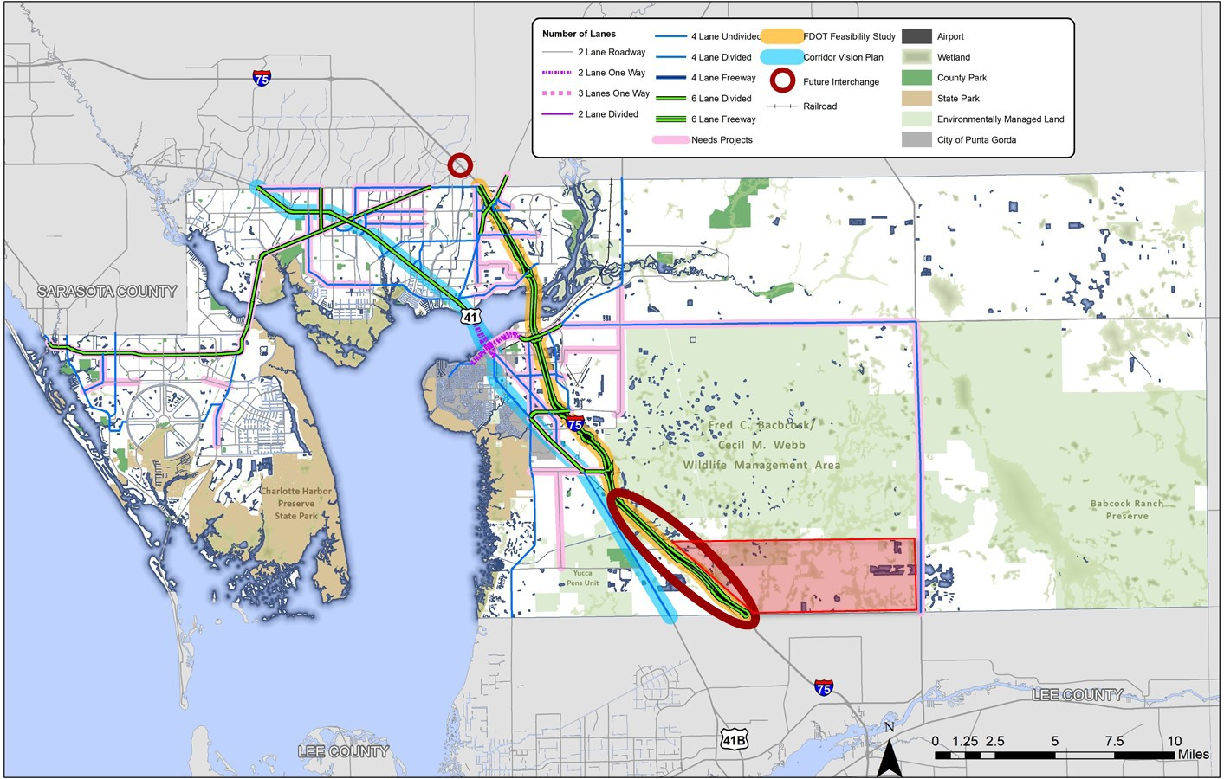

2045 Long Range Transportation Plan | Public Review Summary Report
4-16

Environmental Mitigation
Transportation projects can significantly impact many aspects of the environment including wildlife and their habitats, wetlands, and groundwater resources. In situations where impacts cannot be completely avoided, mitigation or conservation efforts are required. Environmental mitigation is the process of addressing damage to the environment caused by transportation projects or programs. The process of mitigation is best accomplished through enhancement, restoration, creation and/or preservation projects that serve to offset unavoidable environmental impacts. In the State of Florida, environmental mitigation for transportation projects is completed through a partnership between the MPO, FDOT, and regulatory agencies, such as Water Management Districts and the Florida Department of Environmental Protection. Steps towards environmental mitigation include the following.
- Avoidance of impacts altogether
- Minimizing a proposed activity/project size or its involvement
- Repairing, rehabilitating, or restoring the affected environment
- Reducing or eliminating impacts over time through preservation and maintenance
- Compensating for environmental impacts by providing appropriate or alternate environmental resources of equivalent or greater value, on or off-site.
Table 4-4 outlines potential environmental mitigation opportunities which can be considered when addressing environmental impacts from future projects listed in the LRTP.
Table 4-4: Potential Environmental Mitigation Strategies

Resource / Impacts | Potential Mitigation Strategy
Wetlands and Water Resources | - Restore degraded wetlands  - Create new wetland habitats  - Enhance or preserve existing wetlands  - Improve storm water management  - Purchase credits from a mitigation bank
Forested and other natural areas | - Use selective cutting and clearing  - Replace or restore forested areas  - Preserve existing vegetation
Habitats | - Construct underpasses, such as culverts  - Design measures to minimize fragmenting animal habitats
Streams | - Stream restoration  - Vegetative buffer zones  - Strict erosion and sedimentation control measures
Threatened or Endangered Species | - Preservation  - Enhancement or restoration of degraded habitat  - Creation of new habitats  - Establish buff areas around existing habitat
As a coastal community in Florida, much of Charlotte County is low-lying and vulnerable to flooding and storm surge. Figure 4-9 illustrates how the transportation system in Charlotte County is predominately within the 100-Year Flood Plain. This map also illustrates the environmental and conservation areas within the County that conflict with existing roadways.

2045 Long Range Transportation Plan | Public Review Summary Report
4-17

Figure 4-9: Charlotte County Environmental Features
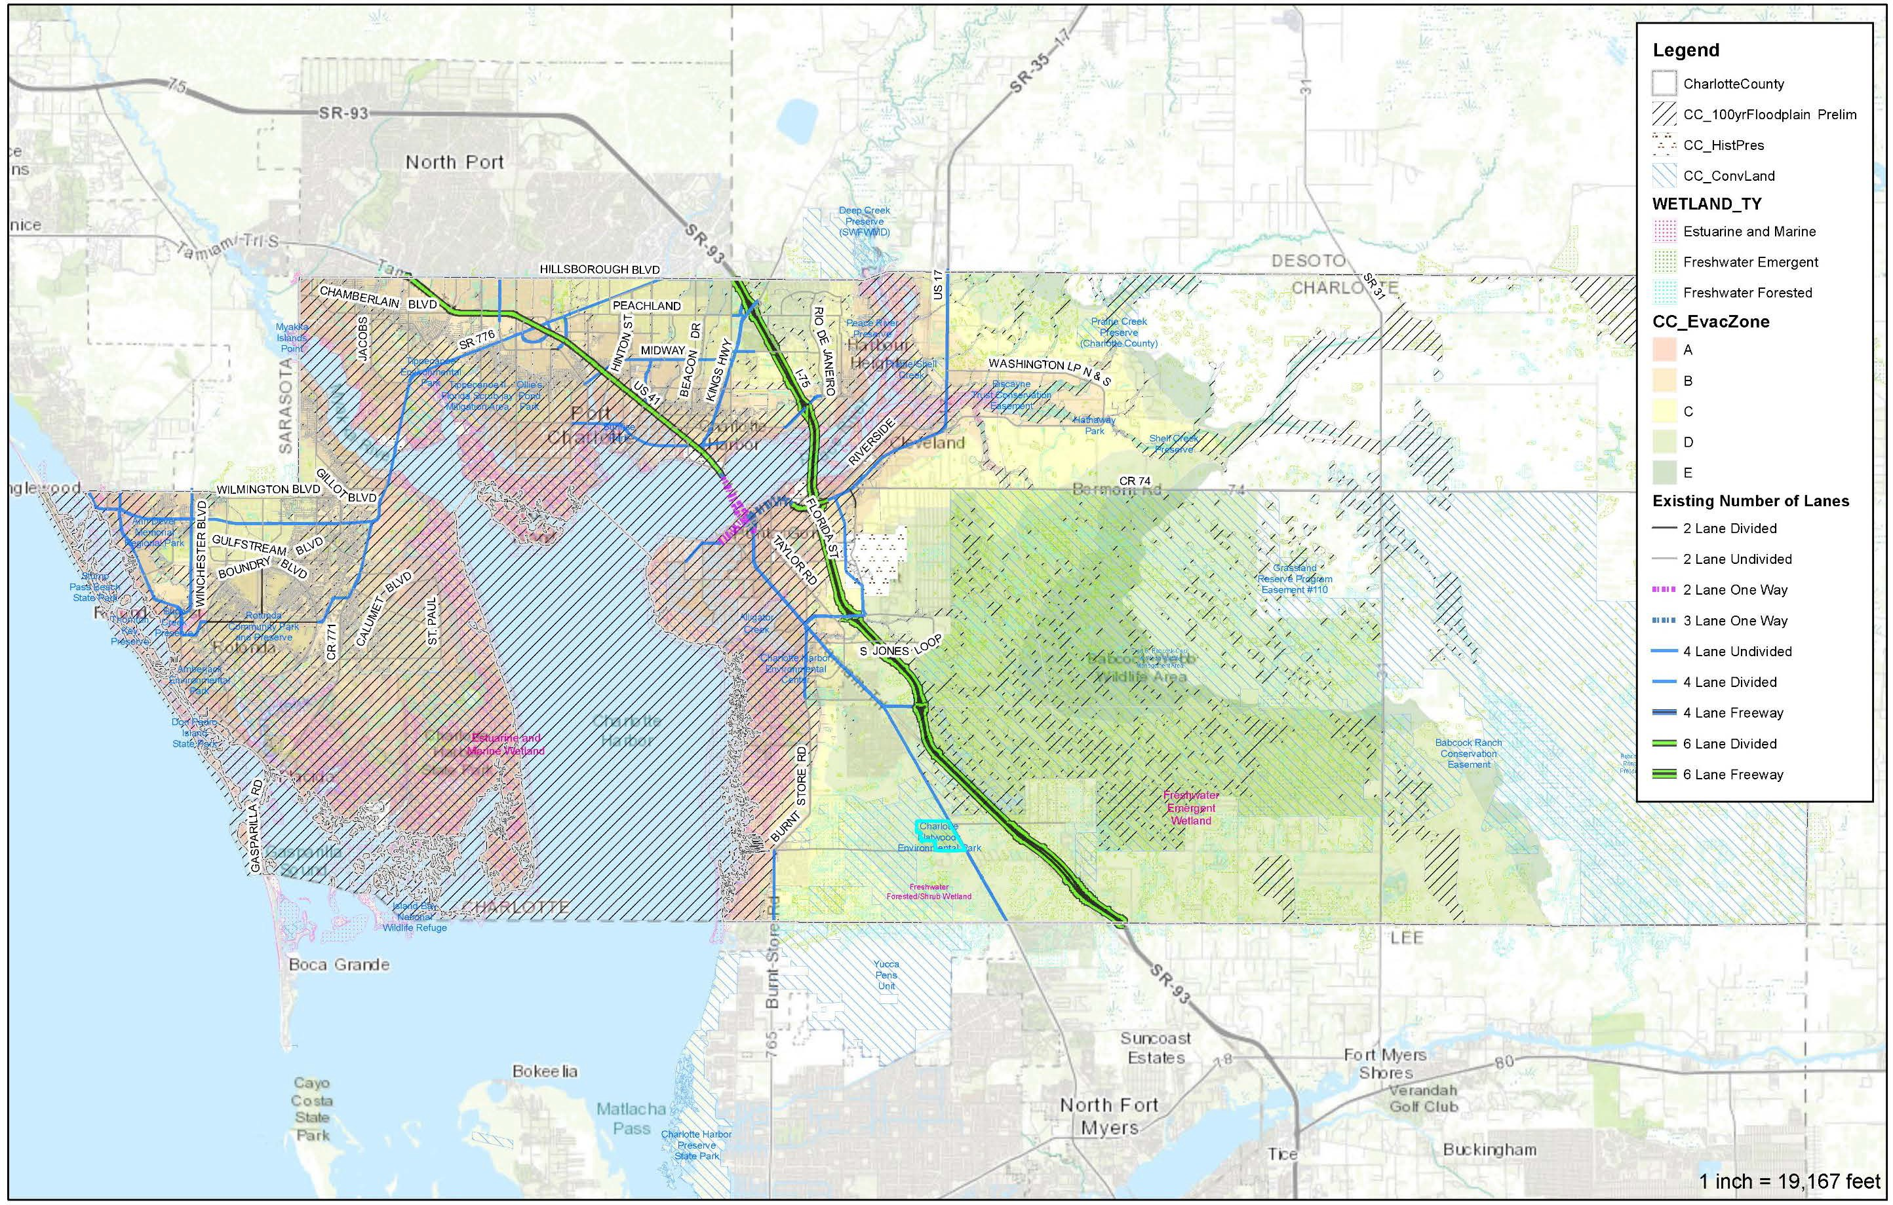

Funding for Route to 2045
The Route to 2045 LRTP includes revenue projections from federal, State, and local sources used to develop the 2045 Cost Feasible Plan. Estimates of federal and State revenues were developed in coordination with FDOT. This revenue forecast includes estimates of available 2045 revenues for certain capacity programs for each MPO. The estimated revenues can be used to fund planned capacity improvements to major elements of the transportation system (e.g., highways, transit).
These metropolitan estimates are grouped into 5-year periods and one final 10-year period.
In addition to the estimates provided by FDOT, revenue information was also collected from Charlotte County, Charlotte County Transit and the City of Punta Gorda to provide forecasts of Federal and other state funds not provided by FDOT. Table 4-5 presents a summary of the total projected revenues anticipated to be available. These revenues from federal, State and local sources exceed $1.2 billion in future “year-of-expenditure” format.
Existing revenues are insufficient to address the County’s future mobility needs that result from future growth in population and employment expected by 2045. In 2020, voters in Charlotte County will be asked to extend a one-penny Local Government Infrastructure Surtax that was first enacted in 1995 and has been extended by referendum four times since.
Table 4-5: Revenue Projection Summary – Year-of-Expenditure Revenues ($ millions)

Funding Programs and Sources | 2021-  2025 | 2026-  2030 | 2031-  2035 | 2036-  2045 | Total
Roadways | $105.52 | $213.62 | $218.03 | $460.32 | $997.50
Strategic Intermodal System | $0.00 | $0.00 | $31.09 | $55.43 | $86.53
Other Roads Construction & ROW - Capacity | $48.59 | $59.02 | $63.68 | $132.51 | $303.81
Other Roads Construction & ROW – Product Support | $10.69 | $12.99 | $14.01 | $29.15 | $66.84
Other Roads Construction & ROW - Federal Portion | $8.58 | $10.42 | $11.24 | $23.38 | $53.61
TRIP Funds | $1.32 | $1.97 | $2.19 | $4.49 | $9.97
Fuel Taxes to Local Governments | $7.22 | $7.48 | $7.64 | $15.53 | $37.87
Local Option Fuel Taxes | $17.39 | $18.21 | $24.64 | $50.08 | $110.32
Mobility/Impact Fees | $0.00 | $23.80 | $23.80 | $47.60 | $95.20
Local Government Infrastructure Sales Tax | $11.73 | $33.38 | $39.74 | $102.15 | $187.00
Developer Contributions | $0.00 | $46.36 | TBD | TBD | $46.36
Transit Revenues | $21.88 | $23.81 | $26.36 | $65.41 | $137.47
State and Federal Funding | $16.78 | $17.78 | $20.33 | $50.32 | $105.21
Local (County, Farebox, Other) | $5.10 | $6.03 | $6.03 | $15.09 | $32.26
Bicycle and Pedestrian | $5.78 | $12.09 | $13.87 | $34.09 | $65.83
Federal Transportation Alternatives | $2.50 | $2.50 | $2.50 | $5.01 | $12.52
Mobility/Impact Fees (Punta Gorda) | $0.00 | $0.25 | $0.25 | $0.50 | $1.00
Local Government Infrastructure Sales Tax | $3.28 | $9.34 | $11.12 | $28.58 | $52.32
Roadway Maintenance | $45.85 | $47.46 | $48.42 | $98.41 | $240.13
Fuel Taxes to Local Governments | $10.84 | $11.22 | $11.45 | $23.29 | $56.80
Local Option Fuel Taxes | $35.01 | $36.24 | $36.96 | $75.12 | $183.33

Route to 2045 Cost Feasible Plan

Transit Projects
Expanding on the analysis completed in the Charlotte County 10-Year TDP, the 2045 cost feasible transit projects include increased demand response service and technology solutions for more efficient delivery of transit to the community. Highlights of the projects listed in Table 4-1 include:
- Enhanced Dial-A-Ride Service – Using upgraded technology, enhance the current dial-a-ride service by adding a mobile application that allows for real-time bus tracking.
- Charlotte Link Service – Mobility-on-demand service in Charlotte Link zones in Englewood, west Port Charlotte, central Port Charlotte, and Punta Gorda. The service would allow use of a rideshare provider such as Uber, Lyft, taxi, or wheelchair transport. Anyone within a two-mile radius of these locations (Charlotte Link zones) would be eligible, and services would be available every weekday from 6:00am to 8:00pm and on Saturday from 9:00am to 8:00pm.
- US-41/Airport Connector – Implement regularly-scheduled transit service with mobile app/live bus tracking technology on US-41 from Port Charlotte Town Center to Punta Gorda Airport. The service will be provided every 60 minutes every weekday from 6:00am to 8:00pm.
- Babcock Express – Implement mobile app-based limited service (two trips during morning and afternoon hours) from the Bayfront Health in Punta Gorda to Babcock Ranch’s Founder’s Square every weekday. The service will be within the hours of 6:00am to 8:00pm.
- Establish New Administration & Operations Facility – Establish the proposed new Administration and Operations facility, funded fully by federal grants.
- Implement Bus Stop Infrastructure Program – To support the growth and implementation of any new transit services, Charlotte County Transit (CCT) should continue the infrastructure program to install bus stops with benches, shelters, bicycle storage facilities, and other infrastructure needed to improve rider experience at bus stops and potentially attract new riders.
- Implement Real-Time Bus Locator App and Reservation Technology Upgrades – CCT should work with Route Match software to upgrade its system technologies to include real-time bus tracking app for demand-response service and regularly-scheduled transit.
- Expand Transit Marketing/Awareness Campaign – CCT should explore all avenues to expand its marketing program for residents and visitors. This should also include coordinating with the FDOT Commuter Services program to use any avenues/opportunities or piggy-back on its events to increase awareness and promote the benefits of using transit.

Develop Employee Bus Pass/Subsidy Programs

Promote TDM Strategies

Bicycle/Pedestrian/Multi-Use Trails Program
Developing an active (walking and cycling) transportation system in Charlotte County is built on completing the existing network of sidewalk, trails, bike lanes, and paths in a manner that recognizes the unique needs of the users and function of transportation facilities.
The needs assessment process used in the Bicycle/Pedestrian Master Plan identified a series of gaps and needs within the County which were used to generate prospective projects. Prioritization of these projects, grouped into tiers, was developed using criteria which fell into one of four themes.
- Mobility: Provide access to places where people live, work, and play by extending and closing gaps in the network.
- Safety: Improve safety of high crash locations and where high‐volume roads create stressful walking and biking conditions.
- Land Use/Economic Development Impacts: Identify the economic impact of historically disadvantaged areas and areas with substantial planned growth of jobs and residents in 2040.
- Public Opinion: Integrate public preference from public workshops and online surveys into prioritization.
Highlights of the approach encompassed in the Route to 2045 LRTP include the following:
- All road widening and construction projects in the Cost Feasible LRTP will include appropriate bicycle facilities and sidewalks
- Continued implementation of bicycle and sidewalk safety projects currently prioritized for implementation.
- Use the recently adopted Regional Bicycle/Pedestrian Master Plan when filling gaps in the system or resurfacing/rehabilitation of existing roadways.
- Construct the prioritized projects based on Tiers listed in the Regional Bicycle/Pedestrian Master Plan through annual development of funding decisions during the Transportation Improvement Program update.
- Coordinate with FDOT, County and City staff through the Bicycle / Pedestrian Advisory Committee review of priorities for utilizing the $60 million allocated in the LRTP through 2045 for bicycle/pedestrian projects
Table 4-6 provides a listing of the cost feasible projects recommended from the Charlotte County Regional Bicycle / Pedestrian Master Plan. Several of these projects can be incorporated with roadway widening and construction projects. The location of these bicycle and pedestrian projects are illustrated in Figure 4-10.

Table 4-6: Bicycle/Pedestrian Master Plan Cost Feasible Projects

Map ID | On Street | From | To | Project Type | Total Cost (2019 $) | Total Cost (Future  YOE $) | Project Status
TIER 1 Projects
1 | Notre Dame Blvd | Burnt Store Rd | US 41 | Sidewalk or SUP, one side | $417,391 | $524,243
2 | Port Charlotte Blvd | Edgewater Dr | US 41 | SUP, one side | $209,124 | $262,660
3 | Tucker’s Grade | US 41 | Wildlife Management Area | Sidewalk, one side and Buffered Bike Lanes | $1,395,816 | $1,753,145
6 | South County Reg.  Park Internal Rd | Carmalita St | Cooper St | Sidewalk, one side and  Advisory Shoulder | $127,662 | $160,343
8 | Harbor View Rd | US 41 | Sulstone Dr | SUP, one side | $783,263 | $983,778 | Widening under design from  Melbourne to I-75
9 | Edgewater Dr | Collingswood Blvd | Midway Blvd | SUP, one side | $378,990 | $476,011 | Widening priority  project for MPO
12 | E/W Utility Easement | Education Ave |  | SUP, one side | $181,953 | $181,953 | $144,867
13 | Airport Rd | FSW to Piper Rd | Riverside Dr | SUP, one side | $935,495 | $1,174,982
15 | US 41 | Tucker’s Grade | Burnt Store Rd | SUP, one side | $775,896 | $974,526
16 | Zemel Rd | Burnt Store Rd | US 41 | SUP, one side | $1,323,443 | $1,662,245
24 | US 41 | Lee County Line | Tucker's Grade | SUP, one side | $1,721,213 | $2,161,844
41 | US 41 | Peace River Bridge | Midway Blvd | SUP, one side | $1,132,642 | $1,422,598 | FPN: 438262-1  $840,001 PE in 2023  $4,452,174 CST in  2025
45 | Taylor Road | Royal Road | Airport Road | Separated Bike Lane, One Way | $2,103,800 | $2,642,373 | FPN: 435105-2  $664,999 PE in  2024
53 | Loveland Blvd | Peachland Blvd | Veterans Blvd | SUP, one side | $243,081 | $305,310
 |  |  |  | Tier 1 Subtotal: | $11,692,684 | $14,686,011

Map ID | On Street | From | To | Project Type | Total Cost (2019 $) | Total Cost  (Future YOE $) | Project Status
TIER 2 Projects
7 | San Casa Dr | Placida Rd | SR 776 | Separated Bike Lane, One Way | $1,069,901 | $1,434,737
11 | Harbor Blvd | Port Charlotte Beach | Midway Blvd | Sidewalk, gap closures and  Separated Bike Lane, One Way | $1,749,997 | $2,346,746
17 | Fruitland Ave/Avenue  of the Americas | San Casa Dr | Gulfstream Blvd | Sidewalk, one side | $266,519 | $357,402
20 | SR 776 | Sarasota County Line | Gasparilla Rd | SUP, both sides | $3,297,817 | $4,422,373
21 | Oil Well Rd | US 41 | Granville Rd | Sidewalk | $568,338 | $762,141
36 | SUN Trail | SR 776 | Myakka State  Forest | SUP, one side | $505,805 | $678,285
37 | SUN Trail on SR 776 | Gasparilla Rd | US 41 | SUP, one side | $1,866,641 | $2,503,165
38 | SUN Trail on US 41 | Midway Blvd | SR 776 | SUP, one side | $539,509 | $723,481 | FPN: 440442-1  $6,090,709 CST in  2024
39 | SUN Trail on Burnt  Store Rd | Scham Rd | Jones Loop Rd | SUP, one side | $517,289 | $693,684
40 | SUN Trail on Beach  Rd | Gulf Blvd | SR 776 | SUP, one side | $807,584 | $1,082,970
42 | Cape Haze Pioneer  Trail | S McCall Road | Boca Grande | SUP, one side | $164,239 | $220,245
44 | SUN Trail on Placida  Rd | Gasparilla Rd | SR 776 | SUP, one side | $2,234,628 | $2,996,636
47 | Rampart Blvd. | Kings Hwy | Rio de Janeiro Ave | Sidewalk, one side and  Separated Bike Lane, One Way | $433,703 | $581,596
48 | Atwater St | Veterans Blvd | Hillsborough Blvd | Sidewalk or SUP, one side | $98,841 | $132,546
 |  |  |  | Tier 2 Subtotal: | $14,120,811 | $18,936,007

Map ID | On Street | From | To | Project Type | Total Cost (2019 $) | Total Cost  (Future YOE $) | Project Status
TIER 3 Projects
4 | Moss Rd | Charlotte Sports  Park | North Charlotte  Regional Park | Advisory Shoulder | TBD | TBD
10 | Pellam Blvd/Prineville  Dr | Edgewater Dr | County Line | SUP, one side | TBD | TBD
19 | Edgewater  Dr/Flamingo Blvd Ext. | Collingswood Blvd | County Line | Sidewalk or SUP, and/or  Paved Shoulder | TBD | TBD
50 | O’Donnell Blvd | North Charlotte  Regional Park |  | Advisory Shoulder | TBD | TBD
51 | Royal Poinciana | Burnt Store Rd | US 41 | SUP, one side | $1,426,760 | $2,250,000
5 | Gulfstream Blvd | Fruitland Ave | SR 776 | Sidewalk, one side and Bike Lane | $2,125,982 | $3,943,696
14 | Washington Loop Rd | US 17 S | US 17 N | Paved Shoulder | $4,422,320 | $8,203,403
18 | CR 74/Bermont Rd. | Richards Blvd | SR 31 | Paved Shoulder | $4,955,218 | $9,191,930
22 | Riverside Drive | Marion Ave | US 17 | Paved Shoulder | $3,996,513 | $7,413,532
23 | Babcock Ranch  Connection | Granville Rd | SR 31 | SUP, one side | $3,201,980 | $5,939,673
35 | SUN Trail on US 41 | N Jones Loop Rd | Peace River Bridge | SUP, one side | $789,689 | $1,464,873 | FPN: 446339-1  $290,000 PE in 2025
43 | SUN Trail on Burnt  Store Rd | Lee County Line | Zemel Rd | SUP, one side | $371,396 | $688,940
46 | Jones Loop Rd | Burnt Store Rd | Piper Rd | Paved Shoulder | $2,268,520 | $4,208,105
49 | Kings Hwy | Veterans Blvd | Sandhill Blvd | Sidewalk, one side and  Separated Bike Lane, One Way | $160,770 | $298,229
52 | Hillsborough Blvd | Cranberry Blvd | Toledo Blade Blvd | Sidewalk, one side and  Separated Bike Lane, One Way | $153,115 | $284,028
 |  |  |  | Tier 3 Subtotal: | $23,872,263 | $43,886,409

Map ID | On Street | From | To | Project Type | Total Cost (2019 $) | Total Cost  (Future YOE $) | Project Status
Additional Projects as funds become available
25 | Cape Haze Pioneer Trail near Rotonda Blvd E. |  | Enhanced Crosswalk |  | TBD | TBD
26 | San Casa Drive @ Avenue of the Americas |  | Full Traffic Signal |  | $257,597 | $257,597
27 | SR 776 @ Fairgrounds / Charlotte Sports Park |  | Crossing Enhancements/Traffic Signal |  | $1,100,000 | $1,100,000 | FPN: 446393-1  $151,000 PE in 2025
28 | US 41 @ Harbor Blvd |  | Enhanced Crosswalk |  | TBD | TBD
29 | US 41 @ Murdock Circle E |  | Median Safety Islands and at intersection |  | TBD | TBD
30 | US 41 @ Harbor View Rd/Edgewater Dr |  | North to South Crossing across US 41, Median Safety  Islands |  | TBD | TBD
31 | Veterans Blvd @ Murdock Circle E |  | Median Safety Islands and at intersection |  | TBD | $2,250,000
32 | US 41 @ Burnt Store Road |  | Median Safety Islands and at intersection. |  | TBD | TBD
33 | US 41 @ Carmalita St |  | Full Traffic Signal |  | TBD | TBD
34 | US 41 @ Tuckers Grade |  | Median safety islands and at intersection |  | TBD | TBD
 |  |  |  | Additional Projects Subtotal: | $1,357,597 | $3,607,597
 |  |  | Bicycle/Pedestrian Master Plan Total: |  | $51,043,355 | $81,116,024

Figure 4-10: Bicycle/Pedestrian Master Plan Cost Feasible Projects
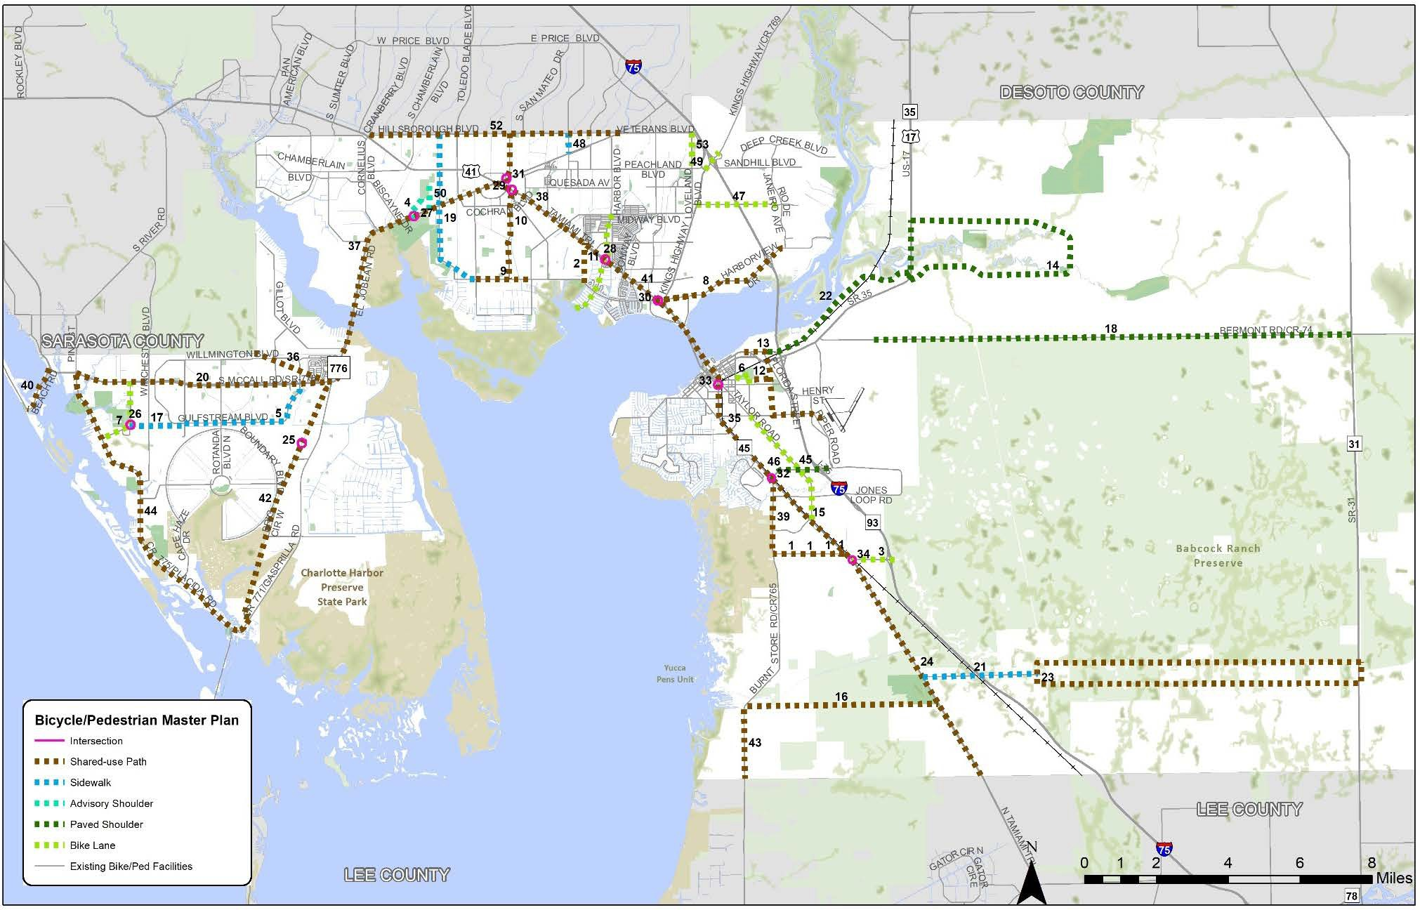

2045 Long Range Transportation Plan | Public Review Summary Report
4-26

Roadway Projects
Determining the roadway projects and strategies to include in the Route to 2045 Cost Feasible LRTP was based on an evaluation of the prioritized needs and availability of transportation revenues.
Highlights of the projects listed in Table 4-7 and shown in Figure 4-11 are listed below based on geographic region of Charlotte County.

West County
- Widening of SR 776 west of Spinnaker Blvd to 6-lanes
- Corridor Study of SR 776 to identify future intersection improvements.

Mid County
- Corridor Study of SR 776 to identify future intersection improvements.
- Widening of Edgewater Drive / Flamingo Blvd to 4-lanes from Midway Blvd to US 41
- Widening of Toledo Blade Blvd to 4-lanes from SR 776 to US 41
- Widening of Prineville Drive to 4-lanes from Paulson Drive to Hillsborough Blvd.
- Funding for implementation of US 41 Corridor Vision Plan recommendations.
- New connection between Veterans Blvd and Hillsborough Blvd (coordinated with the Sarasota/Manatee MPO and future I-75 interchange opportunity)
- Widening of Harbor View Rd to 4-lanes from Melbourne St. to I-75
- Study of I-75 interchange improvements

South County
- Complete Streets Project on US 17 from US 41 to I-75
- Roundabout at CR 74 and SR 31 intersection
- Funding for implementation of US 41 Corridor Vision Plan recommendations
- Widening of Taylor Road to 4-lanes parallel to US 41
- Widening of Old Burnt Store Road to 4-lanes from N. Jones Loop Road to Taylor Road
- Widening of SR 31 to 4/6-lanes from Lee County Line to North of Cook Brown Road
- Land Purchase for N. Jones Loop widening from US 41 to Piper Road
- Study of future Burnt Store Road extension north of Taylor Road to US 17
- Study of future Airport Road widening from Taylor Road to Piper Road
- Study of I-75 interchange improvements

Table 4-7: Roadway Cost Feasible Projects List ($ Millions Future Year of Expenditure)

Map ID | Facility | From | To | Existing Lanes | Project Description | LRTP Funding Source | 2021 – 2025 (YOE) |  |  | 2026-2030 (YOE) |  |  | 2031-2035 (YOE) |  |  | 2036-2045 (YOE)
 |  |  |  |  |  |  | PD&E  / PE | ROW | CST | PD&E /  PE | ROW | CST | PD&E /  PE | ROW | CST | PD&E /  PE | ROW | CST
1 | Airport Road | Taylor Rd | Piper Road | 2 | Widen 2 to 4 lanes | Local |  |  |  |  |  |  | $5.80 | $7.43
4 | Burnt Store Rd | Zemel Rd | Scham Rd | 2 | Widen 2 to 4 lanes | TIP
5 | Burnt Store Rd | N Jones Loop | Taylor Rd | 2 | Widen 2 to 4 lanes | Local |  |  |  |  |  |  |  |  |  | $2.75 | $2.45 | $21.30
6 | Burnt Store Rd  Extension | Taylor Rd | Florida St @ US 17 | 0 | New 4-lane | Local |  |  |  |  |  |  |  |  |  | $12.53
7 | Edgewater Dr  (Phase 3) | Midway Blvd | Collingswood Blvd | 2 | Widen 2 to 4 lanes | TRIP / Local |  |  |  |  |  | $31.40
8 | Edgewater Dr (Phase 4) | Collingswood Blvd | Samantha Ave | 0 | Roadway realignment and new bridge | Local | $2.10 |  | $23.00
9 | Edgewater Dr /  Flamingo (Phase 5) | Collingswood Blvd | SR 776 | 2 | Widen 2 to 4 lanes | Local | $1.00 |  |  |  |  | $25.12
10 | Flamingo Blvd | SR 776 | US 41 | 2 | Widen 2 to 4 lanes | Local |  |  |  |  |  |  | $3.21 | $5.33 | $17.92
12 | Hillsborough Blvd /  Raintree Blvd | Veterans Blvd |  | 0 | New 2-lane | Local |  |  |  |  |  |  | $0.45 | $1.40 | $2.53
21 | N Jones Loop | Burnt Store Rd | Piper Road | 4 | Widen 4 to 6 lanes | State | $1.22 |  |  |  |  |  | $4.48 |  |  |  | $5.27
23 | Prineville Dr | Paulson Dr | Hillsborough Blvd | 2 | Widen 2 to 4 lanes | TRIP / Local |  |  |  |  |  |  |  |  |  | $9.07 | $15.64 | $52.59
30 | SR 776 | CR 775 | Spinnaker Blvd | 4 | Widen 4 to 6 lanes | State | $2.00 |  |  | $6.49 | $6.13 |  |  |  | $57.38
31a | SR 776 Future  Corridor Study | Pine Street / Placida  Rd | US 41 |  | Future Corridor Study | State |  |  |  | $6.48 | $20.28 |  | $2.57 |  |  |  | $9.98 | $67.38
(Funding for up to 8 intersection locations) Potential Candidate Intersections: Sunnybrook Blvd, Oceanspray Blvd, David Blvd, Coliseum Blvd, San Casa Dr, Winchester Blvd, Hollis Ave, Biscayne Dr.)
34 | SR 31 | Lee County Line  Cypress Parkway | Cypress Parkway  Lake Babcock Dr. | 2 | Widen 2 to 6 lanes  Widen 2 to 4 lanes | Developer |  |  |  | $2.56 | $7.18 | $28.99
36 | Taylor Rd | US 41 | Jones Loop Rd | 2 | Widen 2 to 4 lanes | Local |  |  |  |  |  |  | $5.37 | $8.90 | $29.93
37 | Taylor Rd | N Jones Loop Rd | Airport Rd | 2 | Widen 2 to 4 lanes | Local |  |  |  |  |  |  |  |  |  | $7.42 | $12.80 | $43.03
38 | Taylor Rd | Airport Rd | US 41 | 2 | Complete Streets | Local |  |  |  |  |  |  |  |  |  | $3.22 | $4.23 | $18.66
39a | Toledo Blade Blvd (CR 39) | SR 776 | Whitney Avenue | 2 | Widen 2 to 4 lanes | Developer |  |  |  |  |  | $7.62
43 | US 17 | Copley Ave | CR 74 | 4 | Widen 4 to 6 lanes | SIS |  |  |  |  |  |  | $1.05 |  |  | $2.00
51 | Harbor View Road | Melbourne St | I-75 | 2 | Widen 2 to 4 lanes | Federal / Local | $4.02 | $9.79 |  |  |  | $31.60
54 /  55 | Marion Avenue / Olympia Avenue | US 41 | Marlympia Way | 3 | Lane Repurposing - resurface and striping | State | $0.29 |  |  | $1.42 |  | $9.32
59 | US 41 Corridor  Vision Plan |  |  | 4/6 | Corridor & Safety  Improvements | State |  |  |  | $5.95 |  | $6.28 |  |  |  |  |  | $18.55
60 | SR 31 | @ CR 74 |  | 2 | Roundabout | State |  | $0.64 |  |  |  | $0.89
61 | SR 776 | @ Flamingo Blvd |  | 4 | Intersection - turn  lanes | TIP |  |  | $1.46
62 | US 41 | @ Easy Street |  | 4 | Intersection - turn lanes | State |  |  |  |  |  |  |  |  |  | $1.09 |  | $8.44
63 | US 41 | @ Forrest Nelson |  | 4 | Intersection - turn  lanes | State |  |  |  |  |  |  |  |  |  | $1.09 |  | $8.44

Map ID | Facility | From | To | Existing Lanes | Project Description | LRTP Funding Source | 2021 – 2025 (YOE) |  |  | 2026-2030 (YOE) |  |  | 2031-2035 (YOE) |  |  | 2036-2045 (YOE)
 |  |  |  |  |  |  | PD&E  / PE | ROW | CST | PD&E /  PE | ROW | CST | PD&E /  PE | ROW | CST | PD&E /  PE | ROW | CST
64 | SR 776 | @ Jacobs St |  | 4 | Intersection - turn  lanes | State |  |  |  |  |  |  |  |  |  | $1.09 |  | $8.44
65 | US 41 | @ Carousel Plaza |  | 4 | Intersection - turn  lanes | State |  |  |  |  |  |  |  |  |  | $1.09 |  | $8.44
66 | SR 776 | @ Charlotte Sports  Park |  | 4 | Intersection - turn  lanes | State | $0.15 |  |  |  |  | $1.27
67 | I-75 | at CR 769/Kings Hwy |  |  | Interchange  Modifications | SIS |  |  |  |  |  |  | $6.50
68 | I-75 | at CR 776/Harbor View |  |  | Interchange  Modifications | SIS |  |  |  |  |  |  | $6.50
69 | I-75 | at US 17/SR35 |  |  | Interchange  Modifications | SIS |  |  |  |  |  |  | $7.50
70 | I-75 | at North Jones Loop  Rd |  |  | Interchange  Modifications | SIS |  |  |  |  |  |  | $6.50
71 | ITS Master Plan  Implementation |  |  |  |  | State / Federal /  Local |  |  |  |  |  | $3.14 | $7.07 |  | $3.54 |  |  | $16.00
72 | SR 776 | @ Gulfstream Blvd /  Wilmington Blvd |  | 4 | Intersection - turn  lanes | State |  |  |  | $0.81 |  | $5.71
73 | SR 776 | @ Biscayne Blvd |  | 4 | Intersection - turn  lanes | State |  |  |  | $0.81 |  | $5.71
74 | SR 776 | @ Cornelius |  | 4 | Intersection - turn  lanes | State |  |  |  |  |  |  | $0.96 | $7.17 | $7.17
80 | Burnt Store Road | Vincent Avenue | Wallaby Lane | 2 | Widen 2 to 4 Lanes | Federal |  |  |  |  |  |  | $0.56 | $0.27 | $3.11
99 | Kings Hwy /  Peachland / Veterans |  |  |  | Intersection Modification | Local |  |  |  | $5.95
 |  |  |  |  |  | Subtotal: | $10.78 | $10.43 | $24.46 | $30.47 | $33.59 | $157.05 | $58.52 | $30.5 | $128.58 | $41.35 | $50.37 | $271.27
 |  |  |  |  |  | Total: | $840.37

Notes:
  - Project Costs shown in current year format based on 2019 project costs]
  - PD&E/PE are product support phases for Project Development & Environment phase and Preliminary Engineering phase
  - ROW is Right-of-Way costs associated with land acquisition
  - CST is the Construction cost for completing the identified project
  - Existing Funding is included in the MPO’s 2020/2021 – 2024/2025 Transportation Improvement Program.

Figure 4-11: Roadway Cost Feasible Map
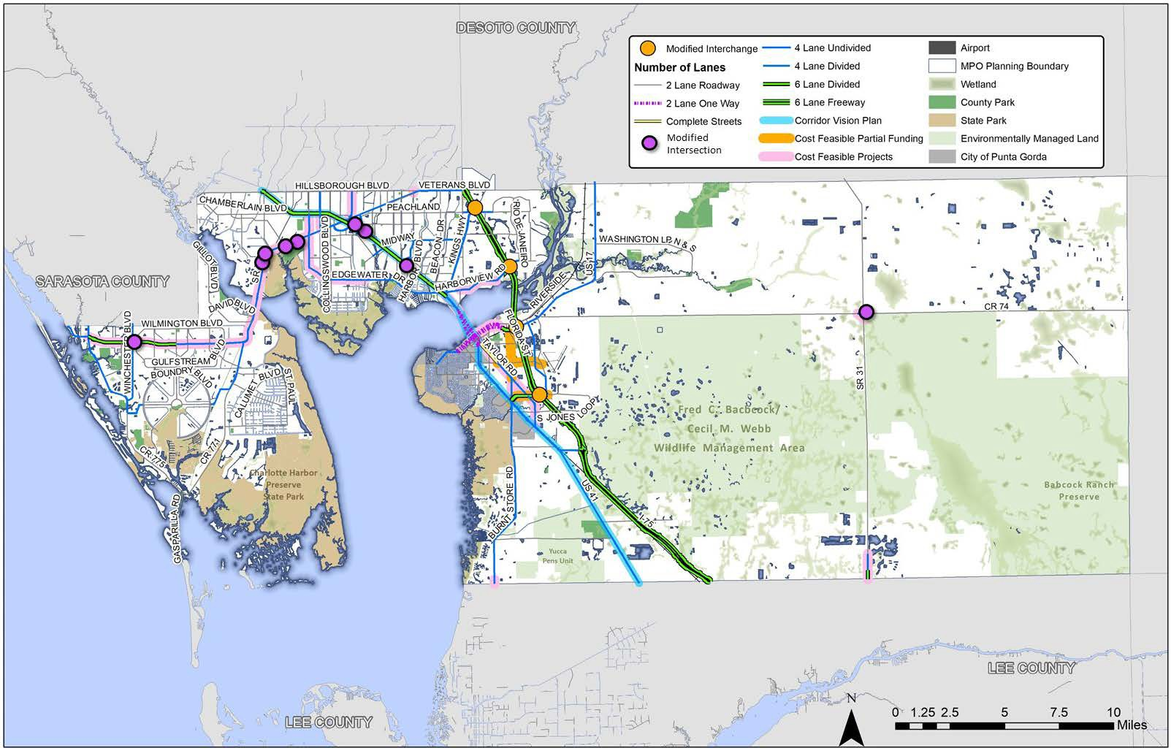

Appendix A. Performance Measures and System Performance Report

Charlotte County-Punta Gorda Metropolitan Planning Organization Long-Range Transportation Plan System Performance Report

Office of Policy Planning Florida Department of Transportation

August 2019

- - Purpose
This document provides language that Florida’s metropolitan planning organizations (MPO) may incorporate in Long-Range Transportation Plan (LRTP) System Performance Reports to meet the federal transportation performance management rules. Updates or amendments to the LRTP must incorporate a System Performance Report that addresses these measures and related information no later than:
- May 27, 2018 for Highway Safety measures (PM1);
- October 1, 2018 for Transit Asset Management measures;
- May 20, 2019 for Pavement and Bridge Condition measures (PM2);
- May 20, 2019 for System Performance measures (PM3); and
- July 20, 2021 for Transit Safety measures. (Due to the emergency declaration resulting from the COVID-19 pandemic, FTA issued a Notice of enforcement discretion which delayed the initial deadline of July 20, 2020 for one-year)
This document is intended as a resource for Florida’s MPOs as they update their LRTPs; the language can be adapted as appropriate for each MPO. In most sections, there are two options for the text, to be used by MPOs supporting statewide targets or MPOs establishing their own targets. Highlighted in yellow are the areas that require MPO input. This may range from simply adding the MPO name and adoption dates to providing MPO-specific background information and relevant strategies and prioritization processes.
The document is consistent with the Transportation Performance Measures Consensus Planning Document developed jointly by the Florida Department of Transportation (FDOT) and the Metropolitan Planning Organization Advisory Council. This document outlines the minimum roles of FDOT, the MPOs, and the public transportation providers in the MPO planning areas to ensure consistency to the maximum extent practicable in satisfying the transportation performance management requirements promulgated by the United States Department of Transportation in Title 23 Parts 450, 490, 625, and 673 of the Code of Federal Regulations (23 CFR).
The document is organized as follows:
  - Section 2 provides a brief background on transportation performance management;
  - Section 3 covers the Highway Safety measures (PM1);
  - Section 4 covers the Pavement and Bridge Condition measures (PM2);
  - Section 5 covers System Performance measures (PM3);
  - Section 6 covers Transit Asset Management (TAM) measures; and
  - Section 7 covers Transit Safety measures.

- - Background
Pursuant to the Moving Ahead for Progress in the 21st Century Act (MAP-21) Act enacted in 2012 and the Fixing America's Surface Transportation Act (FAST Act) enacted in 2015, state departments of transportation (DOT) and metropolitan planning organizations (MPO) must apply a transportation performance management approach in carrying out their federally required transportation planning and programming activities. The process requires the establishment and use of a coordinated, performance-based approach to transportation decision-making to support national goals for the federal-aid highway and public transportation programs.
On May 27, 2016, the Federal Highway Administration (FHWA) and the Federal Transit Administration (FTA) issued the Statewide and Nonmetropolitan Transportation Planning; Metropolitan Transportation Planning Final Rule (The Planning Rule).1 This rule details how state DOTs and MPOs must implement new MAP-21 and FAST Act transportation planning requirements, including the transportation performance management provisions.
In accordance with the Planning Rule, the Charlotte County-Punta Gorda MPO must include a description of the performance measures and targets that apply to the MPO planning area and a System Performance Report as an element of its Long-Range Transportation Plan (LRTP). The System Performance Report evaluates the condition and performance of the transportation system with respect to required performance targets, and reports on progress achieved in meeting the targets in comparison with baseline data and previous reports. For MPOs that elect to develop multiple scenarios, the System Performance Report also must include an analysis of how the preferred scenario has improved the performance of the transportation system and how changes in local policies and investments have impacted the costs necessary to achieve the identified targets.2
There are several milestones related to the required content of the System Performance Report:
  - In any LRTP adopted on or after May 27, 2018, the System Performance Report must reflect Highway Safety (PM1) measures;
  - In any LRTP adopted on or after October 1, 2018, the System Performance Report must reflect Transit Asset Management measures;
  - In any LRTP adopted on or after May 20, 2019, the System Performance Report must reflect Pavement and Bridge Condition (PM2) and System Performance (PM3) measures; and
  - In any LRTP adopted on or after July 20, 2021, the System Performance Report must reflect Transit Safety measures.
The Charlotte County-Punta Gorda MPO 2020-2045 Long-Range Transportation Plan was adopted on October 5, 2020. Per the Planning Rule, the System Performance Report for the Charlotte County-

1 The Final Rule modified the Code of Federal Regulations at 23 CFR Part 450 and 49 CFR Part 613.
2 Guidance from FHWA/FTA for completing the preferred scenario analysis is expected in the future. As of August 2019, no guidance has been issued.

Punta Gorda MPO is included for the required Highway Safety (PM1), Bridge and Pavement (PM2), System Performance (PM3), and Transit Asset Management, and Transit Safety targets
- - Highway Safety Measures (PM1)
Effective April 14, 2016, the FHWA established five highway safety performance measures3 to carry out the Highway Safety Improvement Program (HSIP). These performance measures are:
- Number of fatalities;
- Rate of fatalities per 100 million vehicle miles traveled (VMT);
- Number of serious injuries;
- Rate of serious injuries per 100 million vehicle miles traveled (VMT); and
- Number of non-motorized fatalities and non-motorized serious injuries.
The Florida Department of Transportation (FDOT) publishes statewide safety performance targets in the HSIP Annual Report that it transmits to FHWA each year. Current safety targets address calendar year 2018 and are based on a five-year rolling average (2011-2015). For the 2018 HSIP annual report, FDOT established statewide HSIP interim safety performance measures and FDOT’s 2019 safety targets, which set the target at “0” for each performance measure to reflect the Department’s vision of zero deaths.
The Charlotte County-Punta Gorda MPO adopted/approved safety performance targets on October 28, 2019. Table A-3.1 indicates the areas in which the MPO is expressly supporting the statewide target developed by FDOT, as well as those areas in which the MPO has adopted a target specific to the MPO planning area.
Table A-3.1 Highway Safety (PM1) Targets

Performance Target | MPO agrees to plan and program projects so that they contribute toward the accomplishment of the  FDOT safety target of zero | MPO has adopted a target specific to the MPO Planning Area
Number of fatalities | ✓
Rate of fatalities per 100 million  vehicle miles traveled (VMT) | ✓
Number of serious injuries | ✓
Rate of serious injuries per 100 million vehicle miles traveled (VMT) | ✓
Number of non-motorized fatalities and non-motorized  serious injuries. | ✓

3 23 CFR Part 490, Subpart B

Statewide system conditions for each safety performance measure are included in Table A-3.2, along with system conditions in the Charlotte County-Punta Gorda MPO metropolitan planning area. System conditions reflect baseline performance, which for this first system performance report is the same as the current reporting period (2011-2015). The latest safety conditions will be updated annually on a rolling 5-year window and reflected within each subsequent system performance report, to track performance over time in relation to baseline conditions and established targets.
Table A-3.2 Highway Safety (PM1) Conditions and Performance

Performance Measures | Florida Statewide Baseline Performance  (Five-Year Rolling Average 2012-2016) | Calendar Year 2019 Florida Performance Targets
Number of Fatalities | 2,533 | 0
Rate of Fatalities per 100 Million Vehicle Miles Traveled (VMT) | 1.287 | 0
Number of Serious Injuries | 20,552 | 0
Rate of Serious Injuries per 100 Million VMT | 10.452 | 0
Number of Non-Motorized Fatalities and Non- Motorized Serious Injuries | 3,173 | 0

Trend and Baseline Conditions
To evaluate baseline Safety Performance Measures, the most recent five-year rolling average (2013- 2017) of crash data and Vehicle Miles Traveled (VMT) were utilized. Table A-3.3 presents the Baseline Safety Performance Measures for Charlotte County-Punta Gorda MPO. Trend data is also presented which covers the previous four reporting periods.

Table A-3.3 Baseline and Trend Crash Data

Performance Measures | 2009-2013 | 2010-2014 | 2011-2015 | 2012-2016 | 2013-2017
Number of Fatalities | 22.8 | 21.0 | 21.4 | 22.4 | 24.2
Rate of Fatalities per 100 VMT | 1.048 | 0.964 | 0.969 | 0.990 | 1.041
Number of Serious Injuries | 164.2 | 149.2 | 134.6 | 126.8 | 113.0
Rate of Serious Injuries per 100 Million VMT | 7.555 | 6.864 | 6.128 | 5.668 | 4.898
Number of Non-Motorized Fatalities and Non- Motorized Serious Injuries | 24.2 | 23 | 21.4 | 20.4 | 20.6

Coordination with Statewide Safety Plans and Processes
The Charlotte County-Punta Gorda MPO recognizes the importance of linking goals, objectives, and investment priorities to established performance objectives, and that this link is critical to the achievement of national transportation goals and statewide and regional performance targets. As such, the Route to 2045 LRTP reflects the goals, objectives, performance measures, and targets as they are available and described in other state and public transportation plans and processes; specifically the Florida Strategic Highway Safety Plan (SHSP), the Florida Highway Safety Improvement Program (HSIP), and the Florida Transportation Plan (FTP).
- The 2016 Florida Strategic Highway Safety Plan (SHSP) is the statewide plan focusing on how to accomplish the vision of eliminating fatalities and reducing serious injuries on all public roads. The SHSP was developed in coordination with Florida’s 27 metropolitan planning organizations (MPOs) through Florida’s Metropolitan Planning Organization Advisory Council (MPOAC). The SHSP guides FDOT, MPOs, and other safety partners in addressing safety and defines a framework for implementation activities to be carried out throughout the State.
- The FDOT HSIP process provides for a continuous and systematic process that identifies and reviews traffic safety issues around the state to identify locations with potential for improvement. The ultimate goal of the HSIP process is to reduce the number of crashes, injuries and fatalities by eliminating certain predominant types of crashes through the implementation of engineering solutions.
- Transportation projects are identified and prioritized with the MPOs and non-metropolitan local governments. Data are analyzed for each potential project, using traffic safety data and traffic demand modeling, among other data. The FDOT Project Development and Environment Manual requires the consideration of safety when preparing a proposed project’s purpose and need, and

defines several factors related to safety, including crash modification factor and safety performance factor, as part of the analysis of alternatives. MPOs and local governments consider safety data analysis when determining project priorities.

LRTP Safety Priorities
Route to 2045 LRTP increases the safety of the transportation system for motorized and non- motorized users as required. The LRTP aligns with the Florida SHSP and the FDOT HSIP with specific strategies to improve safety performance focused on prioritized safety projects, pedestrian and/or bicycle safety enhancements, and traffic operation improvements to address our goal to reduce fatalities and serious injuries.
The LRTP identifies safety needs within the metropolitan planning area and provides funding for targeted safety improvements. The MPO has developed a project selection process that includes an assessment of crash hot spots based on frequency of crashes as well as addressing crash locations which resulted in serious injuries or fatalities which were identified as part of the Congestion Management Process.
The Route to 2045 LRTP will provide information from the FDOT HSIP annual reports to track the progress made toward the statewide safety performance targets. The MPO will document the progress on any safety performance targets established by the MPO for its planning area
Additionally, the MPO has coordinated with FDOT on the US 41 Corridor Vision Plan in setting aside funding for implementation of study recommendations. US 41 has routinely experienced the highest level of traffic crashes in Charlotte County. Addressing bicycle and pedestrian safety has also been a focus of the MPO for developing the Route to 2045 LRTP. Adoption of the Countywide Bicycle/Pedestrian Master Plan has identified more than 165 miles of proposed multimodal transportation facilities.

- - Pavement and Bridge Condition Measures (PM2)

Pavement and Bridge Condition Performance Measures and Targets Overview
In January 2017, USDOT published the Pavement and Bridge Condition Performance Measures Final Rule, which is also referred to as the PM2 rule. This rule establishes the following six performance measures:
- Percent of Interstate pavements in good condition;
- Percent of Interstate pavements in poor condition;
- Percent of non-Interstate National Highway System (NHS) pavements in good condition;
- Percent of non-Interstate NHS pavements in poor condition;
- Percent of NHS bridges (by deck area) classified as in good condition; and
- Percent of NHS bridges (by deck area) classified as in poor condition.
For the pavement measures, five pavement metrics are used to assess condition:
- International Roughness Index (IRI) - an indicator of roughness; applicable to all asphalt and concrete pavements;
- Cracking percent - percentage of the pavement surface exhibiting cracking; applicable to all asphalt and concrete pavements;
- Rutting - extent of surface depressions; applicable to asphalt pavements;
- Faulting - vertical misalignment of pavement joints; applicable to certain types of concrete pavements; and
- Present Serviceability Rating (PSR) – a quality rating applicable only to certain lower speed roads.
For each pavement metric, a threshold is used to establish good, fair, or poor condition. Pavement condition is assessed for each 0.1 mile section of the through travel lanes of mainline highways on the Interstate or the non-Interstate NHS using these metrics and thresholds. A pavement section is rated as good if all three metric ratings are good, and poor if two or more metric ratings are poor. Sections that are not good or poor are considered fair.
The good/poor measures are expressed as a percentage and are determined by summing the total lane-miles of good or poor highway segments and dividing by the total lane-miles of all highway segments on the applicable system. Pavement in good condition suggests that no major investment is needed and should be considered for preservation treatment. Pavement in poor condition suggests major reconstruction investment is needed due to either ride quality or a structural deficiency.
The bridge condition measures refer to the percentage of bridges by deck area on the NHS that are in good condition or poor condition. The measures assess the condition of four bridge components: deck, superstructure, substructure, and culverts. Each component has a metric rating threshold to establish good, fair, or poor condition. Each bridge on the NHS is evaluated using these ratings. If the lowest rating of the four metrics is greater than or equal to seven, the structure is classified as good. If the lowest rating is less than or equal to four, the structure is classified as poor. If the lowest rating is five or six, it is classified as fair.

The bridge measures are expressed as the percent of NHS bridges in good or poor condition. The percent is determined by summing the total deck area of good or poor NHS bridges and dividing by the total deck area of the bridges carrying the NHS. Deck area is computed using structure length and either deck width or approach roadway width.
A bridge in good condition suggests that no major investment is needed. A bridge in poor condition is safe to drive on; however, it is nearing a point where substantial reconstruction or replacement is needed.
Federal rules require state DOTs and MPOs to coordinate when setting pavement and bridge condition performance targets and monitor progress towards achieving the targets. States must establish:
- Four-year statewide targets for the percent of Interstate pavements in good and poor condition;
- Two-year and four-year targets for the percent of non-Interstate NHS pavements in good and poor condition; and
- Two-year and four-year targets for the percent of NHS bridges (by deck area) in good and poor condition.
MPOs must establish four-year targets for all six measures. MPOs can either agree to program projects that will support the statewide targets, or establish their own quantifiable targets for the MPO’s planning area.
The two-year and four-year targets represent pavement and bridge condition at the end of calendar years 2019 and 2021, respectively.

Pavement and Bridge Condition Baseline Performance and Established Targets
This System Performance Report discusses the condition and performance of the transportation system for each applicable target as well as the progress achieved by the MPO in meeting targets in comparison with system performance recorded in previous reports. Because the federal performance measures are new, performance of the system for each measure has only recently been collected and targets have only recently been established. Accordingly, this first Charlotte County-Punta Gorda MPO LRTP System Performance Report highlights performance for the baseline period, which is 2017. FDOT will continue to monitor and report performance on a biennial basis. Future System Performance Reports will discuss progress towards meeting the targets since this initial baseline report.
Table A-4.1 presents baseline performance for each PM2 measure for the State and for the MPO planning area as well as the two-year and four-year targets established by FDOT for the State.

Table A-4.1. Pavement and Bridge Condition (PM2) Performance and Targets

Performance Measures | Statewide Performance (2017 Baseline) | Statewide 2-year Target (2019) | Statewide 4-year Target (2021) | MPO  Performance (2017 Baseline)
Percent of Interstate pavements in good condition | 67.5% | n/a | 60% | 70.6%
Percent of Interstate pavements in poor condition | 0.0% | n/a | 5% | 0.0%
Percent of non-Interstate NHS pavements in good condition | 44.0% | 40% | 40% | 47.1%
Percent of non-Interstate NHS pavements in poor condition | 0.5% | 5% | 5% | 1.1%
Percent of NHS bridges (by deck area) in good condition | 67.7% | 50% | 50% | 72%
Percent of NHS bridges (by deck area) in poor condition | 1.2% | 10% | 10% | 1%

FDOT established the statewide PM2 targets on May 18, 2018. In determining its approach to establishing performance targets for the federal pavement and bridge condition performance measures, FDOT considered many factors. To begin with, FDOT is mandated by Florida Statute
334.046 to preserve the state’s pavement and bridges to specific standards. To adhere to the statutory guidelines, FDOT prioritizes funding allocations to ensure the current transportation system is adequately preserved and maintained before funding is allocated for capacity improvements. These statutory guidelines envelope the statewide federal targets that have been established for pavements and bridges.
In addition, MAP-21 requires FDOT to develop a Transportation Asset Management Plan (TAMP) for all NHS pavements and bridges within the state. The TAMP must include investment strategies leading to a program of projects that would make progress toward achievement of the state DOT targets for

asset condition and performance of the NHS. FDOT’s TAMP was updated to reflect MAP-21 requirements in 2018.
Further, the federal pavement condition measures require a new methodology that is a departure from the methods currently used by FDOT and uses different ratings and pavement segment lengths. For bridge condition, the performance is measured in deck area under the federal measure, while the FDOT programs its bridge repair or replacement work on a bridge by bridge basis. As such, the federal measures are not directly comparable to the methods that are most familiar to FDOT.
In consideration of these differences, as well as the unfamiliarity associated with the new required processes, FDOT took a conservative approach when setting its initial pavement and bridge condition targets.
The Charlotte County-Punta Gorda MPO agreed to support FDOT’s pavement and bridge condition performance targets on July 30,2018. By adopting FDOT’s targets, the Charlotte County-Punta Gorda MPO agrees to plan and program projects that help FDOT achieve these targets.
Several resurfacing projects are underway or programmed in the MPO’s Transportation Improvement Program for maintaining and improving pavement conditions in Charlotte County. The eastbound SR 776 bridge of the Myakka River, built in 1959, has been a topic of concern for the MPO Board. In Coordination with FDOT, review of the bridge condition has determined that a replacement is not eminent. The MPO will continue to coordinate with FDOT regarding the appropriate timing for needed repairs or replacement of this bridge. As the only connection in Charlotte County across the Myakka River, this connection is a critical piece of the regional transportation network.
The Charlotte County-Punta Gorda MPO recognizes the importance of linking goals, objectives, and investment priorities to established performance objectives, and that this link is critical to the achievement of national transportation goals and statewide and regional performance targets. As such, the Route to 2045 LRTP reflects the goals, objectives, performance measures, and targets as they are described in other state and public transportation plans and processes, including the Florida Transportation Plan (FTP) and the Florida Transportation Asset Management Plan.
- The FTP is the single overarching statewide plan guiding Florida’s transportation future. It defines the state’s long-range transportation vision, goals, and objectives and establishes the policy framework for the expenditure of state and federal funds flowing through FDOT’s work program. One of the seven goals defined in the FTP is Agile, Resilient, and Quality infrastructure.
- The Florida Transportation Asset Management Plan (TAMP) explains the processes and policies affecting pavement and bridge condition and performance in the state. It presents a strategic and systematic process of operating, maintaining, and improving these assets effectively throughout their life cycle.
The Route to 2045 LRTP seeks to address system preservation, identifies infrastructure needs within the metropolitan planning area, and provides funding for targeted improvements.

On or before October 1, 2020, FDOT will provide FHWA and the Charlotte County-Punta Gorda MPO a detailed report of pavement and bridge condition performance covering the period of January 1, 2018 to December 31, 2019. FDOT and the Charlotte County-Punta Gorda MPO also will have the opportunity at that time to revisit the four-year PM2 targets.

- - System Performance, Freight, and Congestion Mitigation & Air Quality Improvement Program Measures (PM3)

System Performance/Freight/CMAQ Performance Measures and Targets Overview
In January 2017, USDOT published the System Performance/Freight/CMAQ Performance Measures Final Rule to establish measures to assess passenger and freight performance on the Interstate and non-Interstate National Highway System (NHS), and traffic congestion and on-road mobile source emissions in areas that do not meet federal National Ambient Air Quality Standards (NAAQS). The rule, which is referred to as the PM3 rule, requires MPOs to set targets for the following six performance measures:
National Highway Performance Program (NHPP)
- Percent of person-miles on the Interstate system that are reliable, also referred to as Level of Travel Time Reliability (LOTTR);
- Percent of person-miles on the non-Interstate NHS that are reliable (LOTTR);
National Highway Freight Program (NHFP)
- Truck Travel Time Reliability index (TTTR);
Congestion Mitigation and Air Quality Improvement Program (CMAQ)
- Annual hours of peak hour excessive delay per capita (PHED);
- Percent of non-single occupant vehicle travel (Non-SOV); and
- Cumulative 2-year and 4-year reduction of on-road mobile source emissions (NOx, VOC, CO, PM10, and PM2.5) for CMAQ funded projects.
In Florida, only the two LOTTR performance measures and the TTTR performance measure apply. Because all areas in Florida meet current NAAQS, the last three measures listed measures above pertaining to the CMAQ Program do not currently apply in Florida.
LOTTR is defined as the ratio of longer travel times (80th percentile) to a normal travel time (50th percentile) over all applicable roads during four time periods (AM peak, Mid-day, PM peak, and weekends) that cover the hours of 6 a.m. to 8 p.m. each day. The LOTTR ratio is calculated for each roadway segment, essentially comparing the segment with itself. Segments with LOTTR ≥ 1.50 during any of the above time periods are considered unreliable. The two LOTTR measures are expressed as the percent of person-miles traveled on the Interstate or non-Interstate NHS system that are reliable. Person-miles take into account the number of people traveling in buses, cars, and trucks over these roadway segments. To obtain person miles traveled, the vehicle miles traveled (VMT) for each segment are multiplied by the average vehicle occupancy for each type of vehicle on the roadway. To calculate the percent of person miles traveled that are reliable, the sum of the number of reliable person miles traveled is divide by the sum of total person miles traveled.
TTTR is defined as the ratio of longer truck travel times (95th percentile) to a normal travel time (50th percentile) over the Interstate during five time periods (AM peak, Mid-day, PM peak, weekend, and overnight) that cover all hours of the day. TTTR is quantified by taking a weighted average of the

maximum TTTR from the five time periods for each Interstate segment. The maximum TTTR is weighted by segment length, then the sum of the weighted values are divided by the total Interstate length to calculate the Travel Time Reliability Index.
The data used to calculate these PM3 measures are provided by FHWA via the National Performance Management Research Data Set (NPMRDS). This dataset contains travel times, segment lengths, and Annual Average Daily Travel (AADT) for Interstate and non-Interstate NHS roads.
The PM3 rule requires state DOTs and MPOs to coordinate when establishing performance targets for these measures and to monitor progress towards achieving the targets. FDOT must establish:
- Two-year and four-year statewide targets for percent of person-miles on the Interstate system that are reliable;
- Four-year targets for the percent of person-miles on the non-Interstate NHS that are reliable⁴; and
- Two-year and four-year targets for truck travel time reliability
MPOs must establish four-year performance targets for all three measures within 180 days of FDOT establishing statewide targets. MPOs establish targets by either agreeing to program projects that will support the statewide targets, or setting quantifiable targets for the MPO’s planning area.
The two-year and four-year targets represent system performance at the end of calendar years 2019 and 2021, respectively.

PM3 Baseline Performance and Established Targets
The System Performance Report discusses the condition and performance of the transportation system for each applicable PM3 target as well as the progress achieved by the MPO in meeting targets in comparison with system performance recorded in previous reports. Because the federal performance measures are new, performance of the system for each measure has only recently been collected and targets have only recently been established. Accordingly, this first Charlotte County- Punta Gorda MPO LRTP System Performance Report highlights performance for the baseline period, which is 2017. FDOT will continue to monitor and report performance on a biennial basis. Future System Performance Reports will discuss progress towards meeting the targets since this initial baseline report.
Table A-5.1 presents baseline performance for each PM3 measure for the state and for the MPO planning area as well as the two-year and four-year targets established by FDOT for the state.

4 Beginning with the second performance period covering January 1, 2022 to December 31, 2025, two year targets will be required in addition to four-year targets for the percent of person-miles on the non-Interstate NHS that are reliable measure.

Table A-5.1 System Performance and Freight (PM3) - Performance and Targets

Performance Measures | Statewide Performance (2017  Baseline) | Statewide 2-year Target (2019) | Statewide 4-year Target (2021) | MPO  Performance (2017 Baseline)
Percent of person-miles on the Interstate system that are reliable (Interstate LOTTR) | 82.2% | 75.0% | 70.0% | N/A
Percent of person-miles on the non-Interstate NHS that are reliable (Non-Interstate NHS LOTTR | 84.0% | n/a | 50.0% | N/A
Truck travel time reliability index (TTTR) | 1.43% | 1.75 | 2.00% | N/A

FDOT established the statewide PM3 targets on May 18, 2018. In setting the statewide targets, FDOT reviewed external and internal factors that may affect reliability, conducted a trend analysis for the performance measures, and developed a sensitivity analysis indicating the level of risk for road segments to become unreliable within the time period for setting targets. One key conclusion from this effort is that there is a lack of availability of extended historical data with which to analyze past trends and a degree of uncertainty about future reliability performance. Accordingly, FDOT took a conservative approach when setting its initial PM3 targets.
The Charlotte County-Punta Gorda MPO agreed to support FDOT’s PM3 targets on July 30, 2018. By adopting FDOT’s targets, the Charlotte County-Punta Gorda MPO agrees to plan and program projects that help FDOT achieve these targets.
The Charlotte County-Punta Gorda MPO recognizes the importance of linking goals, objectives, and investment priorities to established performance objectives, and that this link is critical to the achievement of national transportation goals and statewide and regional performance targets. As such, the Route to 2045 LRTP reflects the goals, objectives, performance measures, and targets as they are described in other state and public transportation plans and processes, including the Florida Transportation Plan (FTP) and the Florida Freight Mobility and Trade Plan.
- The FTP is the single overarching statewide plan guiding Florida’s transportation future. It defines the state’s long-range transportation vision, goals, and objectives and establishes the policy framework for the expenditure of state and federal funds flowing through FDOT’s work program. One of the seven goals of the FTP is Efficient and Reliable Mobility for People and Freight.
- The Florida Freight Mobility and Trade Plan presents a comprehensive overview of the conditions of the freight system in the state, identifies key challenges and goals, provides project needs, and

identifies funding sources. Truck reliability is specifically called forth in this plan, both as a need as well as a goal.
The Route to 2045 LRTP seeks to address system reliability and congestion mitigation through various means, including capacity expansion and operational improvements.
On or before October 1, 2020, FDOT will provide FHWA and the Charlotte County-Punta Gorda MPO a detailed report of performance for the PM3 measures covering the period of January 1, 2018 to December 31, 2019. FDOT and the Charlotte County-Punta Gorda MPO also will have the opportunity at that time to revisit the four-year PM3 targets.

- - Transit Asset Management Measures

Transit Asset Performance
On July 26, 2016, FTA published the final Transit Asset Management rule. This rule applies to all recipients and subrecipients of Federal transit funding that own, operate, or manage public transportation capital assets. The rule defines the term “state of good repair,” requires that public transportation providers develop and implement transit asset management (TAM) plans, and establishes state of good repair standards and performance measures for four asset categories: transit equipment, rolling stock, transit infrastructure, and facilities. The rule became effective on October 1, 2018.
Table A-6.1 below identifies performance measures outlined in the final rule for transit asset management.
Table A-6.1 FTA TAM Performance Measures

Asset Category | Performance Measure and Asset Class
1. Equipment | Percentage of non-revenue, support-service and maintenance vehicles that have met or exceeded their useful life benchmark
2. Rolling Stock | Percentage of revenue vehicles within a particular asset class that have either met or exceeded their useful life benchmark
3. Infrastructure | Percentage of track segments with performance restrictions
4. Facilities | Percentage of facilities within an asset class rated below condition 3 on the TERM scale

For equipment and rolling stock classes, useful life benchmark (ULB) is defined as the expected lifecycle of a capital asset, or the acceptable period of use in service, for a particular transit provider’s operating environment. ULB considers a provider’s unique operating environment such as geography and service frequency and is not the same as an asset’s useful life.
Public transportation agencies are required to establish and report transit asset management targets annually for the following fiscal year. Each public transit provider or its sponsors must share its targets, TAM, and asset condition information with each MPO in which the transit provider’s projects and services are programmed in the MPO’s TIP.
MPOs are required to establish initial transit asset management targets within 180 days of the date that public transportation providers establish initial targets. However, MPOs are not required to establish transit asset management targets annually each time the transit provider establishes targets. Instead, subsequent MPO targets must be established when the MPO updates the TIP or LRTP.

When establishing transit asset management targets, the MPO can either agree to program projects that will support the transit provider targets, or establish its own separate regional transit asset management targets for the MPO planning area. In cases where two or more providers operate in an MPO planning area and establish different targets for a given measure, the MPO has the option of coordinating with the providers to establish a single target for the MPO planning area, or establishing a set of targets for the MPO planning area that reflects the differing transit provider targets.
To the maximum extent practicable, transit providers, states, and MPOs must coordinate with each other in the selection of performance targets.
The TAM rule defines two tiers of public transportation providers based on size parameters. Tier I providers are those that operate rail service or more than 100 vehicles in all fixed route modes, or more than 100 vehicles or more in one non-fixed route mode. Tier II providers are those that are a subrecipient of FTA 5311 funds, or an American Indian Tribe, or have 100 or less vehicles across all fixed route modes, or have 100 vehicles or less in one non-fixed route mode. A Tier I provider must establish its own transit asset management targets, as well as report performance and other data to FTA. A Tier II provider has the option to establish its own targets or to participate in a group plan with other Tier II providers whereby targets are established by a plan sponsor, typically a state DOT, for the entire group.
As a Tier II provider, Charlotte County Transit provides demand response service to Charlotte County residents and does not participate in the FDOT group TAM plan.
On October 29, 2018, the Charlotte County-Punta Gorda MPO agreed to support Charlotte County Transit’s transit asset management targets, thus agreeing to plan and program projects in the TIP that once implemented, are anticipated to make progress toward achieving the transit provider targets.
For the purposes of complying with applicable federal regulations, Charlotte county Transit developed a TAM plan which includes the following required elements:
- An inventory of the number and type of capital assets that includes all capital assets owed by the agency except “non-service vehicle” equipment with an acquisition value under $50,000.
- A condition assessment of inventoried assets in a level of detail sufficient to:
  - Monitor and predict the performance of the assets
  - Inform the investment prioritization
- A description of analytical processes or decision-support tools that allows CCT to estimate capital investment needs over time and develop an investment prioritization.
- A project-based prioritization of investments developed in accordance with CFR 49 Section 625.33.
The Transit Asset Management targets set by Charlotte County Transit and adopted by the Charlotte County-Punta Gorda MPO are summarized in Table A-6.2.

Table A-6.5 Charlotte County-Punta Gorda MPO Transit Asset Management Targets

Asset Category - Performance Measure | Asset Class | FY 2017 Asset Condition | FY2021  Target | FY2025  Target
Revenue Vehicles
Age - % of revenue vehicles within a particular asset class that have met or exceeded their ULB | Bus | X | 11%% | 4%
 | Mini-Bus | X | 0% | 0%
 | Van | X | 40% | 0%
Equipment
Age - % of non-revenue vehicles within a particular asset class that have met or exceeded their ULB | Bus Lift | X | 50% | 65%
 | Data Equipment | X | 0% | 60%
Facilities
Condition - % of facilities with a condition rating below 3.0 on the FTA Transit Economic Requirements Model (TERM) Scale | Parking Lot | n/a | 22%% | 30%
 | Bus Wash | n/a | 6% | 9%

These targets for the MPO planning area reflect the targets established by Charlotte County Transit through their Transit Asset Management Plan

- - Transit Safety Performance
The Federal Transit Administration (FTA) published a final Public Transportation Agency Safety Plan (PTSAP) rule and related performance measures as authorized by Section 20021 of the Moving Ahead for Progress in the 21st Century Act (MAP– 21). The PTASP rule requires operators of public transportation systems that receive federal financial assistance under 49 U.S.C. Chapter 53 to develop and implement a PTASP based on a safety management systems approach. Development and implementation of PTSAPs is anticipated to help ensure that public transportation systems are safe nationwide.
The rule applies to all operators of public transportation that are a recipient or sub-recipient of FTA Urbanized Area Formula Grant Program funds under 49 U.S.C. Section 5307, or that operate a rail transit system that is subject to FTA’s State Safety Oversight Program. The rule does not apply to certain modes of transit service that are subject to the safety jurisdiction of another Federal agency, including passenger ferry operations that are regulated by the United States Coast Guard, and commuter rail operations that are regulated by the Federal Railroad Administration.
Rail operators subject to the rule, and operators of large bus systems (more than 100 vehicles in peak revenue service), must draft and implement their own PTASP. For small operators (defined as those operating 100 or fewer vehicles in peak revenue service) subject to the rule, states must draft and certify PTASPs on their behalf, unless a small provider opts to draft and certify its own safety plan and notifies the State that they will do so. FTA allows the state and small providers within the state to decide whether the state will develop a single statewide PTASP for all small providers, or whether it will draft and certify multiple individualized safety plans for each provider. FTA recommends as best practice that the state develop individualized PTASPs for each small provider. If a state drafts a single statewide PTASP, the state must ensure that the plan clearly identifies the specific safety information for each provider, including the safety performance targets. Regardless of whether the state or small transit provider drafts and certifies a safety plan, each transit provider is required to implement its own safety plan.
The PTASP rule was published on July 19, 2018 with an effective date of July 19, 2019. Transit operators subject to the rule must have a PTASP and safety targets in place by July 20, 2020. MPOs must then establish transit safety targets no later then 180 days after the transit operators establishes its targets.

Transit Provider Coordination with States and MPOs
Key considerations for MPOs and transit agencies:
- Transit operators are required to review, update, and certify their PTASP annually.
- A transit agency must make its safety performance targets available to states and MPOs to aid in the planning process, along with its safety plans.
- To the maximum extent practicable, a transit agency must coordinate with states and MPOs in the selection of state and MPO safety performance targets.
- MPOs are required to establish initial transit safety targets within 180 days of the date that public transportation providers establish initial targets. MPOs are not required to establish

transit safety targets annually each time the transit provider establishes targets. Instead, subsequent MPO targets must be established when the MPO updates the TIP or LRTP. When establishing transit safety targets, the MPO can either agree to program projects that will support the transit provider targets, or establish its own regional transit targets for the MPO planning area. In cases where two or more providers operate in an MPO planning area and establish different targets for a given measure, the MPO has the option of coordinating with the providers to establish a single target for the MPO planning area, or establishing a set of targets for the MPO planning area that reflects the differing transit provider targets.
- MPOs and states must reference those targets in their long-range transportation plans. States and MPOs must each describe the anticipated effect of their respective transportation improvement programs toward achieving their targets.

Transit Safety Performance Measures
The transit agency sets targets in the PTASP based on the safety performance measures established in the National Public Transportation Safety Plan (NPTSP). The required transit safety performance measures are:
- Total number of reportable fatalities.
- Rate of reportable fatalities per total vehicle revenue miles by mode.
- Total number of reportable injuries.
- Rate of reportable injuries per total vehicle revenue miles by mode.
- Total number of reportable safety events.
- Rate of reportable events per total vehicle revenue miles by mode.
- System reliability - Mean distance between major mechanical failures by mode.
On October 5, 2020, the Charlotte County-Punta Gorda MPO agreed to support Charlotte County Transit’s transit safety targets, thus agreeing to plan and program projects in the TIP that once implemented, are anticipated to make progress toward achieving the transit provider targets.
The Charlotte County Transit established the transit safety targets identified in Table A-7.1 on August 27, 2020. The transit safety targets are based on review of the previous 4 years of Charlotte County Transit’s safety performance data from 2016 to 2019. The table summarizes the targets for 2021 and the available data for existing safety performance for the most recent year.

Table A-7.1 Charlotte County Transit Safety Performance Targets

Performance Measure | Baseline Performance (2019) | 2021 Target
Total number of reportable fatalities | 0 | 0
Rate of reportable fatalities per total vehicle revenue miles by mode | 0 | 0
Total number of reportable injuries | 0 | 7
Rate of reportable injuries per total vehicle revenue miles by mode | 0 | 0.2
Total number of reportable safety events | Not Available | 9
Rate of reportable safety events per total vehicle revenue miles by mode | Not Available | 0.3
Mean distance between major mechanical failures by mode | 18,002 | 19,768

Charlotte County-Punta Gorda MPO Programmatic Support to Transit Safety Performance Targets
The LRTP systems performance report discusses the condition and performance of the transportation system for each applicable target as well as the progress achieved by the MPO in meeting targets in comparison with performance recorded in previous reports. The FTA transit safety performance measures are new.
The Charlotte County-Punta Gorda MPO recognizes the importance of linking goals, objectives, and investment priorities to stated performance objectives, and that establishing this link is critical to the achievement of national transportation goals and statewide and regional performance targets. As such, the LRTP directly reflects the goals, objectives, performance measures, and targets as they are described in other public transportation plans and processes and the current Charlotte County-Punta Gorda MPO 2045 LRTP.

