Congestion
Management

Introduction
The Congestion Management Process (CMP) is a management system and process conducted to improve traffic operations and safety through operational improvements and strategies that reduce travel demand. Federal regulations require that metropolitan areas use a CMP while planning transportation investments. The CMP uses a number of analytic tools to define and identify congestion within a region, corridor, and activity center, or project area.
The CMP is also used to develop and select appropriate strategies to reduce congestion or mitigate the impacts of congestion. Greater availability of data, enhanced tools for data management and modeling, expanded use of intelligent transportation systems, and opportunities for regional cooperation and collaboration can improve the active management of the regional transportation system. The CMP addresses congestion through effective management and operations.

Causes of Congestion
The process of congestion management begins by understanding the causes of the congestion. Congestion results from the interaction between many different sources but can be broadly classified into two categories:
- Recurring congestion – when the number of vehicles attempting to use a roadway exceeds the capacity of that roadway during peak travel periods (e.g. commute hours). This type of congestion is predictable because travel routes follow a specific pattern with regards to time of day and route selection.
- Non-recurring congestion – unexpected or non-regular disruptions to the normal flow of traffic on a roadway (e.g. traffic incidents, weather, road construction and maintenance, special events). This type of congestion is more difficult to measure and predict.

Figure 6-1 shows the results of a national study conducted by FHWA on the sources of congestion and the type/category of congestion. The figure shows that while bottlenecks account the largest source disruption, non-recurring congestion events (e.g. special events, work zones, weather, incidents) account for over half of the causes of congestion. This national data is widely used in CMP updates due to the lack of comprehensive local studies on the causes of congestion. The data suggest that local causes are likely to be similar, with bottlenecks and traffic incidents typically being the top two causes of congestion.

Figure 6-1: Causes of Congestion
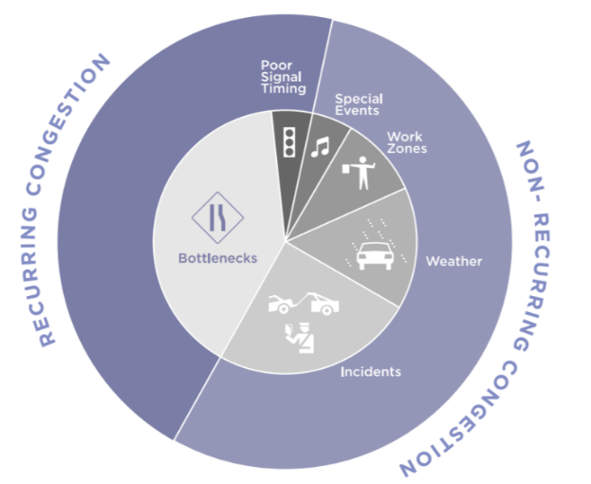
Source: FHWA, “Incorporating Travel Time Reliability into the Congestion Management Process: A Primer.”

Federal Requirements
The initial federal requirements for congestion management were introduced by the Intermodal Surface Transportation Efficiency Act (ISTEA) of 1991 and were continued under the successor law, the Transportation Equity Act for the 21st Century (TEA-21). The Safe Accountable Flexible Efficient Transportation Equity Act – A Legacy for Users (SAFETEA-LU) was passed into law in August 2005, and the requirements were further evolved under Moving Ahead for Progress in the 21st Century Act (MAP-21) signed into law on July 6, 2012.
Fixing America’s Surface Transportation Act, or the FAST Act, was passed on December 4, 2015. The FAST Act included the previous requirements for an MPO serving a population of greater than 200,000 to include a CMP. While the Charlotte County-Punta Gorda MPO Area does not exceed that threshold, Florida Statutes require that all MPOs develop a Congestion Management Process. Consistent with guidance provided by FHWA, the intent of the CMP Update is to “address congestion management through a process that provides for safe and effective integrated management and operation of the multimodal transportation system.” A summary of the key points of the CMP is provided in Figure 6-2.
Figure 6-2: Key Components of the Congestion Management Process

National Goals
A key feature of MAP-21 and continued in the FAST Act is the establishment of a performance-based program. The results of having a CMP is for MPO’s to develop priorities for funding projects that collectively will make progress toward the achievement of the following national goals:
- Safety to achieve a significant reduction in traffic fatalities and serious injuries
- Infrastructure condition to keep the highway infrastructure in good repair
- Congestion reduction to achieve a significant reduction in congestion on the National Highway System (NHS)
- System reliability to improve the efficiency of the surface transportation system
- Freight movement and economic vitality to improve the national freight network, strengthen the ability of rural communities to access trade markets, and support regional economic development
- Environmental sustainability to enhance the performance of the transportation system while protecting the natural environment
- Reduced project delivery delays to reduce project costs, promote the economy, and expedite the movement of people and goods by eliminating delays in project development and delivery, including reducing regulatory burdens and improving agencies’ work practices.

Congestion Management Process Eight Actions
Developing a CMP typically follows an approach consisting of eight-actions. The CMP looks at management and operations as well as other strategies, focusing on developing objectives that drive performance-based planning for responding to congestion.
The CMP is based upon objectives articulated in the LRTP. The CMP incorporates specific, measurable, agreed-upon, realistic, and time-bound objectives that reflect regional goals. And, as an integral part of the planning process, the CMP feeds projects and strategies directly into the LRTP and TIP. Figure 6-3 summarizes framework for the CMP process as described in the FHWA’s Congestion Management Process: A Guidebook.

Figure 6-3: Congestion Management Process 8-Step Framework

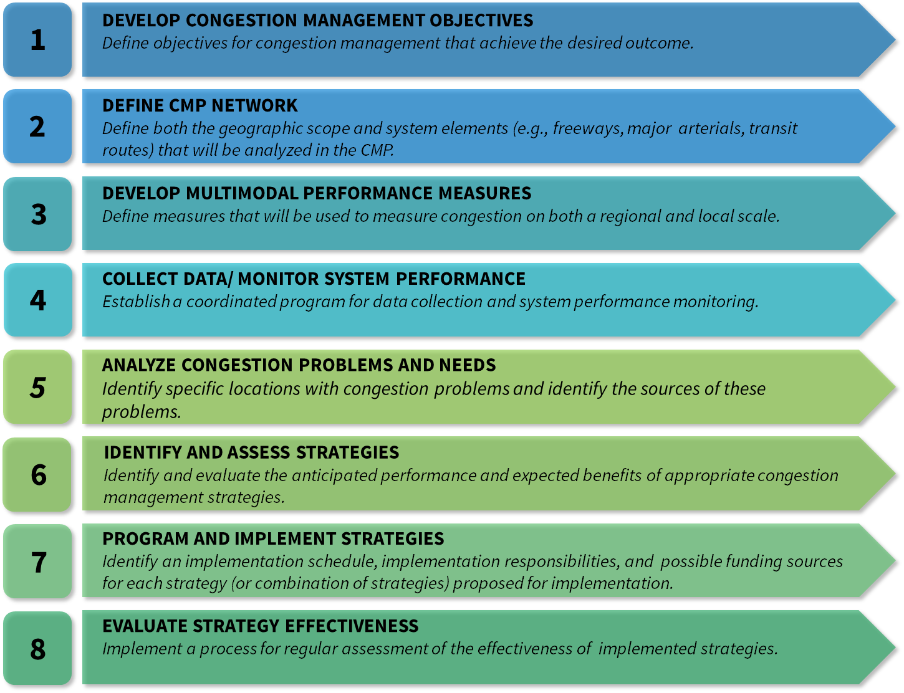
Source: Federal Highway Administration (FHWA), “Congestion Management Process: A Guidebook”, 2011.

Identifying Congested Areas
Using the Existing plus Committed network (discussed in Chapter 2), an assessment of projected roadway congestion was conducted using existing traffic counts and estimated growth rates. Traffic Counts collected by the City of Punta Gorda, Charlotte County and FDOT were assigned to the major roadway corridors. Using historic trends, future traffic volumes were estimated for the year 2024 to analyze the existing plus committed conditions. A complete listing of the results of this analysis is listed in Technical Report 6 and illustrated in Figure 6-4.
Identifying existing and projected deficiencies is one method of determining the future transportation needs. The roadway needs include projects to address expanded capacity as well as addressing safety operational and mobility needs.
Analysis of traffic crashes is another method of identifying areas of congestion. Figure 6-5 highlights the locations within Charlotte County when traffic congestion and hot spot crash locations are considered together. Locations along US 41, within the City of Punta Gorda and the I-75 at Kings Highway interchange appear as the congested and high-crash locations.
Figure 6-4: Existing Plus Committed Roadway Volume to Capacity Ratios
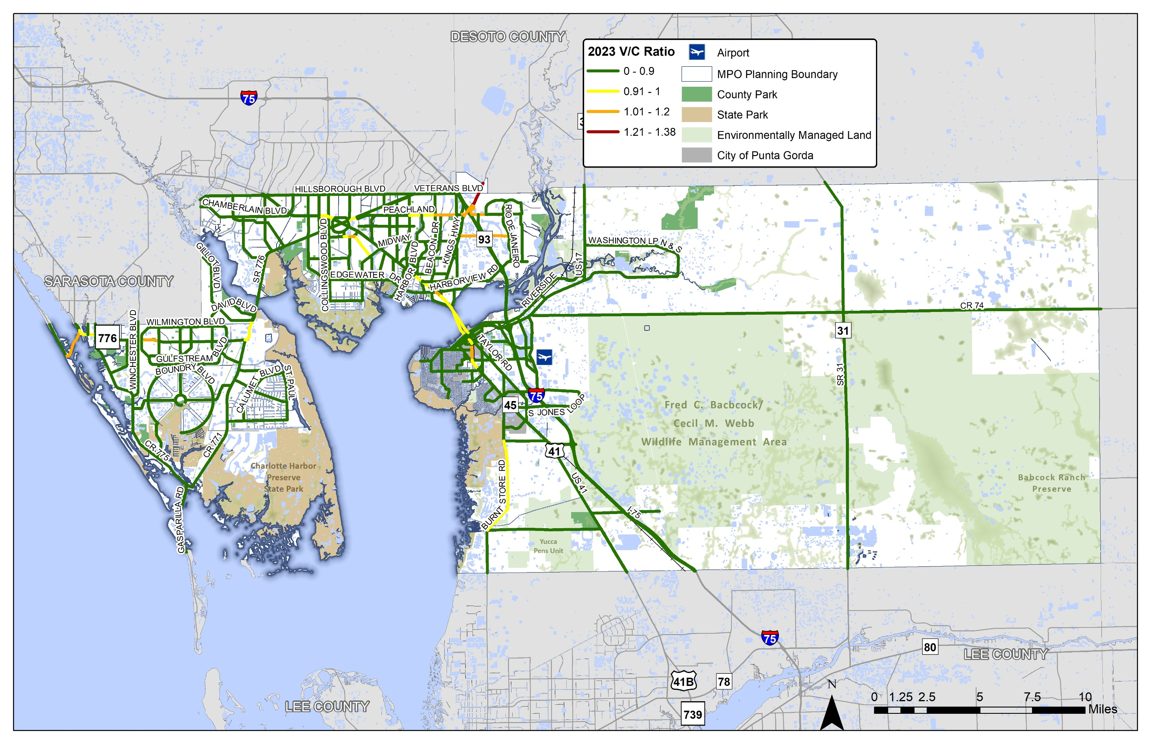
Figure 6-5: Congested and High Crash Locations
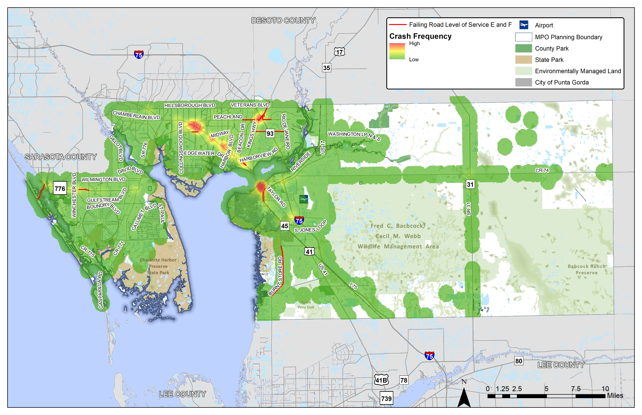

Analysis of Crashes
Providing and improving safety of the transportation system is crucial to the health and well-being of residents, visitors and business travelers in Charlotte County. As a federally required component of the metropolitan transportation planning process, safety is analyzed within this section through the combination of GIS and the FDOT’s Crash Analysis Reporting System (CARS).
Under the Federal Highway Safety Improvement Program (HSIP), five performance measures have been established for evaluating safe traveling conditions on the highway system. These measures became effective on April 14, 2016 and were developed to consider the safety of motorists, bicyclists, and pedestrians. The goal of the HSIP is to achieve a significant reduction in traffic fatalities and serious injuries on all public roads, supported by the following five performance measures established under MAP-21 and reinforced through the FAST Act.
PM 1 | Number of fatalities
PM 2 | Rate of fatalities  (measured against roadway traffic volumes)
PM 3 | Number of serious injuries
PM 4 | Rate of serious injuries  (measured against roadway traffic volumes)
PM 5 | Number of non-motorized (bicycle and pedestrian)  fatalities and serious injuries
In addition to reporting on the established performance measures, the Florida Department of Transportation (FDOT) and the MPO are now responsible for establishing annually reported targets for each of these five measures. The State of Florida and the MPO have adopted a Vision Zero approach for establishing safety targets. Appendix B includes a discussion of the Vision Zero targets.
Since crash data from any given year may have extreme peaks or valleys, a rolling five-year average of the data is used as the basis for evaluating crash patterns and trends. The visualizations and data analysis for 2045 LRTP utilized crash data from 2014 to 2018. Table 6-1 provides a complete summary of the crashes and analysis of the roadway conditions, causal factors, and severity of the resulting injuries. Figure 6-6 illustrates how the five-year averages of crashes have trended recently. A similar comparison of the fatalities and serious injury crashes in shown in Figure 6-7.
Maps illustrating the locations of fatalities (Figure 6-8), serious injuries (Figure 6-9), and non-motorized fatalities and serious injuries (Figure 6-10)are also included consistent with the federally required performance measures.
Table 6-1: Summary of Traffic Crashes from 2014-2018
Charlotte County |  | 2014 | 2015 | 2016 | 2017 | 2018 | 5-Year Total Crashes
Crash Type | Animal | 20 | 15 | 13 | 20 | 39 | 107
 | Angle | 354 | 411 | 434 | 415 | 436 | 2,050
 | Bike | 20 | 25 | 23 | 25 | 37 | 130
 | Head-On | 84 | 62 | 69 | 65 | 27 | 307
 | Left-turn | 242 | 274 | 290 | 309 | 325 | 1,440
 | Other | 1,604 | 2,056 | 2,071 | 1,992 | 1,464 | 9,187
 | Overturn | 31 | 56 | 42 | 57 | 88 | 274
 | Pedestrian | 37 | 22 | 27 | 30 | 70 | 186
 | Rear-end | 1,247 | 1,447 | 1,528 | 1,505 | 1,140 | 6,867
 | Right-turn | 43 | 38 | 41 | 41 | 54 | 217
 | Run Off-road | 266 | 226 | 229 | 240 | 536 | 1,497
 | Sideswipe | 346 | 429 | 531 | 529 | 257 | 2,092
 | Unknown | 189 | 109 | 117 | 114 | 809 | 1,338
 | Total | 4,483 | 5,170 | 5,415 | 5,342 | 5,282 | 25,692
Injury Severity | Fatal | 19 | 22 | 29 | 24 | 25 | 119
 | Incapacitating | 84 | 103 | 98 | 74 | 93 | 452
 | Non-Incapacitating | 285 | 384 | 310 | 360 | 331 | 1,670
 | Possible | 531 | 622 | 689 | 621 | 635 | 3,098
 | None | 3,564 | 4,039 | 4,289 | 4,263 | 4,198 | 20,353
 | Total | 4,483 | 5,170 | 5,415 | 5,342 | 5,282 | 25,692
Lighting Condition | Daylight | 3,537 | 4,031 | 4,301 | 4,272 | 4,242 | 20,383
 | Dawn | 56 | 51 | 56 | 60 | 66 | 289
 | Dusk | 128 | 146 | 132 | 108 | 111 | 625
 | Dark-Lighted | 451 | 575 | 586 | 578 | 544 | 2,734
 | Dark-Not Lighted | 265 | 337 | 314 | 301 | 288 | 1,505
 | Dark-Unknown Lighting | 46 | 30 | 26 | 23 | 31 | 156
 | Total | 4,483 | 5,170 | 5,415 | 5,342 | 5,282 | 25,692
Surface Conditions | Dry | 3,712 | 4,464 | 4,771 | 4,769 | 4,697 | 22,413
 | Wet | 509 | 654 | 592 | 528 | 555 | 2,838
 | Mud, Dirt, Gravel | 11 | 15 | 10 | 6 | 12 | 54
 | Oil | 0 | 0 | 1 | 1 | 0 | 2
 | Water (Standing, Moving) | 9 | 5 | 8 | 12 | 2 | 36
 | Other, Explain in Narrative | 5 | 0 | 7 | 8 | 4 | 24
 | Unknown | 237 | 32 | 26 | 18 | 12 | 325
 | Total | 4,483 | 5,170 | 5,415 | 5,342 | 5,282 | 25,692

Figure 6-6: Trend of Crashes in Charlotte County

Figure 6-7: Trend of Fatal and Serious Injury Crashes in Charlotte County

Figure 6-8: Fatal Crash Locations in Charlotte County (2014-2018)
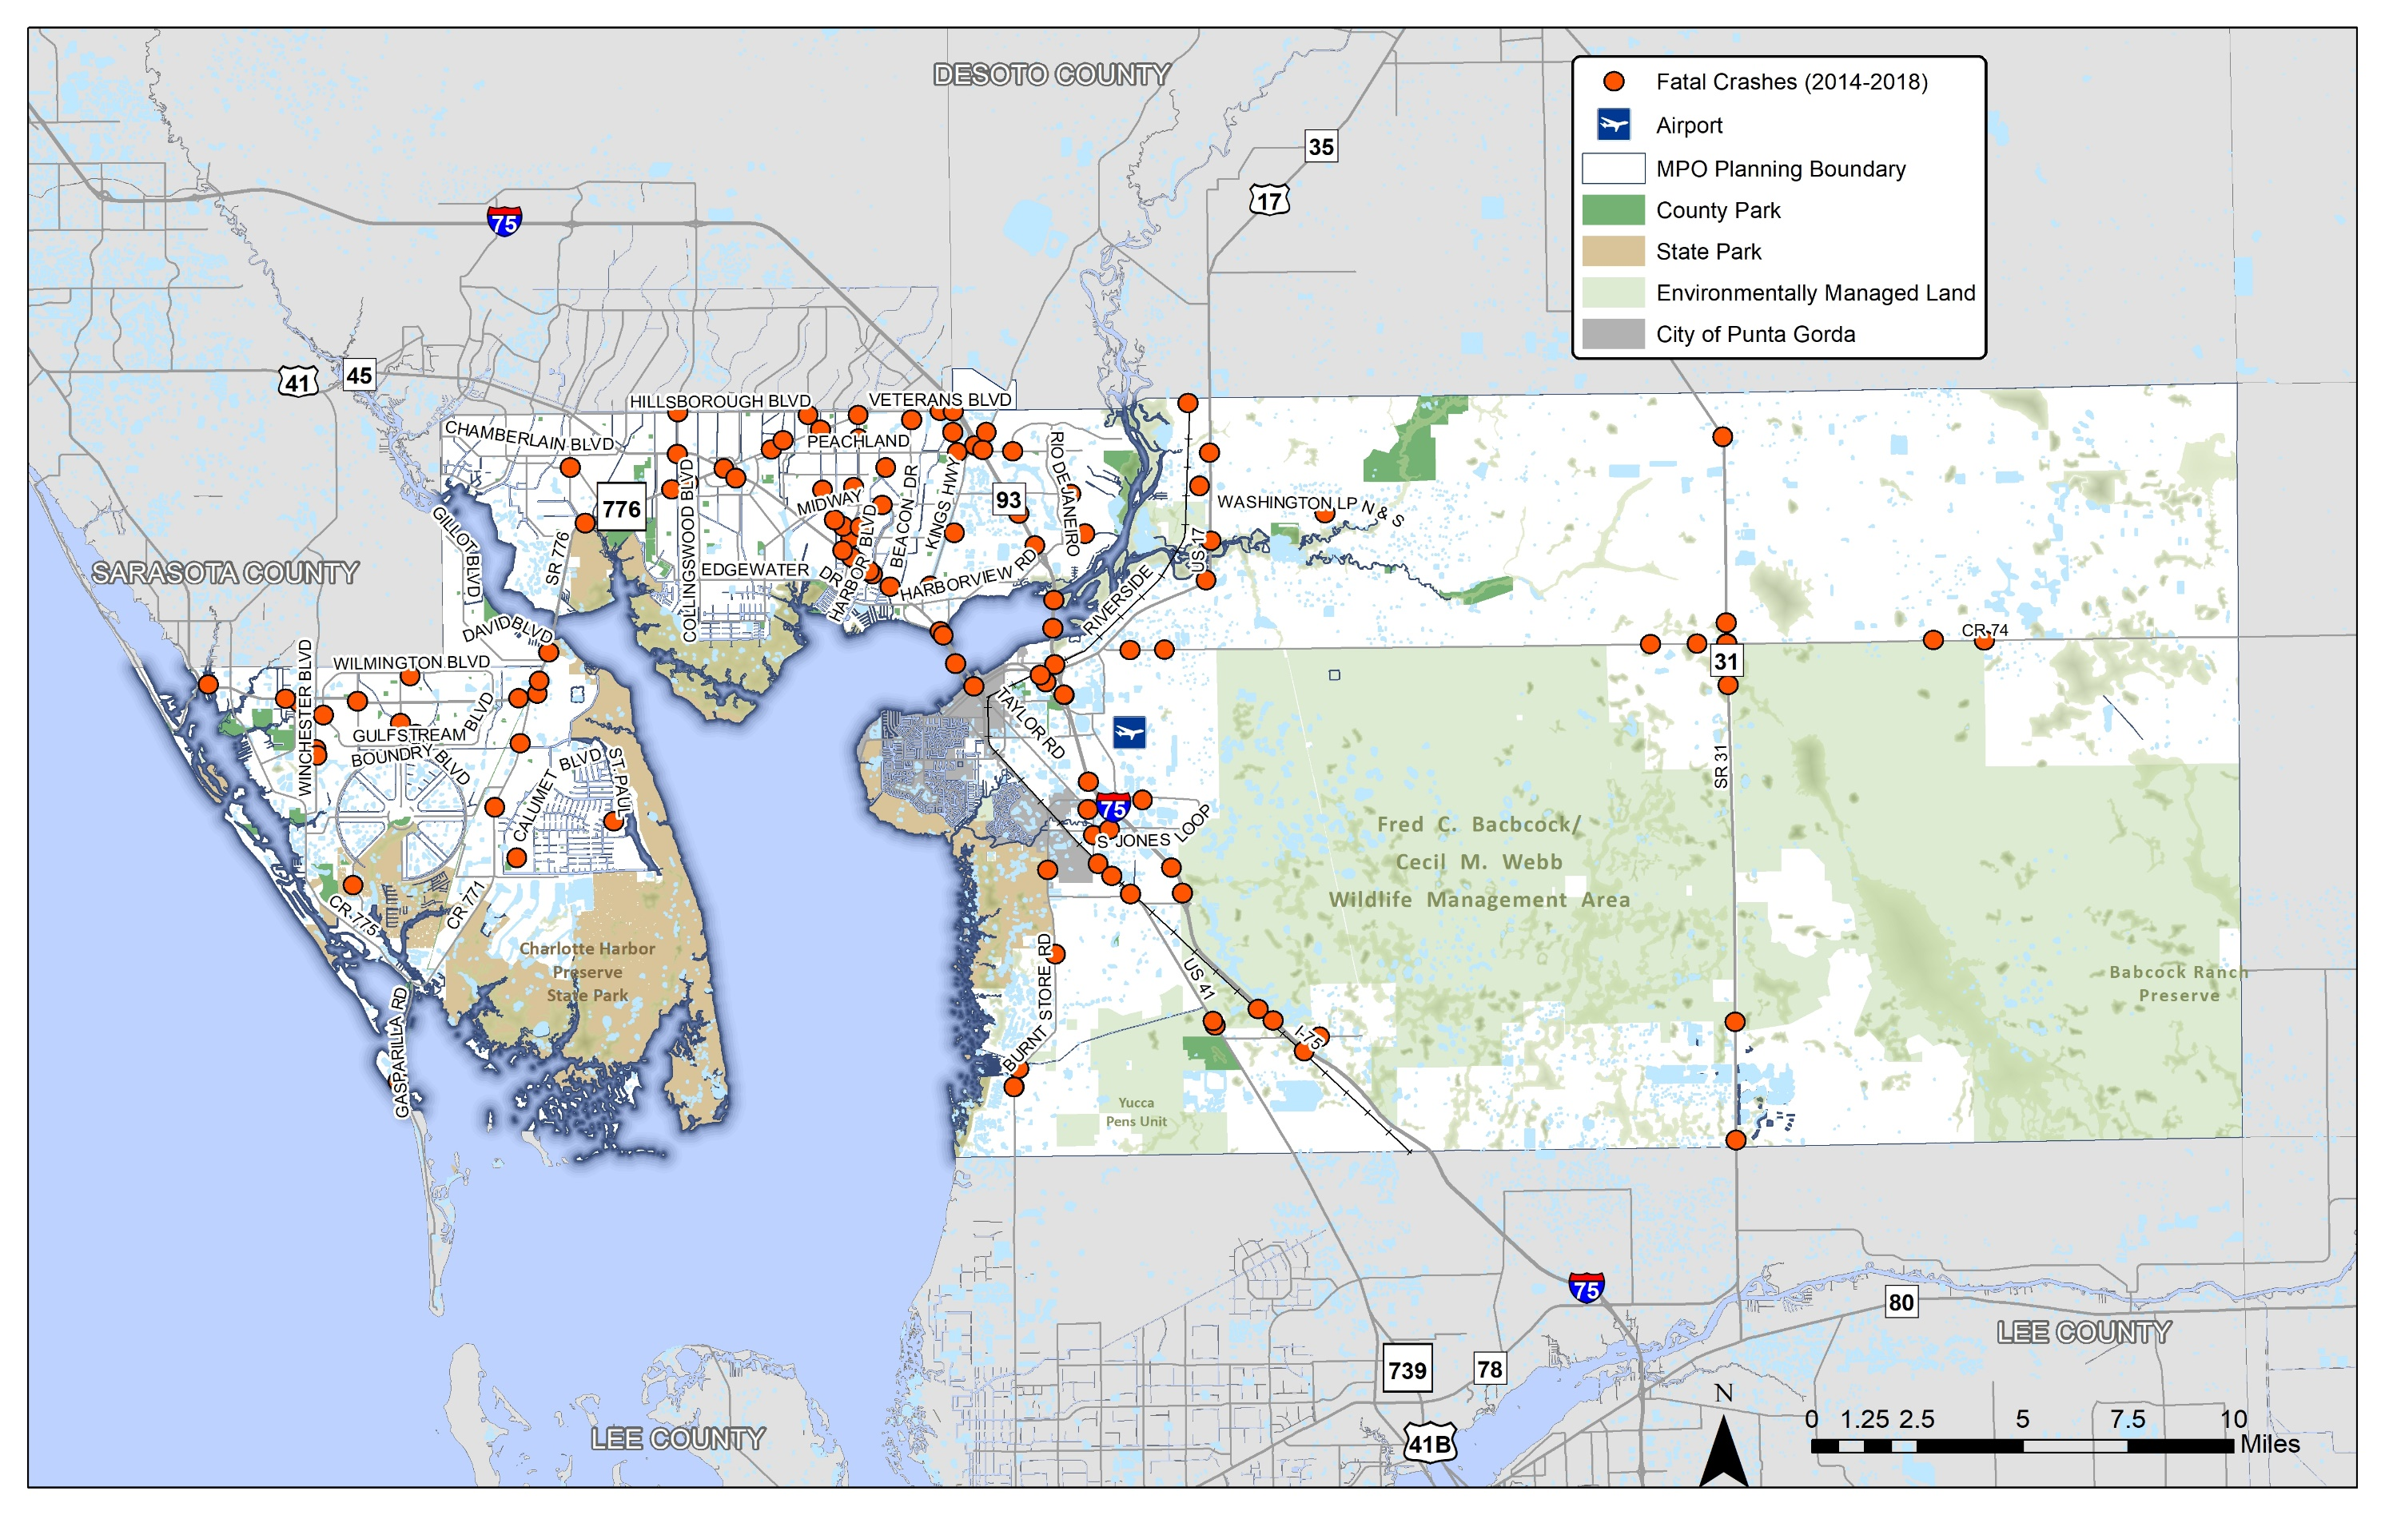
Figure 6-9: Serious Injury Crash Locations in Charlotte County (2014-2018)
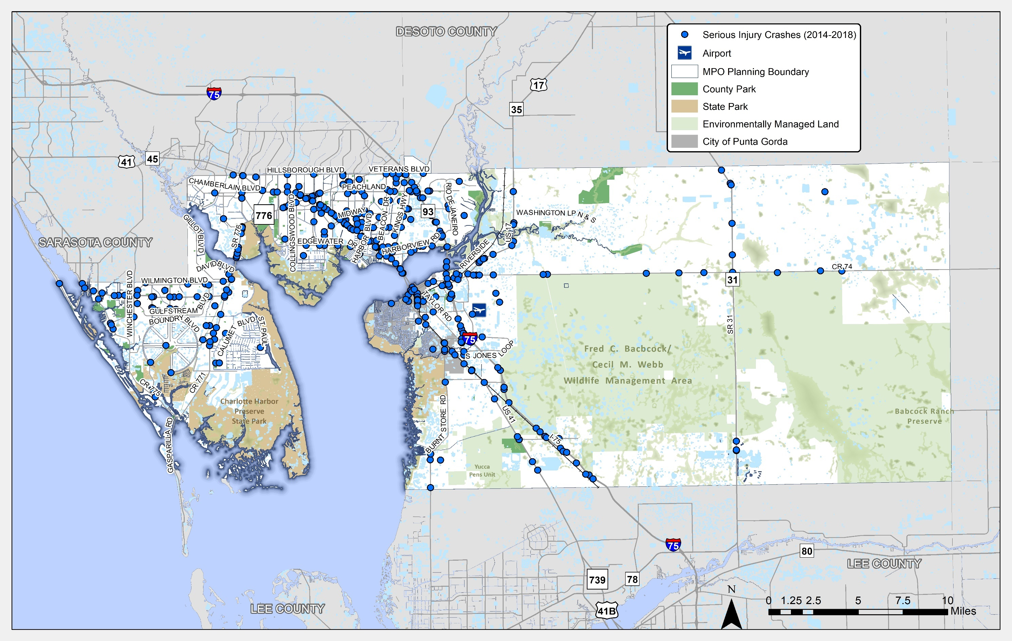
Figure 6-10: Non-Motorized Fatal and Serious Injury Crash Locations in Charlotte County (2014-2018)
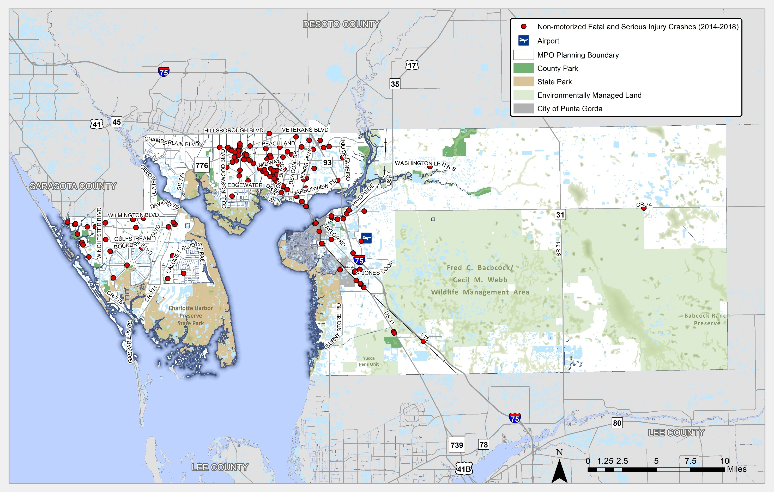

Congestion Reduction Strategies
The CMP uses a toolbox of strategies with multiple tiers to identify the most appropriate and effective projects for addressing congestion. The following approach used by other MPOs and promoted by FHWA is arranged so that the measures at the top take precedence over those at the bottom. The CMP Toolbox of Strategies is presented in Figure 6-11.
Figure 6-11: CMP Toolbox of Strategies
Tier 5: Add Capacity
The top-down approach promotes the growing sentiment in today’s transportation planning arena and follows FHWA’s clear direction to consider all available solutions before recommending additional roadway capacity. The CMP Toolbox of Strategies is divided into tiers, strategies, and specific examples.
Tier 1: Strategies to Reduce Person Trips or Vehicle Miles Traveled
- Transportation Demand Management (TDM) Strategies – These strategies are used to reduce the use of SOVs, as the overall objective of TDM is to reduce the miles traveled by automobile or to shift automobile travel outside the peak travel hours.
- Land Use/Growth Management Strategies – These strategies include policies and regulations that would decrease the total number of auto trips and trip lengths while promoting transit and non-motorized transportation options.
Tier 2: Strategies to Shift Automobile Trips to Other Modes
- Public Transit Strategies – Two types of strategies, capital improvements and operating improvements, are used to enhance the attractiveness of public transit services to shift auto trips to transit. Transit capital improvements generally modernize the transit systems and improve their efficiency; operating improvements make transit more accessible and attractive.
- Non-Motorized Transportation Strategies – Non-motorized strategies include bicycle, pedestrian, and multiuse path facility improvements that encourage non-motorized modes of transportation instead of Single-Occupant Vehicles (SOVs) trips.
Tier 3: Strategies to Shift Trips from Single-Occupant Vehicles (SOVs) to High-Occupancy Vehicles (HOVs)
- Transportation Demand Management Strategies – In addition to the TDM Strategies included in Tier 1, additional strategies are available in Tier 3 that encourage the use of ride-sharing and other forms of HOV implementation.
Tier 4: Strategies to Improve Roadway Operations
- Autonomous, Connected, Electric, and Shared-Use(ACES) – The strategies in ACES use new and emerging technologies to mitigate congestion while improving safety and environmental impacts. Typically, these systems are made up of many components, including sensors, electronic signs, cameras, controls, and communication technologies. ACES strategies are sets of components working together to provide information and allow greater control of the operation of the transportation system.
- Transportation Systems Management (TSM) strategies identify operational improvements to enhance the capacity of the existing system. These strategies typically are used together with ACES technologies to better manage and operate existing transportation facilities.
- Freeway Incident Detection and Management – This strategy addresses primarily non-recurring congestion, which typically includes video monitoring and dispatch systems and may also include roving service patrol vehicles.
- Access Management – This strategy includes adoption of policies to regulate driveways and limit curb cuts and/or policies that require continuity of sidewalk, bicycle, and multiuse path networks.
- Corridor Preservation – This strategy includes implementing, where applicable, land acquisition techniques such as full title purchases of future rights-of-way and purchase of easements to plan proactively in anticipation of future roadway capacity demands.
- Corridor Management – This strategy is applicable primarily in moderate- to high-density areas and includes strategies to manage corridor rights-of-way. The strategies range from land-use regulations to landowner agreements such as subdivision reservations, which are mandatory dedications of portions of subdivided lots that lie in the future right-of-way.
Tier 5: Strategies to Add Capacity
Strategies to add capacity are the costliest and least desirable strategies and should be considered as last-resort methods for reducing and managing congestion. As the strategy of cities trying to “build” themselves out of congestion has not provided the intended results, capacity-adding strategies should be applied after determining the demand and operational management strategies identified earlier are not feasible or are insufficient in their mitigative impact. The key strategy in Tier 5 is to increase the capacity of congested roadways through additional general-purpose travel lanes.

Selected Strategies for the LRTP
This step involves implementing and managing the defined strategies. The congested corridors can be screened for application of the strategies above. However, New strategies may be added and/or removed based on the prevailing conditions and local decisions.
Managers of the CMP should work closely with the operating agencies that have participated in the CMP. Information developed throughout the process should be applied to establish priorities in the TIP, thereby facilitating the implementation of the CMP. This ensures a linkage between the CMP and funding decisions either through a formal ranking and weighting of strategies and projects, or through other formal or informal approaches.

Traffic Signals and Intelligent Transportation Systems
An essential component to provide for safe and effective operation of a transportation system includes the traffic control devices that impact capacity of the roadway network but can improve safety and efficiency through traffic signal timing and incident management via adjustments made by the Charlotte County Traffic Management Center (TMC) staff. As a study prioritized by the MPO and funded for completion next year, the ITS Master Plan will provide guidance for relevant ITS technologies and discuss project implementation priorities throughout the County. ITS technology projects that should be considered within the ITS Master Plan should provide congestion mitigation and safety improvements. These types of projects include but are not limited to dynamic messaging, advanced traveler information systems, integrated corridor management, transit signal priority, and support for operational strategies and improvements. Figure 6-12 provides an overview of the 100 traffic signals currently communicating with the TMC, 13 isolated signals that are not connected and the location of 65 Closed Circuit Television (CCTV) cameras used for traffic monitoring.

Figure 6-12: Traffic Signals and ITS
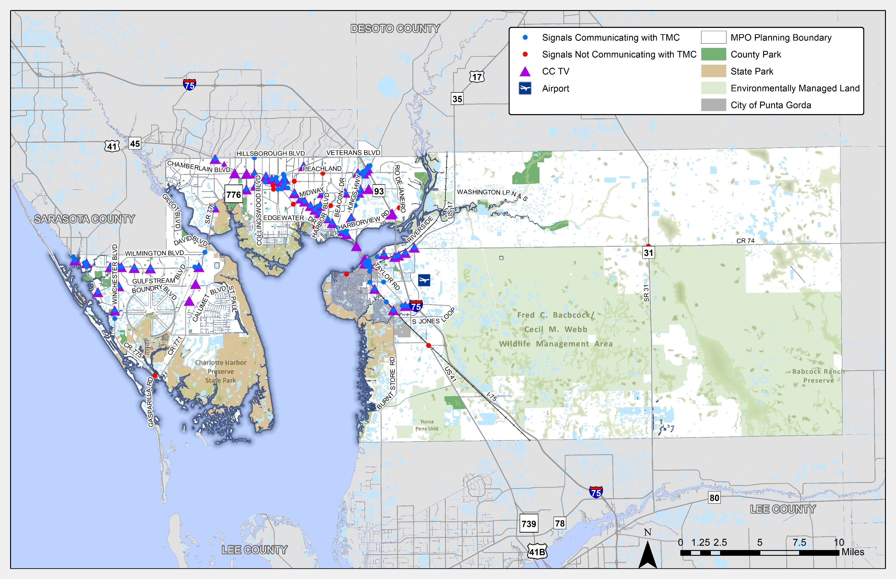

Priority Intersections and Corridors
To improve how traffic operates and the safety of those using the transportation system, strategies for improving the function of roads or reducing travel demand were identified. The MPO has prioritized improvements at intersections and along key corridors consistent with the crash and congestion analysis. Figure 6-13 shows the specific intersection along SR 776, US 41 and US 17 at SR 31 where the MPO has prioritized funding for intersection improvements.
FDOT has conducted the US 41 Corridor Vision Plan which includes a series of mobility and safety related strategies for the corridor that align with the community’s vision. Strategies identified in the study were grouped into categories of Design, Traffic/Speed/Safety, Planning and Project Development, Aesthetics and Landscaping, Transit and Bicycle/Pedestrian Improvements, and Freight. Additional information on the study recommendations is available at the project website (http://www.swflroads.com/us41charlottevision/).
SR 776 serves as the only connection in Charlotte County across the Myakka River. The MPO has identified this critical transportation corridor as a priority. Future study and evaluation of this corridor will provide the MPO and FDOT with the specific strategies and locations for future transportation investments.
A list of the CMP Projects included in the Cost Feasible Plan are listed below in Table 6-2. Additional information on project costs and timing are included in Chapter 8.
Table 6-2: Cost Feasible Congestion Management Projects
Facility | From | Project Description
SR 776 Future Corridor Study | From Pine Street/Placida Rd to US 41 | Future Corridor Study
Taylor Rd | From Airport Rd to US 41 | Complete Streets
Marion Avenue / Olympia Avenue | From US 41 to Marlympia Way | Lane Repurposing - resurface and striping
US 41 Corridor Vision Plan |  | Corridor & Safety Improvements
SR 31 | @ CR 74 | Roundabout
SR 776 | @ Flamingo Blvd | Intersection - turn lanes
US 41 | @ Easy Street | Intersection - turn lanes
US 41 | @ Forrest Nelson | Intersection - turn lanes
SR 776 | @ Jacobs St | Intersection - turn lanes
US 41 | @ Carousel Plaza | Intersection - turn lanes
SR 776 | @ Charlotte Sports Park | Intersection - turn lanes
ITS Master Plan Implementation
SR 776 | @ Gulfstream Blvd / Wilmington Blvd | Intersection - turn lanes
SR 776 | @ Biscayne Blvd | Intersection - turn lanes
SR 776 | @ Cornelius | Intersection - turn lanes
Kings Hwy / Peachland / Veterans |  | Intersection Modification

Figure 6-13:MPO Prioritized Traffic Signals and ITS Projects
