Environmental /
Socio-Cultural Effects &
Environmental Justice

Environmental Mitigation
Transportation projects can significantly impact many aspects of the environment including wildlife and their habitats, wetlands air quality, and groundwater resources. In situations where impacts cannot be completely avoided, mitigation or conservation efforts are required. Environmental mitigation is the process of addressing damage to the environment caused by transportation projects or programs. The process of mitigation is best accomplished through enhancement, restoration, creation and/or preservation projects that serve to offset unavoidable environmental impacts. In the State of Florida, environmental mitigation for transportation projects is completed through a partnership between the MPO, FDOT, and regulatory agencies, such as Water Management Districts and the Florida Department of Environmental Protection and the US Environmental Protection Agency among others.
When addressing mitigation there are general guidelines and protocols associated with avoiding impacts, minimizing impacts, or mitigating for impacts when impacts are unavoidable. These guidelines can be applied at the planning level, when MPOs are identifying areas of potential environmental concern during the development of a transportation project. Environmental mitigation activities include the following:
- Avoidance of impacts altogether
- Minimizing a proposed activity/project size or its involvement
- Repairing, rehabilitating, or restoring the affected environment
- Reducing or eliminating impacts over time through preservation and maintenance
- Compensating for environmental impacts by providing appropriate or alternate environmental resources of equivalent or greater value, on or off-site.
Table 5-1 outlines potential environmental mitigation opportunities which can be considered when addressing environmental impacts from future projects listed in the LRTP. Preparing for specific mitigation strategies can be challenging over the course of the long-range transportation plan. Unforeseen funding circumstances or natural disasters such as, global or statewide pandemics, hurricanes, tornadoes, flooding, fire hazards, permitting disputes between regulatory agencies are common challenges to environmental mitigation. Such challenges can be met by a well planned and executed public involvement program. Additionally, the preparation of Efficient Transportation Decision Making (ETDM) processes and utilization of Environmental Screening Tools. These approaches provide assurance that mitigation opportunities are identified, considered, evaluated, and viable as the plan is developed and projects are advanced. Through these approaches, the State of Florida along with its MPO partners ensures that mitigation will occur to offset the adverse effects of proposed transportation projects.
Mitigation of transportation impacts to air quality is also an important consideration of the MPO’s decision making process. Because vehicle emissions pollute the air, improving air quality and reducing congestion can be accomplished through funding of multimodal transportation solutions. The evaluation known as air-quality conformity is required by the Clean Air Act which was revised last in 1990. This evaluation compares the transportation related emissions resulting from travel and the funding decisions included in the MPO’s plans to determine if future air quality will meet the clean air standards. Data collected from air monitoring stations is used to determine if current air quality standards are being met. Since Charlotte County has been designated as an area that meets the current standards, an evaluation of future air quality is not required. However, the MPO still pursues a blend of multimodal transportation projects in an effort to maintain clean air for the region. Focusing on bicycle and pedestrian modes of travel and improvements to intersections where traffic is congested are ways the MPO is looking to mitigate for the air quality impacts of transportation.
Table 5-1: Potential Environmental Mitigation Strategies
Resource / Impacts | Potential Mitigation Strategies
Wetlands and Water Resources | - Restore degraded wetlands  - Create new wetland habitats  - Enhance or preserve existing wetlands  - Improve storm water management  - Purchase credits from a mitigation bank
Forested and other natural areas | - Use selective cutting and clearing  - Replace or restore forested areas  - Preserve existing vegetation
Habitats | - Construct underpasses, such as culverts for animal crossings  - Design measures to minimize fragmenting animal habitats
Rivers/Streams | - Stream restoration  - Vegetative buffer zones  - Strict erosion and sedimentation control measures
Threatened or Endangered Species | - Preservation  - Enhancement or restoration of degraded habitat  - Creation of new habitats  - Establish buff areas around existing habitat

Resiliency
As a precursor to the 2035 LRTP, the MPO partnered with the Department of Urban and Regional Planning at Florida State University to conduct a Hazard Mitigation Study. The study identified roadways vulnerable to flooding and natural threats including Sea Level Rise and Storm Surge. As part of the project prioritization, the MPO has continued to use this study and incorporate updated information for identifying potential cost feasible projects. Updated information used include the National Oceanic and Atmospheric Administration’s updated 2020 flood plain maps and the medium sea level rise prediction from the University of Florida’s Sea Level Scenario Sketch Planning Tool. While roadways susceptible to sea level rise received the highest scores, this is assuming these roadways will be designed and engineered with mitigation features for dealing with sea level rise and not for prioritizing additional roadways in vulnerable areas.

Socio-Cultural Effects and Environmental Justice
Environmental Justice (EJ) is broadly defined by the Federal Highway Administration as “identifying and addressing disproportionately high and adverse effects of the Federal Highway Administration’s programs, policies and activities on minority and low-income populations to achieve an equitable distribution of benefits and burdens.” The FWHA considers EJ in all phases of project development including planning, environmental review, design, right-of-way, construction, and maintenance and operations. The FHWA also considers EJ in all other programs and activities, including public involvement, freight planning, safety, Tribal consultation, and the Title VI civil rights program. Outside of EJ and Title VI, federal laws protect a variety of other groups including, but not limited to: the elderly, the disabled, and those who have Limited English proficiency (LEP).
Like many Florida Counties, Charlotte County is made up of mix of ethnicities, incomes, and individuals of diverse needs. Identifying concentrations of populations with diverse needs across the county will aid in assessing the demands and impact upon Charlotte County’s transportation and transit system and help target public investments to areas with specific needs in an efficient manner.
A geographic analysis was conducted to identify census block groups with higher concentrations of each of the EJ factors to produce Equity Assessment Areas. To identify these areas, a GIS-based Transportation Planning Equity Tool was used to objectively identify concentrations of EJ areas and other protected groups, as well as develop a composite of indicators that identifies high concentrations of people traditionally underrepresented in the Transportation Planning Process. Technical Memorandum 5 provides a detailed description of the methodology and framework used to rank block groups for the composite scores.
The following six factors, based on socio-economic measures obtained from the U.S. Census Bureau’s 2017 American Community Survey (ACS) 5-year estimates, were evaluated to identify Equity Assessment Areas and other protected groups, in Charlotte County.
- Non-white/non-Hispanic: percentage of the population that identify themselves as a race other than white or of Hispanic ethnicity.
- Hispanic: percentage of the population that identify themselves as of Hispanic origin.
- English proficiency: percentage of people five years of age or older who identified as speaking English less than ‘very well.’
- Age 65 or older: percentage of population age 65 or older.
- Zero vehicle households: percentage of population without access to a vehicle.
- Below Poverty: Low-Income persons are defined as persons or households whose median household income is at or below the U.S. Department of Health and Human Services (HHS) poverty guidelines. The 2019 HHS guidelines are presented in Table 5-2. The 2017 ACS 5-year dataset uses the 2019 HHS poverty guidelines to determine how many households are considered low-income in the county. For reference, the county-wide average household size is 2.31 persons with an average median income is $46,511.
Figure 5-1 illustrates the Environmental Justice areas resulting from this Equity Assessment within Charlotte County Punta Gorda region.
Table 5-2: 2019 Federal household and poverty thresholds
Persons in Family/Household | Poverty Guideline
1 | $12,490
2 | $16,910
3 | $21,330
4 | $25,750
5 | $30,170
6 | $34,590
7 | $39,010
8 | $43,430
Source: https://aspe.hhs.gov/poverty-guidelines
Note: For families/households with more than 8 persons, add $4,420 for each additional person.
The LRTP development process included efforts to assess countywide performance of transportation projects regarding socio-cultural effects and environmental justice. The process also seeks to ensure equal access to transportation systems and the transportation planning process. The analysis focuses on areas with a high concentration of minority, low-income, and other traditionally under-served and under-represented populations. Technical Report 6 includes additional details on the prioritization process and Technical Report 5 provides analysis of transportation investment in EJ areas.

Facility Inventory
In addition to identifying Equity Assessment Areas a community facilities inventory to evaluate the level of access provided by LRTP projects. Community-based facilities in Charlotte County were inventoried to identify major trip generators or employers within the county and that are likely to attract a variety of population segments due to their community-oriented nature. Community facilities and services are important for maintaining quality of life; not only are the amount and distribution of these facilities and services important, but a person’s ability to access them is an equally important consideration for the LRTP. Community facilities included parks and recreation facilities, libraries, schools, and hospitals. The assessment was performed using GIS software. The community facilities inventory was verified and updated as needed for the 2045 LRTP.
Table 5-3 provides summary information on community facilities and services in Charlotte County and Figure 5-2 shows their locations. Future transportation projects that provide greater access to these community facilities will have positive social-cultural impacts.
Table 5-3: Summary Information on Community Facilities
Facility Type | Number of Facilities
Churches | 186
Parks | 76
Schools | 37
Public Facilities | 26
Fire Stations | 18
Hospital/Clinics | 4
Libraries | 4
Airports | 2
Source: Charlotte County GIS

Figure 5-1: Environmental Justice Equity Areas
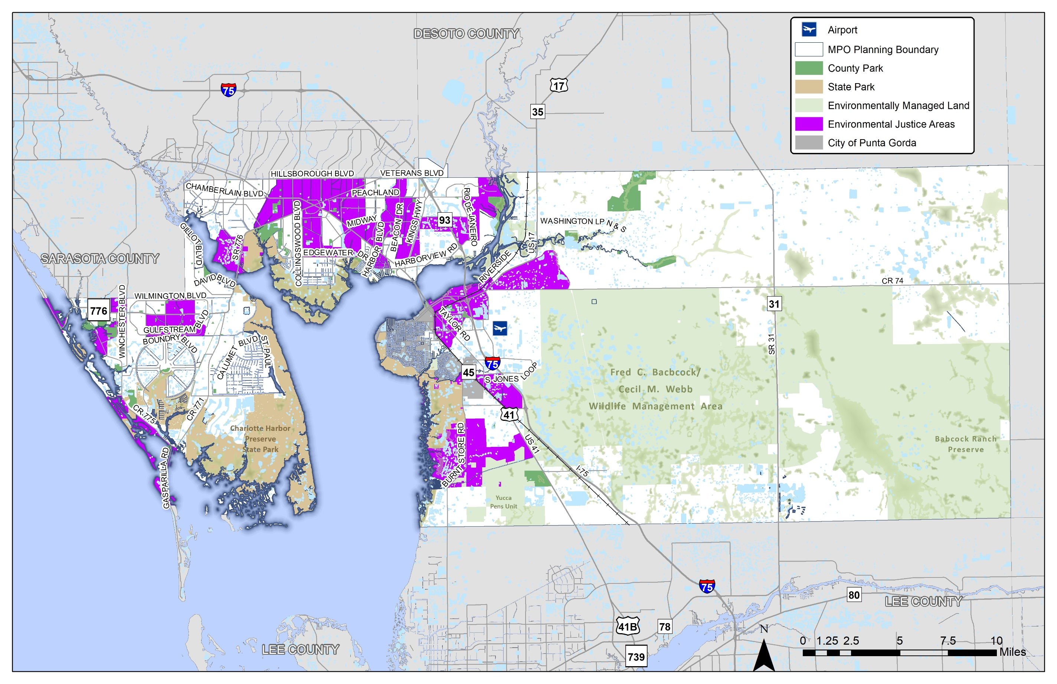
Figure 5-2: Community Facilities
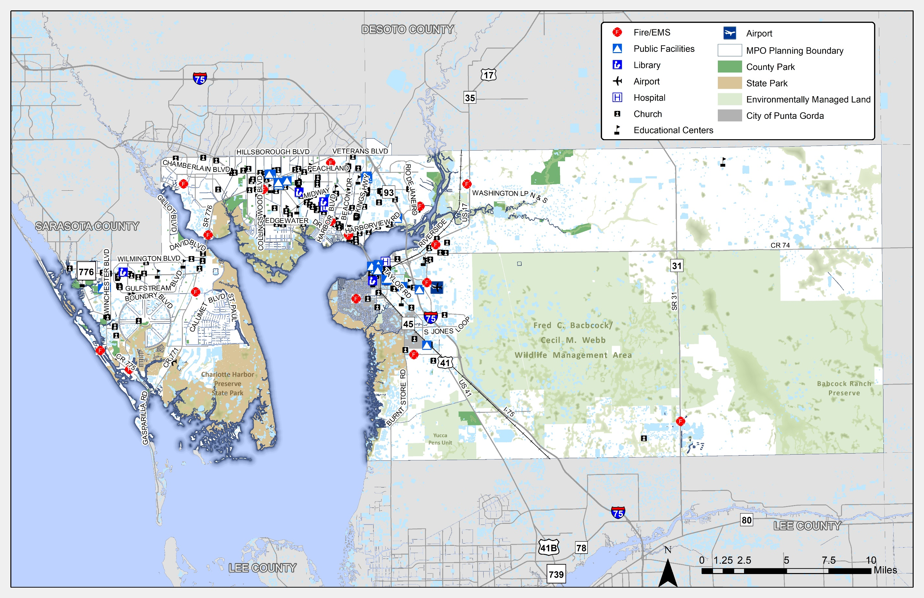

https://www.fhwa.dot.gov/environment/environmental_justice/ej_at_fhwa/

