2045 LRTP Public Participation

Public Participation
Public involvement is a crucial part in building a credible and trusting relationship between transportation agencies and the community they serve. Successfully engaging a broad cross-section of residents, visitors, business owners, employers, agencies, advocacy groups and other interested parties enables the Metropolitan Planning Organization (MPO) to create a vision for the future that serves its constituents. Effective engagement fosters partnerships, builds awareness, and educates stakeholders about the transportation planning process, and attempts to promote active listening and fruitful, two-way dialogue. To be in consistent with Title VI of the Civil Rights Act of 1964 and the Americans with Disabilities Act of 1990, the public involvement efforts recognized and addressed potential obstacles to participation in the planning process. Special attention was paid to participation of minority, low-income and transit-dependent individuals, and those with a low English proficiency. To ensure full and fair participation in the transportation decision-making process by all potentially affected citizens, the MPO provided public notice and allowed for public comment at key decision points in the Long Range Transportation Plan (LRTP) update process. This included outreach efforts for obtaining active public involvement early in the planning and document preparation process.
As a condition to receive federal transportation capital and planning assistance, the MPO must comply with Federal and Florida State requirements in addressing public involvement in transportation planning. The MPO meets public involvement requirements set forth in 23 C.F.R. 450.316 and Title 23 of the United States Code at the Federal level and Section 339.175 of the Florida Statutes. Chapter 339 requires citizens, public agencies and other known interested parties be provided a reasonable opportunity to comment and provide input on the LRTP. To meet this requirement, a specific 2045 LRTP Public Involvement Plan (PIP) was developed to ensure that federal requirements for public participation were met. This PIP is consistent with the MPO’s adopted Public Participation Plan (PPP), and served a resource for the public as the LRTP was being updated.

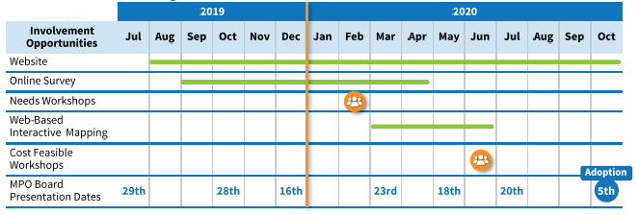
Public Involvement Activity Schedule in the Route to 2045 Newsletter

Public Involvement Activities and Communication Tools
Effective public participation relies upon the use of a broad spectrum of techniques to gather input. The following tools and strategies were used to reach out to the public and provide a forum for open discussion and opportunities to comment on the 2045 LRTP:
- Stakeholder Interviews  - Board & Committee Meetings  - Press Releases and Public Notices  - Email Blasts  - Newsletters  - Online Surveys  - Project Branded Business Cards | - In-Person Workshops  - Virtual Workshops  - TV and Newspaper Interviews  - Project Webpage  - Online Interactive Mapping  - Print and Social Media Ads  - Video Aired on CCTV and Website
A key communication tool used to communicate with the public was to prepare the business cards shown below. These cards were distributed in public gathering spaces and included information about the LRTP. A QR code was included which, when scanned using a mobile device, directed indiviudals to the MPO’s website for more information.
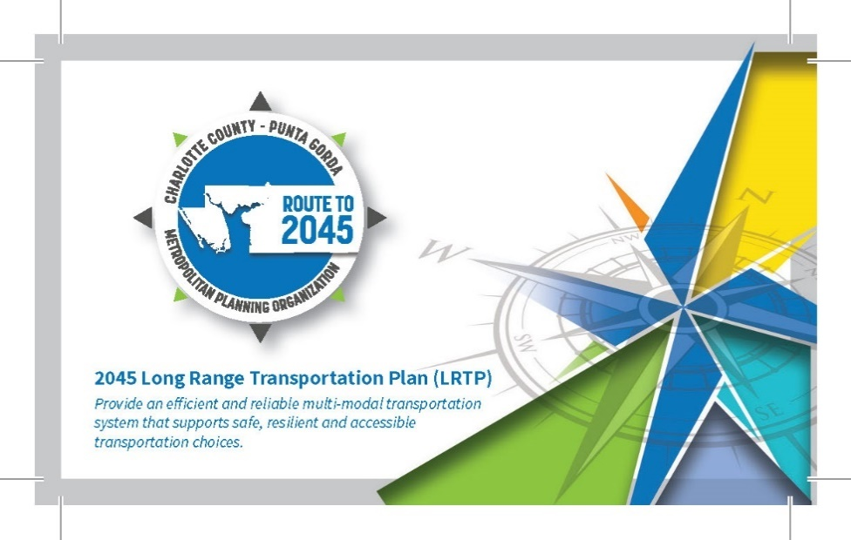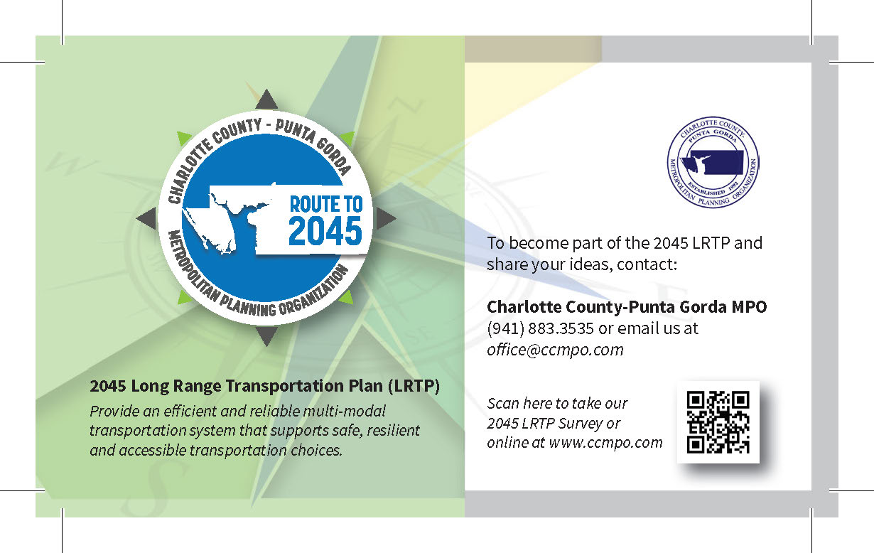
Additional strategies and tools used for communicating with the public are included in the following sections and desribed more fully in Technical Report 2.
As a result of the outreach and engagement of the public, more than 800 people participated in the development of the 2045 LRTP. Figure 4-1 provides a summary of Route to 2045 public involvement activities and the number of participants involved.

Figure 4-1: Summary of Route to 2045 Public Involvement Activities
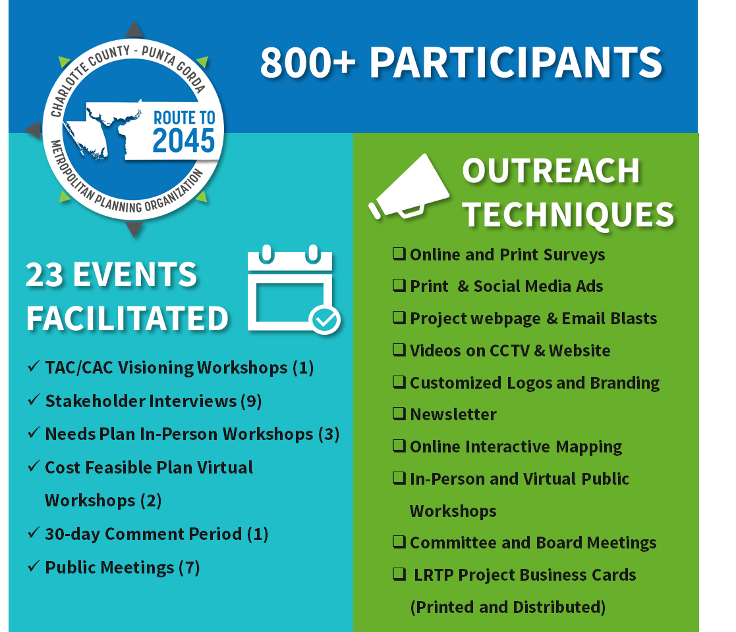

Public Involvement Approach
The public involvement activities were divided into three phases that engaged the public, local stakeholders, and elected leaders (Figure 4-2). Phase I was designed to establish the vision for 2045 and “big picture” transportation topics. Phase II focused on the technical work of identifying transportation needs and improvements throughout the MPO’s planning area. Phase III prioritized transportation projects evaluated projects for cost feasibility and identified steps for implementation.
In addition to specific outreach and engagement activities with the public, monthly updates were provided to the MPO Board, Technical Advisory Committee (TAC), Bicycle/Pedestrian Advisory Committee (BPAC), and Citizens’ Advisory Committee (CAC) throughout the LRTP update. Opportunities for public comment were provided at each of these meetings as well.
Figure 4-2: Public Involvement Phases and Activities

Phase I: Visioning and Big Picture
Phase I of public involvement consisted of interviews with key stakeholders and briefings with the MPO Board and the Technical and Citizen Advisory Committees. These engagement activities were used to gather input from elected officials and stakeholders on the transportation system, future growth, economic development trends, and future transportation needs.

Stakeholder Interviews
In-person and phone interviews were conducted in June and July 2019 with nine key stakeholders interviewed. The goal of the interviews was to obtain input on future growth and transportation investments needed to best serve all of Charlotte County through the year 2045. Key comments and recurring themes from these interviews helped to frame and guide later public involvement activities throughout Plan development. The main transportation themes from the interviews included preserving existing transportation infrastructure, improving freight movement, and improving safety and transportation options for pedestrians and bicyclists. Table 4-1 provides a list of those contacted and interviewed as a part of Route to 2045 outreach efforts.
Table 4-1: Stakeholder Information
Name & Position | Organization
Raymond Sandrock, County Administrator | Charlotte County
Howard Kunik, City Manager | City of Punta-Gorda
Wendie Vestfall, Tourism Development Director | Punta Gorda/Englewood Beach Visitor and Convention Bureau (VCB)
Micah Richins, Chief Operating Officer | Sunseeker Resorts
Gary Nelson, Senior Vice President of Planning and Development | Kitson & Partners (Babcock Ranch)
Jim Parrish, Chief Executive Officer | Charlotte County Airport Authority
Jennifer Hecker, Executive Director | Charlotte Harbor National Estuary Program (CHNEP)
Dave Gammon, Director | Charlotte County Economic Development
Shane Simmons, President | Cheney Brothers Inc.

Prior to the LRTP update, Charlotte County Transit conducted stakeholder interviews in January and February of 2019 as a part of the 2020-2029 Transit Development Plan (TDP) update. These interviews were conducted to gather input from policy, agency, and community leaders regarding the future of the Charlotte County Transit System (CCT). Main themes from the TDP stakeholder interviews indicated the need for more transit options in Charlotte County, including innovative solutions to increase access to key employment and commercial hubs on the US-41 corridor. Additionally, transit services that accommodate the needs of older adults was emphasized in the interviews. The responses from the interviews and main themes from the TDP were taken into consideration and incorporated into the 2045 LRTP update to provide more input on transit service. Table 4-2 shows the list of stakeholders contacted and interviewed in the 2020-2029 TDP update.
Table 4-2: Charlotte Rides TDP Stakeholder Information
Name & Position | Organization
Ken Doherty, Chairman | Board of County Commissioners
Christopher Constance, Commissioner | Board of County Commissioners
Bill Truex, Commissioner | Board of County Commissioners
Stephen R. Deutsch, Commissioner | Board of County Commissioners
Joe Tiseo, Commissioner | Board of County Commissioners
Gordon Burger, Director | Budget & Administrative Services
Carrie Hussey, Director | Human Services
Dave Gammon, Interim Director | Economic Development
Larry Brown, Officer, Veterans Affairs | Local Coordinating Board
Cornelius Moore, Florida Dept. of Children & Families | Local Coordinating Board
Mike Mansfield, CEO/Executive Director Charlotte County Habitat for Humanity | Transportation Disadvantaged Local Coordinating Board
Cindy Montgomery, Workforce Development | CareerSource Southwest Florida-LCB Member
Angie Matthiessen, Executive Director | United Way of Charlotte County
Nancy Johnson, Chief Executive Officer | TEAM Punta Gorda
Eric DeYoung, President | TEAM Punta Gorda
James W. Herston, Business Owner | Charlotte Harbor Redevelopment Agency (CRA) Advisory Committee
Lucienne Pears, Vice President of Economic and Business Development | Kitson & Partners (Babcock Ranch)
Stephen Carter, Member Chair | TEAM Parkside and Bicycle Pedestrian Advisory Committee

MPO Board and Committee Visioning Meetings
The visioning workshops were designed to gather input from the MPO Board and TAC/CAC Advisory Committees regarding the direction and the vision for the 2045 LRTP. The workshops were held on July 17, 2019 and July 29, 2019 as noted in Table 4-3. Two activities were conducted at the workshops to solicit feedback regarding current and future transportation needs in the County. The first activity was a headliner activity to envision the most desired and most feared newspaper headlines in 2045. Figure 4-3 shows the range of headlines that were received from Board and Committee members for this activity. The second activity included a series of questions where Board and Committee members provided their input regarding future growth, transportation funding, and investment in transportation modes. A full list of responses and results from these workshops are included in Technical Report 2.
Table 4-3: Phase I Committee and Board Workshops
Meeting and Date | Participants
TAC / CAC Visioning Workshop (7/17/19) | 19
MPO Board Kick-Off Meeting/ Visioning Workshop (7/29/19) | 16

Figure 4-3: Best Newspaper Headlines for Year 2045
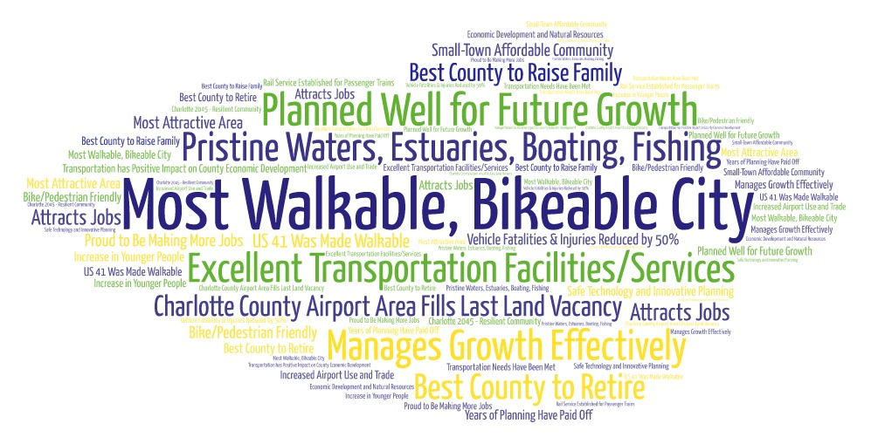

Newsletter
A newsletter was prepared and distributed to keep the MPO partners and the public informed and updated on the 2045 LRTP process. The newsletter outlined the overall framework of the LRTP and provided information on how to get involved in the LRTP process. The newsletter was written in a citizen friendly style and targeted for a non-technical audience, using infographics to convey concepts in a user-friendly manner. Electronic versions of the newsletter were distributed via the MPO’s website and through an e-mail blast utilizing the MPO’s contact list.

Public participation and opportunities for comment were provided at each MPO Board and Committee Meeting.
Figure 4-4: 2045 LRTP Newsletter
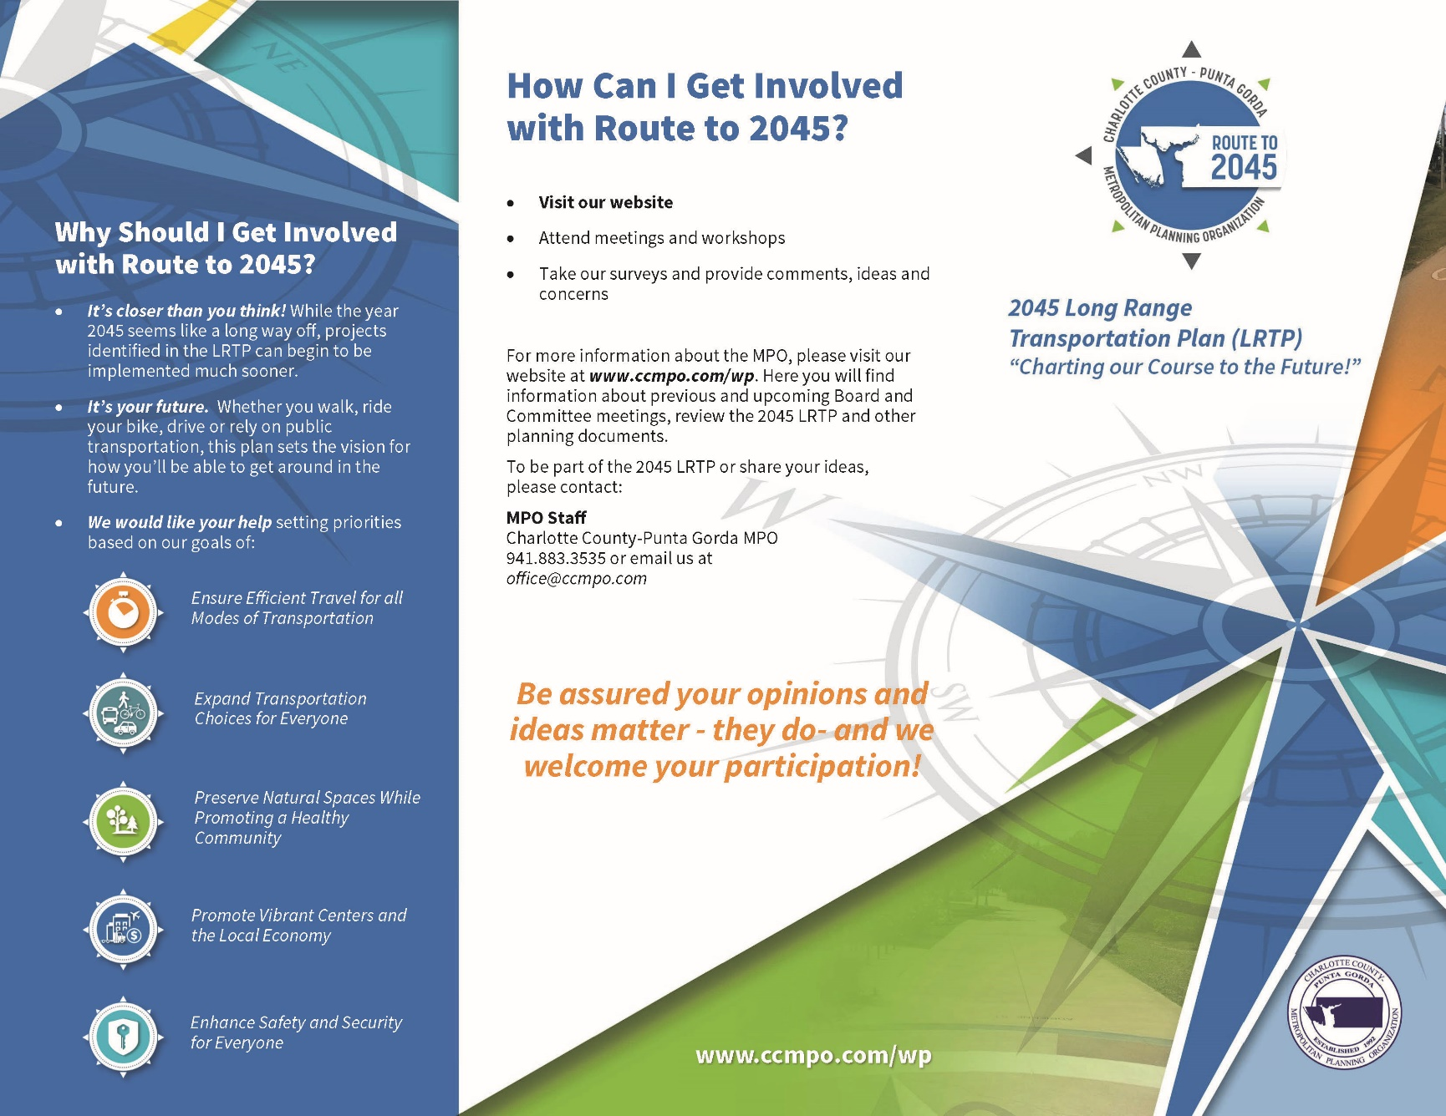

Phase II: Needs Plan
Phase II of public involvement focused on identifying transportation needs and improvement opportunities for the Charlotte County transportation network. Public involvement activities were conducted to seek input from Charlotte County residents about current and future transportation needs in the County.

LRTP Video
The MPO produced a short and informative video in collaboration with staff from Charlotte County’s government access television station, CC-TV-20. The video provided an overview of the MPO’s role in carrying out the federal requirements for Metropolitan Planning and starred members of the BPAC and CAC. Created to optimize virtual public involvement in the 2045 LRTP process and to meet Federal Highway Administration (FHWA) and Federal Transit Administration (FTA) encouragements to use new technologies and engagement platforms in transportation planning, the video was screened at the needs plan public workshops, shared with partner agencies, and made available on the MPO’s website.

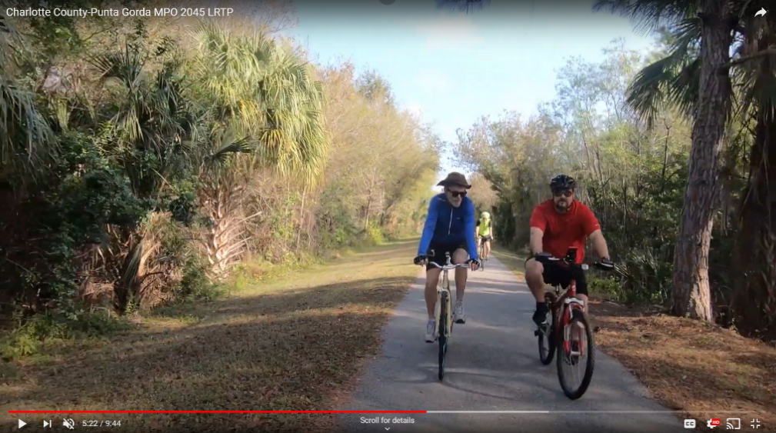
CC-TV staff interviewed a member of the BPAC while riding along Cape Haze Pioneer Trail in West County as part of the LRTP Video.
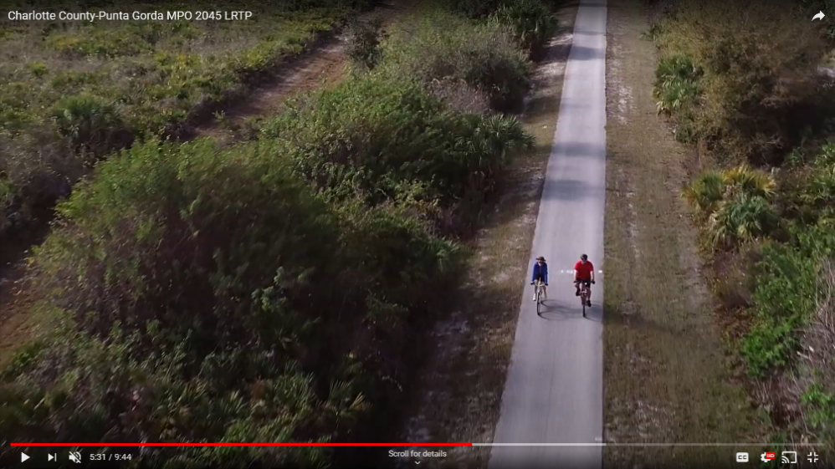

Web-Based Needs Plan Survey
A web-based survey was conducted to gain insights on the community’s vision and priorities for the transportation network to ensure the 2045 LRTP reflected the needs and desires of the community. Input was collected on future growth, transportation challenges, and possible transportation solutions. The survey process was conducted primarily online, with a link to the survey questionnaire available on the MPO’s website. A paper survey questionnaire was made available at the public workshops or by request. The survey was active from November 13, 2019 until April 15, 2020. During that time period, 657 survey questionnaires were successfully completed by residents and visitors who live or work in Charlotte County.
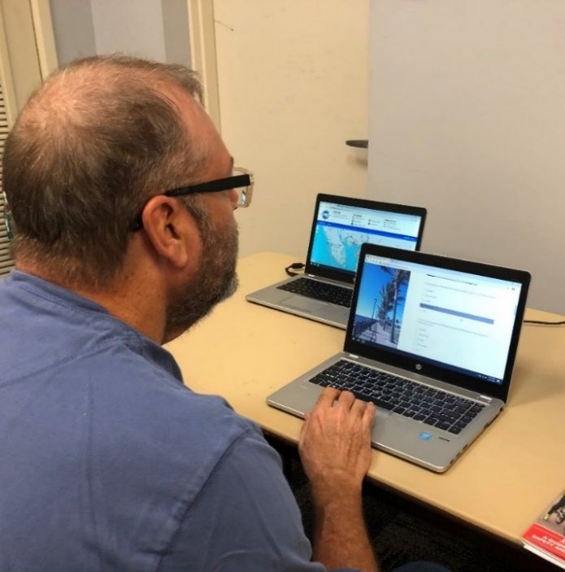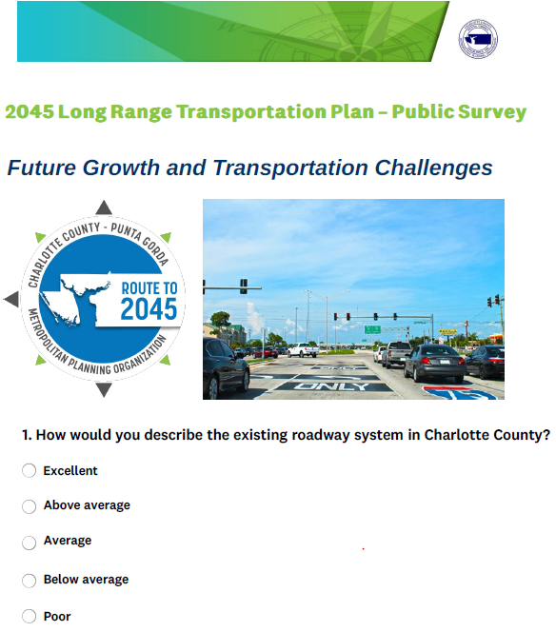
A Charlotte County resident completes the online Needs Survey during the Workshop

Needs Plan Workshops
Workshops were held in each of Charlotte County’s three distinct geographic areas to provide the public with an opportunity to discuss the LRTP with the planning team. The workshop activities were designed to solicit input from participants on solutions to improve mobility in Charlotte County and, identify transportation improvement projects. Attendees were invited to view informational display boards and provide input through completing the web-based survey, speaking with staff, filling out comment forms, and participating in the interactive mapping activity. Overall, 52 people attended the three workshops. The workshops were held at the following times and locations:
- Tringali Community Center
  - 3460 North Access Rd, Englewood- February 25, 2020; 2:00 p.m.-4:00 p.m.
- Mid County Library Meeting Room C
  - 2050 Forrest Nelson Blvd, Port Charlotte - February 26, 2020; 10:00 a.m.-12:00 p.m.
- Punta Gorda Library
  - 401 Shreve St, Punta Gorda - February 26, 2020; 2:00 p.m.-4:00 p.m.
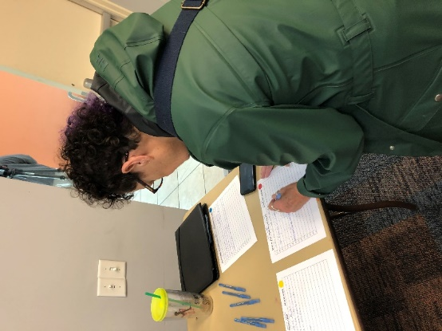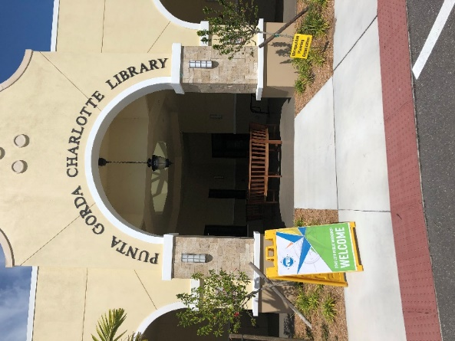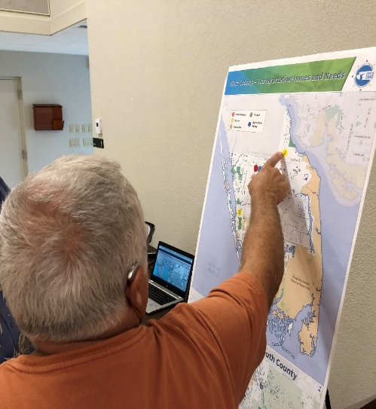

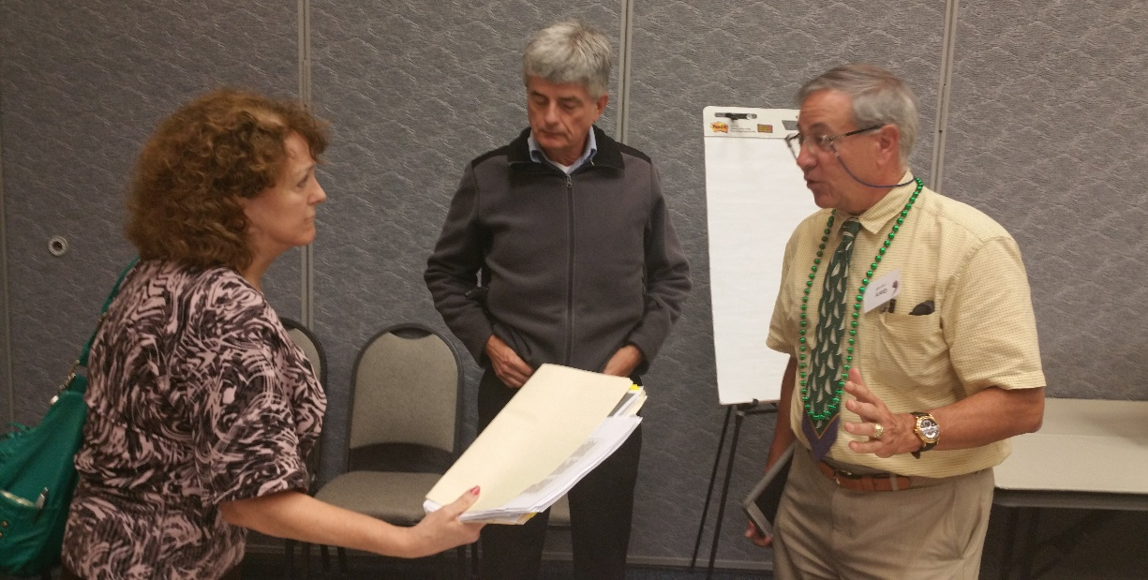
MPO staff and Charlotte County residents at Needs workshops

Web-Based Interactive Mapping Activity
The goal of the web-based interactive mapping activity was to receive citizen input on specific location-based transportation challenges, needs, and opportunities in the Charlotte County transportation network. The web-based interactive mapping activity was made available to respondents from February 25, 2020 through May 15, 2020. The web map provided an opportunity for residents to identify locations in Charlotte County where transportation challenges exist or where transportation improvements are needed. Participants had three ways to engage with the map and provide their input. These options included:
- Selecting a transportation need category (automobile, bicycle, pedestrian, transit, operation/safety) and placing a pin on the map where that need exists,
- Commenting on a pin already placed on the map, or
- “Liking” or “Disliking” a comment.
The mapping activity resulted in the placement of 72 locations/pins, 106 comments, and 56 “likes” and “dislikes”. The main transportation issues that were identified included operation/safety improvements, automobile needs, and bicycle/pedestrian improvements. This data was utilized to inform the prioritization of transportation projects included the Needs Plan. Figure 4-5 shows all public comments received in the web-based mapping activity.
Figure 4-5:Route to 2045 Interactive Web Map Activity
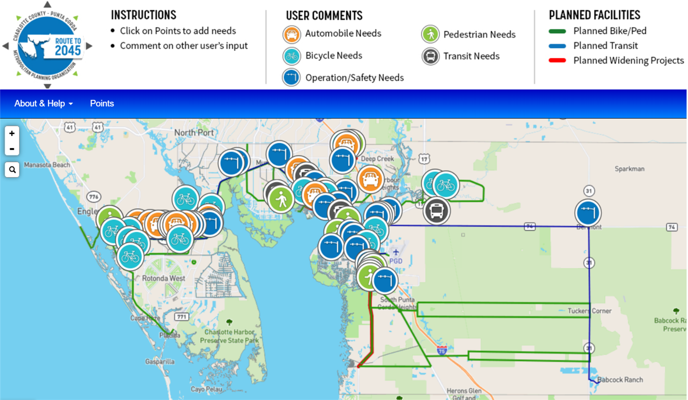

Phase III: Cost Feasible Plan and Implementation
Phase III of public involvement included prioritizing transportation projects identified through technical analysis and the Needs Workshops. These projects were prioritized against available revenues to help finalize the community’s vision for the region’s transportation system over the next 25 years. Virtual workshops, an online survey, and a 30-day comment period were organized to gather input from wide range of individuals to prioritize transportation improvements and projects.

Cost Feasible Virtual Workshops and Survey
Due to the outbreak of coronavirus, the Cost Feasible Plan workshops were organized in a virtual format to solicit input. The MPO made a significant effort to adapt the in-person public workshops into online events to provide meaningful opportunities for citizens to participate in the final stages of the LRTP development. Two virtual workshops held on June 24, 2020 and June 30,2020 with over 40 people in attendance. The virtual workshop presentations provided an overview of the region’s transportation needs, available revenues, and proposed transportation projects.
The virtual workshops were followed by online survey that provided a chance for citizens to weigh in on existing transportation priorities, make suggestions for revisions, and identify priorities based on funding availability. The survey was available for public input from June 22, 2020 to July 7, 2020 on the MPO’s website. Overall, 52 survey questionnaires were successfully completed by residents and visitors who live or work in Charlotte County.

30-Day Comment Period and Board Adoption
The MPO encouraged public participation in the development, review, and adoption process of the LRTP created many opportunities for the public to participate during the 2045 LRTP update process. In addition to the public outreach conducted for the Needs Plan and Cost Feasible Plan, the MPO provided a 30-day review and comment period for the 2045 LRTP draft report prior to adoption by the MPO Board on October 5, 2020. This comment and review period ended on September 2, 2020.
The draft 2045 LRTP report was posted on the MPO’s website and citizens and stakeholders were encouraged to provide input through phone calls, emails, or online comments forms up until the date of the LRTP adoption by the MPO Board (October 5, 2020). The MPO continued to maintain and update the 2045 LRTP project website (www.ccmpo.com ) with the draft 2045 LRTP report and other relevant project materials including workshop recordings and meeting presentations.

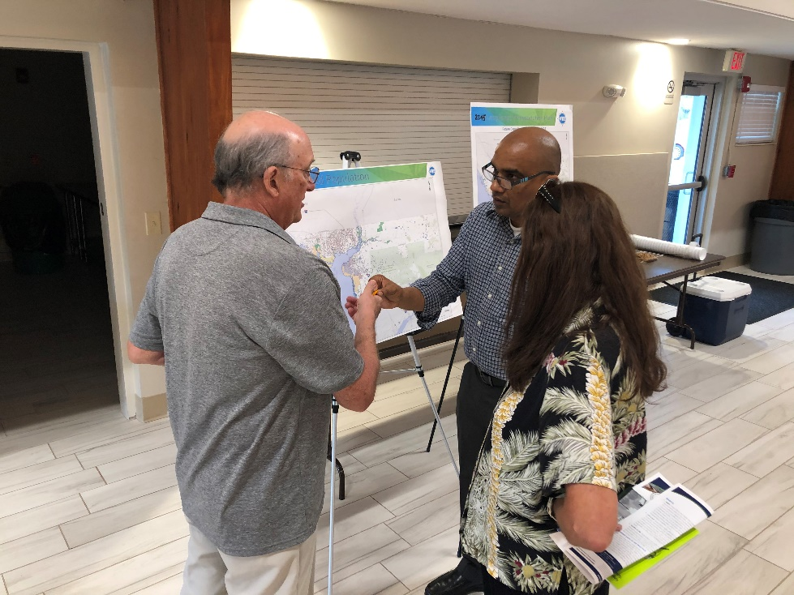
Members of the Public and MPO staff at the Needs Workshop discuss future growth in population and employment.

