Future Population
& Employment
Growth

Population and Employment Growth
Socioeconomic data, such as population and employment information, are a vital component of travel demand forecasting models used for transportation and hazard mitigation planning. Changes and shifts in demographic and socio-economic trends will continue to impact future transportation needs throughout Charlotte County.
Figure 3-1 and Table 3-1 show that Charlotte County’s population forecast will be 260,550 persons with a projected employment total of approximately 77,051 employees in 2045. This represents an increase in population of 94,993 persons and 28,092 employees from 2015 to 2045. The forecasted population and employment for Charlotte County from 2015 to 2045 represents an annualized growth rate of around 1.5 percent. In 2020, the State of Florida implemented stay-at-home orders and social distancing regulations in response to COVID-19. This global pandemic is one example of uncertainties that exist when projecting future populations. While short periods of high growth or decline have existed and will continue to exist, the population forecast to 2045 is based on an expectation of averaged growth over the time period. As seen in historic population estimates, peaks and valleys have existed in Charlotte County that coincide with catastrophic natural events such as Hurricane Charley and times of economic prosperity.
Figure 3-1: Historic Population Growth and Forecast (2000-2045)

Table 3-1: Population and Employment Forecasts
Variable | 2015 | 2045 | Growth | A.G.R*
Household Population | 165,557 | 260,550 | 94,993 | 1.52%
Dwelling Units | 97,813 | 153,144 | 55,331 | 1.51%
Resident Workers | 98,790 | 156,330 | 57,540 | 1.54%
Total Employees | 48,959 | 77,051 | 28,092 | 1.52%
*A.G.R = Annual Growth Rate
The recommended population and employment forecasts assume that over the next thirty years:
- Industrial employment in Charlotte County will increase slower than the rate of population growth.
- Commercial employment will continue to grow at a faster rate than the projected population growth.
- The relationship between population and employment is expected to remain constant.
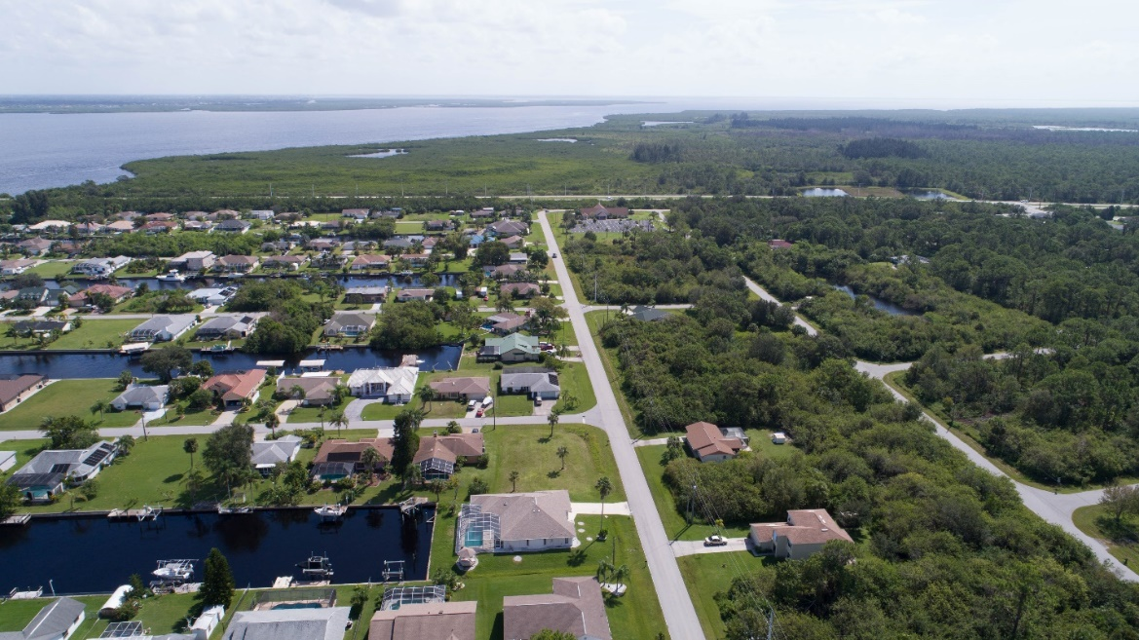
Table 3-2 summarizes the employment forecast by employee type that were used for estimating future travel demand. The employment types include broad categorization of jobs as industrial, commercial, and service. Table 3-2 summarizes majority of new jobs will be in the service sector consistent with current employment opportunities in Charlotte County.
Table 3-2: Employment Forecast by Employee Type
Variable | 2015 | 2045 | Growth
Industrial Employment | 4,874 | 7,546 | 2,672
Commercial Employment | 14,174 | 23,673 | 9,499
Service Employment | 29,911 | 45,832 | 15,921
Total Employment | 48,959 | 77,051 | 28,092

Using the County’s planning areas shown in Figure 3-2, the majority of growth is expected to occur in South County. Details on the existing and projected growth are shown in Table 3-3. The high growth expected in South County is driven by approved developments like Babcock Ranch, Heritage Landing and others. The remainder of this chapter provides a summary of the approved developments and the growth forecasts used for developing the 2045 LRTP.
Figure 3-2: Charlotte County Planning Areas
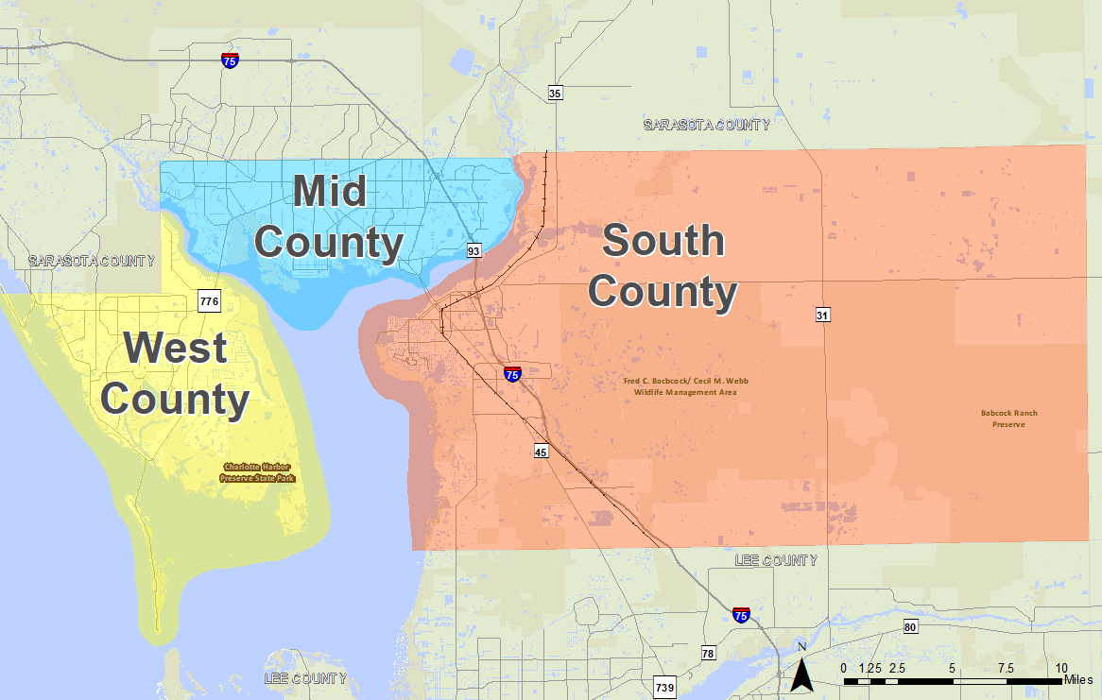
Table 3-3: Existing and Future Population and Employment by Planning Area
Variable | 2015 | 2045 | Growth
South County
Dwelling Units | 17,471 | 48,118 | 30,647
Population | 25,014 | 87,116 | 62,102
Employment | 15,826 | 31,788 | 15,962
Mid County
Dwelling Units | 50,995 | 68,309 | 17,314
Population | 92,790 | 116,291 | 23,501
Employment | 26,456 | 35,572 | 9,116
West County
Dwelling Units | 29,347 | 36,717 | 7,370
Population | 47,753 | 57,143 | 9,390
Employment | 6,677 | 9,691 | 3,014

Growth Allocation
Forecasting population and employment for the year 2045 includes not only estimating the number of people living and working in Charlotte County, but also allocating the people and jobs geographically throughout the County.
Population and employment growth were allocated to subareas of the County to Traffic Analysis Zones (TAZs), which are used for estimating future traffic and use of the transportation system. Approved or planned developments were incorporated into this allocation. Land Use controls through the County and City Comprehensive Plans were also used for determining availability for future growth potential. Coordination with County and City planners identified the major developments and expectations for growth through 2045. Major development areas within Charlotte County (such as Babcock Ranch, Sunseekers, and West Port which is in Murdock Village) are shown in Figure 3-3. Figure 3-4 shows the growth in household population along with the total 2045 population that was estimated. Likewise, Figure 3-5 shows projected growth in employment along with the 2045 employment estimates.

Figure 3-3: Major Development Areas
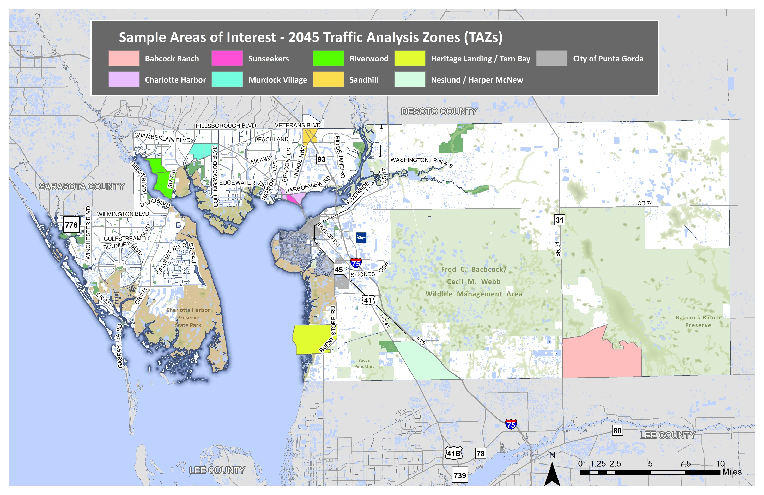

Figure 3-4: Growth in Population and 2045 Forecast
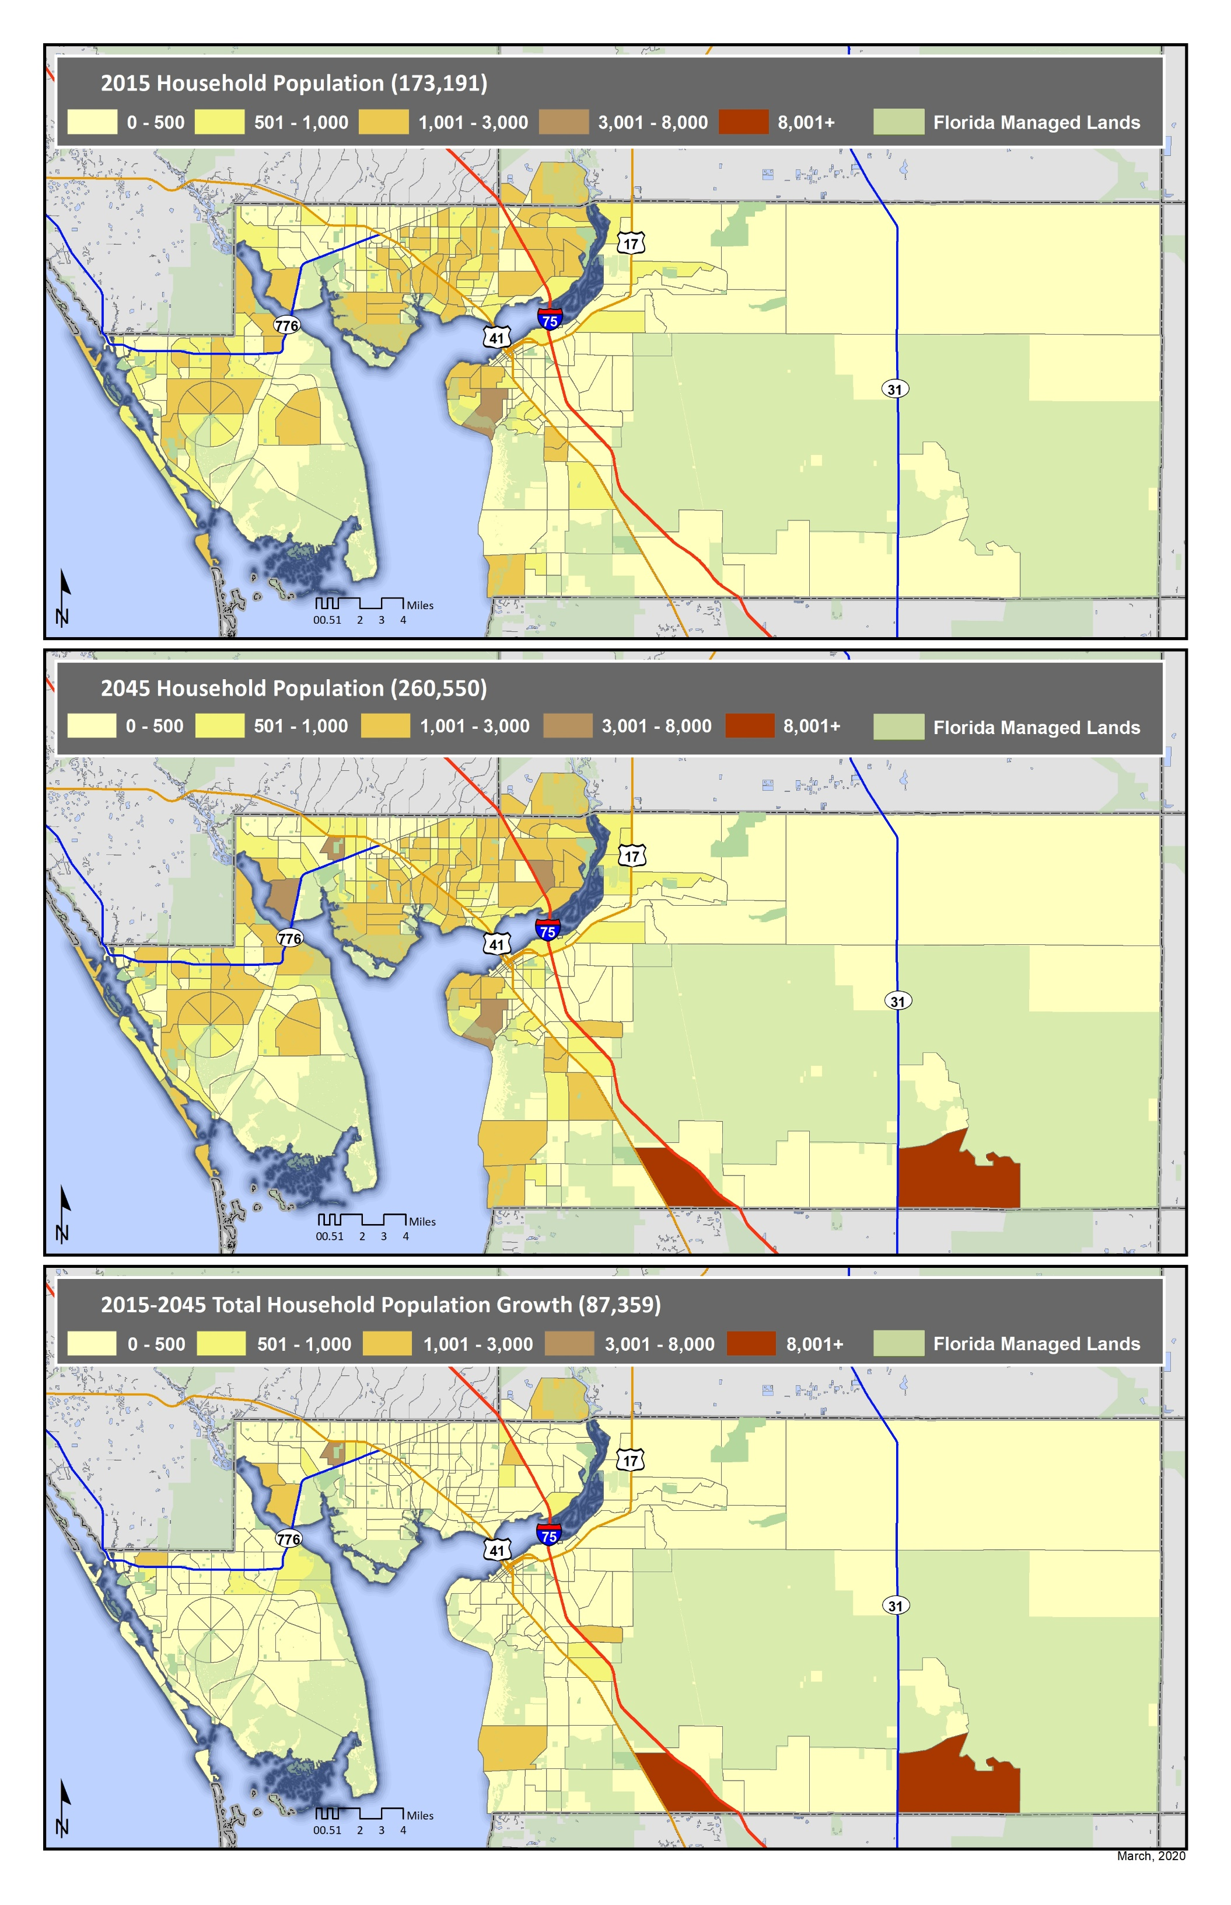
Figure 3-5: Growth in Employment and 2045 Forecast
