Introduction

Introduction
The United States Congress passed the Federal-Aid Highway Act of 1962, which required the formation of a Metropolitan Planning Organization (MPO) for any urbanized area with a population greater than 50,000. MPOs are federally funded transportation policymaking organizations made up of local government and transportation providers. Congress created MPOs to ensure that existing and future expenditures of governmental funds for transportation projects and programs are based on a continuing, cooperative, and comprehensive (“3-C”) planning process. Statewide and metropolitan transportation planning processes are governed by federal law (23 U.S.C. §§ 134-135). The Charlotte County-Punta Gorda MPO was created in July 1992 and is made up of representatives from the Charlotte County Board of County Commissioners, the Charlotte County Airport Authority, the City of Punta Gorda, and the Florida Department of Transportation (FDOT) District One Secretary.
The most significant aspect of the Charlotte County-Punta Gorda MPO’s mission is to ensure future mobility for residents and visitors in Charlotte County and Punta Gorda, as well as a portion of southwest DeSoto County within the MPO’s planning area boundary. To do so, the MPO guides the transportation planning process which includes the development of the Long Range Transportation Plan (LRTP) to identify future transportation improvements.
The LRTP is required by the Federal Highway Administration (FHWA) to identify strategies to ensure current and future mobility needs. The analysis used to develop the plan is based on population and employment projections, the expected travel patterns, and amount of travel to the year 2045. The plan is updated every five years to refine the long-term strategy for the transportation system based on changes in transportation needs and outlook for the MPO’s planning area.
The short-range component of the LRTP is the Transportation Improvement Program (TIP), which covers the first five years. The TIP identifies, prioritizes, and allocates funding for transportation projects and is updated annually. Projects must be in the LRTP to be added to the TIP.
The LRTP meets federal guidelines with the adoption of a set of goals and objectives that allow potential projects’ performance to be measured. This ensures the projects included in the LRTP best address the goals and vision established by the MPO.
Route to 2045 is the brand name for the LRTP, coined by the Charlotte County Punta Gorda MPO, that identifies the “route” to meet the transportation needs of the MPO’s planning area for the next 25 years. The plan addresses cost feasible highway, transit, bicycle, and pedestrian projects through the year 2045. The improvements identified in this Plan highlights the future multimodal needs and enhance safety and security within the planning area boundary. The map in Figure 1-1 shows the planning area and key features within the MPO’s planning area.
Figure 1-1 Charlotte County-Punta Gorda MPO Planning Area Map
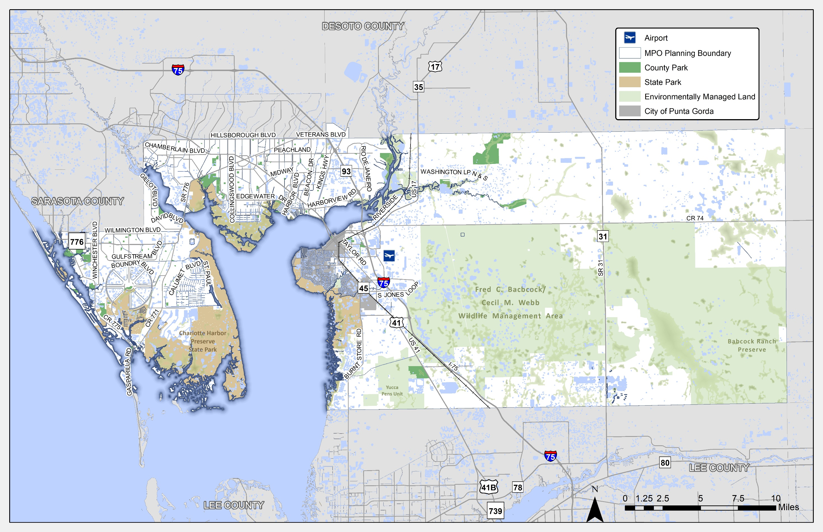

Mapping the Route to 2045
The LRTP establishes a vision to address the transportation system needs through cost feasible improvements over the next 25 years. The multimodal plan documented in this report outlines highways; public transportation (transit); and bicycle, pedestrian, and multi-use trail facilities. The purpose of this plan is to address federal and state requirements by identifying projects that are cost feasible for each mode of travel.
This 2045 LRTP represents a significant and visionary effort to address the long-term transportation needs of Charlotte County, City of Punta Gorda, and the southwest corner of DeSoto County. Key highlights of this plan include:
- Population and employment forecasts that consider growth in the existing core and current plans for the Babcock Ranch Development in the eastern portion of the county.
- Updated revenue projections from federal, State, and local transportation sources.
- Extensive public involvement included in-person meetings and workshops, multiple online surveys, an interactive online mapping application, and the MPO’s first “cost feasible” virtual workshops.
- A review of existing public transportation priorities and incorporation of the first-ever Charlotte County Regional Bicycle/Pedestrian Master Plan.
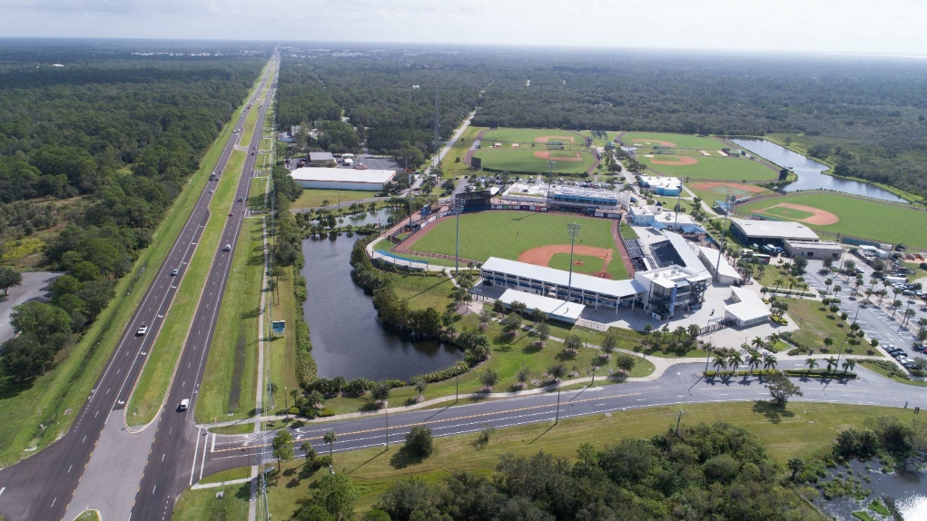
Improving intersections along SR 776, like this one at the Charlotte Regional Sports Park, are key locations identified in the Route to 2045 LRTP.

Plan Development
There are two major aspects required in the development of the LRTP. The first is the identification of the transportation needs of the community. Second is determining how will we pay for the needs (Cost Feasible). The identification of needs considers projected growth and how it may affect the transportation system, and the community’s aspirations for the future. The Cost Feasible Plan identifies the needs that can be funded with available transportation revenues. The LRTP addresses the surface transportation network including roadways, transit, and non-motorized (bicycle and pedestrian) facilities.
This document summarizes the 2045 LRTP components in both map and tabular formats while providing an overview of the process followed for establishing a community vision and goals that guided the LRTP development. Figure 1-2 provides an overview of the steps that were followed in developing the results and recommendations for the LRTP. Appendix A provides a checklist demonstrating how and where the long range transportation planning requirements identified in State Statutes and Federal Regulations have been addressed.
Figure 1-2: Route to 2045 Development Process
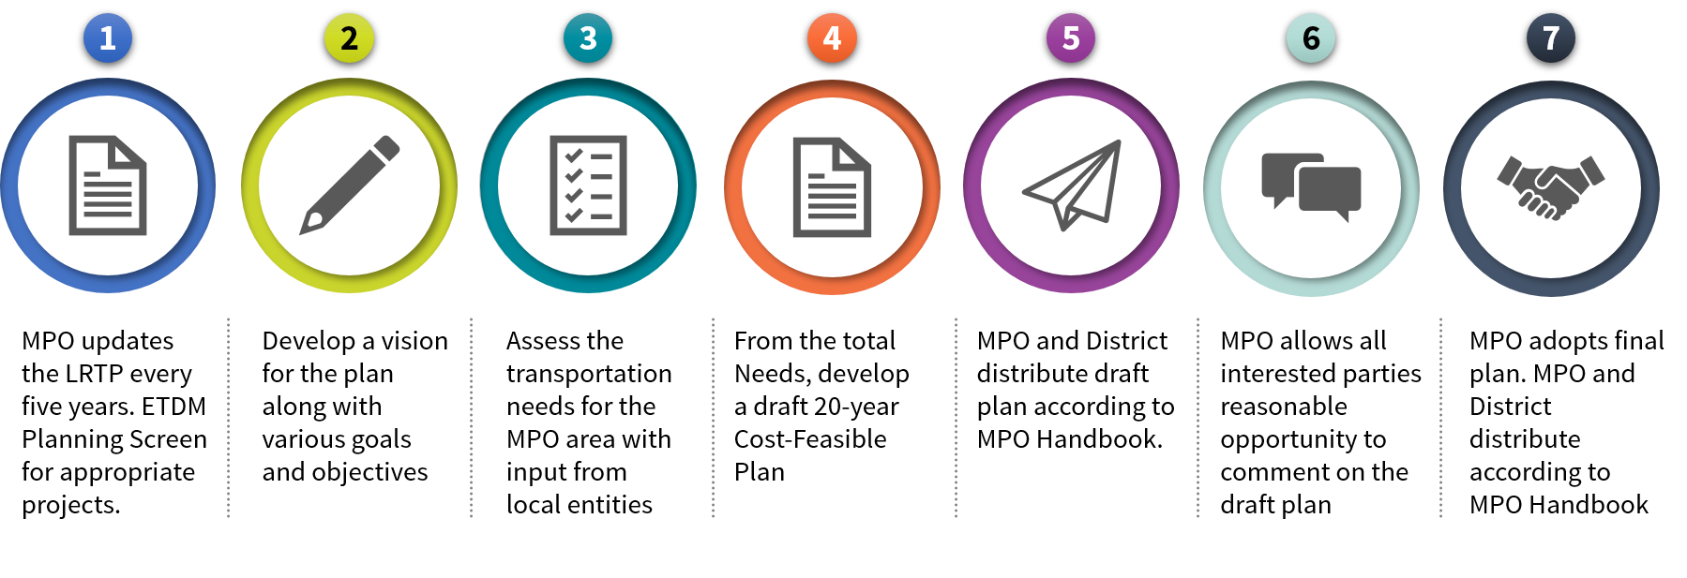

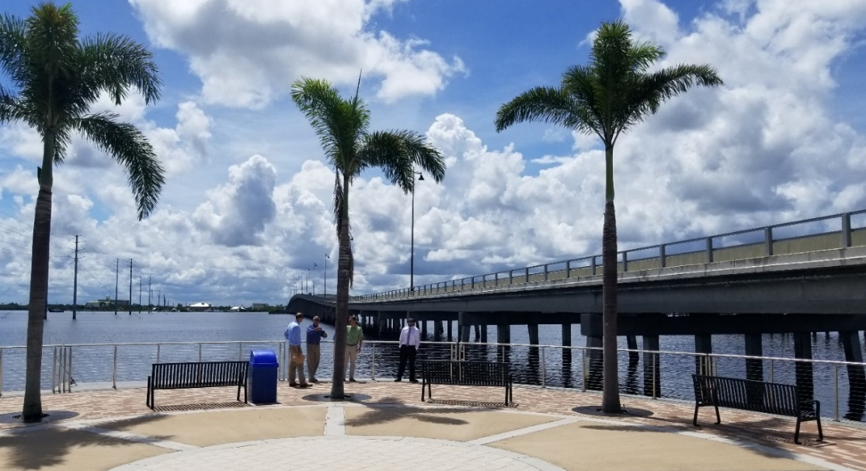
The Riverwalk Live Oak Point was dedicated by the Board of County Commissioners on June 2, 2016 and connects with the Riverwalk to the west under US 41.

About this Document
Route to 2045 is organized into 10 chapters, as follows:
Chapter 1: Introduction – This chapter introduces the plan, the purpose of the plan, and why the plan is updated every five years.
Chapter 2: 2045 LRTP Guidance – This chapter presents the MPO’s policy-related goals and objectives adopted by the MPO Board to guide the plan development process, compliance with federal and state guidelines, and the effectiveness measures used to evaluate the performance of the cost feasible plan. Included in this chapter is the Existing Plus Committed (E+C) Network that outlines the existing transportation system with the improvements committed to be built by 2025 through the TIP.
Chapter 3: Future Population and Employment Growth – This chapter presents the approach and planning assumptions used in the plan, including the anticipated population and employment growth.
Chapter 4: 2045 LRTP Public Participation – This chapter outlines the public engagement process taken throughout the update of the Route to 2045 LRTP.
Chapter 5: Environment/Socio-Cultural – This chapter provides and overview of the natural and human environments by describing the environmental, socio-cultural resources, and community resources within Charlotte County. This chapter also outlines the strategies available for mitigating environmental impacts as well as identifying populations groups that have traditionally experienced disproportionately high and adverse effects from transportation funding decisions under the Environmental Justice definition.
Chapter 6: Congestion Management Process– This chapter outlines the process followed by the Charlotte County-Punta Gorda MPO to reduce congestion and improve safety using operational and travel demand strategies.
Chapter 7: 2045 Needs – This chapter outlines the multimodal Needs Plan for all transportation modes. The Needs Plan includes roads (highway), public transportation (transit), and bicycle and pedestrian improvements identified as needed without financial constraints applied. Also, this chapter outlines the following elements of the transportation program: goods movement, transportation safety and security (including hazard mitigation), assessment of the socio-cultural effects, environmental mitigation, and advancing technologies.
Chapter 8: 2045 Cost Feasible Plan – This chapter outlines the project prioritization process and assumptions of reasonably available revenues for transportation. Using these assumptions, the needed transportation projects are narrowed down to create the fiscally constrained Cost Feasible Plan.
Chapter 9: Plan Performance – This chapter describes the performance of the 2045 Cost Feasible transportation network compared to the E+C Network.
Chapter 10: Realizing the Route to 2045 – This chapter documents issues and activities the MPO will need to consider in implementing the projects and objectives of the LRTP.

